Save project on c drive under location C:\VueJsTypeScriptSite

Start the back-end first

1) Run the UnitTests first: Open new Cmd and cd into: C:\VueJsTypeScriptSite\BackEnd\BackEnd.Tests as shown below and Execute **dotnet test**

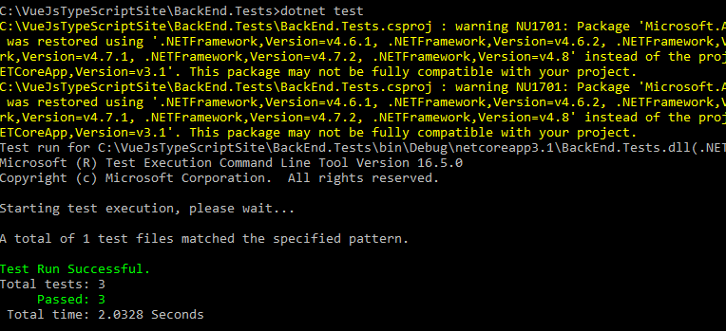

Run the Back-end API

1) Open new cmd and cd into : C:\VueJsTypeScriptSite\BackEnd as shown below and Execute: **dotnet run**

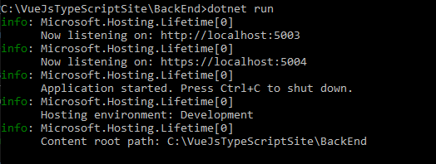

6) Browse the url to verify api running: <http://localhost:5003/swagger/index.html>

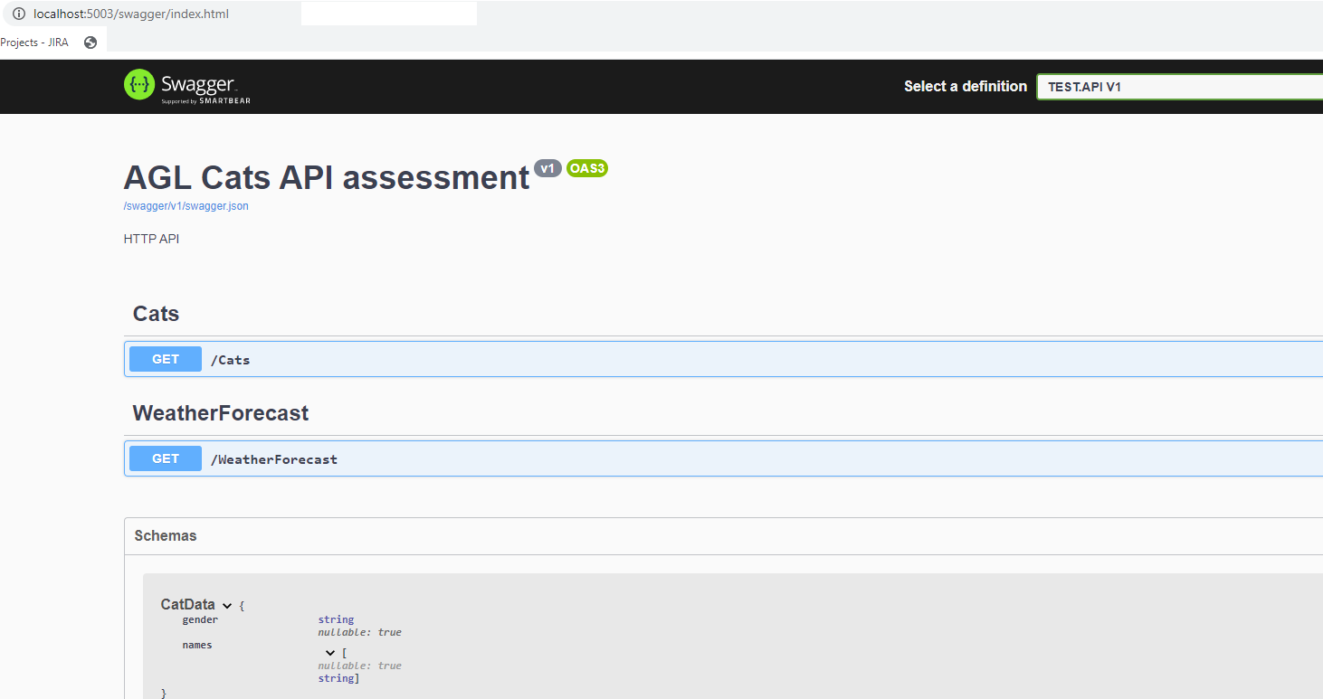

Start the Front – end

1) Open new cmd and cd into : C:\VueJsTypeScriptSite as shown below:

2) Execute:

npm install



npm run build

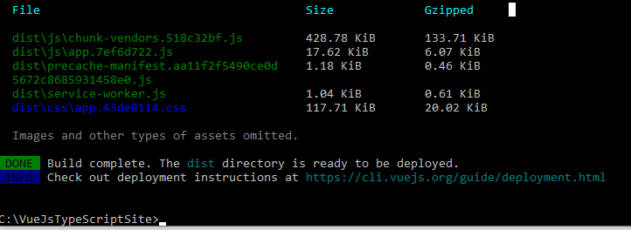

3) Run the functional unit tests:

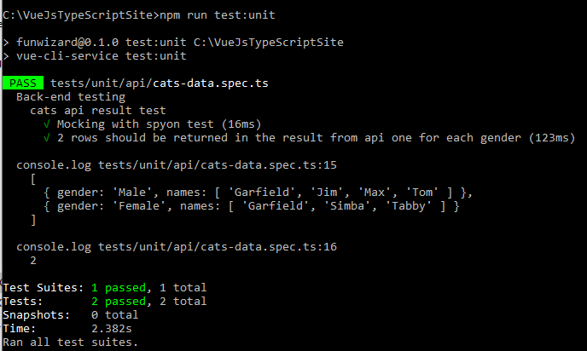

4) npm run serve

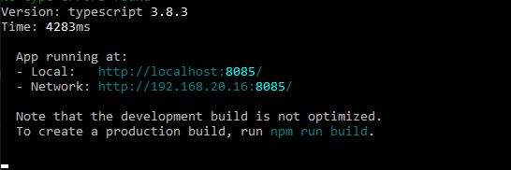

4) Open the site URL: <http://localhost:8085>

It will call the back-end api, the back-end api will make a call to the API server to fetch results

