Save project on c drive under location c:\funwizard-master

1)Open cmd go to path funwizard-master and run below command to install moduels:

npm install

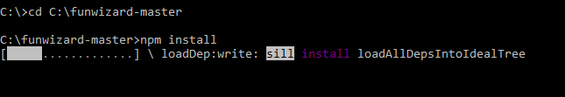

npm run build

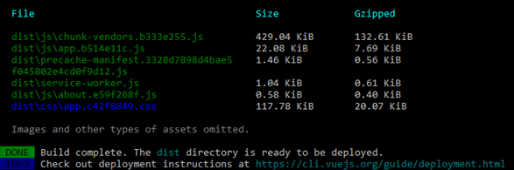

3) npm run serve

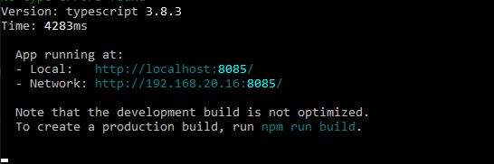

4) Open the site URL: <http://localhost:8085>

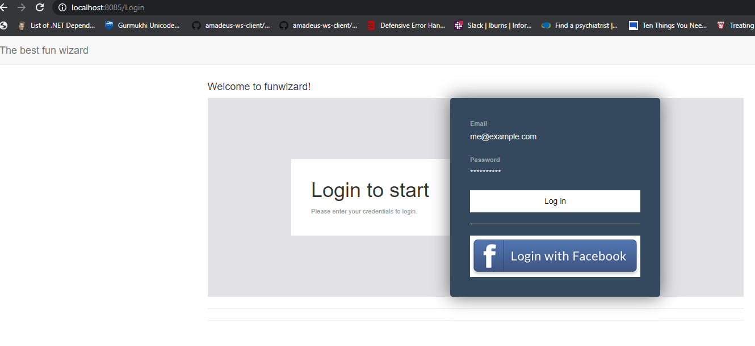

Start the back-end

4) Open new cmd and cd wizard/backend

5) dotnet run

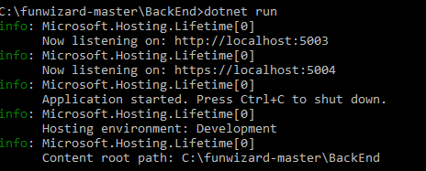

6) Browse the api: <http://localhost:5003/swagger/index.html>

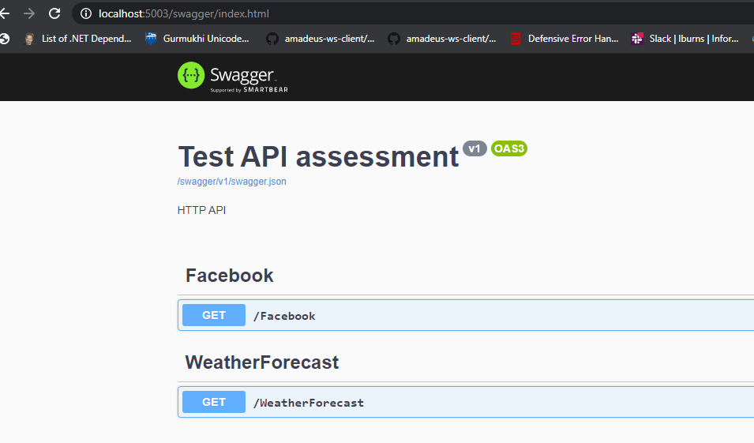

Run unit tests:

6) Open new cmd and cd wizard/backend.tests and run:

dotnet test

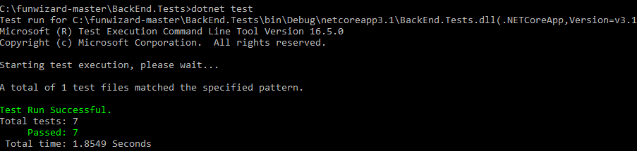

Test ui:

1. Click login with facebook button, load your credentials:
2. 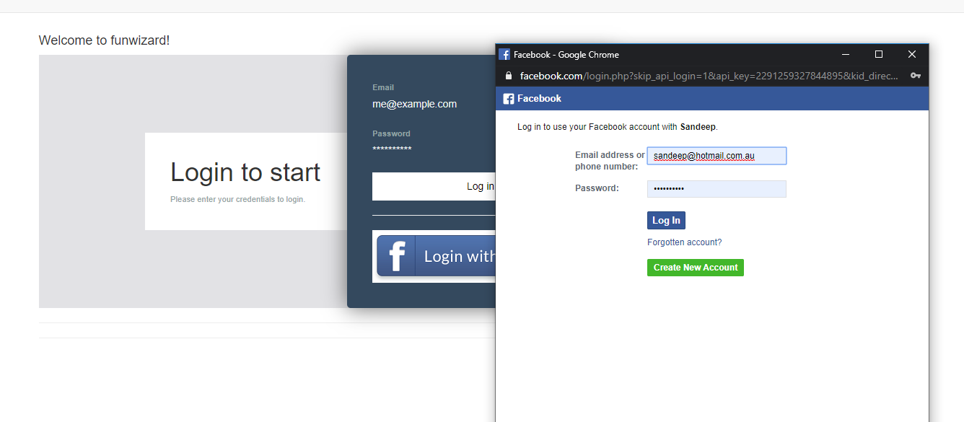
3. UI will redirect to secure welcome page with user details from facebook

