Frequency Plot

Suhaas Ramani

9/17/2020

To the ad numbers on excel I made a new heading called ad_number and imported the file into R. After which I arranged and ordered the data in terms of impressions.

library(tidyverse)

## -- Attaching packages --------------------------------------------------------------------- tidyverse 1.3.0 --

## v ggplot2 3.3.1 v purrr 0.3.4  
## v tibble 3.0.1 v dplyr 1.0.0  
## v tidyr 1.1.0 v stringr 1.4.0  
## v readr 1.3.1 v forcats 0.5.0

## -- Conflicts ------------------------------------------------------------------------ tidyverse_conflicts() --  
## x dplyr::filter() masks stats::filter()  
## x dplyr::lag() masks stats::lag()

library(dplyr)  
library(ggplot2)  
library(readxl)  
library(plotly)

## Warning: package 'plotly' was built under R version 4.0.2

##   
## Attaching package: 'plotly'

## The following object is masked from 'package:ggplot2':  
##   
## last_plot

## The following object is masked from 'package:stats':  
##   
## filter

## The following object is masked from 'package:graphics':  
##   
## layout

library(ggrepel)

## Warning: package 'ggrepel' was built under R version 4.0.2

library(gridExtra)

## Warning: package 'gridExtra' was built under R version 4.0.2

##   
## Attaching package: 'gridExtra'

## The following object is masked from 'package:dplyr':  
##   
## combine

Kerala_ad <- read_excel("C:\\Users\\Suhaas Ramani\\Desktop\\R Research Project - Facebook Ads\\Filtered_Kerala_Ad_Data.xlsx")  
  
Kerala_ad <- Kerala_ad %>%   
 filter(!is.na(creation_date_notime)) %>%  
 mutate(ad_number = as.numeric(ad_number)) %>%   
 arrange(ad_number)  
  
Kerala_ad$impressions <- factor(Kerala_ad$impressions, levels = c("<1K", "1K-5K", "5K-10K", "10K-50K", "50K-100K", "100K-200K", "200K-500K", "500K-1M", ">1M"))  
  
Kerala_ad <- Kerala_ad[order(Kerala_ad$impressions),]

After this I realized it would be difficult to visually interpret the frequencies, impressions and ad numbers for each point with the labels if all the points were on one plot so I had to separate them into 24 plots with an approximate range of 40 observations each. Beside each point on each plot, the ad_number and the region_KL frequency are pasted and separated by a comma. Through this you will be able to visually see how many impressions each ad received, its number and the relative frequency with which it was received in the region of Kerala.

## Warning: Removed 855 rows containing missing values (geom_point).

## Warning: Removed 855 rows containing missing values (geom_text).

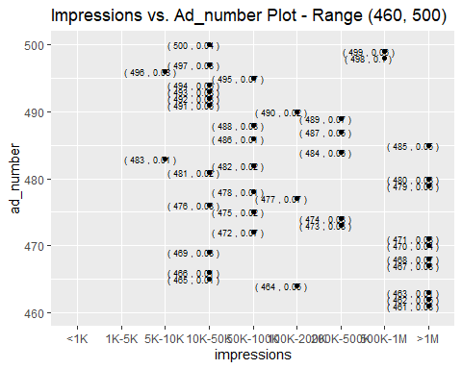

## Warning: Removed 855 rows containing missing values (geom_point).  
  
## Warning: Removed 855 rows containing missing values (geom_text).

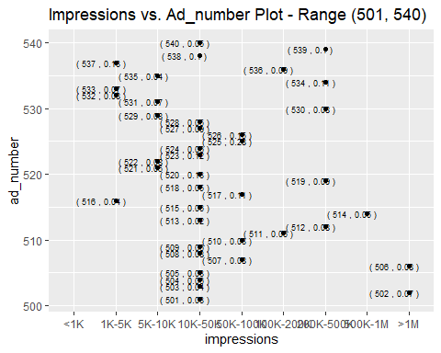

## Warning: Removed 855 rows containing missing values (geom_point).  
  
## Warning: Removed 855 rows containing missing values (geom_text).

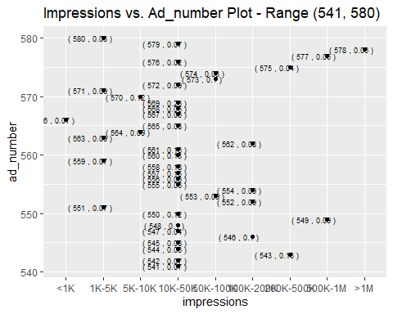

## Warning: Removed 860 rows containing missing values (geom_point).

## Warning: Removed 860 rows containing missing values (geom_text).

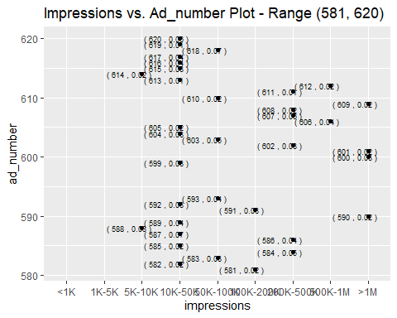

## Warning: Removed 855 rows containing missing values (geom_point).

## Warning: Removed 855 rows containing missing values (geom_text).

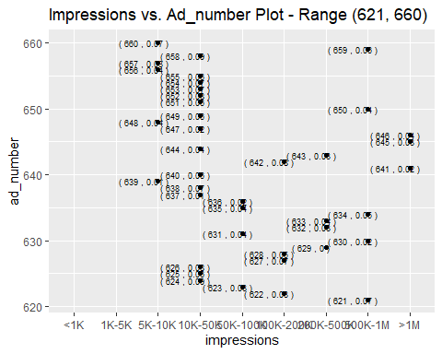

## Warning: Removed 855 rows containing missing values (geom_point).  
  
## Warning: Removed 855 rows containing missing values (geom_text).

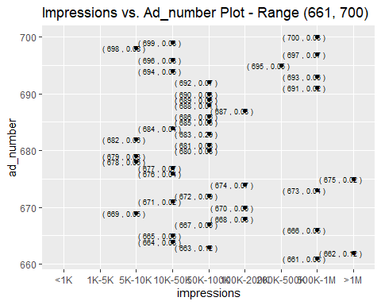

## Warning: Removed 855 rows containing missing values (geom_point).  
  
## Warning: Removed 855 rows containing missing values (geom_text).

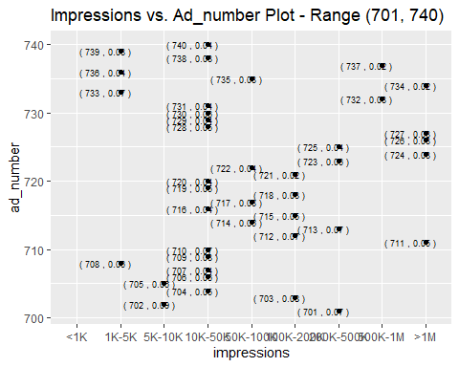

## Warning: Removed 855 rows containing missing values (geom_point).  
  
## Warning: Removed 855 rows containing missing values (geom_text).

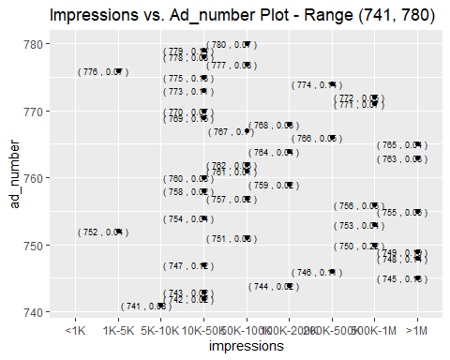

## Warning: Removed 855 rows containing missing values (geom_point).  
  
## Warning: Removed 855 rows containing missing values (geom_text).

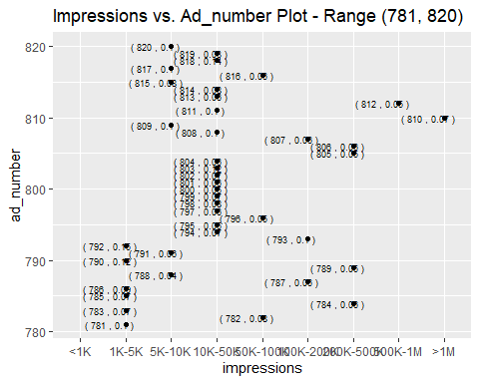

## Warning: Removed 855 rows containing missing values (geom_point).  
  
## Warning: Removed 855 rows containing missing values (geom_text).

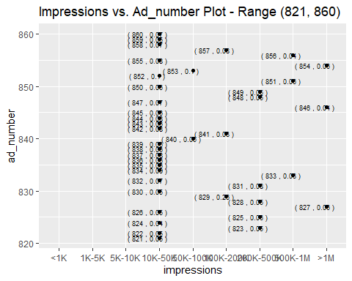

## Warning: Removed 855 rows containing missing values (geom_point).  
  
## Warning: Removed 855 rows containing missing values (geom_text).

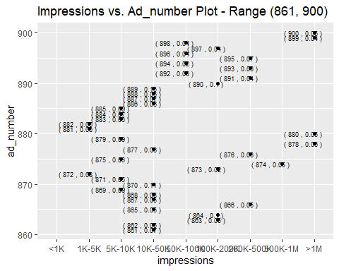

## Warning: Removed 855 rows containing missing values (geom_point).  
  
## Warning: Removed 855 rows containing missing values (geom_text).

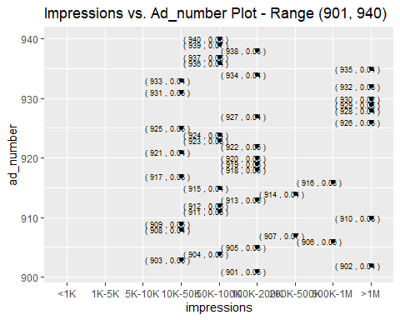

## Warning: Removed 855 rows containing missing values (geom_point).  
  
## Warning: Removed 855 rows containing missing values (geom_text).

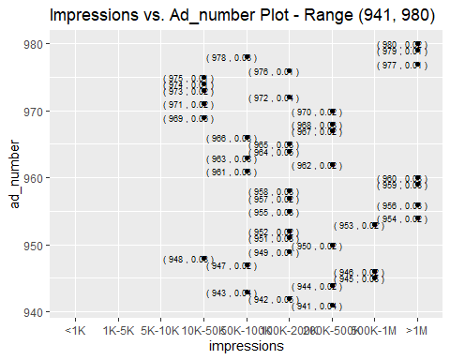

## Warning: Removed 855 rows containing missing values (geom_point).  
  
## Warning: Removed 855 rows containing missing values (geom_text).

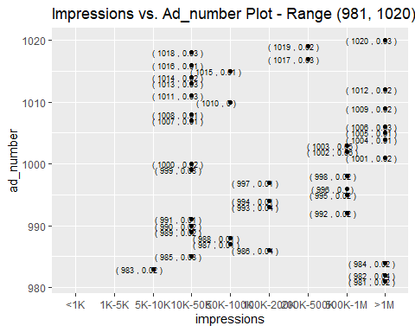

## Warning: Removed 857 rows containing missing values (geom_point).

## Warning: Removed 857 rows containing missing values (geom_text).

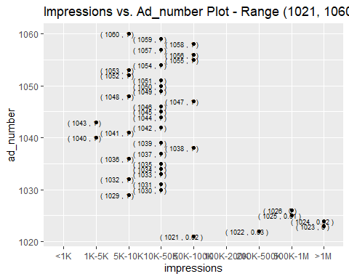

## Warning: Removed 867 rows containing missing values (geom_point).

## Warning: Removed 867 rows containing missing values (geom_text).

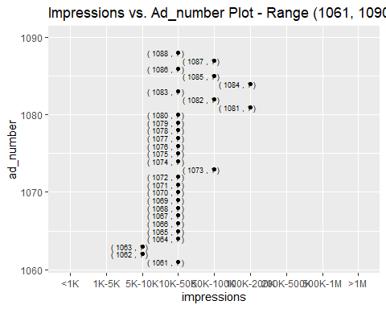

## Warning: Removed 879 rows containing missing values (geom_point).

## Warning: Removed 879 rows containing missing values (geom_text).

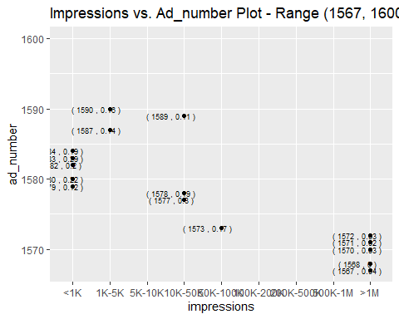

## Warning: Removed 874 rows containing missing values (geom_point).

## Warning: Removed 874 rows containing missing values (geom_text).

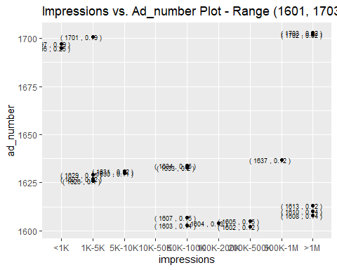

## Warning: Removed 862 rows containing missing values (geom_point).

## Warning: Removed 862 rows containing missing values (geom_text).

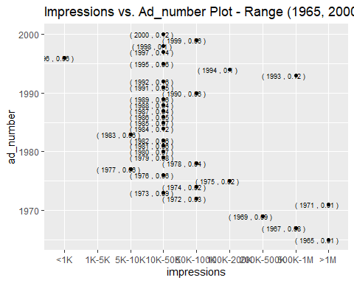

## Warning: Removed 855 rows containing missing values (geom_point).

## Warning: Removed 855 rows containing missing values (geom_text).

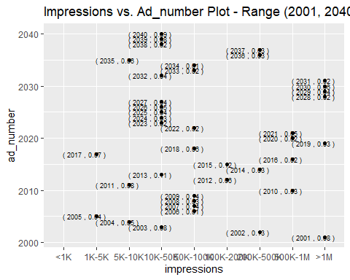

## Warning: Removed 855 rows containing missing values (geom_point).  
  
## Warning: Removed 855 rows containing missing values (geom_text).

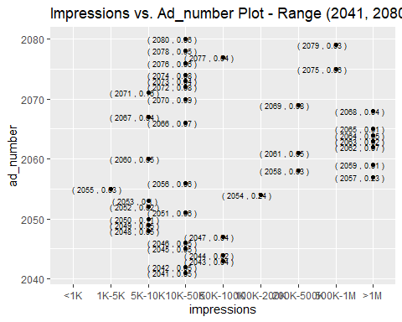

## Warning: Removed 855 rows containing missing values (geom_point).  
  
## Warning: Removed 855 rows containing missing values (geom_text).

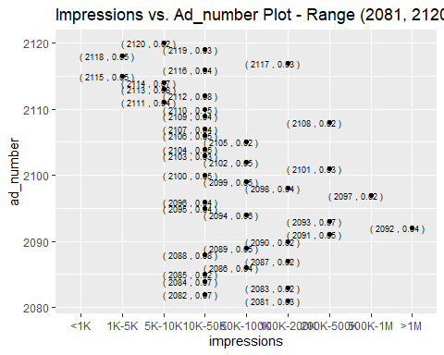

## Warning: Removed 855 rows containing missing values (geom_point).  
  
## Warning: Removed 855 rows containing missing values (geom_text).

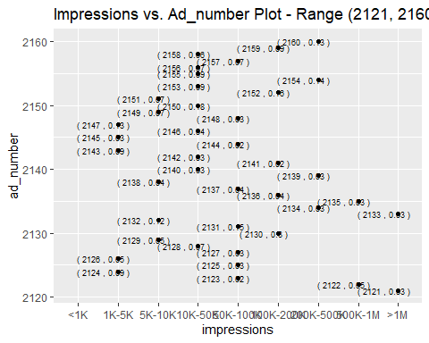

## Warning: Removed 852 rows containing missing values (geom_point).

## Warning: Removed 852 rows containing missing values (geom_text).

