1. Pretty numbers(Python)

The question tells us to print the number of numbers ending with 2, 3 or 9 in the given range of l to r.

So we iterate each number and find last digit using j%10, and then use an if condition to check if it is 2, 3 or 9 and print the number.

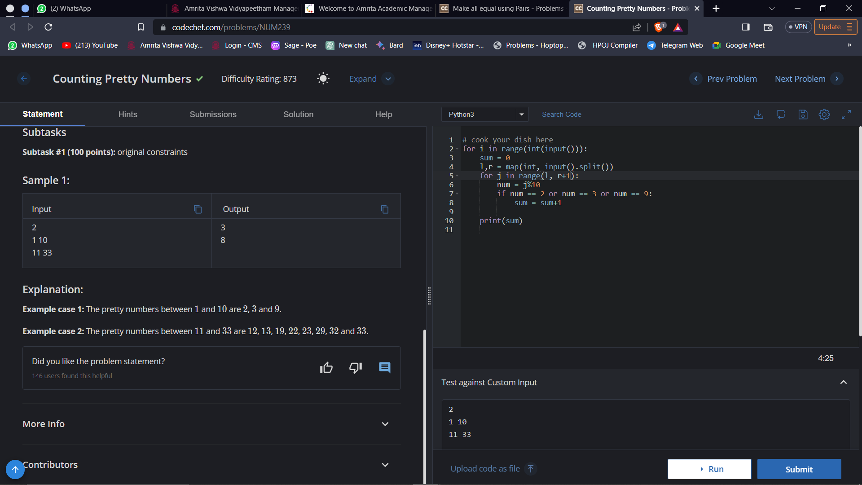

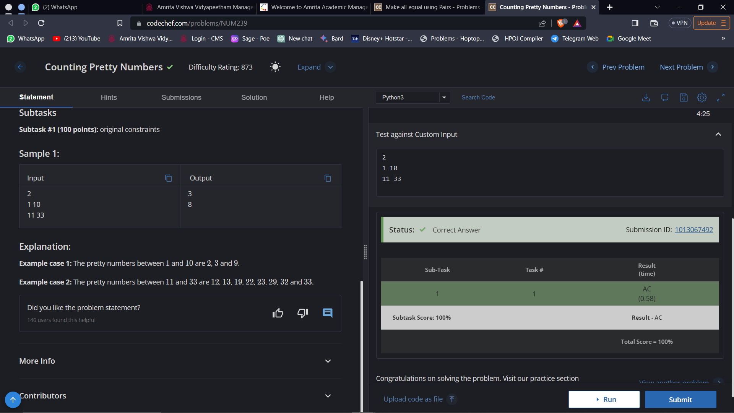

Time complexity: O(n)

1. Make all equal using pairs(Python)

Create a list of numbers given as input and make a dictionary called fr. Find frequency of each number in the list using the dictionary using a for loop. If the number is already present in the dictionary then increment its count by 1, and so on. Find maximum frequency from the dictionary and subtract that from the total number of elements present to get the minimum number of operations.

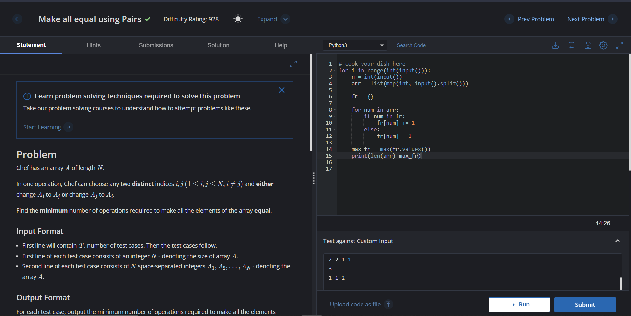

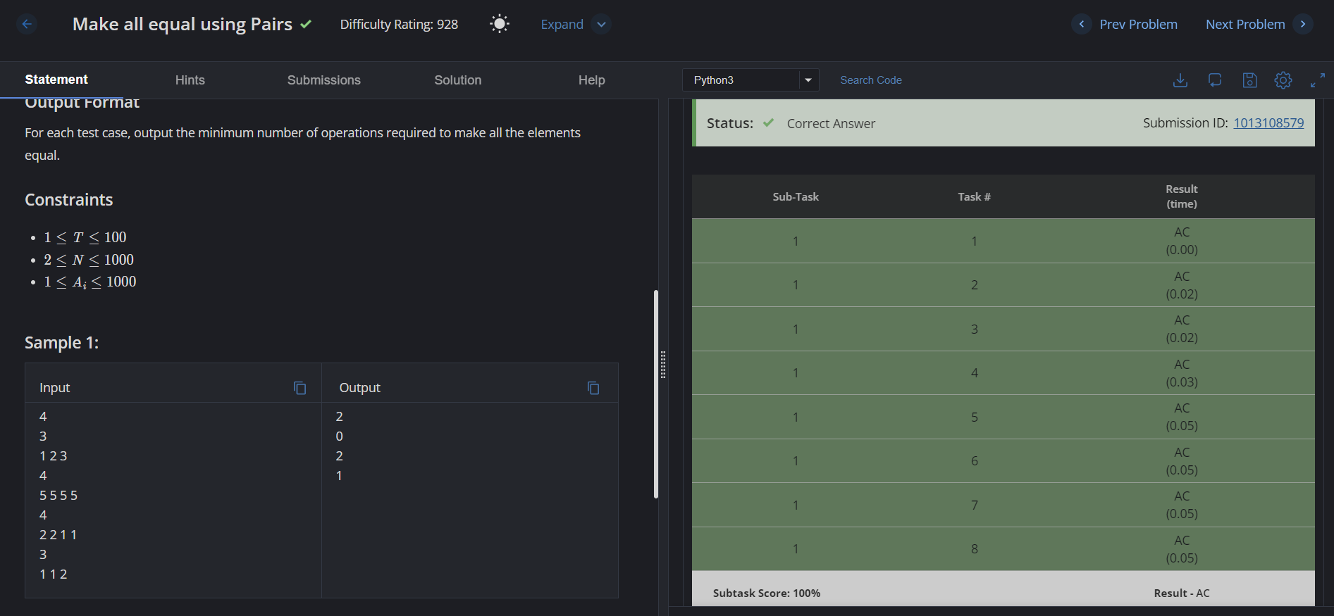

Time complexity: O(n)

1. Ved salesman(C++)

Take inputs for t,n,w. Then iterate and get values for a[i]. Perform bubble sort to arrange in descending order. Then iterate and add each element to the variable amt and after each iteration check if amt>=w. If the condition satisfies, print the number of holidays by subtracting the total number of days and the iteration number,k, and 1 (since k value starts at 0, and not 1)

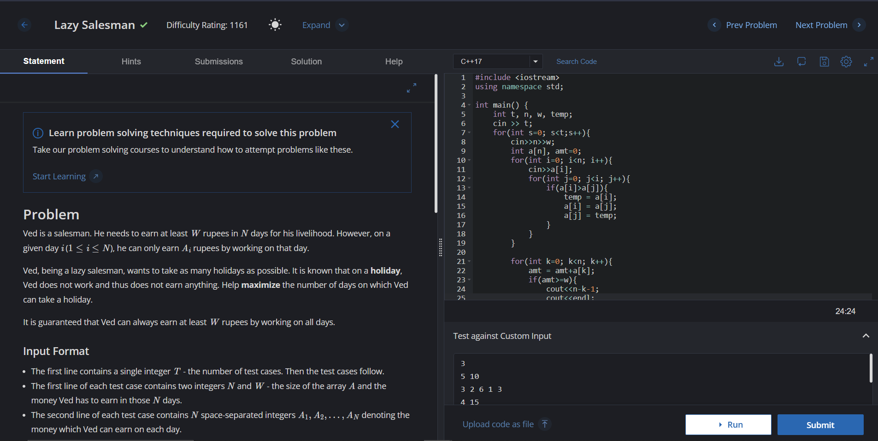

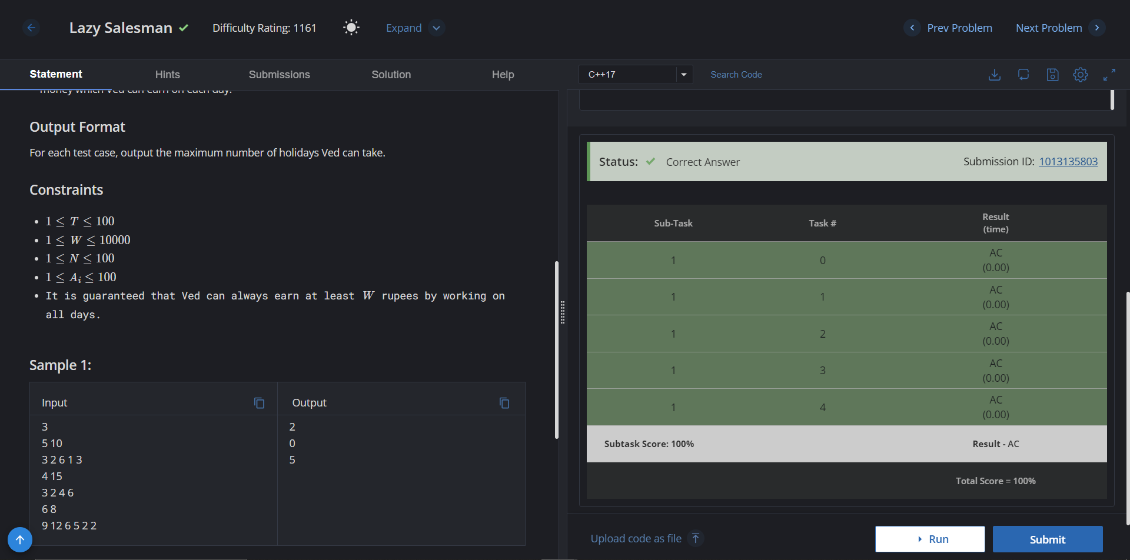

Time complexity: O(n^2)

1. Pretty numbers (C++)

The question tells us to print the number of numbers ending with 2, 3 or 9 in the given range of l to r.

So we iterate each number and find last digit using j%10, and then use an if condition to check if it is 2, 3 or 9 and print the number.

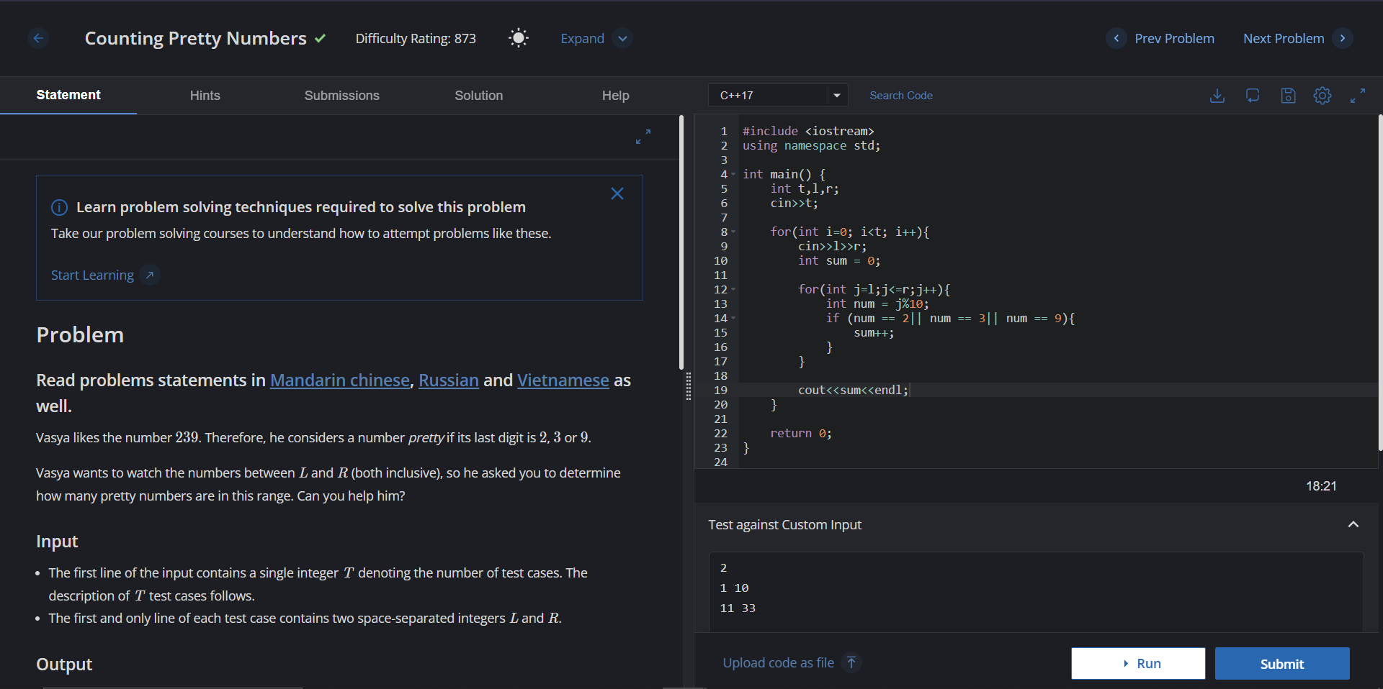

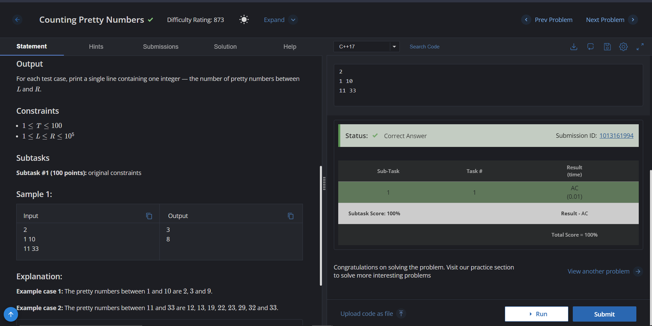

Time complexity: O(n)