Zewail City of Science, Technology and Innovation
University of Science and Technology
School of Computational Sciences and Artificial Intelligence
CSAI 203 - Fall 2026
Introduction to Software Engineering
Shared Expense & Budget Tracker
Software Requirements Specification (SRS)
Team Members:
Pakinam Ahmed Khedr | 202505312
Shadwan Ahmed Khedr | 202505347
Lamar Adel | 202505209
Representative Contact info:
s-shadwan.khedr@zewailcity.edu.eg
October 24, 2026

1. Introduction

1.1 Purpose
This document describes the functional and non-functional requirements of the Shared Expense & Budget Tracker web application. It explains what the system should do, how users interact with it, and the conditions it must satisfy.
The document serves as a reference for developers, testers, project managers, and other stakeholders during development and testing.

1.2 Scope
The Shared Expense & Budget Tracker is a web application that helps users manage personal and shared expenses.
The system allows users to record daily spending, categorize expenses, create roommate groups, split shared bills, track debts, set monthly budgets, and view spending reports.
The application will not connect directly to bank accounts or process real-money payments. Users will record payments manually.

1.3 Definitions, Acronyms, and Abbreviations
Term | Definition
SRS | Software Requirements Specification
UML | Unified Modeling Language
UI | User Interface
API | Application Programming Interface
CRUD | Create, Read, Update, Delete
Budget | A spending limit for a defined period
Expense | Money spent on a product or service
Split Bill | A bill divided among multiple users
Settlement | A recorded repayment of shared debt
Actor | A person or external system interacting with the application

1.4 References
- CSAI 203 — Introduction to Software Engineering, Fall 2026, Course Project Instructions.
- ISO/IEC/IEEE 29148:2018 — Requirements Engineering, as a general SRS reference.
- UML use case and class modeling conventions.

1.5 Overview
Section 1 introduces the project and its terminology.
Section 2 describes the system, users, operating environment, and constraints.
Section 3 presents detailed requirements, use cases, the domain model, and interfaces.
Section 4 contains the data dictionary and glossary.

2. Overall Description

2.1 Product Perspective
The Shared Expense & Budget Tracker is a standalone web application accessible through a browser.
It uses a client-server architecture. The browser displays the application, the backend handles business rules, and a database stores users, expenses, groups, and budgets.

2.2 Product Functions
The main system functions are:
- User registration, login, and profile management.
- Personal expense recording and categorization.
- Roommate group creation and membership management.
- Shared bill splitting and debt tracking.
- Monthly budgeting and spending alerts.
- Expense filtering, analytics, and report export.

2.3 User Classes and Characteristics
User Class | Characteristics
Guest | An unregistered visitor who can access registration and login
Registered User | A person who manages personal expenses, budgets, and shared bills; basic computer skills required
Group Owner | A registered user who creates and manages a roommate group
System Administrator | A technical user who monitors application operation and account status

A registered user may also be a group owner.

2.4 Software Stakeholders
Stakeholder | Main Interest
Individual users | Tracking spending and controlling budgets
Roommates | Splitting bills fairly and tracking repayments
Group owners | Managing group members and shared expenses
Developers | Building and maintaining the application
Testers | Verifying requirements and finding defects
System administrators | Maintaining security and availability
Project supervisor | Reviewing project quality and completeness

2.5 Operating Environment
The system will operate in the following environment:
- Client: Modern versions of Chrome, Firefox, Edge, and Safari.
- Devices: Desktop computers, laptops, tablets, and smartphones.
- Server: A web server running on Windows or Linux.
- Database: A relational database management system.
- Network: Internet connection using HTTPS.

2.6 Design and Implementation Constraints
The system must follow these constraints:
- It must be accessible through a web browser.
- The implementation must follow the Model–View–Controller (MVC) architecture.
- Expense values must use two decimal places.
- The sample system will support one currency per account.
- The system must not process actual financial transfers.
- The implementation must follow the course's approved technologies and development rules.

2.7 User Documentation
The application will provide an FAQ page, a short user guide, and basic instructions for creating groups, adding expenses, and settling shared bills.

2.8 Assumptions and Dependencies
The following assumptions apply:
- Users have internet access and a supported browser.
- Users enter accurate expense and repayment information.
- Shared group members have registered accounts.
- A database service is available.
- Users manually confirm settlements made outside the application.
- Monthly budget periods follow calendar months.

3. Specific Requirements

3.1 Functional Requirements
Functional requirements describe actions the system must perform. Each requirement below has a unique ID, a short explanation, and example scenarios.

FR-01 — User Registration
The system shall allow new users to create accounts by providing a name, email address, and password. Email addresses must be unique, and passwords must contain at least eight characters.
Example scenarios:
- A new user registers using a valid email and password. The system creates the account.
- A user enters an email that already exists. The system rejects the registration and displays an error.

FR-02 — User Login
The system shall allow registered users to log in using their email addresses and passwords. Only authenticated users may access private financial information.
Example scenarios:
- A user enters valid credentials and is redirected to the dashboard.
- A user enters an incorrect password and receives an error message.

FR-03 — User Logout
The system shall allow authenticated users to log out. Logging out must invalidate the user's active session.
Example scenario: A user clicks Logout, and the system returns to the login page. A later attempt to open the dashboard requires authentication.

FR-04 — Profile Management
The system shall allow users to view and update their names, passwords, and preferred display currency. Changes must be saved to the user's account.
Example scenario: A user changes their display name, and the updated name appears on their profile and group member lists.

FR-05 — Add Personal Expense
The system shall allow users to record personal expenses with an amount, description, category, and date. The amount must be greater than zero, and the expense must belong to the logged-in user.
Example scenarios:
- A user records a transportation expense of EGP 50, and it appears in their expense history.
- A user enters a negative amount, and the system rejects it.

FR-06 — Edit Personal Expense
The system shall allow users to modify the amount, description, category, or date of their own expenses. The updated information must be reflected in spending summaries.
Example scenario: A user changes a food expense from EGP 100 to EGP 120. The system updates the expense and recalculates the food category total.

FR-07 — Delete Personal Expense
The system shall allow users to delete their personal expenses after confirmation. Deleted expenses must no longer contribute to spending calculations.
Example scenario: A user removes an incorrectly recorded EGP 200 purchase, and the monthly total decreases by EGP 200.

FR-08 — Manage Expense Categories
The system shall provide default expense categories and allow users to create, rename, or delete custom categories. A category containing expenses cannot be deleted until those expenses are reassigned.
Example scenario: A user creates an Entertainment category and assigns a cinema expense to it.

FR-09 — View and Filter Expense History
The system shall display a chronological list of the user's expenses and allow filtering by date range, category, and amount.
Example scenario: A user selects the Food category and the current month. The system shows only matching food expenses.

FR-10 — Create Shared Expense Group
The system shall allow registered users to create groups by providing a group name. The creator automatically becomes the group owner.
Example scenario: A user creates a group called Apartment A, and the system displays the new group on their dashboard.

FR-11 — Manage Group Members
The system shall allow group owners to add registered users to their groups and remove members who have no outstanding group balance. Duplicate membership must be prevented.
Example scenarios:
- A group owner adds two roommates by their registered email addresses.
- The owner attempts to remove a roommate who still owes money. The system blocks removal and explains why.

FR-12 — Add Shared Expense
The system shall allow group members to record shared expenses by entering the amount, description, date, payer, and participating members. The payer and participants must belong to the selected group.
Example scenario: One roommate records a grocery bill of EGP 600 paid for three members. The system stores the shared expense.

FR-13 — Split Shared Bill Equally
The system shall divide a shared expense equally among the selected participants. If the amount cannot be divided exactly to two decimal places, the system shall distribute the remaining smallest currency units deterministically by participant ID.
Example scenario: A bill of EGP 600 shared by three roommates gives each roommate a share of EGP 200.

FR-14 — Split Shared Bill by Custom Amount
The system shall allow users to assign different amounts to participants. The system must verify that all participant shares add up exactly to the bill's total.
Example scenarios:
- An EGP 500 bill is divided into shares of EGP 200 and EGP 300.
- A user enters shares totaling EGP 450 for an EGP 500 bill. The system rejects the split.

FR-15 — View Group Balances
The system shall calculate and display the net balance of each group member using recorded shared expenses and settlements. Positive balances indicate money owed to a member, while negative balances indicate money the member owes.
Example scenario: A roommate pays EGP 300 for an equally shared bill with another roommate. The system records EGP 150 owed to the payer.

FR-16 — Record Debt Settlement
The system shall allow group members to record payments made to settle shared debts. Each settlement must identify the payer, recipient, amount, date, and group. The system shall prevent settlements exceeding the payer's outstanding net debt within the group.
Example scenario: A roommate records a repayment of EGP 150, reducing their outstanding balance to zero.

FR-17 — Set Monthly Category Budget
The system shall allow users to create or update a monthly spending limit for a selected category. Only one budget limit may exist for each category and month.
Example scenario: A user sets a Food budget of EGP 3,000 for November. The system saves the limit.

FR-18 — Display Budget Alerts
The system shall display warnings when category spending reaches 80% of its monthly budget and when spending exceeds 100%. Alerts shall be recalculated when relevant expenses change.
Example scenarios:
- Food spending reaches EGP 2,400 out of EGP 3,000, triggering an 80% warning.
- Food spending reaches EGP 3,200, triggering an over-budget warning.

FR-19 — View Spending Analytics
The system shall generate monthly spending summaries, category breakdowns, and trend charts using the user's recorded personal expenses. Users shall be able to select the reporting month.
Example scenario: A user opens the Analytics page and sees that Food represents 40% of their personal spending for the selected month.

FR-20 — Export Expense Report
The system shall allow authenticated users to export their filtered personal expense history as a CSV file. The file shall contain each expense's date, category, description, and amount.
Example scenario: A user filters their October expenses and selects Export CSV. The system downloads a file containing only the matching records.

3.2 Use Case Model
A use case model describes how actors interact with the system to achieve specific goals. Figures 1 to 3 show the use cases of the system.

3.2.1 Use Case Diagrams
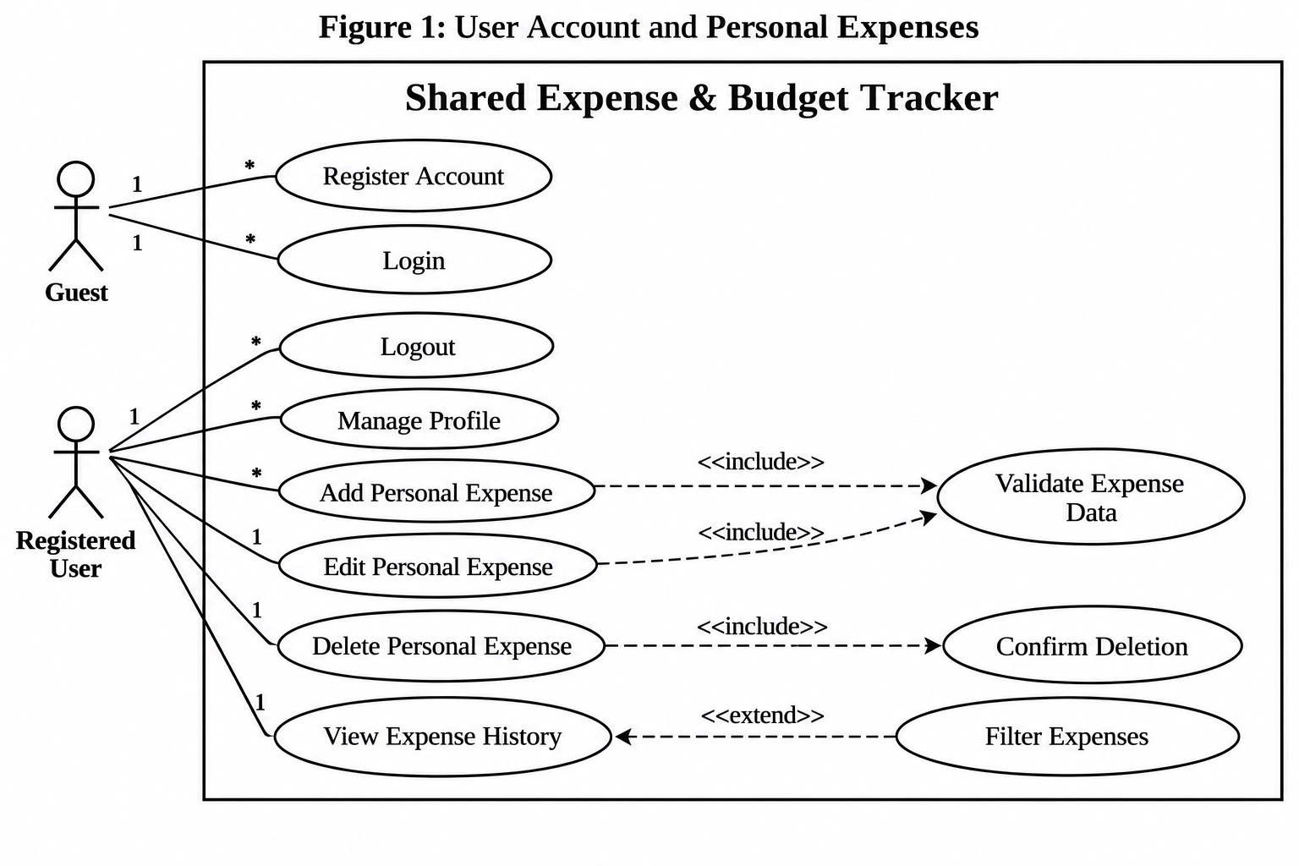
Explanation: The registered user manages personal expenses, while a guest can register or log in. Expense validation is mandatory, but filtering is optional.
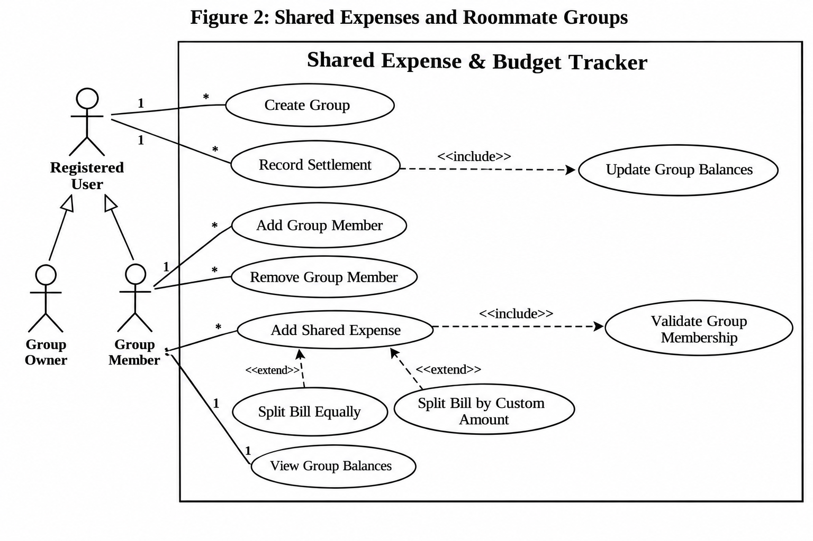
Explanation: A group owner manages membership, while group members record shared bills and view balances. Exactly one split method is selected when adding a bill.
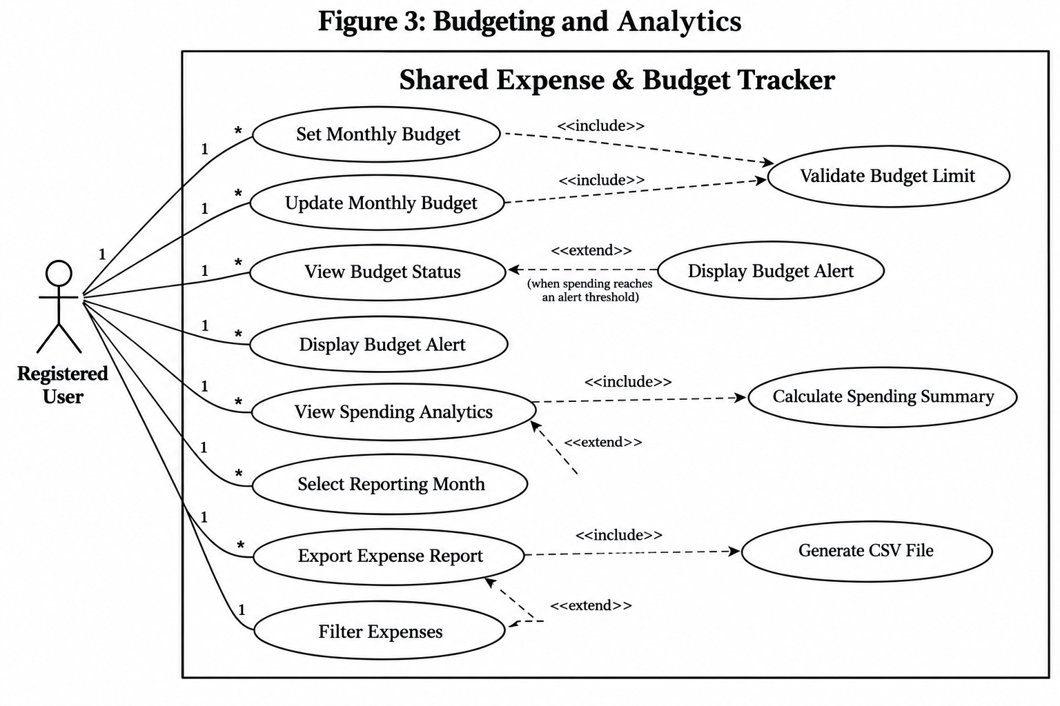
Explanation: Users manage budgets, examine spending patterns, and export reports. Budget alerts appear only when their conditions are satisfied.

3.2.2 Use Case Descriptions
UC-01 — Add Personal Expense
Use Case ID | UC-01
Use Case Name | Add Personal Expense
Primary Actor | Registered User
Preconditions | The user is logged in and has access to at least one expense category.
Trigger | The user selects Add Expense.

Main Flow
- The user opens the Add Expense form.
- The system displays the required fields.
- The user enters the amount, description, category, and date.
- The user selects Save.
- The system validates the entered information.
- The system stores the expense.
- The system updates the spending summary.
- The system displays a success message.
Alternative Flows
- A1 — Invalid Amount: At step 5, if the amount is zero or negative, the system displays an error and returns to step 3.
- A2 — Missing Information: At step 5, if a required field is empty, the system requests the missing information.
- A3 — Database Failure: At step 6, if storage fails, the system displays an error without creating the expense.
Postconditions
- Success: The expense is stored and appears in the user's history and spending totals.
- Failure: No expense is added.
UC-02 — Add and Split Shared Bill
Use Case ID | UC-02
Use Case Name | Add and Split Shared Bill
Primary Actor | Group Member
Supporting Actor | Other Group Members
Preconditions | The user is logged in and belongs to an existing group.
Trigger | The user selects Add Shared Expense.

Main Flow
- The user opens a group.
- The user selects Add Shared Expense.
- The system displays the bill form.
- The user enters an amount, description, date, payer, and participants.
- The user selects Equal Split.
- The system calculates each participant's share.
- The system displays the calculated shares for confirmation.
- The user confirms the bill.
- The system validates and saves the bill and shares.
- The system recalculates group balances and displays a success message.
Alternative Flows
- A1 — Custom Split: At step 5, the user selects Custom Split and enters individual shares. The system validates their sum before continuing to step 7.
- A2 — Invalid Split: At step 9, the shares do not equal the total bill. The system displays an error and returns to the split selection.
- A3 — Invalid Participant: At step 9, a selected participant is no longer a group member. The system rejects the bill and requests correction.
- A4 — Save Failure: At step 9, storage fails. The system saves neither the bill nor its shares.
Postconditions
- Success: The shared expense and participant shares are stored, and group balances are updated.
- Failure: No bill or balances are changed.

3.3 Domain Model
The domain model describes the main concepts in the application and the relationships between them. It focuses on business entities rather than implementation classes.

3.3.1 Conceptual Class Diagram
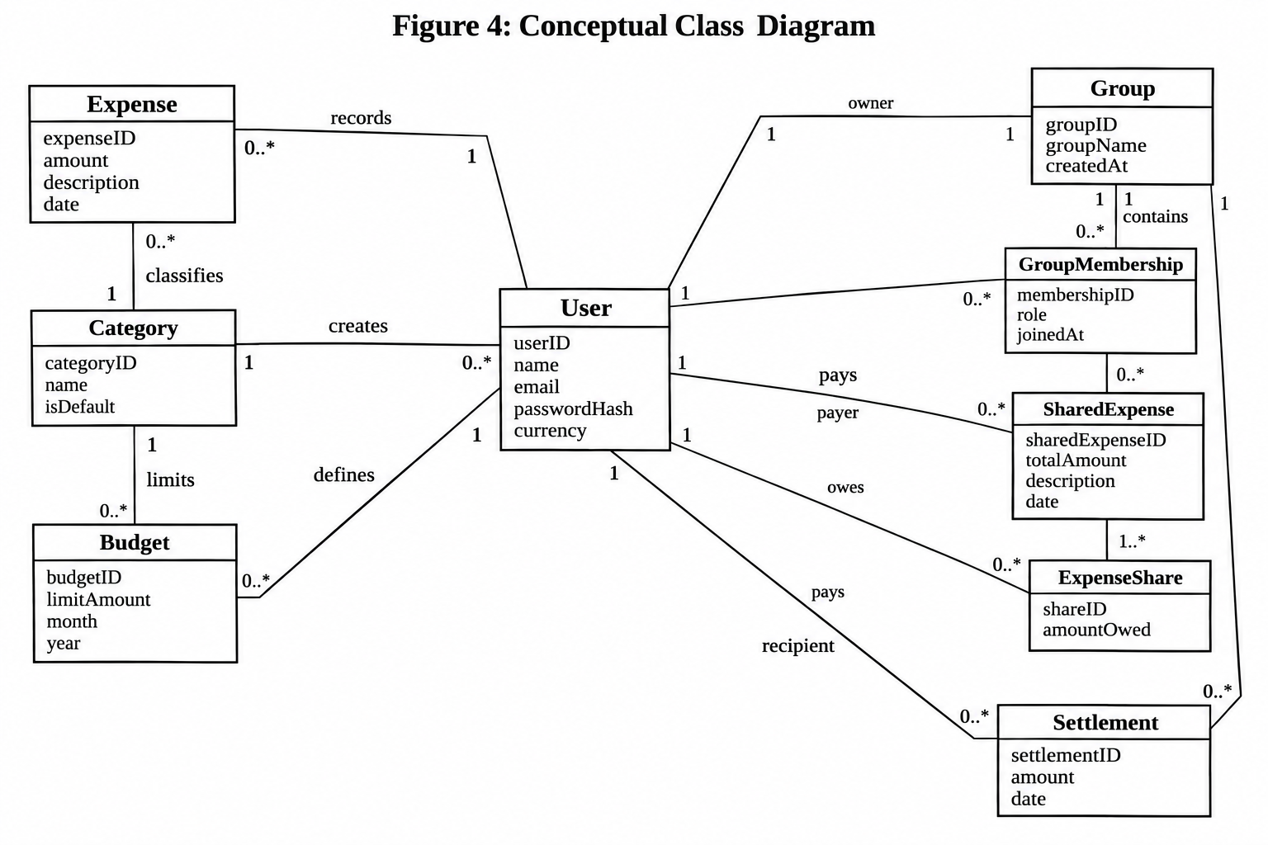

3.3.2 Class Descriptions
Class | Attributes (without types) | Purpose
User | userID, name, email, passwordHash, currency | Represents a registered account
Expense | expenseID, amount, description, date | Represents a personal expense
Category | categoryID, name, isDefault | Classifies expenses
Budget | budgetID, limitAmount, month, year | Stores a monthly category limit
Group | groupID, groupName, createdAt | Represents a roommate group
GroupMembership | membershipID, role, joinedAt | Connects users to groups
SharedExpense | sharedExpenseID, totalAmount, description, date | Represents a group bill
ExpenseShare | shareID, amountOwed | Stores one participant's bill share
Settlement | settlementID, amount, date | Records repayment between members

Associations and Multiplicities
Association | Multiplicity | Meaning
User — Expense | 1 to 0..* | A user can record many personal expenses; each belongs to one user
User — Category | 1 to 0..* | A user can create multiple custom categories; default categories are shared
Category — Expense | 1 to 0..* | A category can classify many expenses
Category — Budget | 1 to 0..* | A category can have budgets for different months
User — Budget | 1 to 0..* | A user can define multiple monthly budgets
User — GroupMembership | 1 to 0..* | A user can belong to many groups
Group — GroupMembership | 1 to 1..* | A group has at least one member
Group — SharedExpense | 1 to 0..* | A group can contain many shared expenses
User — SharedExpense | 1 to 0..* | A user can pay for many shared expenses
SharedExpense — ExpenseShare | 1 to 1..* | A shared expense has one or more participant shares
User — ExpenseShare | 1 to 0..* | A user can have many shares across bills
Group — Settlement | 1 to 0..* | A group can have many recorded repayments
User — Settlement (payer) | 1 to 0..* | A user can make multiple repayments
User — Settlement (recipient) | 1 to 0..* | A user can receive multiple repayments

Additional domain rules: Each group has exactly one owner, who must be a member. Each expense share refers to a participant in the same group as the shared expense. A settlement's payer and recipient must be different members of the same group.

3.4 Non-Functional Requirements
Non-functional requirements describe measurable quality expectations rather than individual system features.
ID | Requirement | How It Will Be Tested | Success Criteria
NFR-01 | Performance: Expense lists and monthly dashboards shall load quickly. | Measure 100 requests for each screen with 100 concurrent users and 1,000 expense records per user. | At least 95% of requests finish within 2 seconds.
NFR-02 | Security: The system shall protect user passwords and restrict access to private financial records. | Inspect stored password values and run automated authorization tests using two different accounts. | Passwords are stored using salted adaptive hashes; all unauthorized test requests are denied.
NFR-03 | Usability: Users shall be able to complete common tasks with minimal guidance. | Ask 10 new users to register, add an expense, and create a budget without help. | At least 9 of 10 users complete all three tasks within 5 minutes.
NFR-04 | Reliability: A shared bill and all its shares shall be saved as one complete operation. | Simulate a database failure during bill creation and repeat the test 20 times. | No test produces a partially saved bill or incorrect balances.
NFR-05 | Compatibility: The interface shall work on supported desktop and mobile browsers. | Run core workflows on the latest stable Chrome, Firefox, Edge, and Safari, at viewport widths of 375px and 1280px. | All core workflows complete without blocking layout or functional errors, with no horizontal page scrolling.

3.5 External Interface Requirements

3.5.1 User Interface
The application shall provide the following pages:
- Login and Registration: Forms for creating accounts and signing in.
- Dashboard: Summary cards showing monthly spending, remaining budgets, and group balances.
- Expenses: Forms and tables for adding, editing, deleting, and filtering expenses.
- Groups: Pages for managing roommates and shared bills.
- Budgets: Category limit forms and progress indicators.
- Analytics: Spending charts, category summaries, and reporting filters.
The interface shall use readable labels, clear error messages, and responsive layouts.

3.5.2 Hardware Interface
The system shall work with standard devices supporting a modern browser, keyboard, mouse, or touchscreen.
No specialized hardware, such as scanners or payment terminals, is required.

3.5.3 Software Interface
The application shall communicate with a relational database to store and retrieve records.
The frontend shall interact with backend services through application API endpoints. Database transactions shall be used for operations that update multiple related records.
No external banking or payment processing API is required.

3.5.4 Communication Interface
The application shall use HTTPS for communication between the browser and server.
API requests and responses shall use JSON. Exported reports shall use CSV.
Authenticated API endpoints shall require a valid user session. Communication failures shall result in understandable error messages.

4. Appendices

4.1 Appendix A — Data Dictionary
This simplified data dictionary lists possible database tables. It does not define a complete physical database schema.
Table Name | Description
Users | Stores registered account information
Expenses | Stores personal spending records
Categories | Stores default and custom expense categories
Budgets | Stores monthly category limits
Groups | Stores roommate groups and their owners
GroupMemberships | Stores users' group memberships and roles
SharedExpenses | Stores shared bills and their payers
ExpenseShares | Stores participants' shares of shared bills
Settlements | Stores recorded repayments between group members

4.2 Appendix B — Glossary
Term | Meaning
Actor | A role that interacts with a system
Association | A relationship between domain classes
Authentication | Verifying a user's identity
Authorization | Determining what a user is allowed to access
Category Limit | Maximum planned spending in a category
Domain Model | A model showing the system's main business concepts
Equal Split | Dividing a bill into equal shares
Functional Requirement | A behavior the system must provide
Multiplicity | The number of objects allowed in a relationship
Non-Functional Requirement | A measurable quality or constraint of the system
Postcondition | A condition that holds after a use case finishes
Precondition | A condition required before a use case starts
Use Case | An interaction between an actor and the system to achieve a goal

