# Assignment 3 Submission

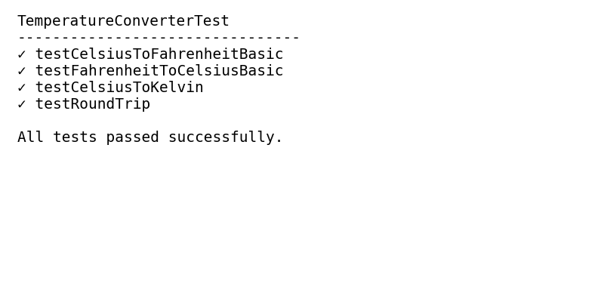

Test results

## Reflection

I followed Test‑Driven Development (TDD) by first writing JUnit 5 test cases for each temperature conversion method. I ensured that each test failed prior to implementing the actual conversion logic. Then I implemented the methods one by one until all tests passed successfully. Maven provided a structured way to manage the project and its dependencies, automatically handling the JUnit library and running tests via the surefire plugin【942349079967819†L150-L161】. Using Git, I tracked each step: committing the project setup, adding failing tests, and then committing the working implementation. This version control history demonstrates the evolution of the code and tests and facilitated pushing the project to GitHub. Git and Maven together made project management and collaboration straightforward and reproducible.