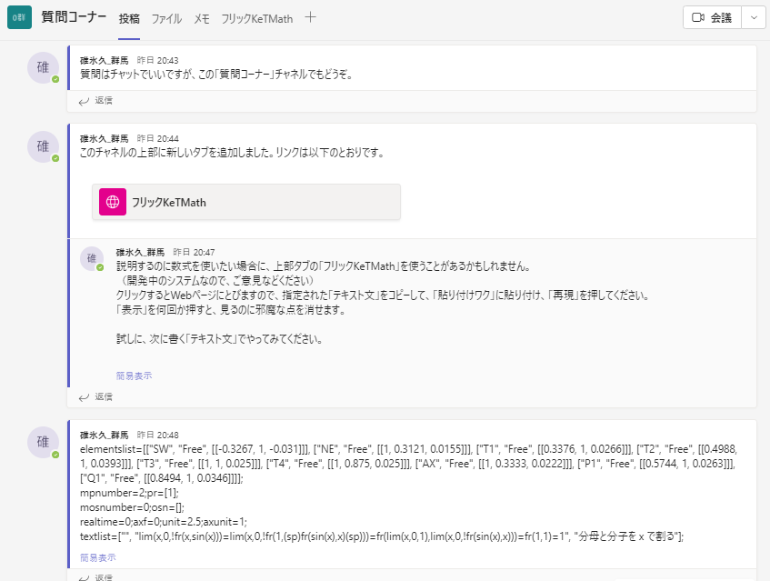elementslist=[["SW", "Free", [[-0.3267, 1, -0.031]]], ["NE", "Free", [[1, 0.3121, 0.0155]]], ["T1", "Free", [[0.3376, 1, 0.0266]]], ["T2", "Free", [[0.4988, 1, 0.0393]]], ["T3", "Free", [[1, 1, 0.025]]], ["T4", "Free", [[1, 0.875, 0.025]]], ["AX", "Free", [[1, 0.3333, 0.0222]]], ["P1", "Free", [[0.5744, 1, 0.0263]]], ["Q1", "Free", [[0.8494, 1, 0.0346]]]];  
mpnumber=2;pr=[1];  
mosnumber=0;osn=[];  
realtime=0;axf=0;unit=2.5;axunit=1;  
textlist=["", "lim(x,0,!fr(x,sin(x)))=lim(x,0,!fr(1,(sp)fr(sin(x),x)(sp)))=fr(lim(x,0,1),lim(x,0,!fr(sin(x),x)))=fr(1,1)=1", "分母と分子を x で割る"];

