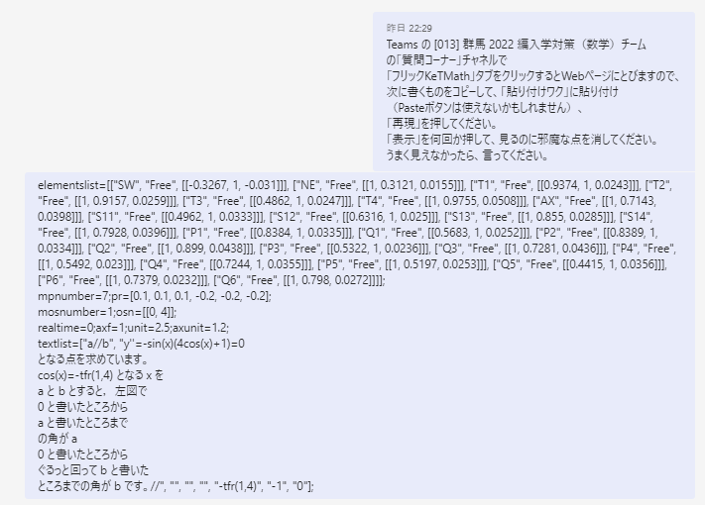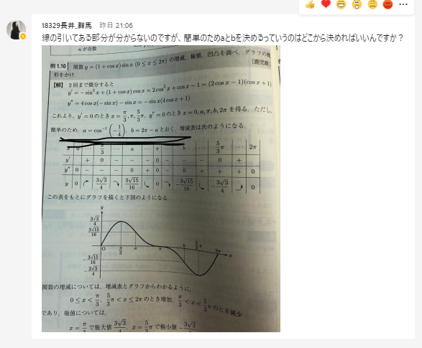

elementslist=[["SW", "Free", [[-0.3267, 1, -0.031]]], ["NE", "Free", [[1, 0.3121, 0.0155]]], ["T1", "Free", [[0.9374, 1, 0.0243]]], ["T2", "Free", [[1, 0.9157, 0.0259]]], ["T3", "Free", [[0.4862, 1, 0.0247]]], ["T4", "Free", [[1, 0.9755, 0.0508]]], ["AX", "Free", [[1, 0.7143, 0.0398]]], ["S11", "Free", [[0.4962, 1, 0.0333]]], ["S12", "Free", [[0.6316, 1, 0.025]]], ["S13", "Free", [[1, 0.855, 0.0285]]], ["S14", "Free", [[1, 0.7928, 0.0396]]], ["P1", "Free", [[0.8384, 1, 0.0335]]], ["Q1", "Free", [[0.5683, 1, 0.0252]]], ["P2", "Free", [[0.8389, 1, 0.0334]]], ["Q2", "Free", [[1, 0.899, 0.0438]]], ["P3", "Free", [[0.5322, 1, 0.0236]]], ["Q3", "Free", [[1, 0.7281, 0.0436]]], ["P4", "Free", [[1, 0.5492, 0.023]]], ["Q4", "Free", [[0.7244, 1, 0.0355]]], ["P5", "Free", [[1, 0.5197, 0.0253]]], ["Q5", "Free", [[0.4415, 1, 0.0356]]], ["P6", "Free", [[1, 0.7379, 0.0232]]], ["Q6", "Free", [[1, 0.798, 0.0272]]]];  
mpnumber=7;pr=[0.1, 0.1, 0.1, -0.2, -0.2, -0.2];  
mosnumber=1;osn=[[0, 4]];  
realtime=0;axf=1;unit=2.5;axunit=1.2;  
textlist=["a//b", "y''=-sin(x)(4cos(x)+1)=0  
となる点を求めています。  
cos(x)=-tfr(1,4) となる x を  
a と b とすると，左図で  
0 と書いたところから  
a と書いたところまで  
の角が a  
0 と書いたところから  
ぐるっと回って b と書いた  
ところまでの角が b です。//", "", "", "", "-tfr(1,4)", "-1", "0"];

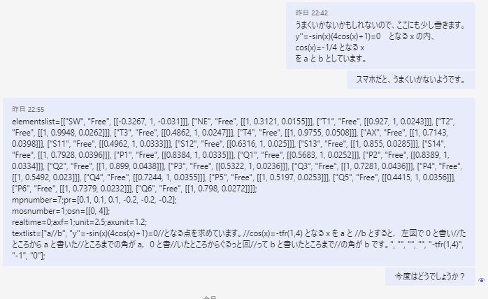

elementslist=[["SW", "Free", [[-0.3267, 1, -0.031]]], ["NE", "Free", [[1, 0.3121, 0.0155]]], ["T1", "Free", [[0.927, 1, 0.0243]]], ["T2", "Free", [[1, 0.9948, 0.0262]]], ["T3", "Free", [[0.4862, 1, 0.0247]]], ["T4", "Free", [[1, 0.9755, 0.0508]]], ["AX", "Free", [[1, 0.7143, 0.0398]]], ["S11", "Free", [[0.4962, 1, 0.0333]]], ["S12", "Free", [[0.6316, 1, 0.025]]], ["S13", "Free", [[1, 0.855, 0.0285]]], ["S14", "Free", [[1, 0.7928, 0.0396]]], ["P1", "Free", [[0.8384, 1, 0.0335]]], ["Q1", "Free", [[0.5683, 1, 0.0252]]], ["P2", "Free", [[0.8389, 1, 0.0334]]], ["Q2", "Free", [[1, 0.899, 0.0438]]], ["P3", "Free", [[0.5322, 1, 0.0236]]], ["Q3", "Free", [[1, 0.7281, 0.0436]]], ["P4", "Free", [[1, 0.5492, 0.023]]], ["Q4", "Free", [[0.7244, 1, 0.0355]]], ["P5", "Free", [[1, 0.5197, 0.0253]]], ["Q5", "Free", [[0.4415, 1, 0.0356]]], ["P6", "Free", [[1, 0.7379, 0.0232]]], ["Q6", "Free", [[1, 0.798, 0.0272]]]];  
mpnumber=7;pr=[0.1, 0.1, 0.1, -0.2, -0.2, -0.2];  
mosnumber=1;osn=[[0, 4]];  
realtime=0;axf=1;unit=2.5;axunit=1.2;  
textlist=["a//b", "y''=-sin(x)(4cos(x)+1)=0//となる点を求めています。//cos(x)=-tfr(1,4) となる x を a と //b とすると，左図で 0 と書い//たところから a と書いた//ところまでの角が a，0 と書//いたところからぐるっと回//って b と書いたところまで//の角が b です。", "", "", "", "-tfr(1,4)", "-1", "0"];

