Cluster Analysis of 37 Countries on 9 ICT-Worker Issues
Prepared for: IMF
Prepared by: [Name], [Roll Number]
Course: [Course Name and Number]
Instructor: [Instructor Name]
Date: 2026

Introduction

Data Preprocessing

Data Visualization

Hypotheses / Theory Building

Analysis

Recommendations

References
This report clusters 37 countries on nine ICT-worker issues using two scores per issue: Score A (factor-score means, FSMean) and Score B (raw issue means, Smean). The 18 features are analyzed with hierarchical (Ward, average linkage), k-means, and Gaussian mixture models. The number of clusters is chosen by silhouette score and dendrogram inspection. All random states are fixed at 42 for reproducibility. Two identifier columns (Code, Num) are excluded from clustering.
The dataset contains 37 countries and 21 columns: Country, Code (country ID 1–46), Num (sample size 93–634), and nine issues × two scores. No missing values exist. Code and Num are identifiers and are excluded. Features are standardized to z-scores because the two score types have different scales. Outliers beyond |z|>3 (one in Score A, two in Score B) are retained as legitimate country profiles.
Per-issue correlation between Score A and Score B is high: FC 0.998, JI 0.986, SE 0.987, WS 0.927, WO 0.972, WH 0.979, WE 0.981, TI 0.961, TA 0.951. The two scores are near-perfect linear transforms of each other, meaning the 'Both' feature set adds no independent information.
Multicollinearity is high: maximum off-diagonal correlation is 0.837 (Score A) and 0.863 (Score B). PCA shows three components explain approximately 80% of variance in each set (Score A: PC1 0.527, PC2 0.190, PC3 0.093; Score B: PC1 0.516, PC2 0.221, PC3 0.083). The 'Both' set yields similar variance concentration (PC1 0.516, PC2 0.204, PC3 0.087).
Score direction from the IMF codebook: higher values indicate worse outcomes for JI (job insecurity), WO (work overload), WH (work-home conflict), WE (exhaustion), TI (turnover intention), and TA (turnaway intention). Higher values indicate better outcomes for SE (self-efficacy) and WS (work satisfaction). FC (friendship circles) is ambiguous.
Silhouette scores peak at k=2 for all three feature sets: Score A 0.325, Score B 0.318, Both 0.321. Values decline at k=3 (0.302, 0.298, 0.299) and k=4 (0.206, 0.237, 0.206). A silhouette of 0.32 is weak, indicating substantial overlap; k=2 is tentative.
Elbow plots (inertia) show diminishing returns after k=2 for all sets. Ward dendrograms for each score set show a clear two-branch split at the top level, supporting k=2. At k=2, Ward and k-means produce identical partitions (ARI 1.000); k-means and GMM also agree. Average linkage degenerates to a 36/1 split and is discarded.
Cross-score ARI at k=2 is 1.000 for all pairs, confirming Score A and Score B yield the same clustering (with label inversion). At k=3, A–B ARI drops to 0.708; at k=4, to 0.428. The 'Both' set tracks Score A at k=3 (ARI 1.000) but diverges at k=4 (ARI 0.443).
Per-country silhouette (Both, k=2) shows one borderline country: Russia (silhouette −0.01). All others have positive silhouette. Cluster 1 members have higher mean silhouette (0.36) than Cluster 0 (0.27), suggesting Cluster 1 is more coherent.
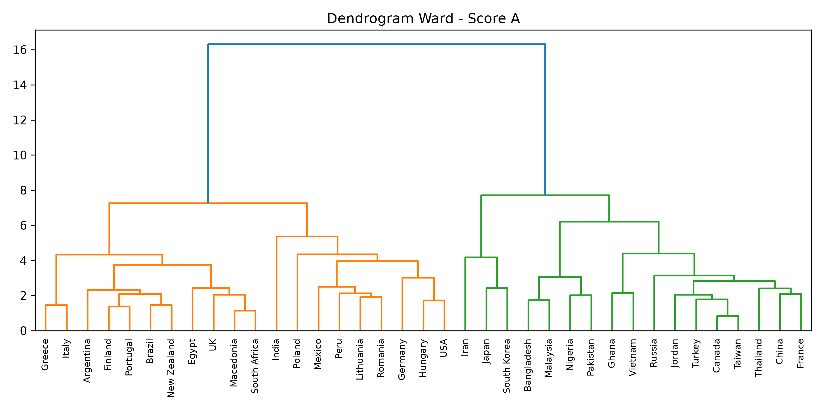
Figure: Ward dendrogram for Score A. The longest vertical gap separates two main branches, supporting k=2.
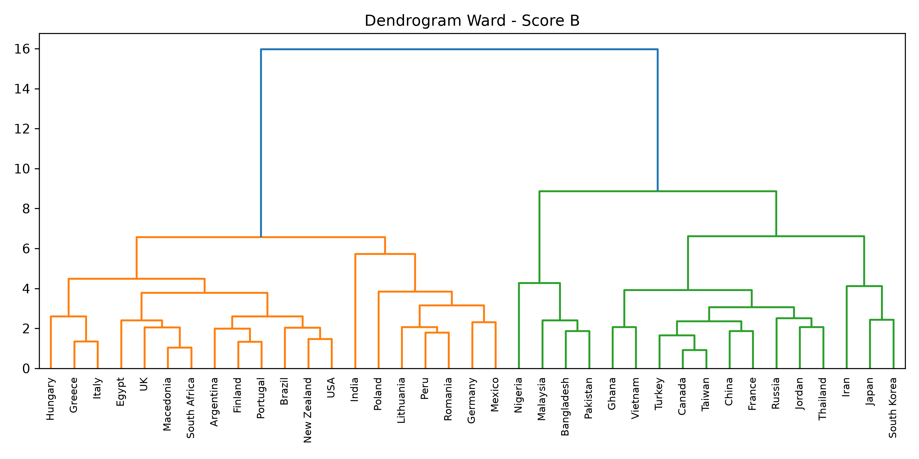
Figure: Ward dendrogram for Score B. The longest vertical gap separates two main branches, supporting k=2.
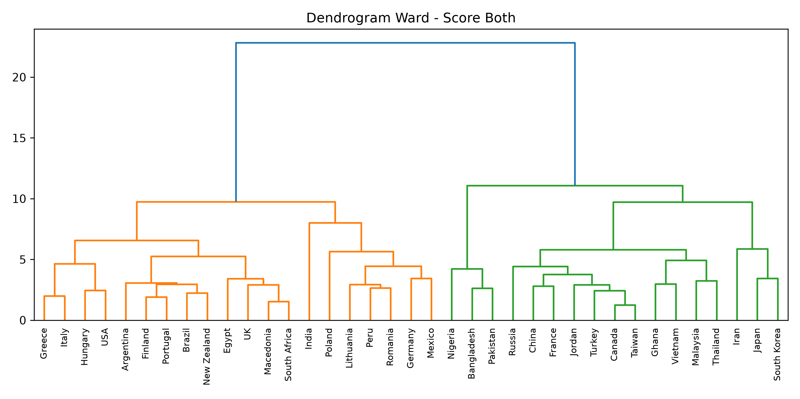
Figure: Ward dendrogram for Score Both. The longest vertical gap separates two main branches, supporting k=2.
H1: Countries separate into two groups distinguished by job insecurity/self-efficacy (high in one cluster) versus work satisfaction/overload/exhaustion/turnover (high in the other). H2: Score A and Score B produce equivalent clusters because they measure the same constructs on different scales. H3: Cluster membership does not align cleanly with income level or geographic region.
The primary solution is k=2 using k-means on the combined standardized features. Cluster 0 (17 countries): Bangladesh, Canada, China, France, Ghana, Iran, Japan, Jordan, Malaysia, Nigeria, Pakistan, Russia, South Korea, Taiwan, Thailand, Turkey, Vietnam. Cluster 1 (20 countries): Argentina, Brazil, Egypt, Finland, Germany, Greece, Hungary, India, Italy, Lithuania, Macedonia, Mexico, New Zealand, Peru, Poland, Portugal, Romania, South Africa, UK, USA.
Cluster profiles on Score B raw means (Cluster 0 minus Cluster 1): FC +0.16, JI +1.01, SE +1.19, WS −1.55, WO −1.10, WH −1.17, WE −1.42, TI −0.79, TA −1.73. Interpretation: Cluster 0 reports substantially higher job insecurity (JI) and higher self-efficacy (SE), but lower work satisfaction (WS), work overload (WO), work-home conflict (WH), exhaustion (WE), turnover intention (TI), and turnaway intention (TA). Cluster 1 shows the opposite: lower insecurity and efficacy, but higher satisfaction alongside higher overload, conflict, exhaustion, and turnover/turnaway intent.
H1 is supported: the two clusters differ sharply on the insecurity/efficacy versus satisfaction/overload/exhaustion/turnover axis. H2 is supported: cross-score ARI is 1.000 at k=2. H3 is supported: clusters do not follow income. Cluster 0 contains high-income (Canada, France, Japan, South Korea), upper-middle (China, Russia, Malaysia), and lower-income (Bangladesh, Ghana, Nigeria, Pakistan, Vietnam) countries. Cluster 1 similarly mixes high-income (Finland, Germany, UK, USA), upper-middle (Argentina, Brazil, Hungary, Poland, Romania, South Africa), and lower-middle (Egypt, India, Peru). Regionally, East Asia, Southeast Asia, and the Middle East lean Cluster 0; Latin America and Western/Eastern Europe lean Cluster 1; Africa and South Asia split. North America splits (Canada in Cluster 0, USA in Cluster 1).
Bootstrap stability (200 resamples) shows mean pairwise ARI of 1.000 at k=2, 3, and 4, indicating the k-means solution is stable to sampling variation. However, this reflects the strong separation in the feature space, not necessarily a meaningful population structure.
At k=3, a small distinct group emerges: Iran, Japan, South Korea (Cluster 0). This trio shows extreme profiles on several issues. The remaining countries split into a large group (21 countries, mostly Cluster 1 from k=2) and a medium group (13 countries, mostly Cluster 0 from k=2). At k=4, the structure fragments further: a 13-country East/Southeast Asia plus Middle East group, a 6-country Central/Eastern Europe group, a 14-country Western group, and a 4-country South Asia group. Cross-method ARI drops at k=4 (0.43–0.76), indicating less reliable partitions.
Sample sizes (Num) range from 93 to 634. Cluster 0 mean 297.5 (median 298), Cluster 1 mean 266.4 (median 300.5). The wide range and presence of small-sample countries (Bangladesh n=284, Ghana n=304, Nigeria n=93, Vietnam n=287) in Cluster 0 warrant caution; small samples may increase score variance. Russia (n=634) is the only country with negative silhouette.
For Cluster 0 countries, where workers report high job insecurity but high self-efficacy and low burnout indicators, policy should target job-security guarantees and retention incentives that convert efficacy into organizational commitment. For Cluster 1 countries, where workers are satisfied but overloaded, conflicted, and exhausted with high turnover intent, the priority is workload management, work-life balance interventions, and burnout prevention.
Given the near-equivalence of Score A and Score B (per-issue r > 0.95), future data collection could reduce respondent burden by using one score set. The weak silhouette (0.32) and mixed regional composition suggest these clusters describe response-pattern similarities, not structural economic divides. Results should be validated with larger samples, documented scoring methods, and longitudinal data. The unknown score construction and n=37 limit causal interpretation.
IMF ICT Workers Individual Issues description (ICTInvFldDesc.pdf). Dataset ICTIndiv.xlsx. Methodological references: scikit-learn, scipy, pandas documentation.

