https://www.selenium.dev/
webOrder - Web Orders Login
codeshare- Codeshare
OrangeHRM- Orange HRM login
WebShop- https://demowebshop.tricentis.com/
Shortcut to import – ctrl+shift+o

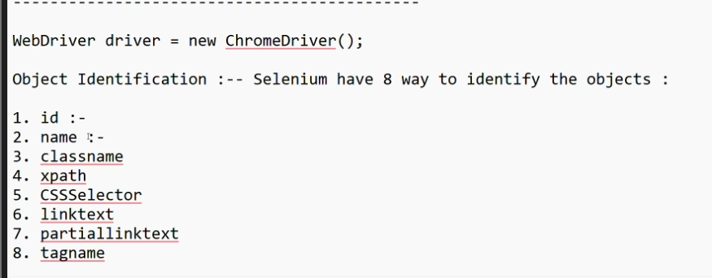

1.Driver-Object reference of chrome driver
WebDriver driver = new ChromeDriver();

2.why TestNG over Junit
->Junit-open source testing tool,provide assertion(to verify), provide annotation(@test)
Selenium does not have inbuilt assertion, so we use junit library assertion
Junit annoataion:
@test, @beforeTest,@afterTest,@beforeAll

TestNG- overcome the limitations of junit
NG- next generation
Benefit of TestNG-1) inbuilt html report, junit does not
2)Annotation
3)Feature-grouping and prioritize
4)Parallel testing
5)parameterization

3.xpath traverse top->down, down->top
Absolute xpath - / (not recommended)
Relative xpath – //
1)//tagname[@attribute name =’ attribute value’]
2)Text -works for exact text , shouldn’t contain space
//tagname[text()=value]
3)Contain
4)normalize-space, works for text which have space in between
//tagname[normalize-space()=’attribute value']

4.css casecading style sheet, top->down approach
1)tagname[@attribute name =’ attribute value’]

5.Automation works on 3 things:
Browser,Object Identification, Action
Driver.findElement(By.mame(“abc”)).sendKeys(“Tester”);
Page.getByRole(“”).fill(“Tester”);

6. Automation Guideline
1)Product Knowledge
2)Object Identification
7.What can’t we automate using selenium?
1)Captcha
2)OTP
3)UI/UX
4)Video playing, stopped, paused
5)Value from Image
6.windows based control(selenium is meant for web based not window based)

8.only 2 things we can’t automate in world?
->if you are unable to identify the object
->if you don’t know the expected result Adhoc testing

9.How do you handle the dynamic value?
->2type of dynamic-a)Known dynamic:- we can automate
b)Unknown dynamic- can’t automate

10.difference between quit() and close()
Quit()terminates the entire WebDriver session and closes all associated windows.
Close()shut down only the currently active browser window or tab.

11.Dynamic value handling
Random randomGenerator = new Random();
int randomInt = randomGenerator.nextInt(100000000);
String UserName = "Dixit"+randomInt;

By.xpath("//td[text()='"+ UserName +"']")

12.Sibling
1)Following-sibling
//*[@type=’text’]//following-sibling::td/input
2)Preceding-sibling
//*[@type=’text’]//preceding-sibling::input

13.Demo WebShop
https://demowebshop.tricentis.com/
--------------------------------------------------------------------------
1. Create : Add_to_Cart - Go to DemoWebShop -> Click on Computers Link -> Click on Desktop -> Click on Add To Cart (Whose name is Simple Computer) -> Click on Slow radio button -> Then Capture the price -> Click on Add to Cart and then Click on Shopping Cart -> Verify that Simple Computer got added here -> Then capture the Price of Simple Computer Total amount and compare with expected Price

2. Update : Update_From_Cart :-Pre-condition ( Product added to Cart ) -> Click on Edit link based on Product Name -> Click on "Image Viewer" Checkbox and Click on Update Button -> Then go to Shopping cart and Verify that "Image Viewer" software got updated for particular product

3. Delete : Remove_From_Cart :-Pre-condition ( Product added to Cart ) -> Select the Check box based on Product Name and Click on Update Shopping Cart button -> Verify that Particular products get deleted from the List

Solution:
package com.DemoWebShop;

import org.openqa.selenium.By;
import org.openqa.selenium.WebDriver;
import org.openqa.selenium.edge.EdgeDriver;
import org.testng.Assert;
import org.testng.annotations.AfterTest;
import org.testng.annotations.BeforeTest;
import org.testng.annotations.Test;

public class Product_AddToCart {

WebDriver driver;
boolean productAdded;

@Test(priority=1,enabled=true)
public void create_AddToCart() throws InterruptedException {

driver.findElement(By.xpath("//strong[text()='Categories']/../..//following-sibling::a[normalize-space()='Computers']")).click();
driver.findElement(By.xpath("//strong[text()='Categories']/../..//following-sibling::a[normalize-space()='Desktops']")).click();
driver.findElement(By.xpath("//h1[text()='Desktops']")).isDisplayed();
driver.findElement(By.xpath("//a[text()='Simple Computer']/../..//input[@value='Add to cart']")).click();
Thread.sleep(4000);
driver.findElement(By.xpath("//h1[normalize-space()='Simple Computer']/../..//label[normalize-space()='Slow']/../input")).click();
String Price = driver.findElement(By.xpath("//h1[normalize-space()='Simple Computer']/../..//span[@itemprop='price']")).getText();
driver.findElement(By.xpath("//h1[normalize-space()='Simple Computer']/../..//input[@value='Add to cart']")).click();
Thread.sleep(2000);
driver.findElement(By.xpath("//a[text()='shopping cart']")).click();
driver.findElement(By.xpath("//h1[text()='Shopping cart']/../..//a[text()='Simple Computer']")).isDisplayed();
String Price_ShoppingCart = driver.findElement(By.xpath("//a[text()='Simple Computer']/../..//span[@class='product-subtotal']")).getText();
Assert.assertEquals(Price_ShoppingCart, Price);

}

@Test(priority=2,enabled=false)
public void update_AddToCart() throws InterruptedException {

Thread.sleep(2000);
productAdded = driver.findElement(By.xpath("//h1[text()='Shopping cart']/../..//following-sibling::a[text()='Simple Computer']")).isDisplayed();
if (productAdded) {
System.out.println("Update: Simple Computer product is added to the cart");
driver.findElement(By.xpath("//a[text()='Simple Computer']/..//a[text()='Edit']")).click();
driver.findElement(By.xpath("//h1[normalize-space()='Simple Computer']/../..//label[normalize-space()='Image Viewer']")).click();
driver.findElement(By.xpath("//h1[normalize-space()='Simple Computer']/../..//input[@value='Update']")).click();
Thread.sleep(2000);
driver.findElement(By.xpath("//a[text()='shopping cart']")).click();
Thread.sleep(2000);
String imageInfo = driver.findElement(By.xpath("//a[text()='Simple Computer']/..//div[@class='attributes']")).getText();
System.out.println(imageInfo);
Assert.assertTrue(imageInfo.contains("Image Viewer"),"Expected text not found");
}else {
Assert.assertTrue(productAdded);
System.out.println("Update: Simple Computer product is not added to the cart");
}

}

@Test(priority=3,enabled=true)
public void delete_AddToCart() throws InterruptedException {

productAdded = driver.findElement(By.xpath("//h1[text()='Shopping cart']/parent::div/following-sibling::div//a[text()='Simple Computer']")).isDisplayed();
if (productAdded) {
System.out.println("Delete: Simple Computer product is added to the cart");
driver.findElement(By.xpath("//a[text()='Simple Computer']/parent::td/preceding-sibling::td//input[@name='removefromcart']")).click();
driver.findElement(By.xpath("//input[@value='Update shopping cart']")).click();
Boolean deltedProductName = driver.getPageSource().contains("Simple Computer");
Assert.assertFalse(deltedProductName);
}else {
Assert.assertTrue(productAdded);
System.out.println("Delete: Simple Computer product is not removed from the cart");
}

}

@BeforeTest
public void pre_condition() {
driver = new EdgeDriver();
driver.manage().window().maximize();
driver.get("https://demowebshop.tricentis.com/");
}
@AfterTest
public void post_condition() {
driver.quit();
}

}
1.OrangeHRM-login_All_TC
2.DemoWebShop_Registration_All_TC
3. OrangeHRM_Login_All_TCs_Using_Excel
4. DemoWebShop_Add_To_Cart_Screenshot_CrossBrowser(Chrome, Edge and Firefox)
5. OrangeHRM_SwitchTo_Tab_MainPage

---------------------------------------------------------------------------------------------------

14.Screenshot in selenium
@AfterMethod: After each method
@AfterTest: only once, after test

15.Methods/Function-3 types
1)Method which perform the action- public void main
2)Method which takes input and perform any action
3)Method which takes input and performs any action and returns

16.Calling any method from BaseClass
1)Creating object
2)Inheritance- extends
3)static methods can be called without creating object

17.chromeOptions class
1)Password Manager
2)Headless browser: execution is faster, 10% faster compare to browser
During execution , we can continue writing the script

18.Incognito mode
19.Cross Browser Testing
-browser compatibility check
20.Parameterization- also called data driven testing
What-to pass different set of data from external source
Why- to test multiple set of data at the same time
Type-1)@Parameter – it is used for data which are common to entire project(edge,firefox,chrome)
2)@DataProvider – data related to application or functionality

21.Parallel Testing/ Execution
Thread-count: how many test you want to open at a time

22.ctrl+shit+f :-alignment
23.Parameterization using @DataProvider
1) to test or validate the different set of data, 100 data
2)to test the functionality of the application using different data set
24.Data can be store in different source- selenium does not support
1)Excel:
2)CSV:
3)Class file: 1st priority (3rd party library is not required) (easy to access)
4)DB:

25.1)2D object: array of array
2)Multi-dimensional object
3)Array: store more than one data
4)2D Array:
5)Variable: hold single data
6)ArrayList:

26.conditional statement
1)if and else: 2 situations
2)If , else if and else: 3 situations
3)switch case: more than 3 situations

27.Thread.sleep() forceful time

28.dynmaic time wait
29.Implicit wait: we just provide time
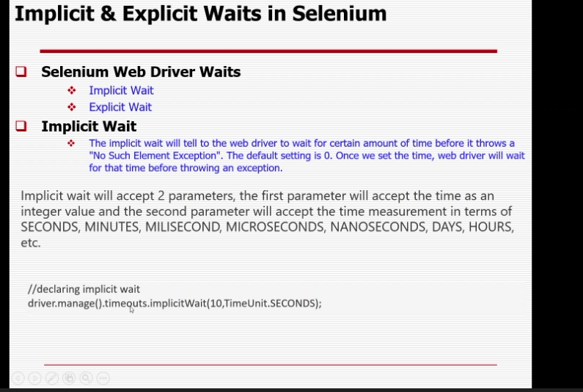

30.Explicit wait: we provide time as well as why we are waiting
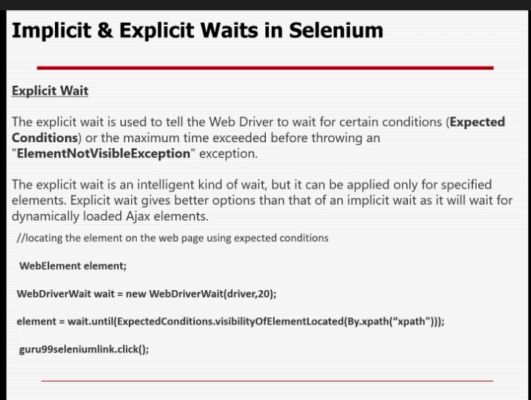

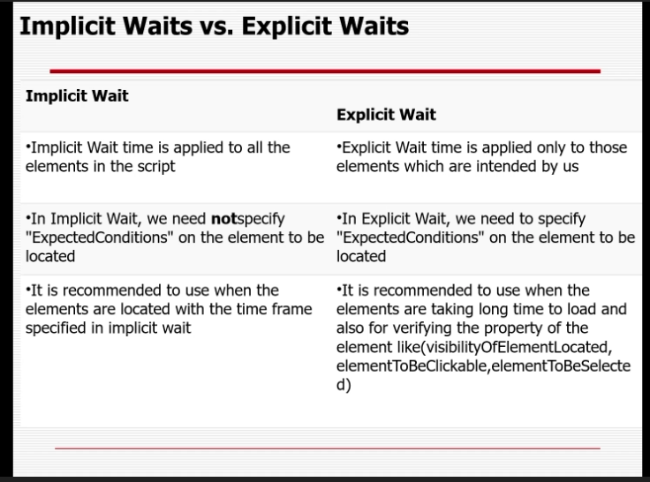

Explicit wait- it for the particular object
Implicit wait- wait for all , wait for next object to appear, won’t wait for time given, if object appears before the given time, it won’t wait for exact time to complete, it start execution the next line.
Thread.sleep()- wait until the given time

31.ListBox- select more than one
32.Popup-1)Web popup
2)JavaScript popup

33.alert in selenium
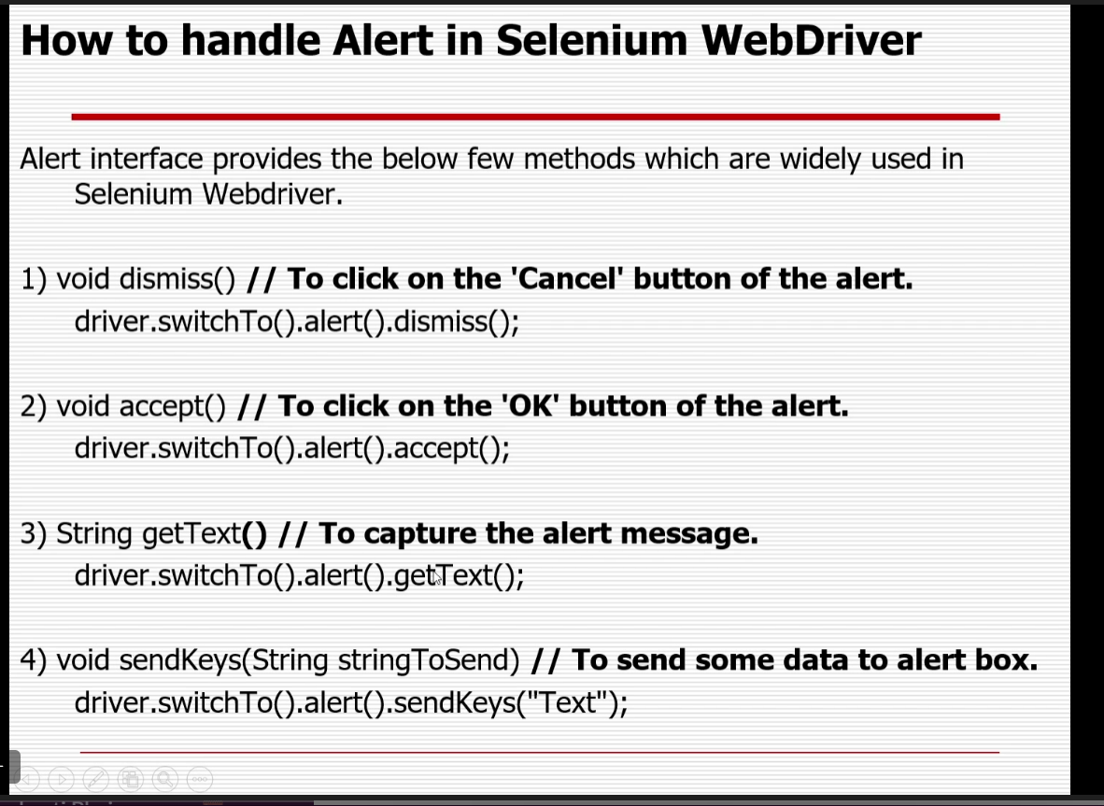

34.Special Controls
1)Mouse hover
2)Drag and drop
3)right click
4)double click

35.iFrame

