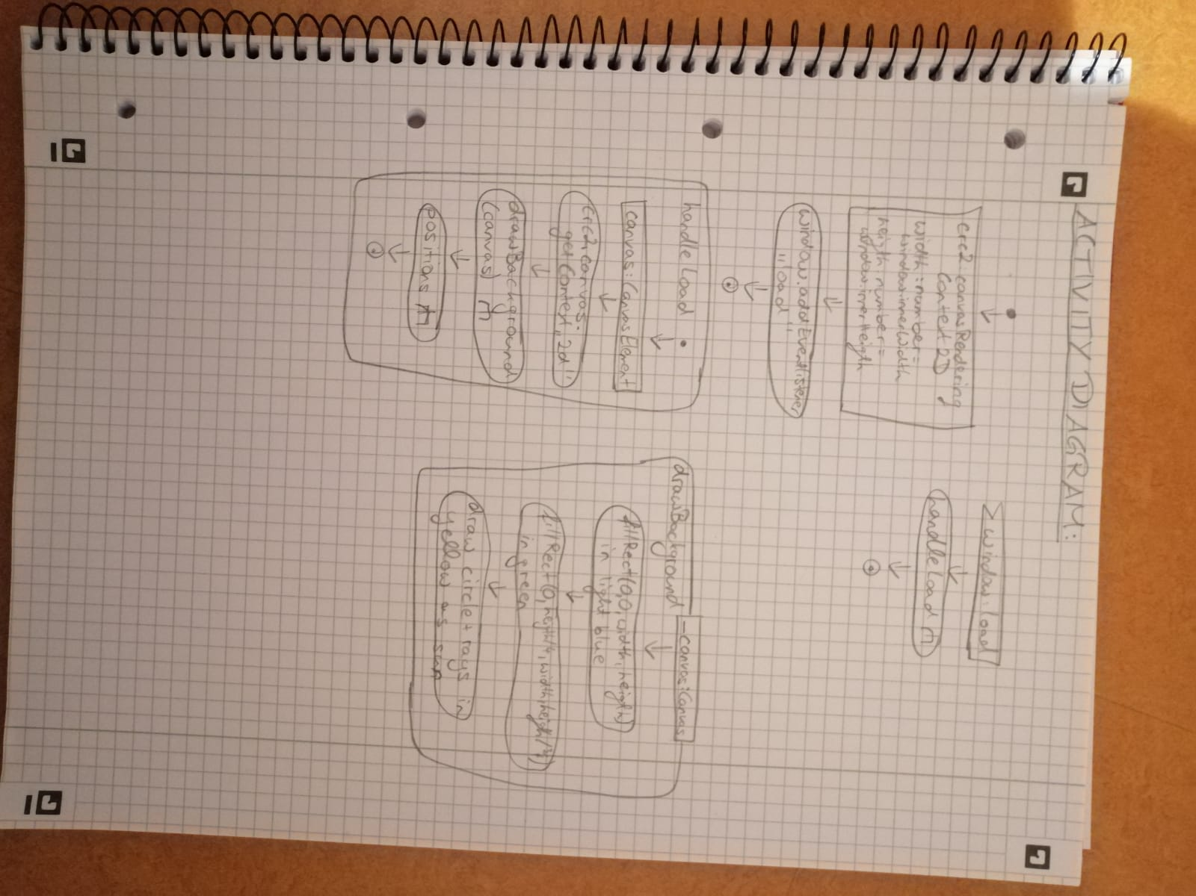ACTIVITY DIAGRAM: