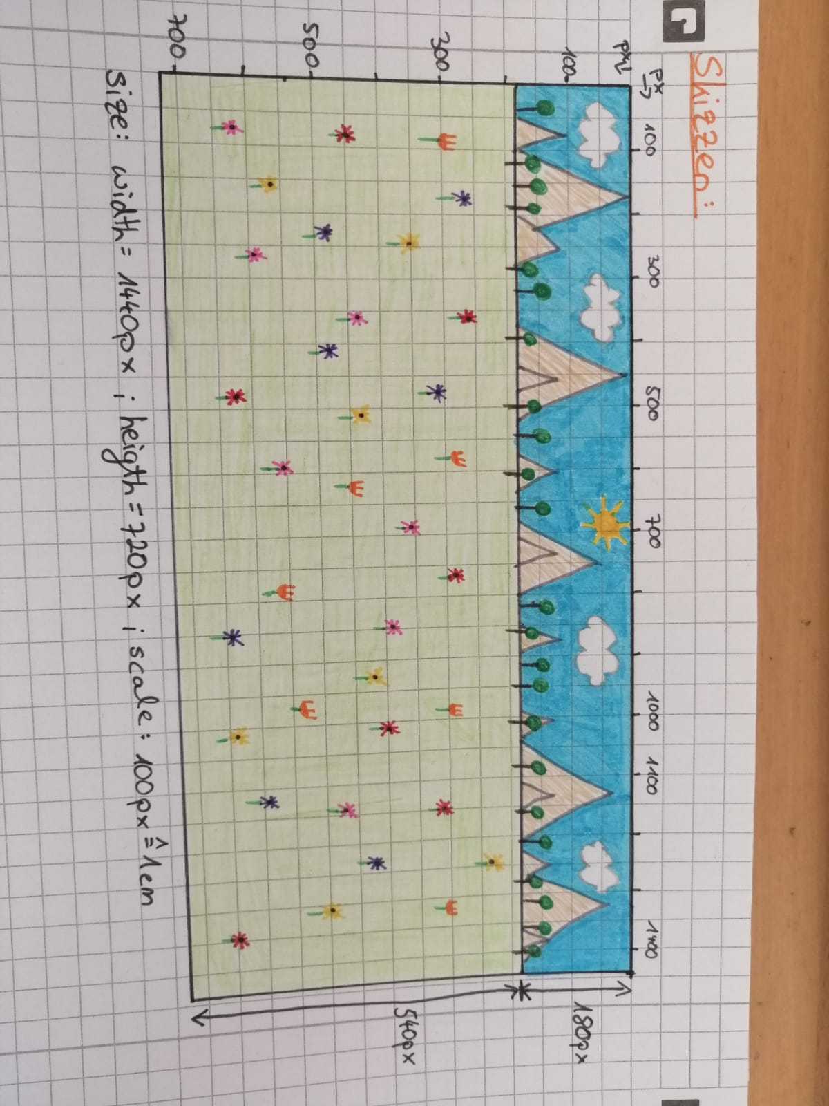USER INTERFACE SKIZZE:

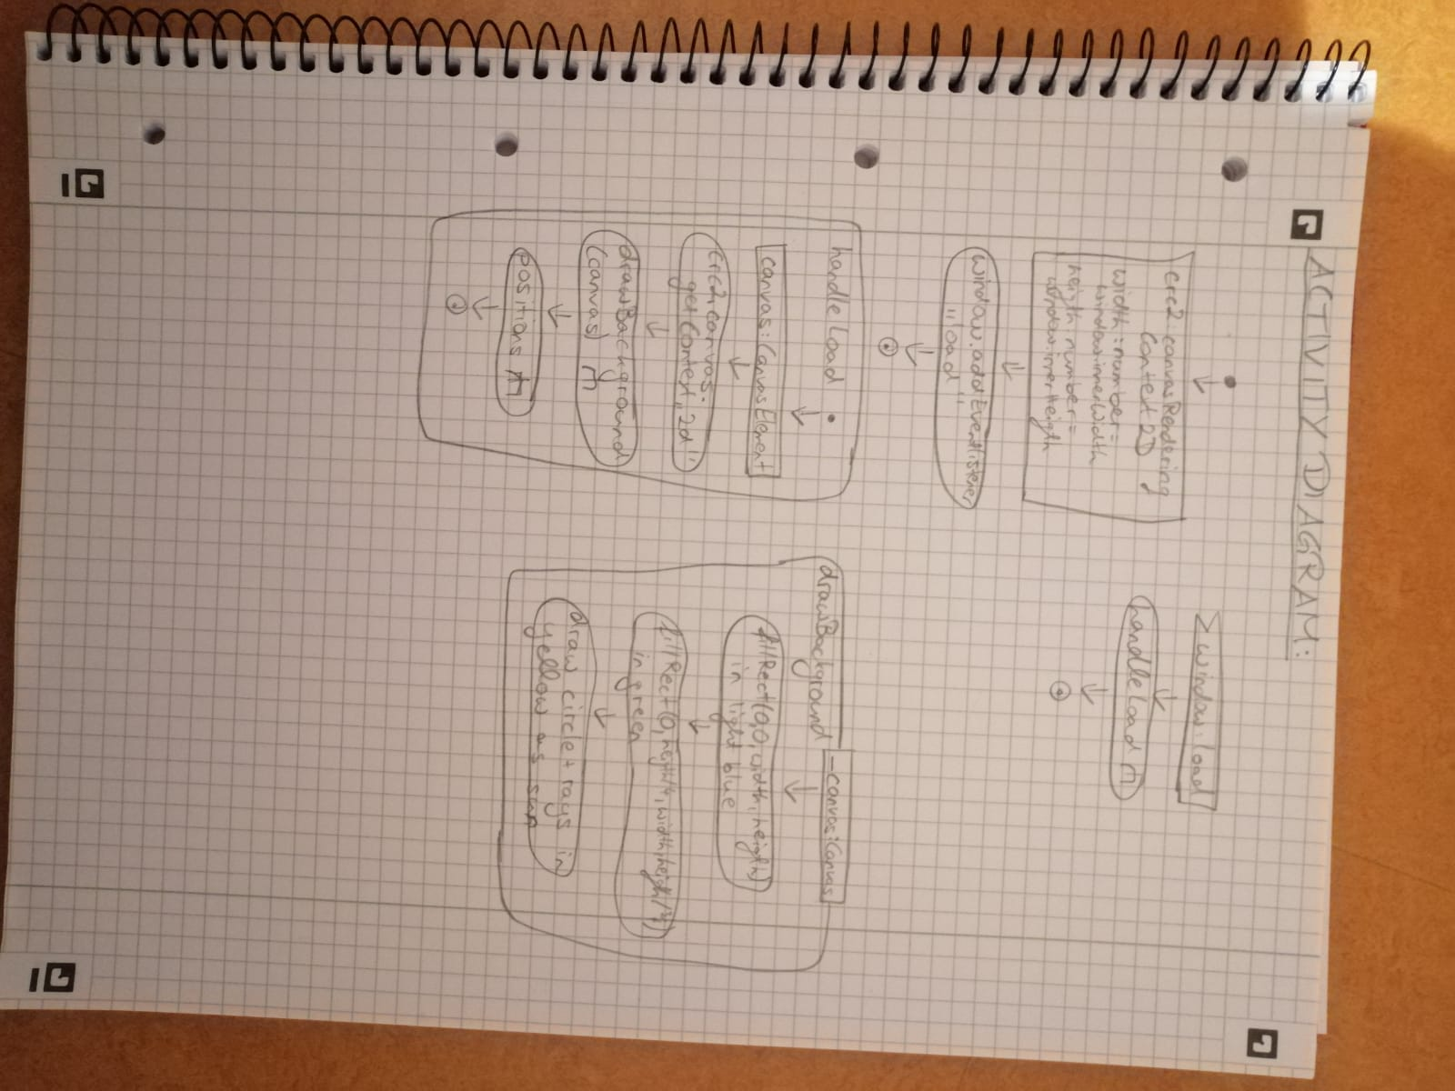ACTIVITY DIAGRAM: