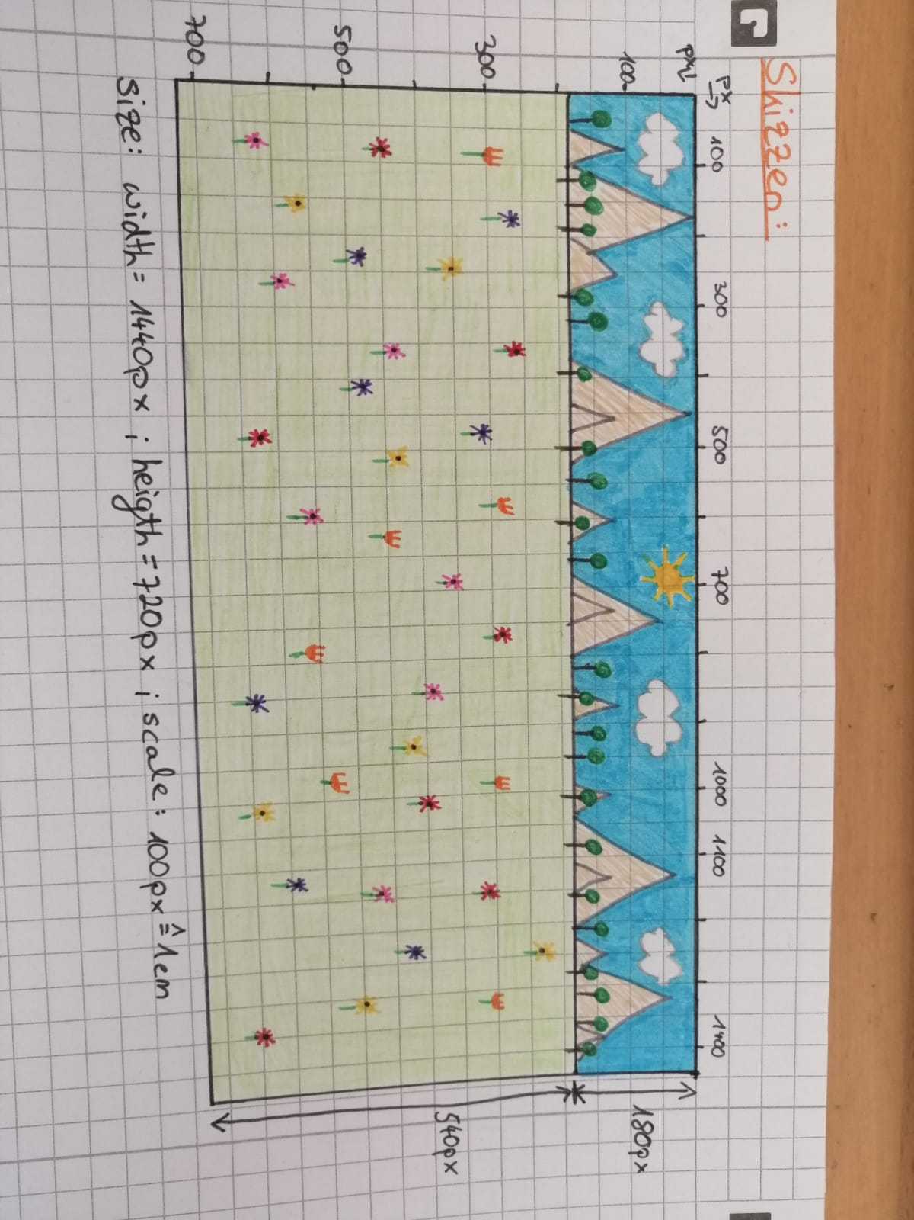USER INTERFACE SKIZZE: