**Case Study - PayXpert Management System**

**Objective:**

PayXpert Management System (Payroll Management System) is a Python project designed to manage employee records, payroll information, taxes, and financial records within a database.

Github link for full source code: <https://github.com/s-yazhini/Case-Study-PayXpert>

**Output Images:**

Tables created:

1. Employee
2. Payroll
3. Tax
4. FinancialRecords

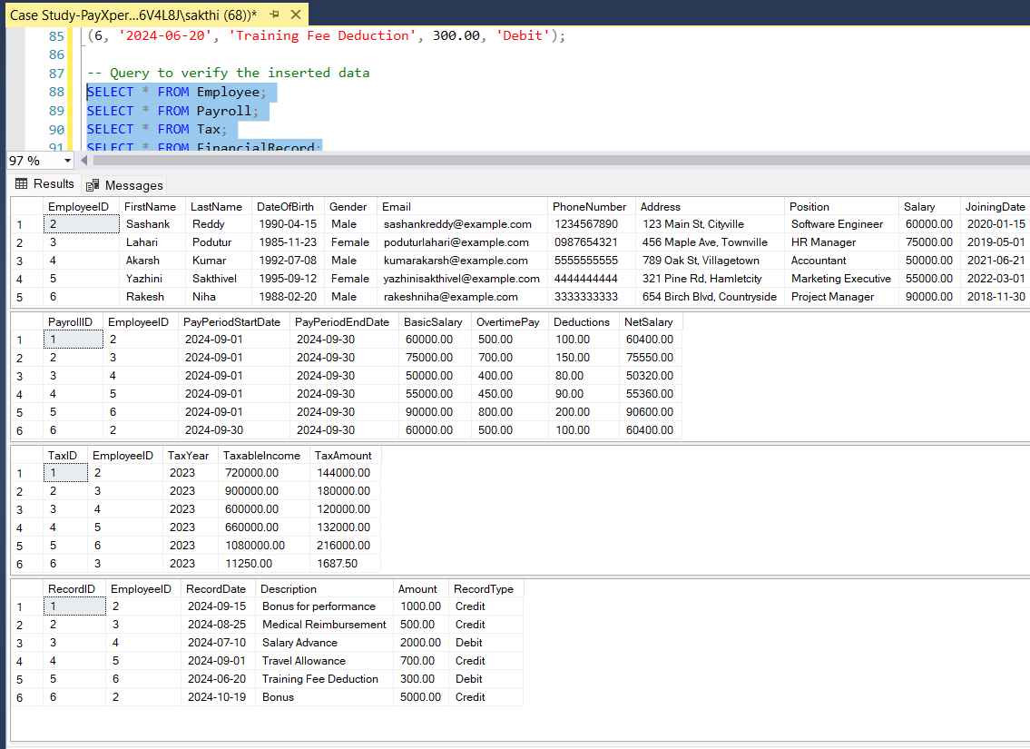

Successful DB Connection:

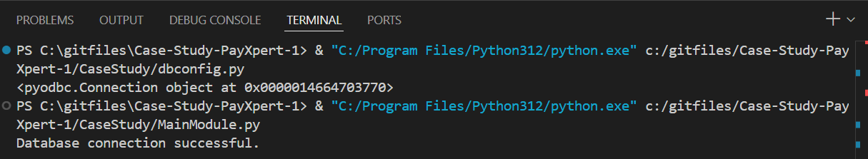

Main menu of our app:

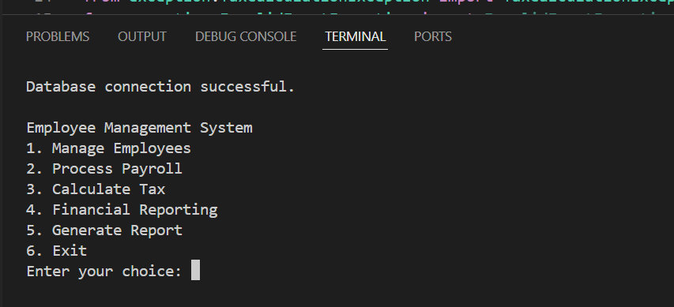

**Inside option 1. Manage Employees:**

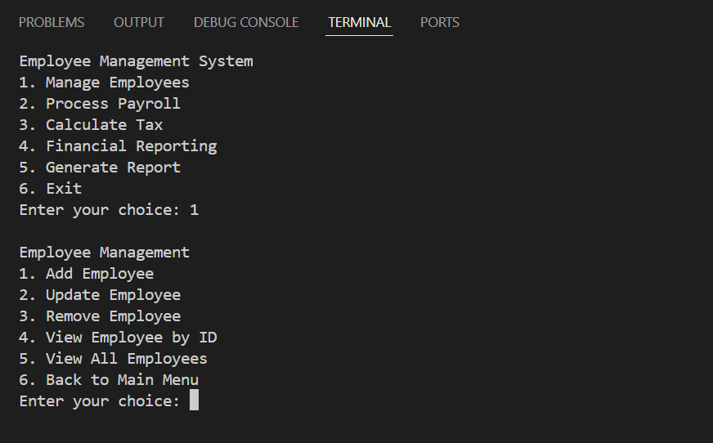

Add Employee:

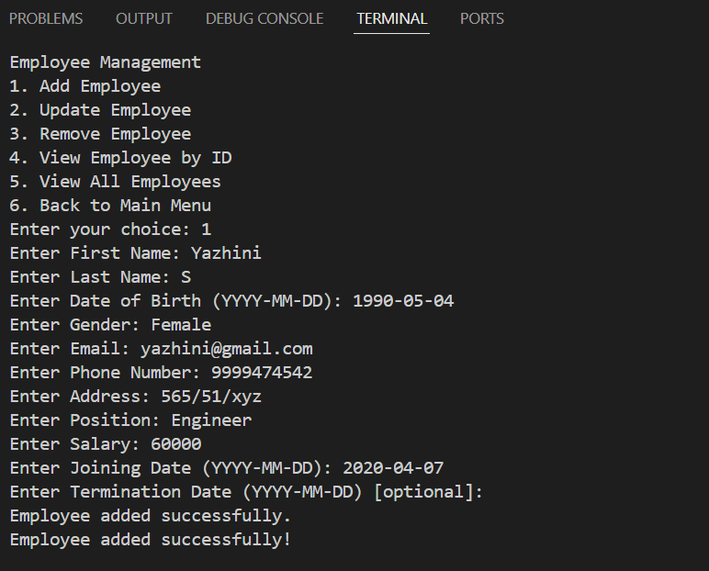

Update Employee data:

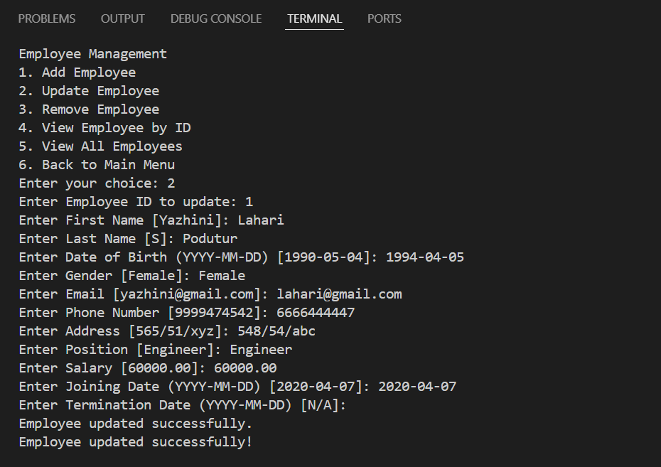

Delete/Remove an employee:

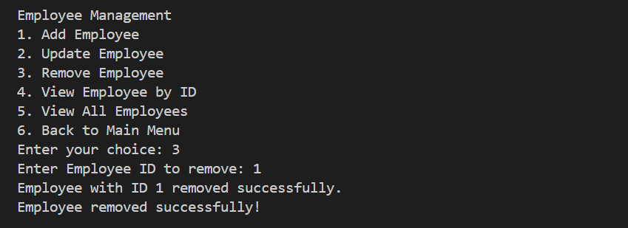

View by Employee ID:



View all employee details:

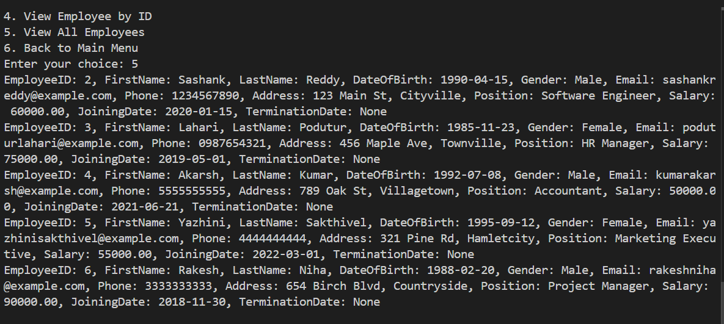

Back to main menu:

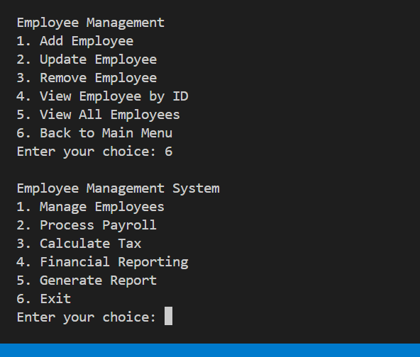

**Inside option 2. Process Payroll:**

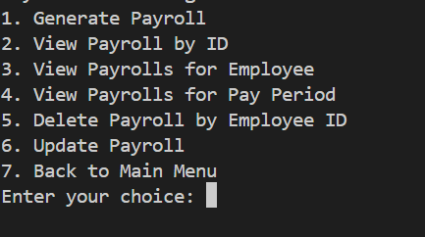

After adding payroll data – viewing payroll with net salary calculated:

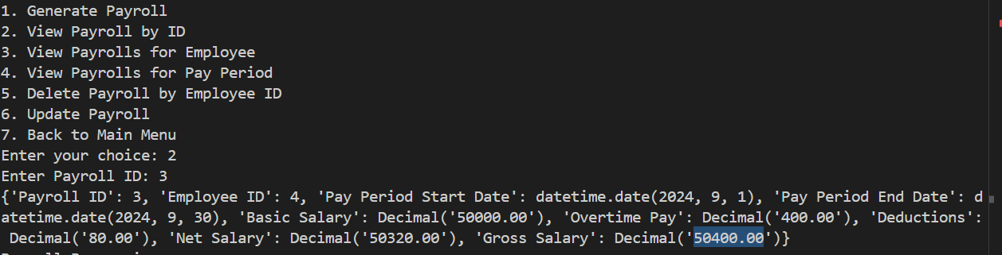

View all payrolls for an employee:

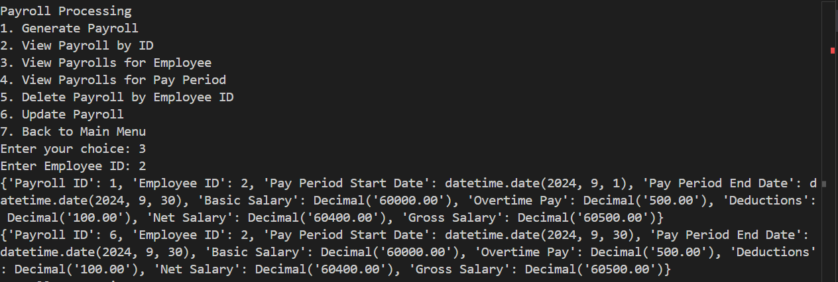

**Inside Tax Calculations:**

Calculate Tax:

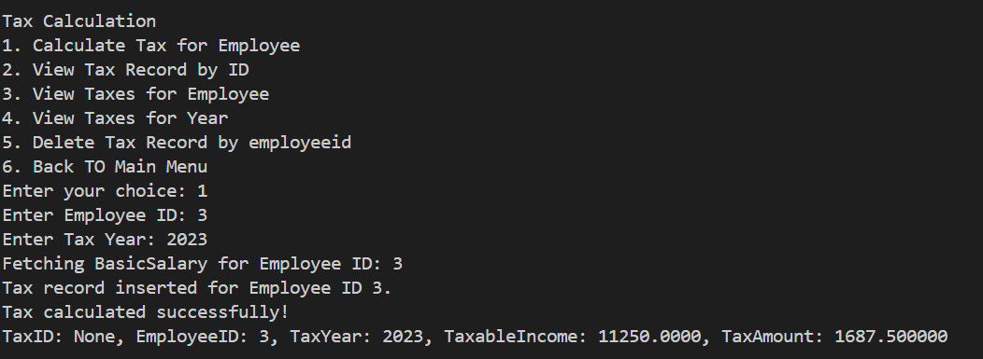

View tax record by Tax ID:

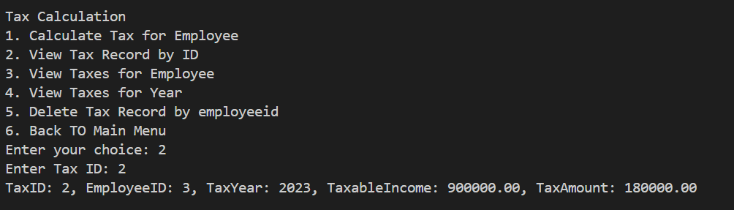

View taxes for a year:

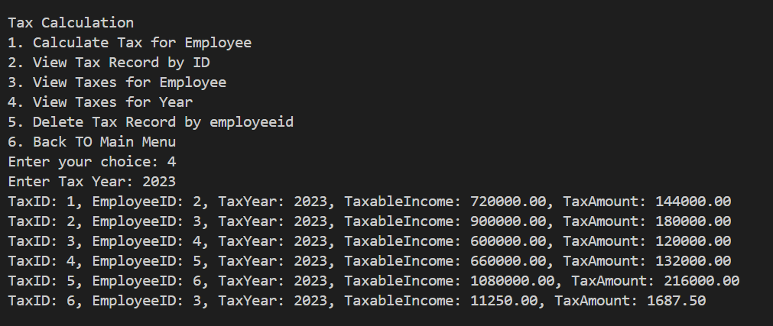

**Inside Financial Reporting (in main menu):**

View Financial Records for Employee:

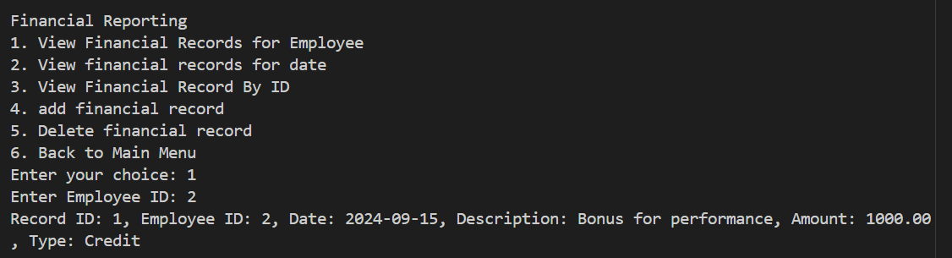

View financial records for date:

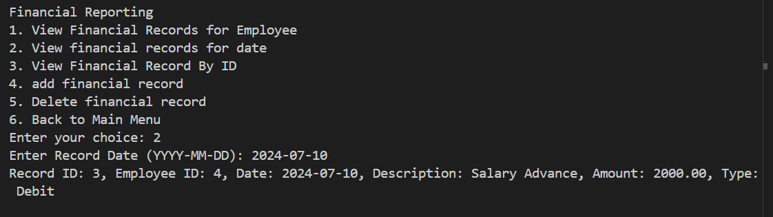

View Financial Record By ID:

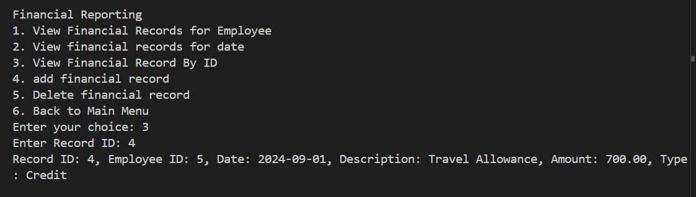

Add financial record:

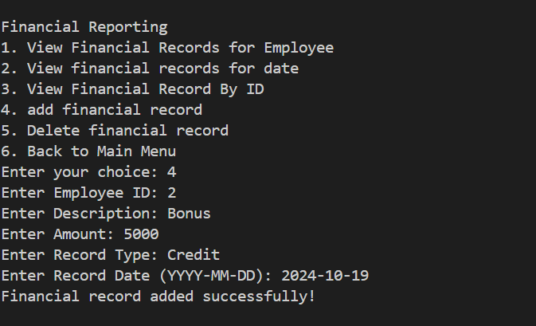

**Inside Generate Report (In main menu):**

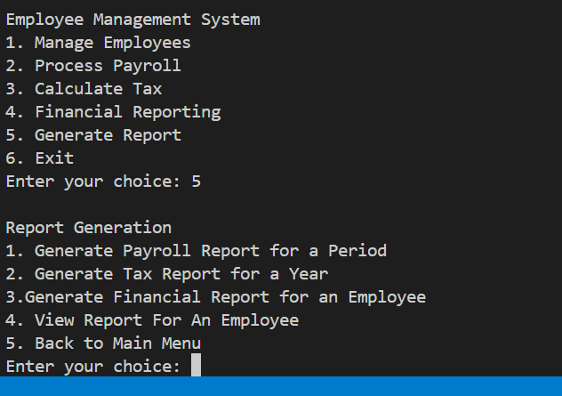

Generate Payroll Report for a Period:

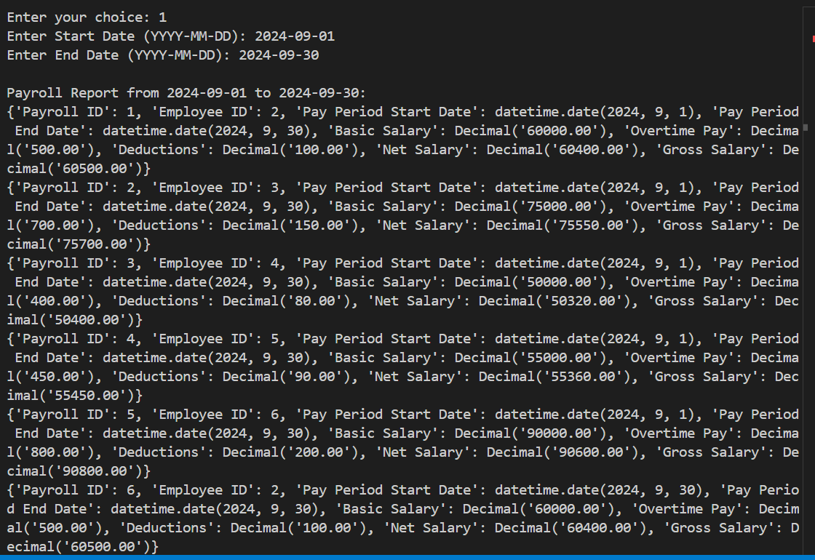

Generate Tax Report for a Year:

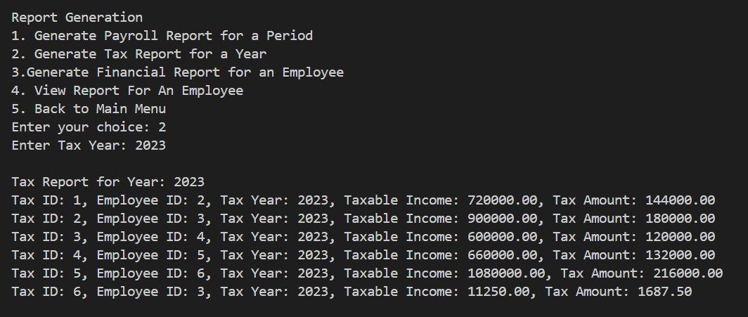

Generate Financial Report for an Employee:

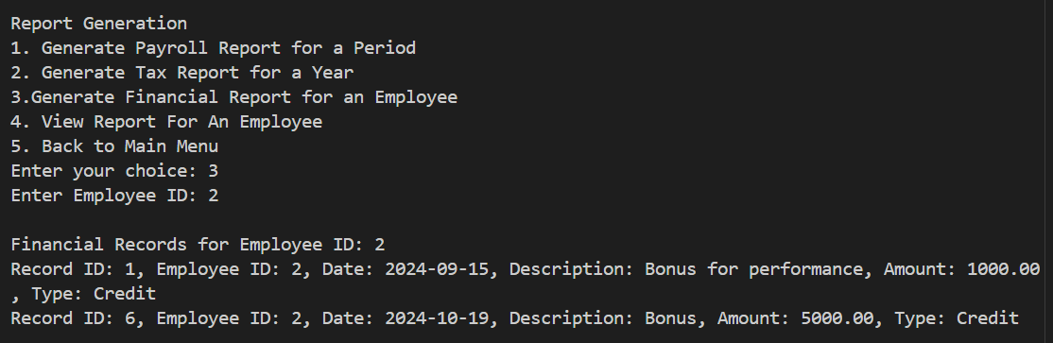

View Report for An Employee:

