# **Game Concept**

## ***Introduction***

*Factory Defect* is a is a sci-fi action adventure puzzle racer set set in a robotics factory testing grounds. You play autonomous drone OHM-1916 model No. 11430w selected to test the line to secure a smooth production run for the fourth quarter of 2259 C.E.

You will search the factory floor looking for parts and completing puzzles to complete the wishes of S.T.o.R.C. (Systematic Tester of Remote Compliance) who is the computer who is in charge of the testing process.

## ***Background***

H.L.C. Robotics Inc. was founded by a team of engineers in 2248C.E. who produced combat drones for military contracts, then expanded into production of drones for the service industry and general tasks of labour.

H.L.C. Robotics Inc. has been at the forefront of industrial drone manufacture, some accuse it of holding a monopoly since its acquisition of robo-helper Ltd. in 2256C.E. and of suppressing more efficient energy sources from the public market so they can continue their current highly profitable business model undisturbed.

Although the company keeps a good public face there is still an internal divide within the corporation where the 2 key engineering teams work from separate labs desperate to outdo each other.

We will be using Unreal Engine with C++

and Visual Studio, and deploying on Azure for the online Multiplayer Functionality.

## ***Description***

Factory Defect is a sci-fi survival/puzzle 3d game to be developed using the unreal engine.

The player controls an autonomous drone which has been selected randomly from the production lines of a robotics factory for quality assurance testing.

The drone is small with mini thrusters and little arms with crocodile clips for hands that can live wires for energy to charge itself. It upgrades itself with modular parts which are found in game adding extra thrusters, weapons, radar, tools, camera upgrades, even a neck and torso for larger equipment in late game.

The drone is released into the testing grounds of the facility where it must learn to adapt to the trials ahead in a labyrinthine world of other drones with varied primary functions from combat to home deliveries submitted for testing (both functional and defective) while R&D engineers stalk the shadows with screwdrivers and clipboards. It encounters puzzles and challenges set by its creators to push its capabilities to the limit alongside arenas where drones compete against each other (player vs player) to increase their market value and prove they’re not obsolete.

Are you fit for the market?

Or will you be to blame for a dreaded product recall?

Test Yourself.

## ***Key Features***

* Platforming
* Racing
* Puzzling
* Adventure
* Crafting
* PvP
* Physical user manual for OHM to fix in game problems
* 3 World areas and 3 online race tracks
* Hidden story within a linear gameplay experience

## ***Genre***

*Factory Defect* is a is a sci-fi action adventure puzzle racer.

## ***Platform***

We will be deploying to the Windows 10 PC platform as well as XBOX ONE.

## ***Concept Art***

## Evolution Of Assets

This section of map will be the starting area for new players and its tasks will serve as an introduction to the gameplay mechanics.

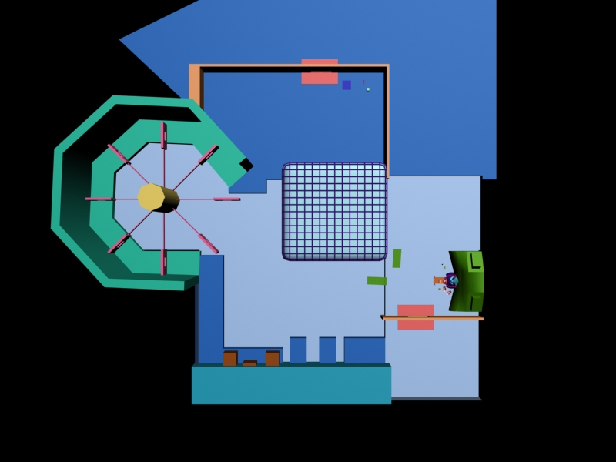

As this is a tutorial level failure of a task should be non fatal, with a simple path to try again. Gameplay should introduce the player to navigation controls, then how to pick-up and equip a mod. This level should present the player with enough of a learning curve to keep them interested. As it is a tutorial it should not take a seasoned gamer more than 5 minuets to complete if they focus. If playtests demonstrate it to be too easy we can easily extend the walkway of things to dodge so don’t worry, we're gonna make sure to challenge you.

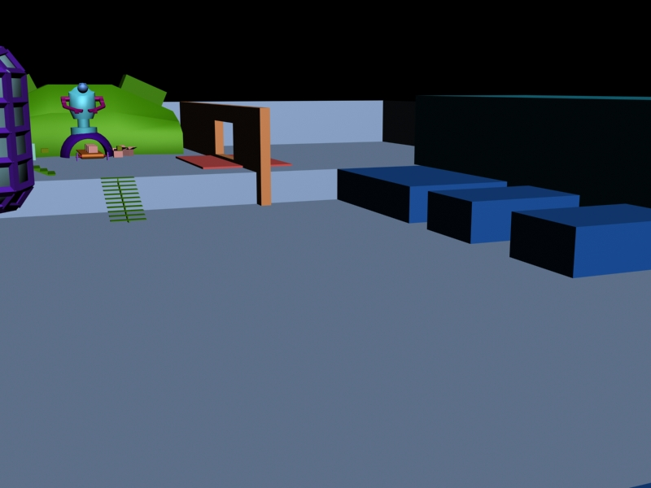

We think it would be nice to add some humour with some incredibly defective drones attempting to pass the obstacles along with you.

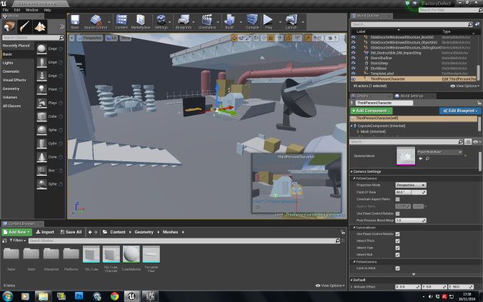

## Ray Casting

In this picture it shows that the red is a line cast that has yet to hit anything and then the green is the confirmation that the line did indeed hit which is please.

