**Part 3: Final report & Screencast**

**a) Incorporate the initial design proposal as the first section of this report**

1. Project description Write a short description of your project idea (max 300 words):

a) What is the idea behind the website

The idea behind my web application is to create a web page “my curriculum vitae” page will include a short detail description of me, including finished courses and qualifications. The page will also include an overview of my experience and other qualifications for job opportunities and a section about the technologies I have studied. This page will gather all information about my education like what technology I learned in the college cycle and my experience in working environments, including what I did before going to college. I would like to use this website as a form of job application when I finish the college.

b) Who are the potential users of your website

This page was created as a form of Electronic CV. The goal is to make the employer interested in me. A typical user would be a recruitment agency, head-hunters and all potential employers who are looking for a professional software developer. The page is also a form of advertising my skills, presenting my knowledge using Angular, Html, CSS, Js and reflects on my use of computer cloud AWS.

c) What are the main features of your website

Description of my lifecycle (curriculum vitae) and all the technologies I learned in IT Sligo with a link for the projects I have done and the amount of time I spent doing a module (i.e. 1 semester). The page is mainly created with Angular using typescript. As a form of server, I will use AWS S3 bucket to host my page. The page will be spaced in a way to bring attention to all programming languages. I have added a link to my project to connect with GitHub API which will add links from my project as I create a new one.

**b) Detail the Components created and their specific task**

**c) Outline how the finished application differs from the original proposal and why**

This application is different from the original application idea in that I implemented more components into the project. User Interface looks like mix of first proposal wireframe and the third one. Reason behind this is that in the version I chose to use it looks better when it displays on the page in the pc browser and mobile version. It creates a better structure for future update. Like programing language was divided into separate components so you can easily add extra contents in the future as the web page will serve me as a CV in the future when I apply for jobs.

**d) Include screenshots of the main elements of the Application**

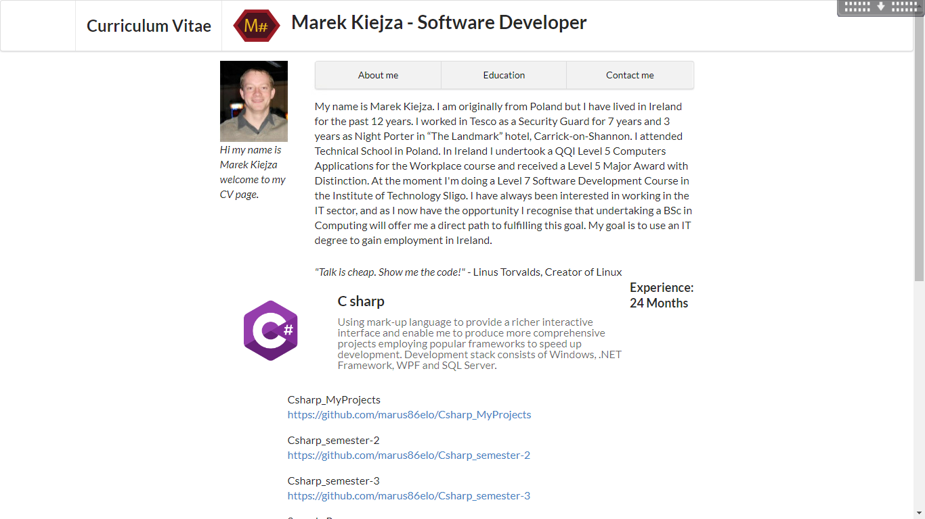

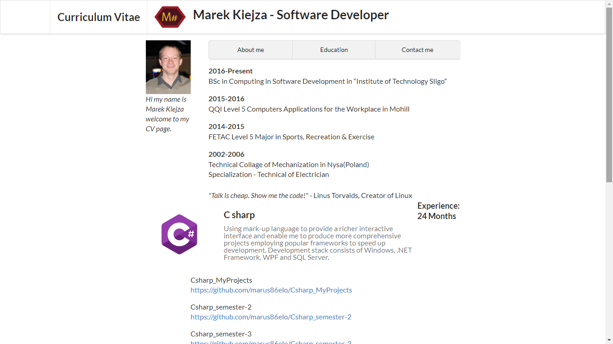 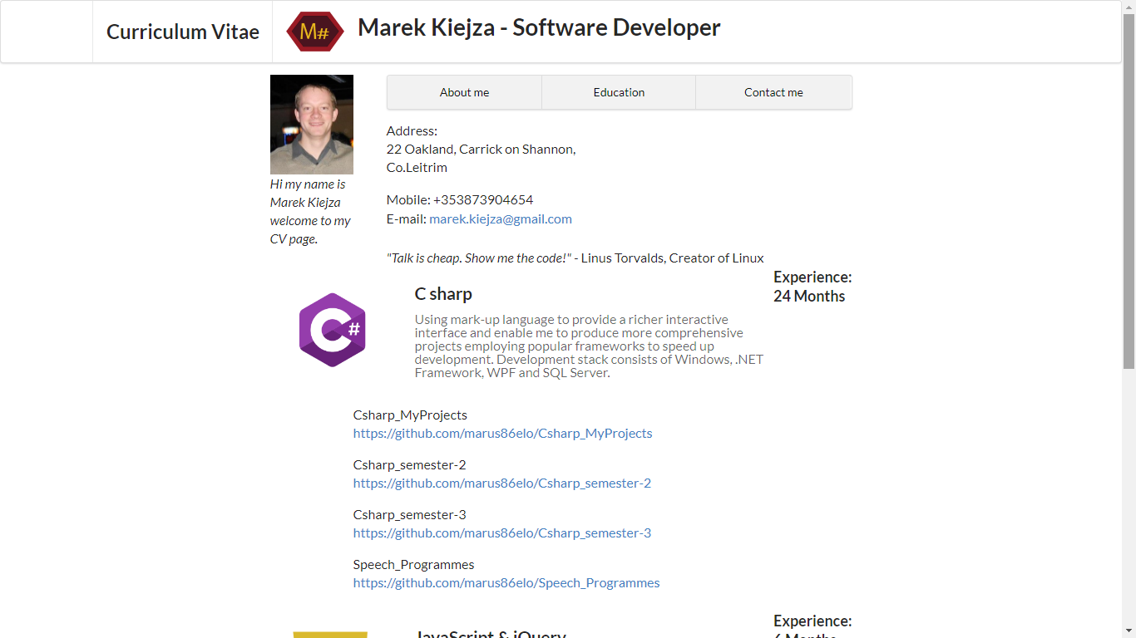

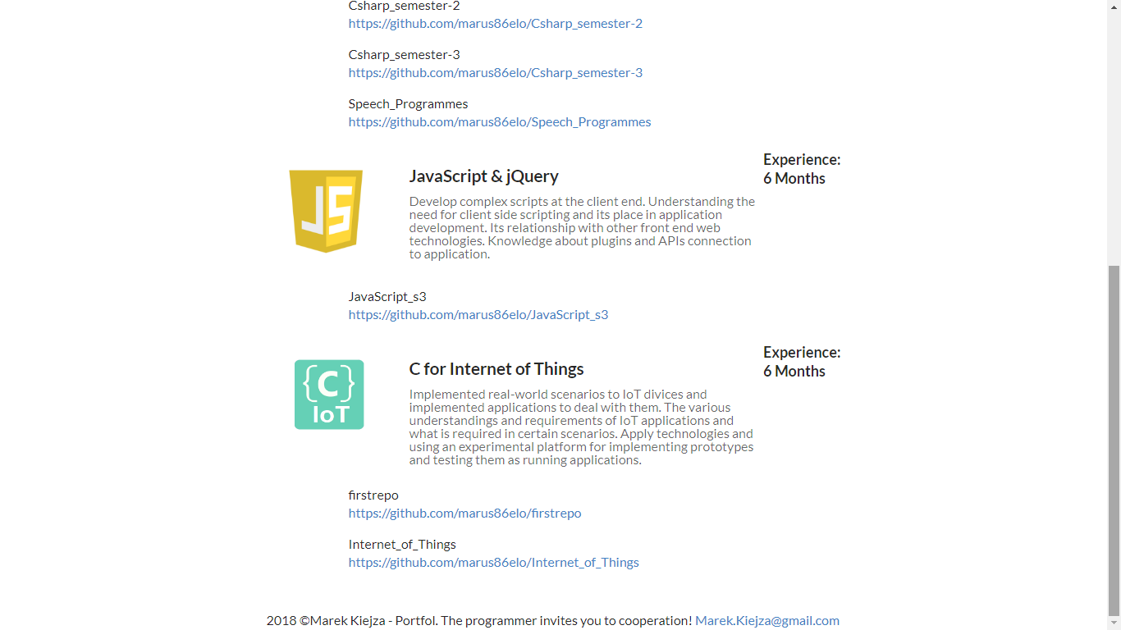

**e) List the main CSS classes used, where they were used and what they were used for**

Most of my CSS was done in the Semantic CSS so I use these classes to space out the elements and style them when displaying it.

Class:

**content** – space out the header with the with the style board between the elements.

**ui item** - space out elements of each of the programming language components.

**ui three item menu** - text with corresponding 3 click elements tabs panel (“About me”, ”Education”, ”Contact me”) space out elements and the tabs are styled.

**container** – use so the “three item menu” stay on the same level with the “profile image”.

**g) A 200 word reflection on this project. Outline how the project has gone for you, detail areas you struggled with and areas you feel you have learned a lot in. Your opinion matters here.**

Creating this project was an opportunity to create my electronic version of my CV which I will use to get employment in the future after I finish the collage. By using Angular it has allowed me to present my information to my future employer and present my skill in the Angular web create aspect.

The aspect of the project I liked the most was how the Angular display information in the component so this allows me too easily display all the information. I like how it includes on one page in very clear to read form. So that my detail was in one place and I easily insert more data in the future as I will progress through the college and getting more projects inserted automatically from the Git hub API.

Creating components and the making them connect with other ones was also the most challenging part as I think when I create more projects it will become more natural for me to use them. The API I used was GitHub API, it was a good choice as it was needed for my project concept and also it is a very well documented API with easy access to chosen components. Overall I was happy with the final result of my project and that the “CV web” I will use in the future. I learn a lot going through it.

**h) Evaluate your work using the marking scheme provided. Give yourself a mark.**

|  |  |  |
| --- | --- | --- |
|  |  | s00173510 |
|  |  | Marek Kiejza |
| **Proposal (20 Marks)** |  |  |
| Well Written Description | **4** | 3 |
| Research | **6** | 5 |
| User Interface (UI) design | **6** | 5 |
| Component Tree Diagram & Architecture Diagram | **4** | 3 |
|  |  |  |
|  |  |  |
| **Implementation (60 Marks)** |  |  |
| Tree of Components created with components having clear functionality, some with complexity | **20** | 19 |
| Connection to RESTful API through a service making use of Observables and Interfaces | **20** | 19 |
| Good CSS Styling using a framework such as Semantic or Bootstrap | **20** | 18 |
|  |  |  |
|  |  |  |
| **Screencast (7 Marks)** |  |  |
| Project and key elements well explained | **7** | 7 |
| **Document (13 Marks)** |  |  |
| Contains proposal, screenshots and CSS explanation. Good reflection. | **13** | 11 |
|  |  |  |
|  |  |  |
| **Total** | **100** | **90** |