
Screenshots of my worksheet 3
Aisling Mc Loughlin – S00189922 Open Stack Development

Feb 15, 2022
Aisling Mc loughlin
S00189922

Screenshot 1 – Adding book title and author
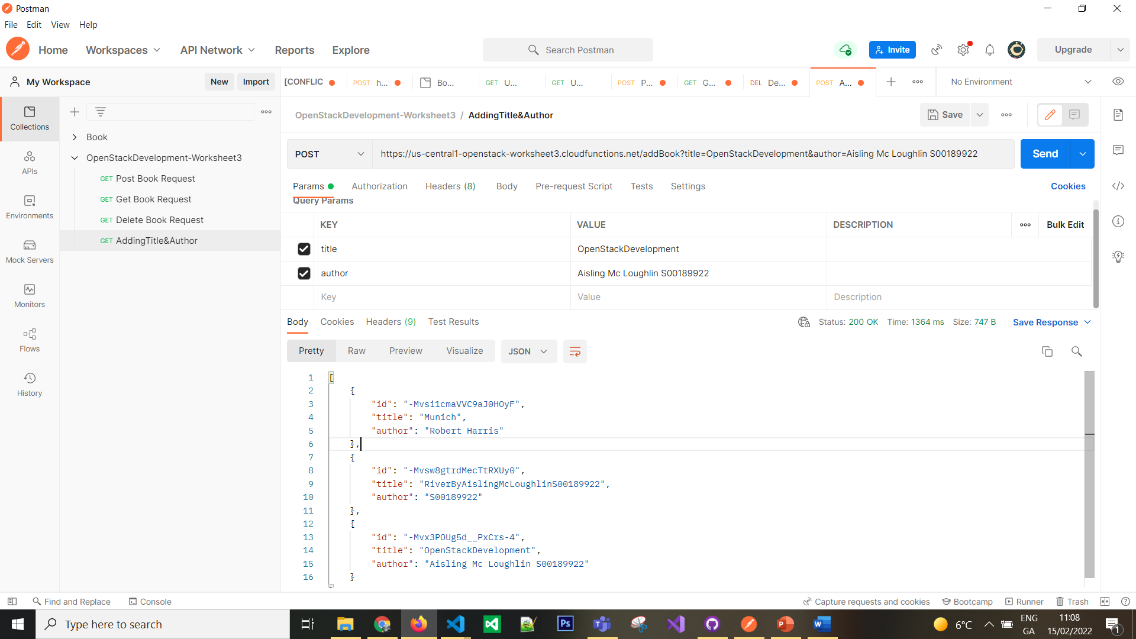
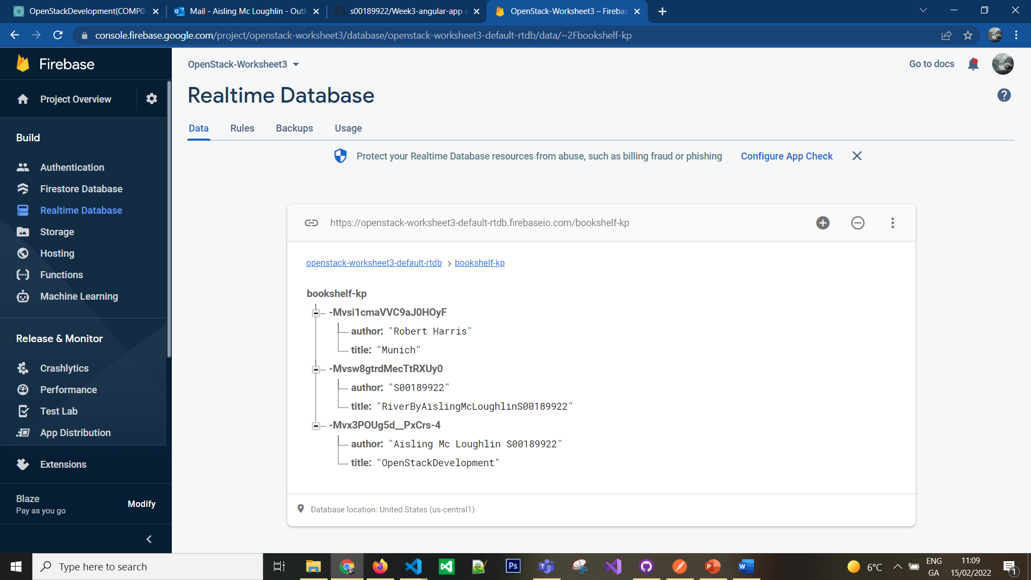

Screenshot 2 – Getting book title and author
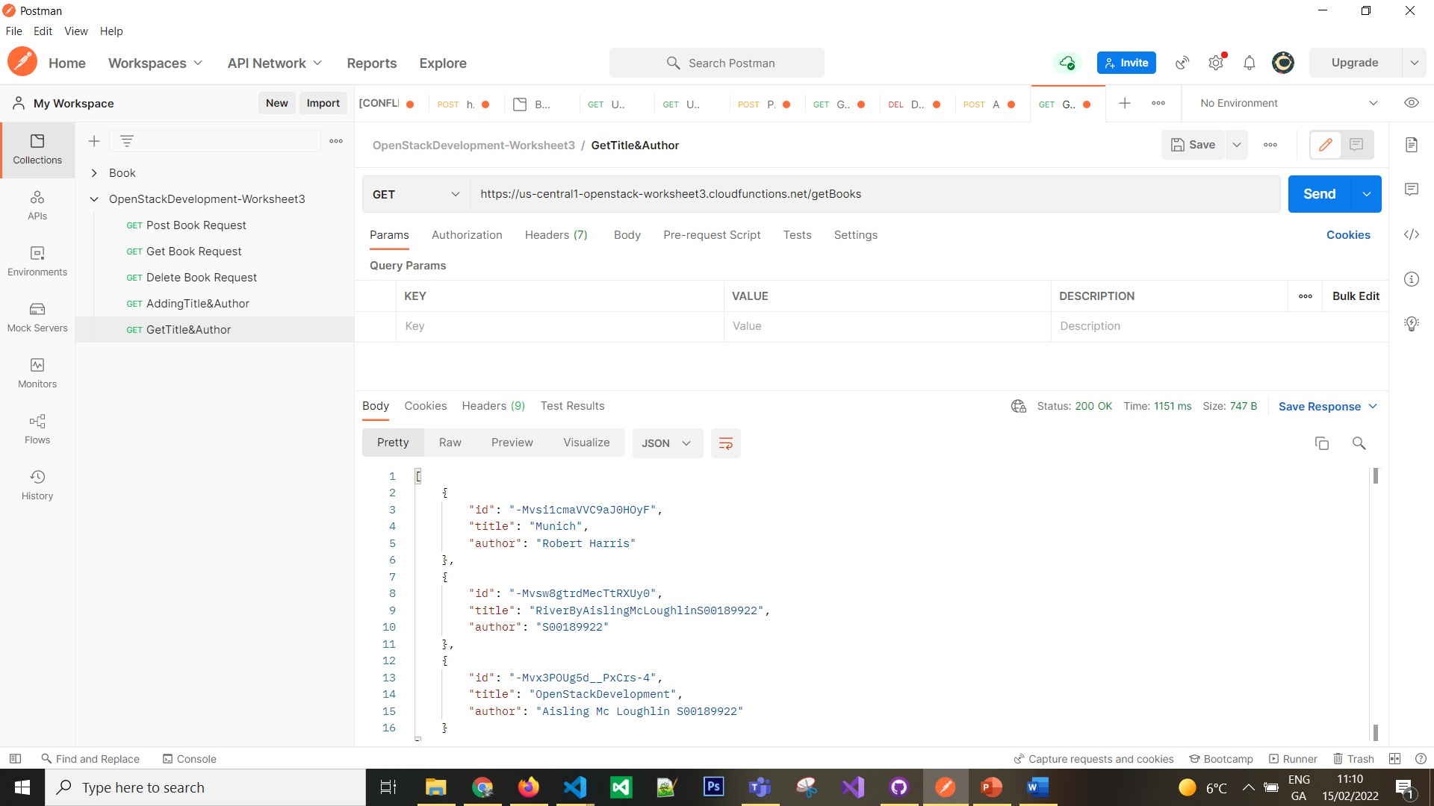

Screenshot 3 – Deleting book title and author
