
Screenshots of my worksheet 1
Aisling Mc Loughlin – S00189922 Open Stack Development

January 26, 2022
Aisling Mc loughlin
S00189922

Task 1 – a basic unit test & Task 2 – add a second test

Compute.spec.ts
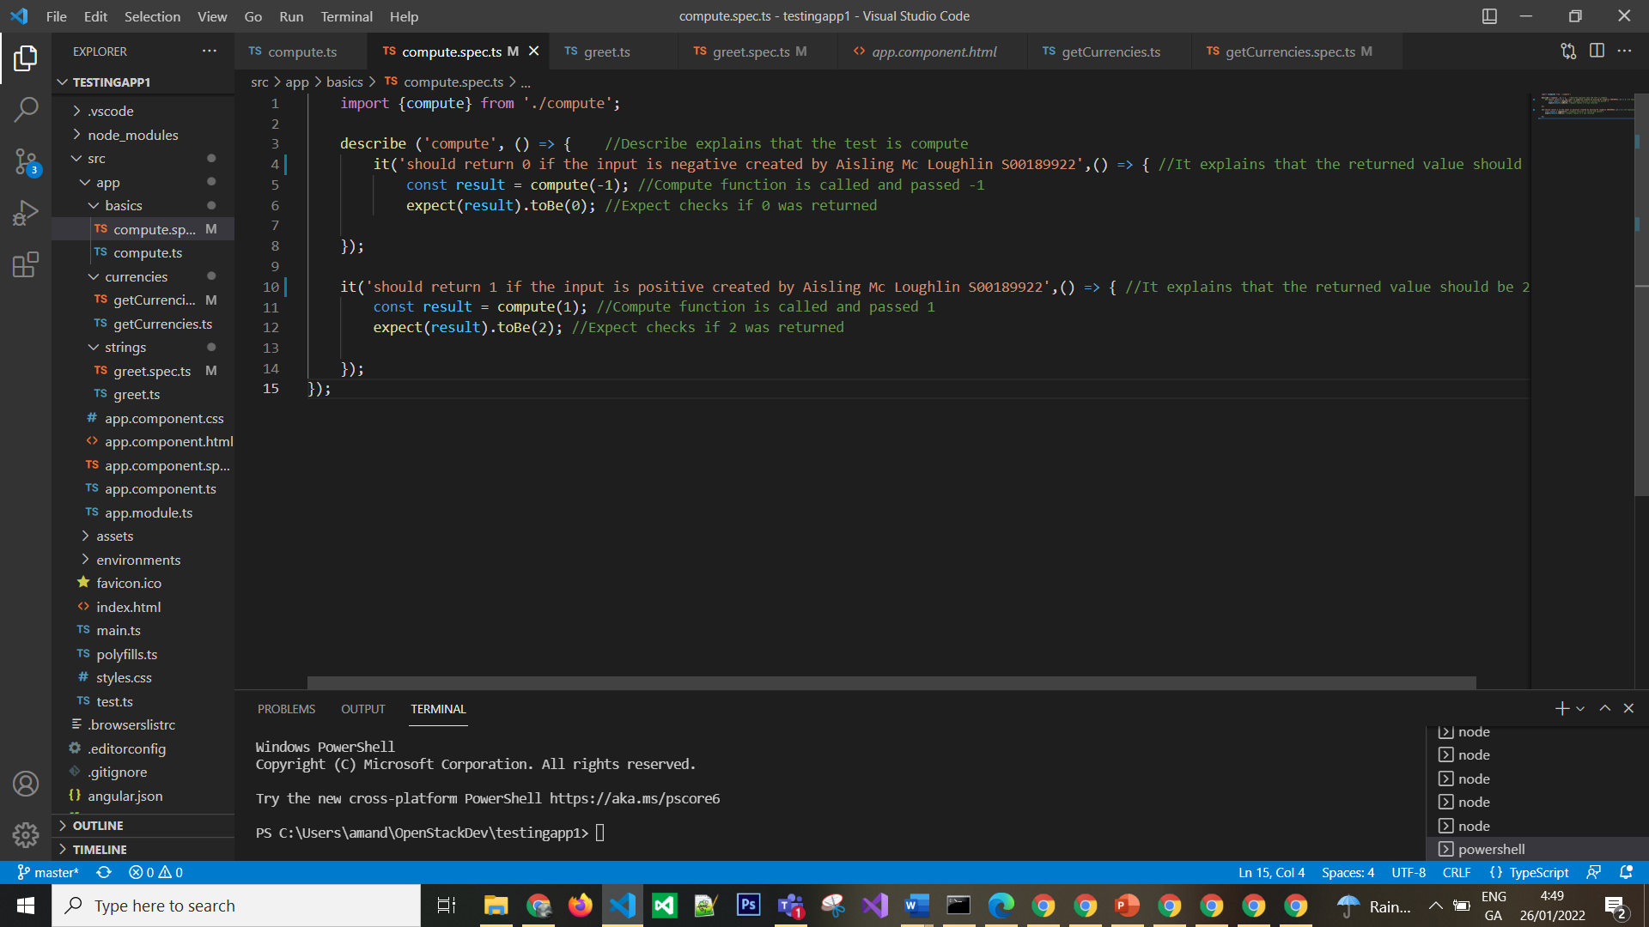

Compute.ts
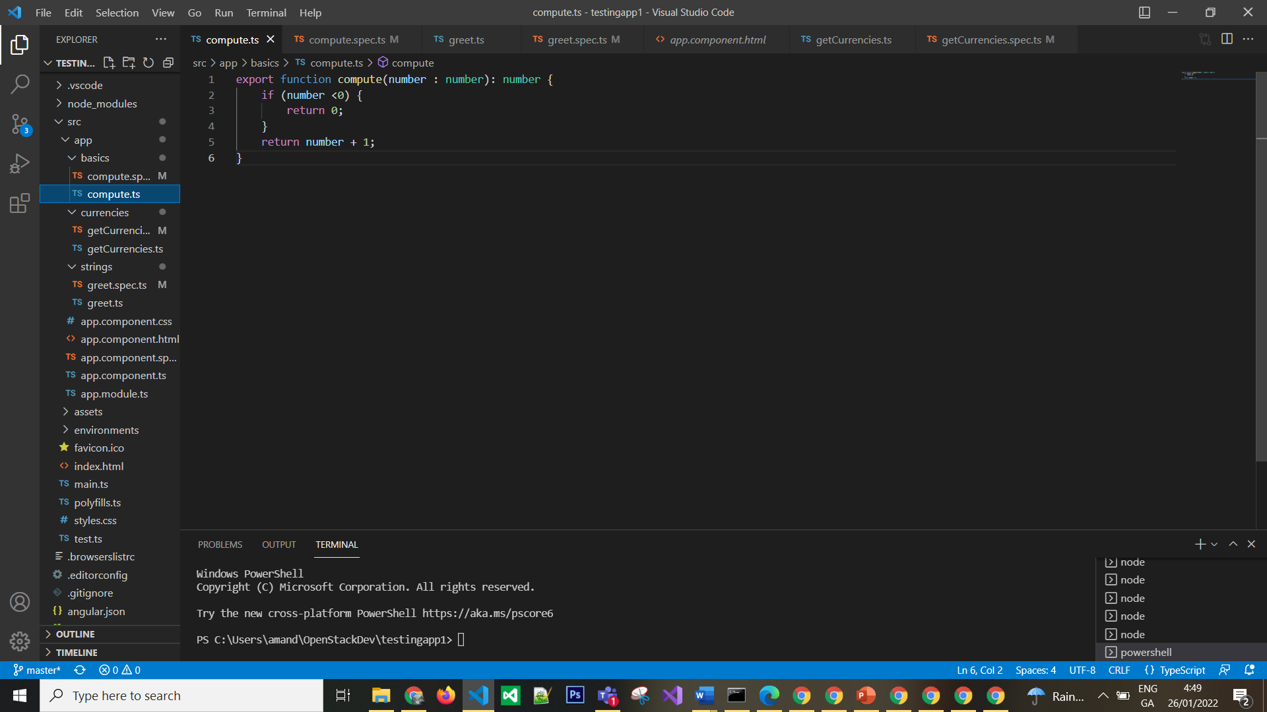

Task 3 – Testing strings

Greet.spec.ts
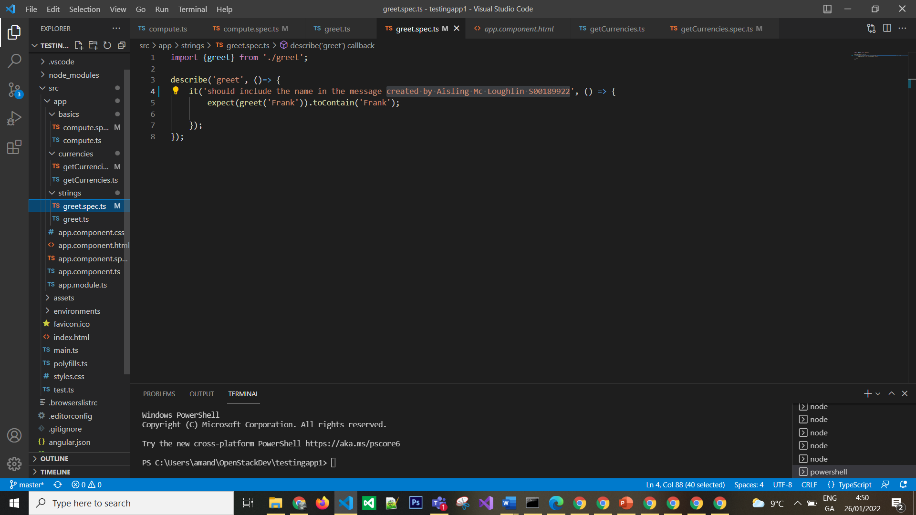

Greet.ts
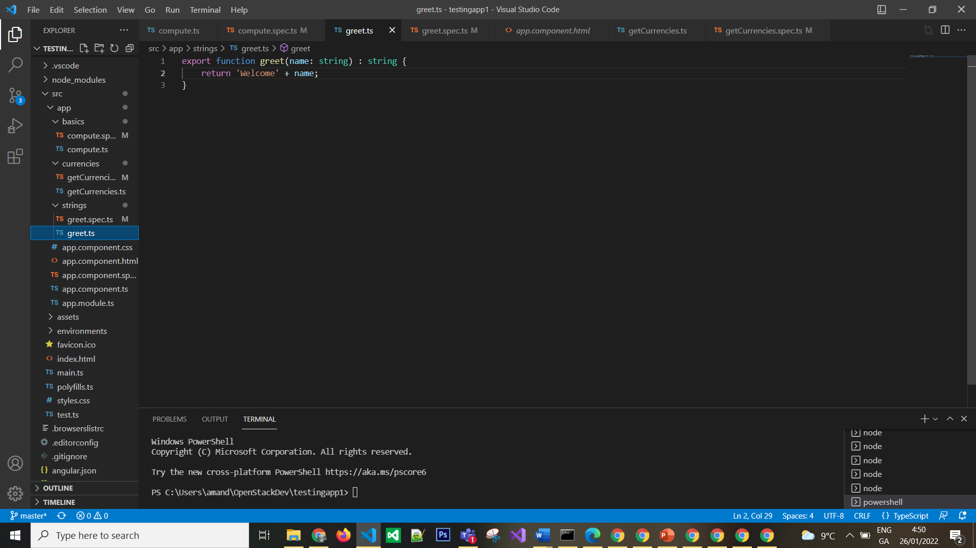

Task 4 – testing arrays

getCurrencies.spec.ts
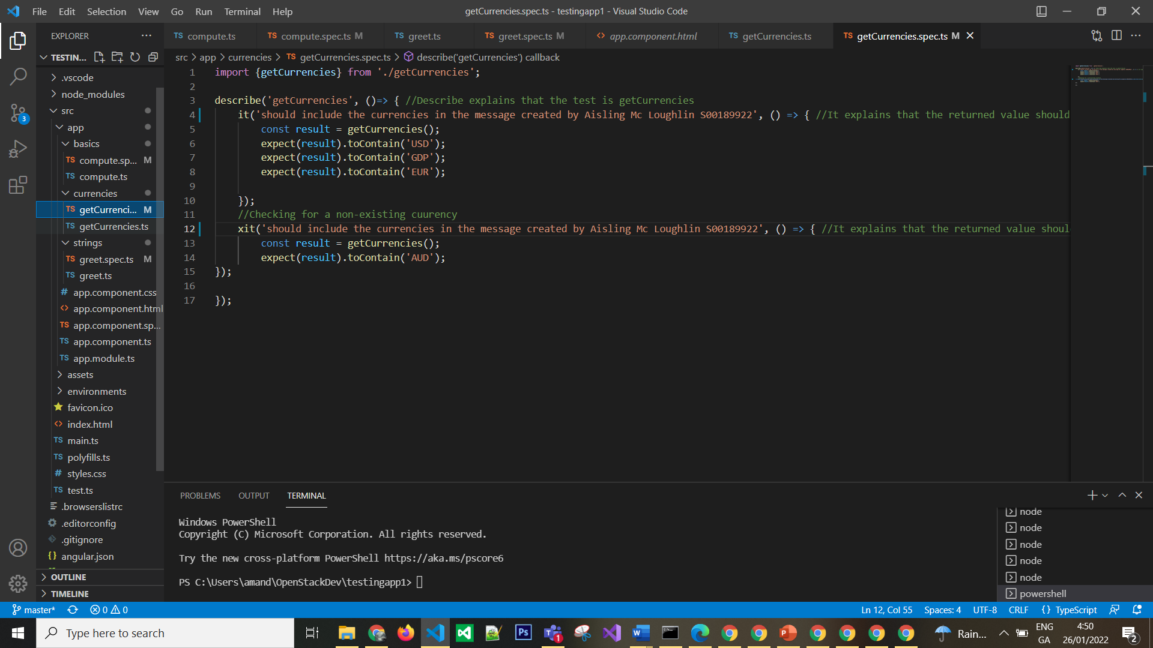

getCurrencies.ts
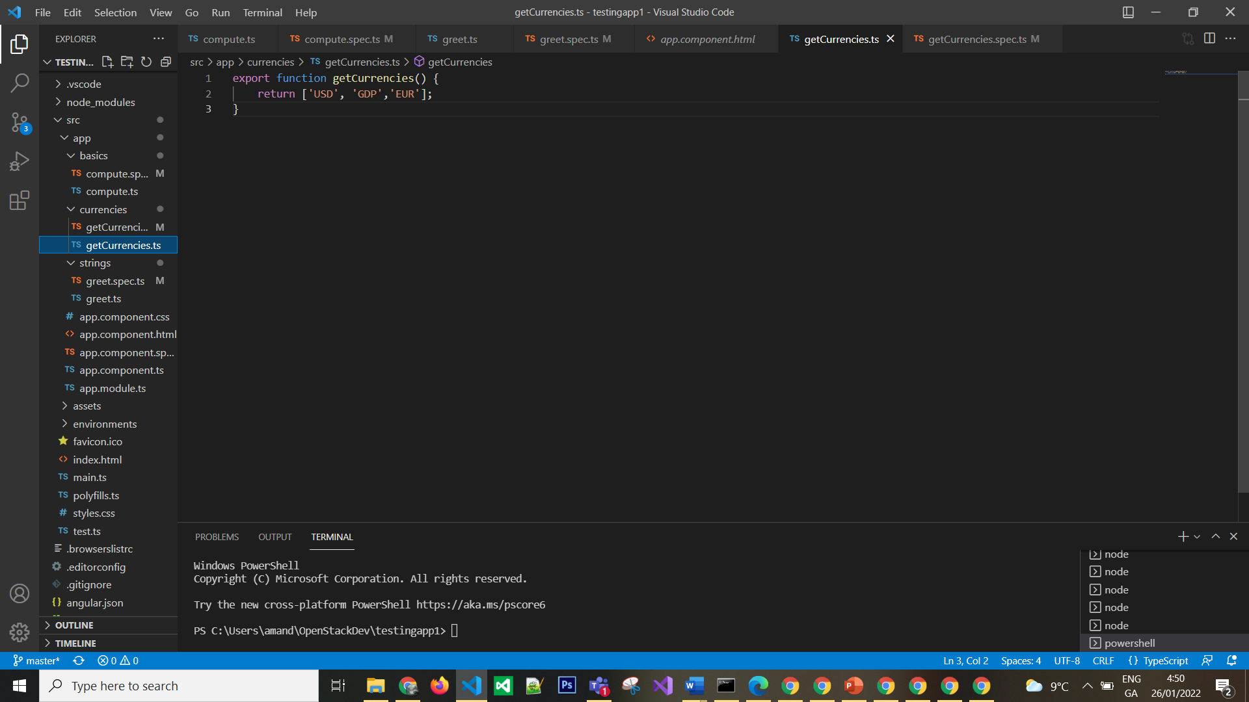

Karma Testing
