# Memory Game

**1. GUI**

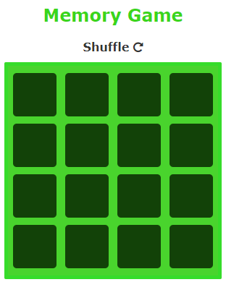

**2. Shuffle**

Screenshots show first click on first cell then first click on first cell after using Shuffle button.

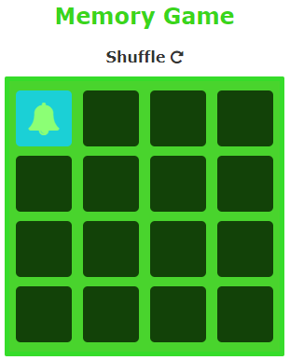

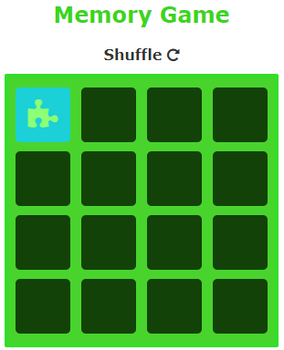

**3. Winner Functionality**

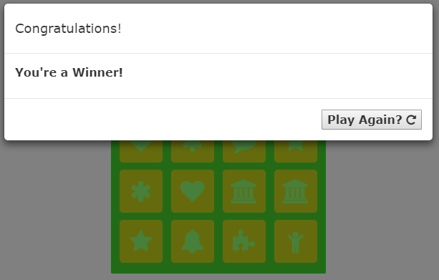

**4. New Game Functionality**

A New Game can be started by clicking the Play Again box in the winner modal or by clicking the Shuffle button.

**5. GitHub**

Commit ID: b3632efa233a6f92a3335c4386cbc9e62557656e ([Link](https://github.com/s00615504/IT2320-AnaSlocum-Fall2018/tree/master/Lab9/REDO))

**6. Loser Functionality**

Loser Functionality is an alert that pops up when a match is not made.

