# Lab 12 Responsive Design

## Standard Web Browser View

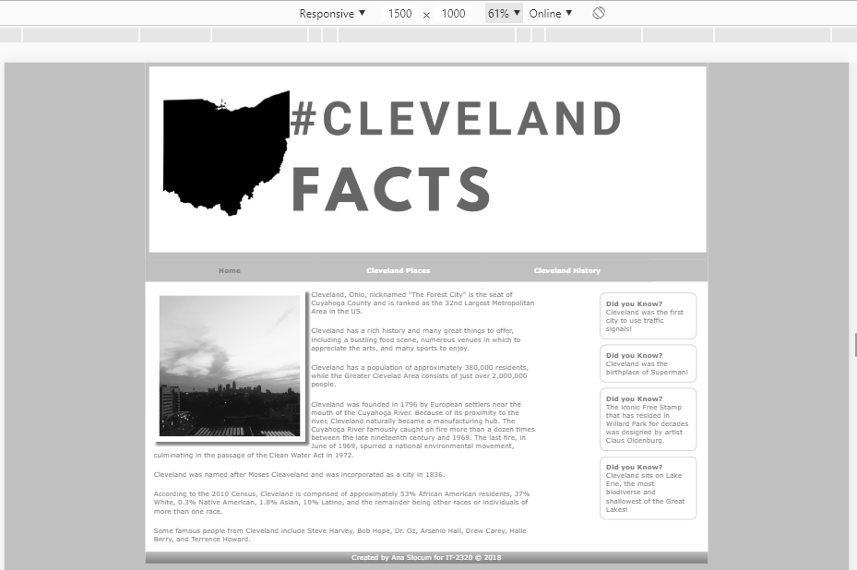

## Tablet View

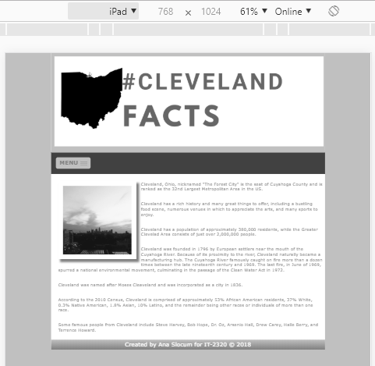

## Mobile View

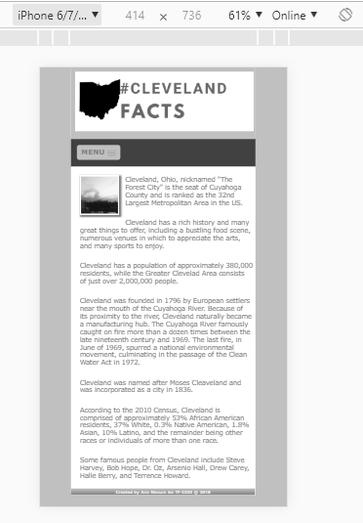

## GitHub

Commit ID: 7c46e780bfbb461c16c1cbefc51283c9ca83e145

Link: https://github.com/s00615504/IT2320-AnaSlocum-Fall2018/tree/master/Lab12