# Canvas Project

**1. Random Path**

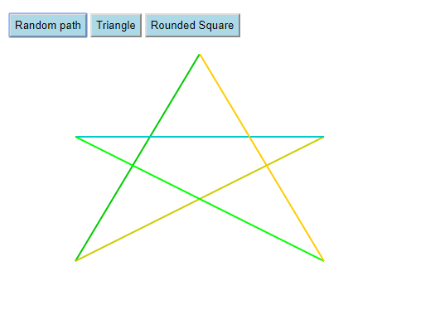Path consisting of 5 lines, each a different color.

**2. Triangles**

Right & Scalene Triangles.

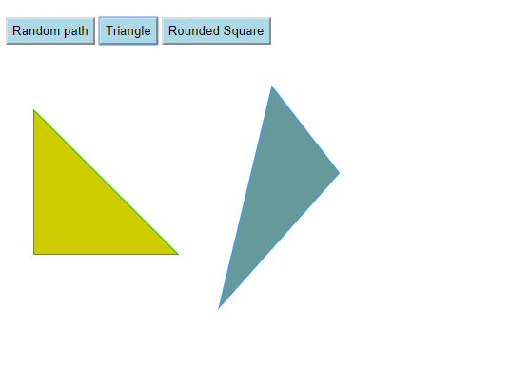

**3. Rounded Square**

Square with rounded edges.

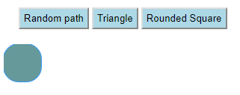

**4. GitHub**

Commit ID: 633ee908b45f0fbb7df4339b8deee832f9127f09 ([Link](https://github.com/s00615504/IT2320-AnaSlocum-Fall2018/commit/633ee908b45f0fbb7df4339b8deee832f9127f09))