## displayFruits/IsTropical

* Added break; for each fruit
* Reordered fruits in order of var fruits array
* Compared declared fruits to fruits in IsTropical; Added watermelon, removed undeclared fruits
* Matched fruit to tropical status and updated where necessary
* Updated for to include i<11 since there were 11 declared fruits

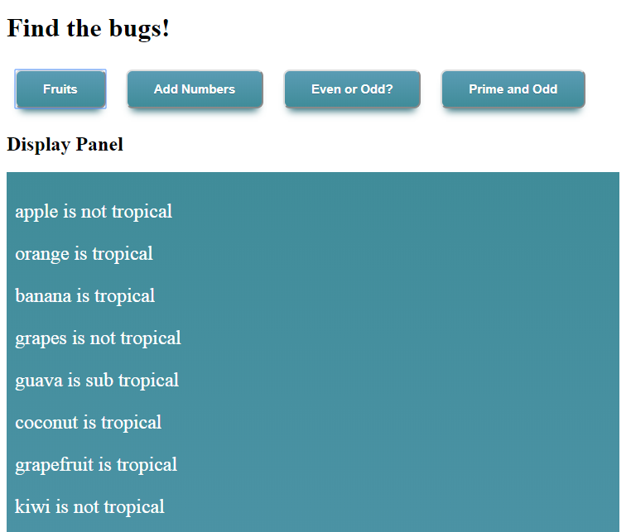

## AddNumbers

* Move var sum out of for loop
* Modify for loop syntax (add var i=; remove = from <; add appropriate spacing)
* Remove semi-colons that didn’t belong
* Add spacing where appropriate

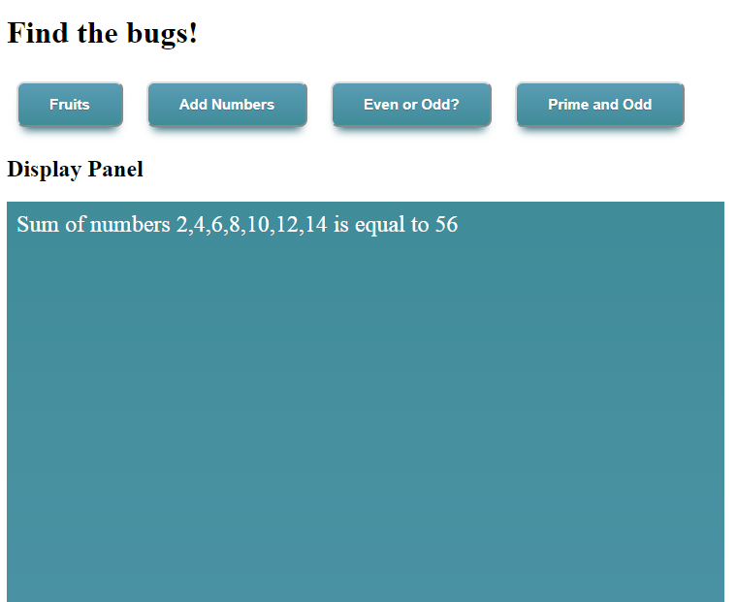

## Even or Odd

* I wasn’t certain what to do with the console write, so I made it accept a Boolean so it would show in the window panel
* Modified flag = 0 to flag == 0

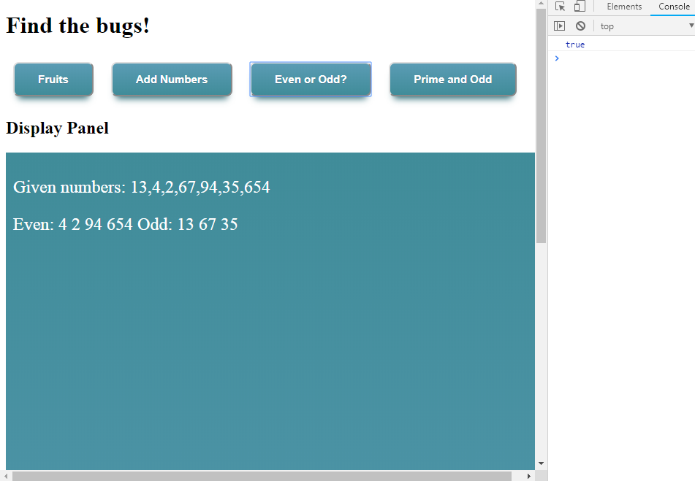

## Prime/Odd Numbers

* Fix counter for odd numbers; Changed to Even Numbers per Blackboard
* Define factorFound = 0
* I could not figure out the prime number coding

