# Memory Game

**1. GUI**

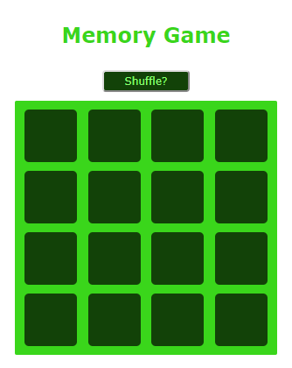

**2. Shuffle**

Screenshots show first click on first cell then first click on first cell after using Shuffle button.

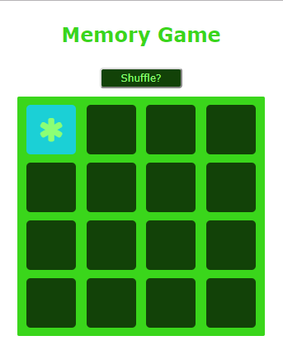

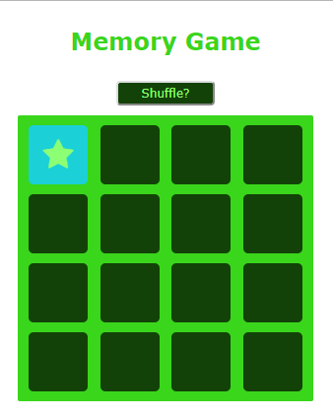

**3. Winner Functionality**

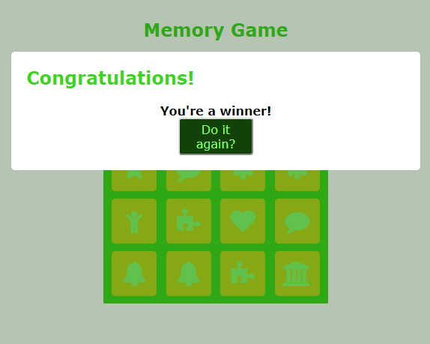

**4. New Game Functionality**

A New Game can be started by clicking the Do It Again box in the winner modal or by clicking the Shuffle button.

**5. GitHub**

Commit ID: 1f8e9f9270bf9944132fbd816a1e58e26cd16b95 ([Link](https://github.com/s00615504/IT2320-AnaSlocum-Fall2018/commit/1f8e9f9270bf9944132fbd816a1e58e26cd16b95))

I know that this is a full week late – I apologize. I scheduled some time with you during your office hours this week to talk with you. I’ve had a number of personal struggles lately, especially the last two weeks, and I’m hoping that I can get at least partial credit for this and a chance to make up some of the work I did not perform as well on recently. I’m normally a very good student and complete work on time and thoroughly. I’m struggling with some of the material, and my problems have been compounded by some personal problems as of late.

**6. Loser Functionality**

Loser Functionality is an alert that pops up when a match is not made.

