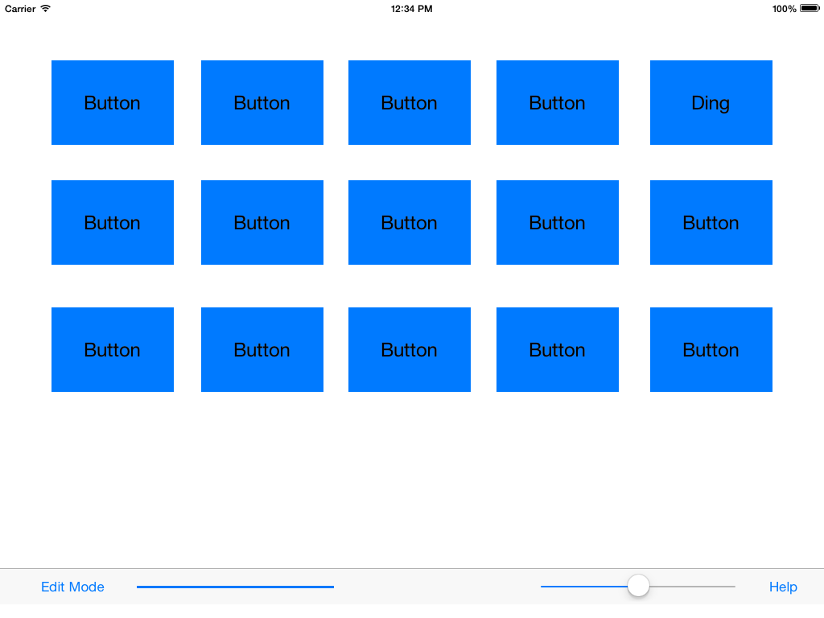

IN PLAY MODE:  
  
Click the buttons to play their sound effect.

Progress Bar and Volume Slider located at bottom of screen.

IN EDIT MODE:

Click button to bring up it’s properties to edit.

Properties Include:

* Audio File
* Button Name
* Button Color
* Loop/Stop
* Audio Trimmer

TO CHANGE MODES click the mode button bottom left.

The current mode is stated there.

SFXPlayer by Levi Orsinger for Rock Valley College CIS 280 Fall 2014