Table of Contents

*Introduction* 2

Bios 2

Alexander V. 2

Bin 2

Fatemeh 2

Lee 3

Susan 3

*Rationale and project goals (n/a)* 3

*Personas (n/a)* 3

*Database schema (n/a)* 3

Content plan 3

NotreDame Heart Navigation 3

Associate Dean (Heather) 4

Erica (staff introduced by Sean) 5

Alphosus Eze (Classmate) CardSort 6

Eric Westcott(Classmate) Card Sort 7

*User roles (n/a)* 8

*Code (n/a)* 8

*Master page(n/a)* 8

*CSS (n/a)* 8

*Features (n/a)* 9

Make an appointment 9

Narratives 9

Database 9

Flow Chart 10

Wireframes 12

Navigation Management 14

Narratives 14

Database 14

Flow Chart 15

Wireframes 16

Add a new page 17

Narratives 17

Database 17

Flow Chart 18

Wireframes 19

*Development schedule (n/a)* 19

*Maintenance plan(n/a)* 20

*Handover plan(n/a)* 20

*SIGN OFF (n/a)* 20

# Introduction

# Bios

### Alexander V.

### Bin

### Fatemeh

Fatemeh Abdizadeh is a web developing student at Humber College who used to work as a problem solving IT supporter in Iran Railways and also junior web developer there. She has a B.A. in Software Engineering and also massive knowledge in backend developing especially with .NET.

### Lee

Lee is a full-stack web developer from Humber College. Having just completed a tenure as an English teacher in Korea and returned from a lengthy journey in Far East, he has a lot of knowledge in understanding other peoples’ wants and needs. Lee has a knack for database solutions when it comes to developing websites. He is based in Toronto and spends his free time with his disobedient shiba inu.

### Susan

Names – no pics

# Rationale and project goals

The goal of this project is to establish a web presence for NDH on all browsers and devices. Previous versions of the website were non-functioning on most web browsers. The new website is to also adhere to AODA standards. This means the web site is to be accessible to persons with disabilities. New developments previously unavailable are to implement mobile layouts of the website so NDH can be viewed comfortable on smaller screens. The redesign of NDH should also be able to attract new staff and donations to the organization in a hassle-free manner.

# *Third party libraries and code*

The following lists the third party libraries utilized in this project. They are available from Visual Studio’s nuget package manager.

## 1. jQuery version 1.10.2

File location: Scripts

Javascript framework that allows concise javascript code and provides a base for other libraries used on this website.

## 2. Bootstrap.js

File location: Scripts

Html framework that uses javascript to quickly scaffold responsive HTML designs.

## 3.jQuery.unobtrusive-ajax.min.js

File location: scripts

jQuery library that allows asynchronous client-side validation of the application without reloading the page. Validation messages appear next to input fields when user has made an error.

## 4. SignalRChat

File locations: References, Scripts

Creates a host that enables two or more users to engage in asynchronous chat. Obtained from NuGet package manager.

## 5. PayPal

File location:

Application that handles user monetary transactions securely. Redirects the user to a payment window.

# Personas (n/a)

**Name**: Jacques Berndadette

**Age**: 60

**Occupation**: Farmer

**Background**: Grew up in French rural Ontario all his life, his children are adults with their own families. He wakes up at 5:30 everyday and tends to his fields with his wife. If he ever uses a computer, it's in the evening to keep in touch with his family and business enquiries.

**Location:** Hearst, Ontario

**Devices**: Desktop computer

**Internet speed:** 1mb/s

**Internet usage:** Occasional email use

**Goals:** Have a bountiful harvest by autumn

**Primary language:** French

**Name**: Antoinette Smith

**Age**: 32

**Occupation**: Graphic designer

**Background**: Currently part time of her job because she is 6 months pregnant with her husband’s child. She goes to work 3 days a week and is very familiar with photoshop. To past the time she watches Netflix on the TV.

**Location:** Thunder Bay, Ontario

**Devices**: iphone, Macintoshcomputer

**Internet speed:** 1mb/s

**Internet usage:** WhatsApps her husband. Netflix. Email to send design files.

**Goals:** Looking forward to the birth of her first child

**Primary language:** English

**Name**: Kim chong

**Age**: 26

**Occupation**:Live streamer

**Background**: Corporate 9-5 in an insurance company turned live streamer, Kim eats meals in front of internet audiences all day. Her income is from viewers sending gifts of monetary value in the chat. Her new found profession requires her to be internet savvy and understand viewing trends. She studied English in high school but is still intimidated by it.

**Location:** Seoul, South Korea

**Devices**: Desktop computer with web camera. Samsung note 2 phone.

**Internet speed:** 50 mb/s

**Internet usage:** KakaoTalk, LINE, afreecaTV.

**Goals:** Break a million views in a single broadcast.

**Primary language:** Korean

**Name**: h@x0r

**Age**: 25

**Occupation**: Freelance hacker

**Background**: Studied computer science for his undergraduate degree but dropped out in his second year. Spends most of his day at home in front of the computer on internet relay chat rooms with other computer savvy netizens. Voted "biggest nerd" in his high school graduation yearbook. Very knowledgeable in web-related technologies. Decent hacker that hides behind multiple VPNs and has not been caught by the authorities for his actions.

**Location:** Seattle, Washington

**Devices**: Custom built desktop computer, rooted smartphone, raspberry PI, 2 rooted tablets

**Internet speed:** 5 mb/s

**Internet usage:** Frequent IRC use, email, online gaming

**Goals:** Hack CITI Bank

**Primary language:** English

**Name**: Oliver Reid

**Age**: 22

**Occupation**: Medical student

**Background**: Very studious, punctual, and highly praised by his superiors. He has a bright future ahead of him if he continues along the path he has right now. He knows medical school is very competitive and has been sending out letters and applications to hospitals all over the province. He wants to get in touch with Ontario’s hospitals to get familiar with his future colleagues but finds the state of hospital websites in Ontario to be all over the place.

**Location:** Toronto, Ontario

**Devices**: Desktop, iPad, Smart Phone

**Internet speed:** 5 mb/s

**Internet usage:** Frequent IRC use, email, online gaming

**Goals:** Find a residency to complete his studies

**Primary language:** English

# Database schema (n/a)

Overall

# Content plan

## NotreDame Heart Navigation



## 

## Associate Dean (Heather)

# 

## Erica (staff introduced by Sean)



# 

## Alphosus Eze (Classmate) CardSort



## Eric Westcott(Classmate) Card Sort



# User roles (n/a)

Fatemeh – Backend Developer

# Code (n/a)

Refer to Appendix A

# Master page(n/a)

__Layout – template wireframe

# CSS (n/a)

Refer to Appendix B

# Features (n/a)

Fatemeh Abdizadeh

## Make an appointment

### Narratives

Users will be able to fill out a form including their personal information like first name, last name, birthday date, email address, phone number etc. Then, they are supposed to choose a service using a dropdown list such as physiotherapy. After that they can choose a preferred therapist from a dropdown list. They will be able to set their preferred date and time as well. At the end they should submit the form.

System will check if any required fields are left blank or contain invalid data, if so error messages will be displayed. Otherwise all the data for this appointment will be saved in the database and a message will be display to confirm that they have booked an appointment successfully. If for some reason the data does not save in the database, an error message will be displayed and ask them to try again.

### Database

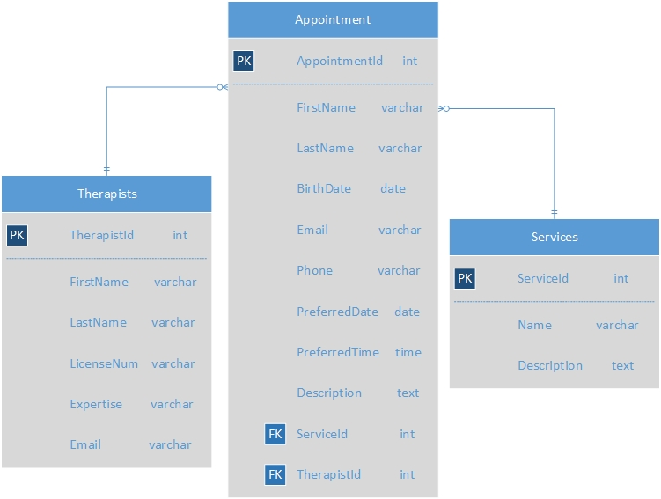

### Flow Chart

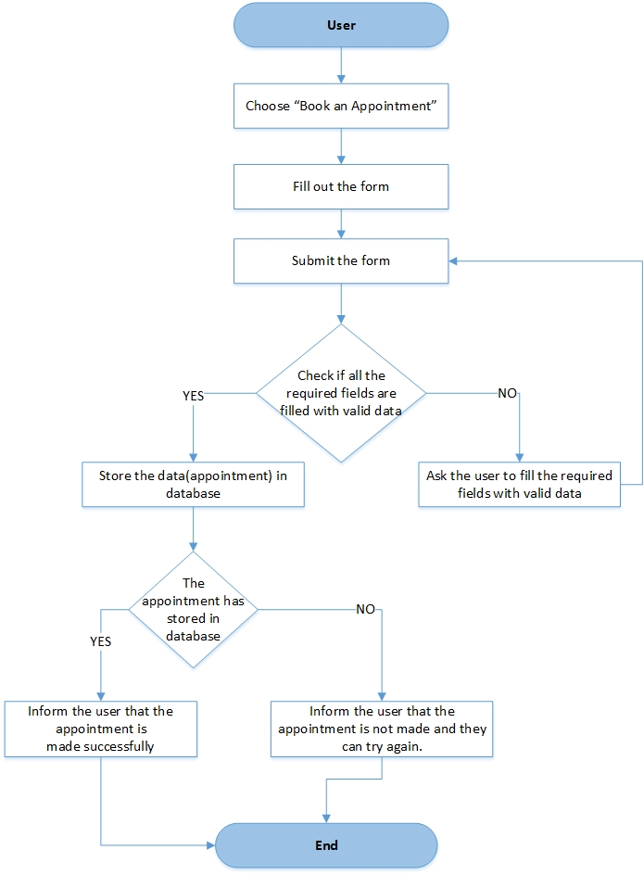

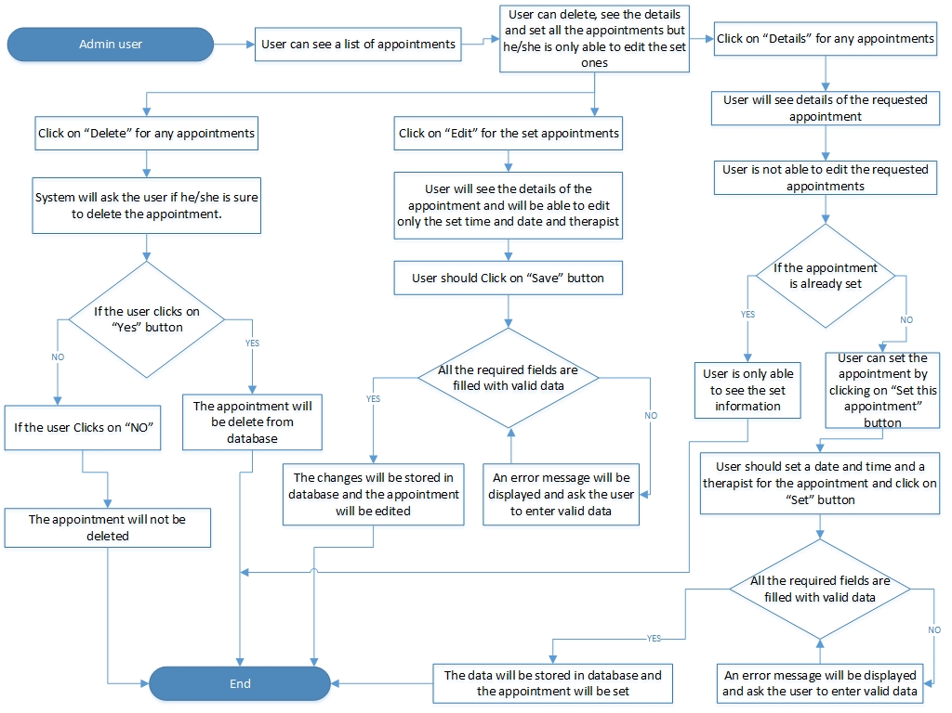

### 

### Wireframes

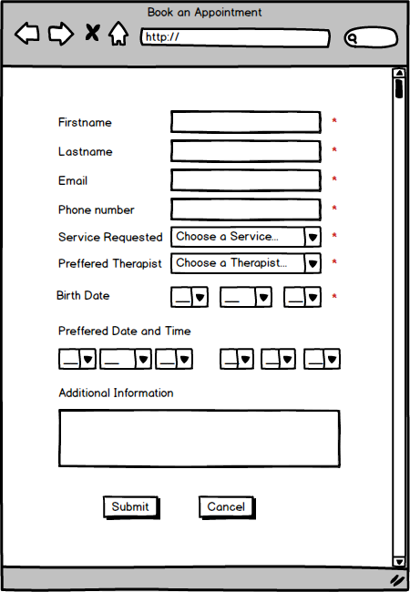

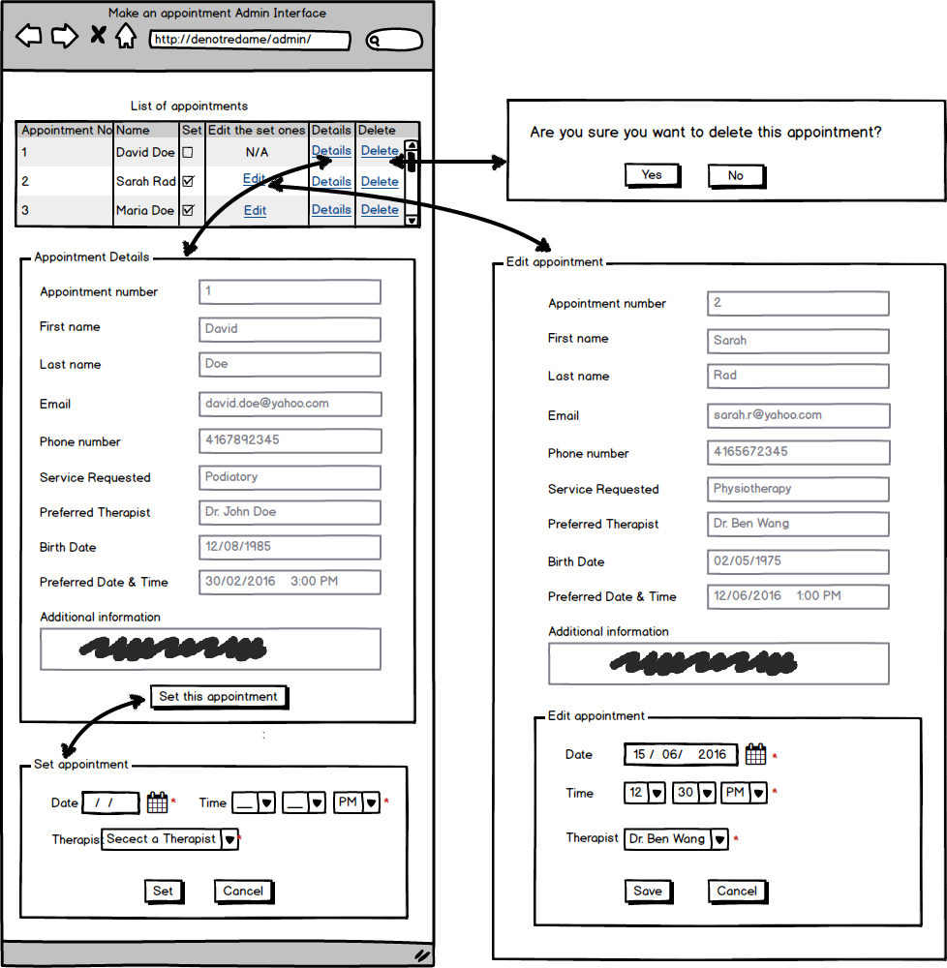

## Navigation Management

### Narratives

In order to add a new link (category) or edit and delete the current ones, we need to be able to manage the navigation which only admin users will be able to make it once they log in successfully into the content management system. They can see the list of categories and by clicking on “Edit” or “Delete” they can make changes.

If they click on the “add new category” button a new page will be displayed in which they are supposed to enter a name and choose a parent link from a dropdown list and write a description and finally click on “Add category” button. System will check if any required fields are left blank or filled with invalid data if so an error message will be displayed. Otherwise new data will be stored in database and the new link will be added to the website.

### Database

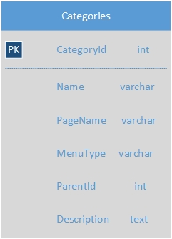

### Flow Chart

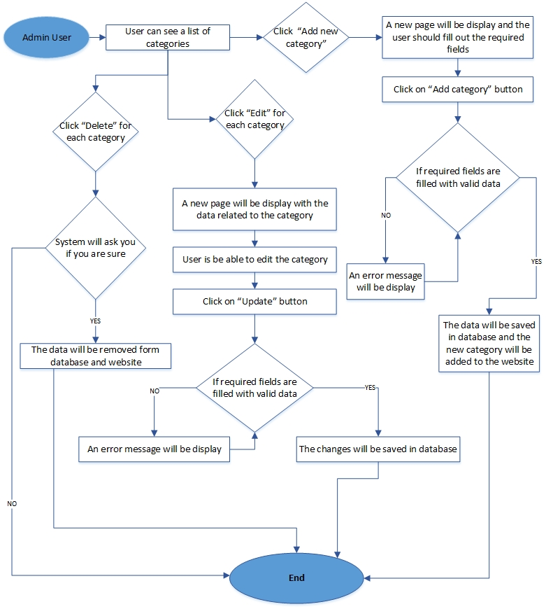

### Wireframes

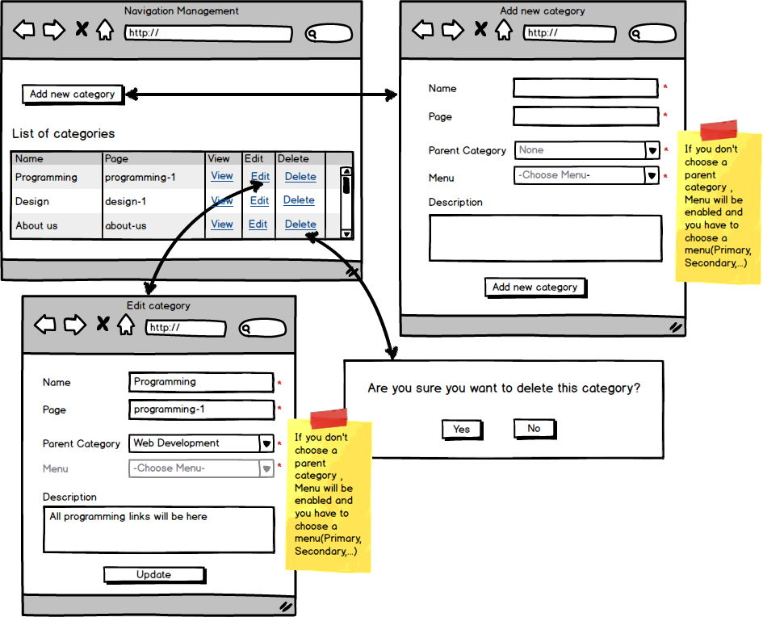

## Add a new page

### Narratives

Only admin users have access to create a new page once they log in successfully into the content management system. When admin users click on “Add new page” button, a new window will be displayed and they are supposed to enter a title for the page and there is a text editor in which they can type or paste the content and edit and style it. Next step is to either choose one of the existing categories which is displayed to them or create a new category by clicking on the “Add a new category” button which will give them a form that they are supposed to give a name to the new category and select the parent category from a dropdown list options.

At the end they are supposed to click on “Publish” button. System will check if any required fields are left blank, if so an error message will be shown. Only if no required fields are left blank or filled with invalid data, system will store the data in the database and publish the new page.

### Database

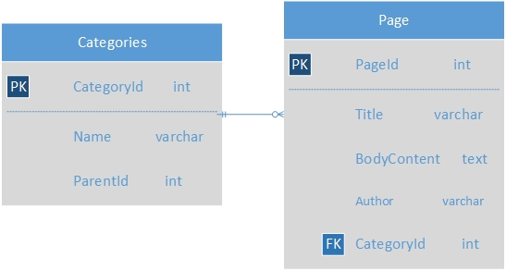

### Flow Chart

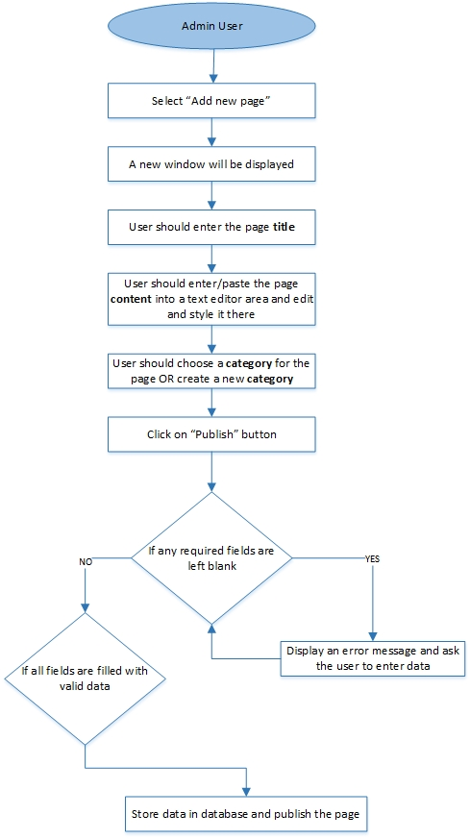

### Wireframes

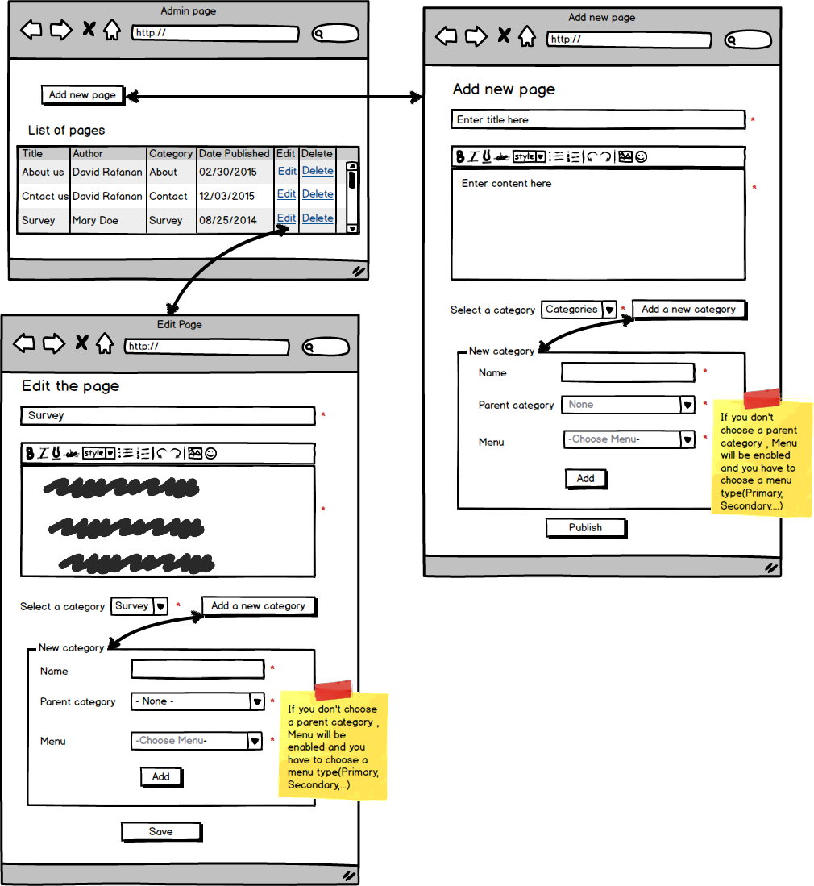

# Development schedule (n/a)

# Maintenance plan

Up to 90 days after handover the development team is to provide unbilled maintenance for the website. The development team can be contacted by whatever means within and up to the 90 days to provide maintenance.

A copy of the website will be retained by the development team when the website launches. The version of this copy (the programming codes, database(s), HTML, CSS, and third party libraries) will be the version of the launch. In case of website crash, the website can be relaunched with this version.

Administrative permission information is to be passed onto NDH upon completion of the project. These permissions refer to the usernames, emails, and passwords used to access the content management system of the website. Administrative permissions cannot be manipulated through the content management system. Forgotten administrative permissions must be retrieved from a database administrator or through the last development team familiar with the database contents of the website. Therefore, it is important to retain a copy of this information somewhere, at NDH’s discretion, other than the database.

# Handover plan(n/a)

# SIGN OFF (n/a)