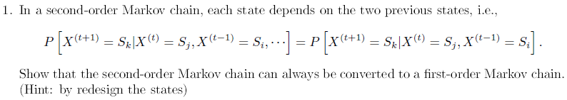

A1:If State={A,C,T,G,…} , we can redesign $Z^{t}=\{X^{t},X^{t-1}\}$

To prove the $P\left(Z^{t} | Z^{t-1}\right) is exist.$

I show the $P\left(Z^{t} | Z^{t-1}\right) by simple permutation at here.$ (just {A,C,T,G})

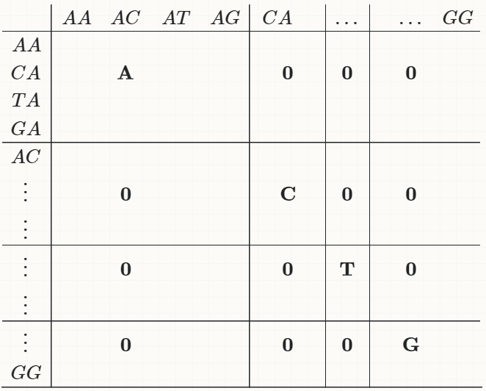

Eg: $P\left(Z^{t}=CA | Z^{t-1}=AT\right)=P(C|A)$



A2:At Bayesian Network , we can let P($X_{1},X_{2},…,X_{N}$) be factorized into $\prod_{i=1}^{N}{P\left(X_{i}|Parient(X_{i})\right)}$. And draw a factorization as a graph.

(if the node $X_{i}$ don’t have the $Parient$ s. We can use the notation $P\left(X_{i}\right)$)

I assume the graph of Bayesian Network is a Directed **cyclic** Graph , and then I got a contradiction because the factorization can’t be finished…(every node has a parent but I just have N node.)

So the graph of Bayesian Network is a Directed A**cyclic** Graph.

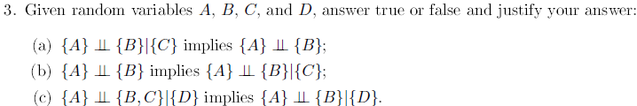

A3(a): false , because we just need to consider the situations

1.tail to tail -> P(A,B)= $\int{P(A,B,C)d_{c}}=\int{P\left(A | C\right)P(B|C)P(C)d_{c}≠P(A)P(B)}$

2.head to tail -> P(A,B)= $\int{P(A,B,C)d_{c}}=\int{P\left(B | C\right)P(C|A)P(A)d_{c}≠P(A)P(B)}$

A3(b): false , because we just need to consider the situation

1. head to head -> P(A,B|C)= $\frac{P(A,B,C) }{P(C)}=\frac{\frac{P(A,B,C)}{P(A,B)}*P(A,B)}{P(C)}=\frac{P\left(C | A,B\right)*P\left(A\right)*P(B)}{P(C)}≠P(A|C)P(B|C)$

A3(c): yes , because we just need to consider the situations

1. tail to tail -> P(A,B|D)=

2. head to tail ->P(A,B|D)= $\frac{P(A,B,D) }{P(D)}=\frac{P(A|B,D)P(B,D) }{P(D)}=\frac{P(A|D)P(B,D) }{P(D)}=\frac{P\left(D | A\right)P\left(A\right)P(B|D) }{P(D)}=P(B|D)P(A|D)$

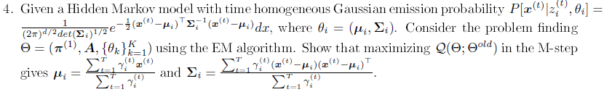

A4: let $γ_{i}=\left\{\begin{aligned}1 x^{t} is state i \\ 0 Others\end{aligned}\right.$, and $N_{i}=\sum_{t=1}^{T}{{γ_{i}}^{t}}$

To Max $\log{P(X|Z_{i},Θ_{i})}$ = $\log\left(\prod_{t=1}^{T}{{\left((\frac{1}{{\left(2π\right)}^{\frac{d}{2}}*{\det\left(Σ_{i}\right)}^{\frac{1}{2}}})e^{-\frac{1}{2}{(x^{t}-u_{i})}^{T}{Σ_{i}}^{-1}(x^{t}-u_{i})}\right)}^{{γ_{i}}^{t}}}\right)$

= $-\frac{N_{i}d}{2}\log\left(2π\right)-\frac{N_{i}}{2}\log\left(det\left(Σ_{i}\right)\right)-\frac{1}{2}\sum_{t=1}^{T}{{γ_{i}}^{t}}{\left(x^{t}-u_{i}\right)}^{T}{Σ_{i}}^{-1}\left(x^{t}-u_{i}\right)$

$\frac{d\log{P(X|Z_{k},Θ_{k})}}{du}$ = - $\sum_{t=1}^{T}{{γ_{i}}^{t}}{\left(x^{t}-\right)}^{T}{Σ_{i}}^{-1}=0$ $→ u_{i}=\frac{\sum_{t=1}^{T}{{γ_{i}}^{t}x^{t}}}{\sum_{t=1}^{T}{{γ_{i}}^{t}}}$

$$\frac{d\log{P\left(X | Z_{i},Θ_{i}\right)}}{d{Σ_{i}}^{-1}}=\frac{N_{i}}{2}Σ_{i}-\frac{1}{2}\sum_{t=1}^{T}{{γ_{i}}^{t}}\left(x^{t}-u_{i}\right){\left(x^{t}-u_{i}\right)}^{T}=0$$

$$→ Σ_{i}=\frac{\sum_{t=1}^{T}{{γ_{i}}^{t}}\left(x^{t}-u_{i}\right){\left(x^{t}-u_{i}\right)}^{T}}{N_{i}}=\frac{\sum_{t=1}^{T}{{γ_{i}}^{t}}\left(x^{t}-u_{i}\right){\left(x^{t}-u_{i}\right)}^{T}}{\sum_{t=1}^{T}{{γ_{i}}^{t}}}$$