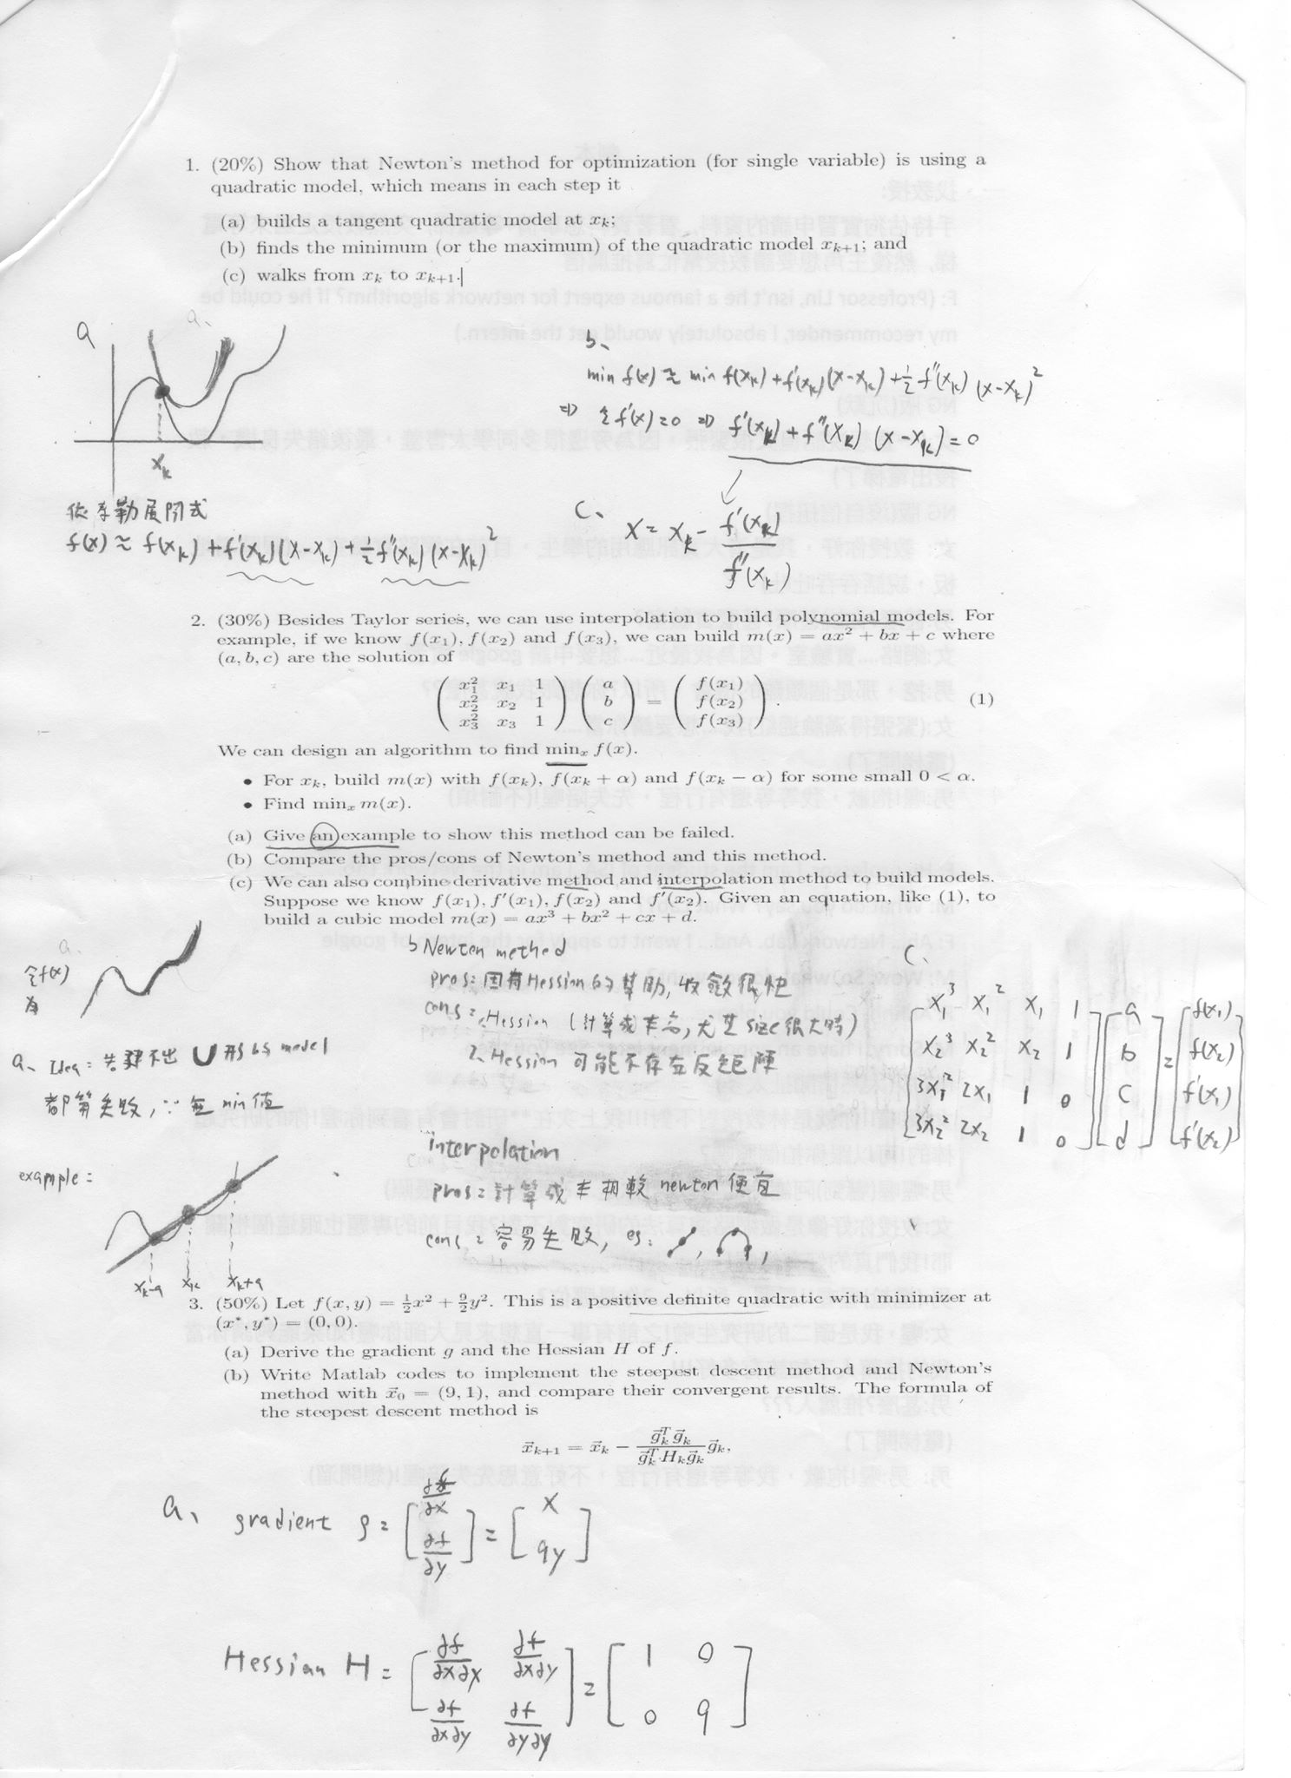

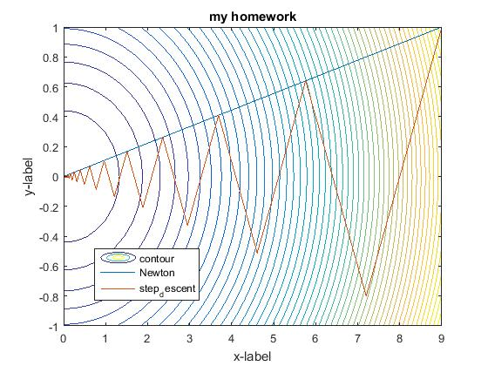

(此圖由於y軸間距 與x軸間距 不同 所以無法呈現, step descent方向為該點之-f’(x) )

由此圖可發現 step descent 在大方向來說,與newton 方向是一致的.

都能找到最佳解.

若是f(x) 呈現之形狀 為 凹型 (H全部之 $ℷ$ > 0 ) 與 newton建立motel 相符合

Or 相似

則newton能很快找到solution (如圖,一步到達)

否則 step descent 是比較快速的方法.

function draw_trace()

step = 0.1;

X = 0:step:9;

Y = -1:step:1;

n = size(X,2);

m = size(Y,2);

Z = zeros(m,n);

for j = 1:m

for i = 1:n

Z(j,i) = f(X(i),Y(j));

end

end

contour(X,Y,Z,50);

hold on; % this is important!! This will overlap your plots.

Xs=[9;1];

g=[1;9];

H=[1,0;0,9];

pathS=step_descent(Xs);

pathN=Newton(Xs);

plot(pathN(1,:),pathN(2,:));

plot(pathS(1,:),pathS(2,:));

%axis equal ;

title('my homework');xlabel('x-label');ylabel('y-label');

h_leg =legend('contour','Newton','step_descent');

set(h_leg,'position',[0.2 0.2 0.2 0.1]);

hold off;

% function definition

function z = f(x,y)

z = (x*x+9*y*y)/2;

end

function N = Newton(Xs)

N = Xs;

G=[1;1];

while( ~isequal(round(G,5),[0;0]) )

G=[g(1)*Xs(1);g(2)*Xs(2)];

Xs = Xs-(H\G);

N = [N Xs];

end

end

function S = step_descent(Xs)

S = Xs;

G=[1;1];

while( ~isequal(round(G,5),[0;0]) )

G=[g(1)*Xs(1);g(2)*Xs(2)];

Xs = Xs-(((G)'*H*(G))^(-1)*((G)'*(G)))*(G);

S = [S Xs];

end

end

end