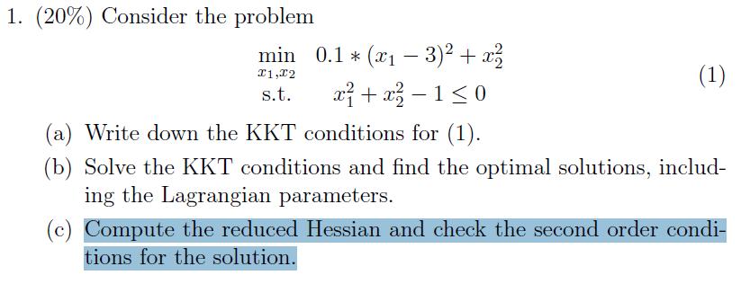

**A1.(a):**

$∇L\left(\vec{x},λ\right)=∇\left[0.1*{\left(x_{1}-3\right)}^{2}+x_{2}^{2}\right]+λ∇\left[x_{1}^{2}+x_{2}^{2}-1\right]=0$

${ x}_{1}^{2}+x_{2}^{2}-1≤0$

* $λ*[x_{1}^{2}+x_{2}^{2}-1]$**=0**

$λ≥0$

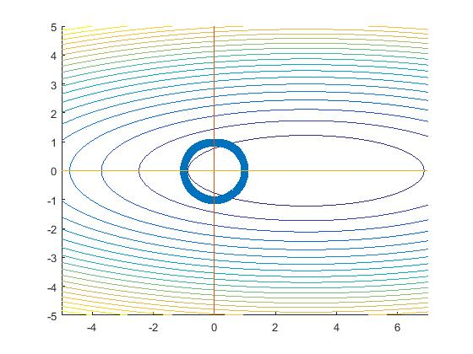

**A1.(b)** **由圖可知min at (1,0)**

$d_{x_{1}}L\left(\vec{x},λ\right)=0.2*(x_{1}-3$)+2 $*λ*x_{1}$ =0 -> $x_{1}*\left(0.2+2*λ\right)=0.6$

$d_{x_{2}}L\left(\vec{x},λ\right)=2*x_{2}+2*{λ*x}_{2}=0$-> $x_{2}=0$

$d_{λ}L\left(\vec{x},λ\right)=x_{1}^{2}+x_{2}^{2}-1=0$-> ${(\frac{0.6}{0.2+2*λ})}^{2}=1→50λ^{2}+5λ-4=0$

$\left(無整數解,以matlab求近似解到小數點第一位\right)≅\left(λ+0.3\right)\left(λ-0.2\right)=0$ 取 $λ=0.2$

$x_{1}=\left(\frac{0.6}{0.2+2*0.2}\right)=1 ,x_{2}=0$ $λ=0.2$**>=0**

**A1.(c)**

$∇L=\left[\begin{matrix}0.2*\left(x_{1}-3\right)+2*λ*x_{1} \\ 2*x_{2}+2*{λ*x}_{2}\end{matrix}\right]$ =0

$$∇∇L=\left[\begin{matrix}0.2+2*λ & 0 \\ 0 & 2+2*λ\end{matrix}\right]→∇∇L\left(λ=0.2\right)=\left[\begin{matrix}0.6 & 0 \\ 0 & 2.4\end{matrix}\right]$$

$∇C_{1}\left(x^{*}\right)=\left[\begin{matrix}2*x_{1} \\ 2{*x}_{2}\end{matrix}\right]→∇C_{1}\left(1,0\right)=\left[\begin{matrix}2 \\ 0\end{matrix}\right]$ $∵λ>0 ∴∇C_{1}\left(x,λ\right)w=0$

$∴$ W= $\left(\begin{matrix}0 \\ w_{2}\end{matrix}| w_{2}∈R and w_{2}≠0\right)≠\vec{0}$

$∴w*∇∇L*w={\left(\begin{matrix}0 \\ w_{2}\end{matrix}\right)}^{T}*\left[\begin{matrix}0.6 & 0 \\ 0 & 2.4\end{matrix}\right]*\left(\begin{matrix}0 \\ w_{2}\end{matrix}\right)=2.4*{{(w}_{2})}^{2}>0$

$$∵the sufficient conditions staified ∴x^{*}=\left(\begin{matrix}1 \\ 0\end{matrix}\right)is stric local soultion$$

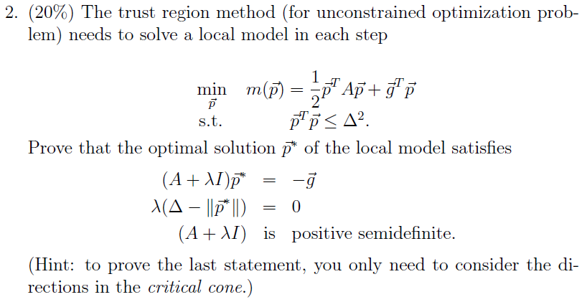

**A2:**

**假設 $p^{*}為最佳解$**(使m($p^{*}$)<=m($p$))

$$L=\frac{1}{2}p^{T}Ap+g^{T}p-{u*(△^{2}-p}^{T}p)$$

$∵KKT ∴∇_{x}L=g+A*p^{*}+2*u*p^{*}$ =0

令 $λ=2u→ ∇_{x}L=g+A*p^{*}+λ*p^{*}=0 →\left(A+λI\right)p^{*}=-g$

$∵$ complementarity condition $∴λ*\left({△^{2}-p^{*}}^{T}p^{*}\right)=0→λ*\left(△-||p^{*}||\right)=0$

if $λ=0→$ $inactive→{△^{2}-p^{*}}^{T}p^{*}≥0此限制式無存在意義.$

$→轉為無限制式求極值問題.→A+λI=A 為半正定矩陣$ (否則無解)

If $λ>0→$ active $→{△^{2}-p^{*}}^{T}p^{*}=0→△^{2}={p^{*}}^{T}p^{*}→△=||p^{*}||$

$由假設m\left(p^{*}\right)≤m\left(p\right)→g^{T}*p^{*}+\frac{1}{2}{p^{*}}^{T}*A*p^{*}≤g^{T}*p+\frac{1}{2}p^{T}*A*p$---1

$$∵\left(A+λI\right)p^{*}=-g→ -\left(A+λI\right)p^{*}=g$$

$$∴-{p^{*}}^{T}*\left(A+λI\right)*p^{*}+\frac{1}{2}{p^{*}}^{T}*A*p^{*}≤{{-p}^{*}}^{T}*\left(A+λI\right)*p+\frac{1}{2}p^{T}*A*p$$

式子兩邊同加上 $\frac{1}{2}{λ△}^{2}=\frac{1}{2}λ{{(p}^{*}}^{T}p^{*})=\frac{1}{2}λ{(p}^{T}p)$

$$-{p^{*}}^{T}*\left(A+λI\right)*p^{*}+\frac{1}{2}{p^{*}}^{T}*\left(A+λI\right)*p^{*}≤-{p^{*}}^{T}*\left(A+λI\right)*p+\frac{1}{2}p^{T}*\left(A+λI\right)*p$$

上式整理後 $→\frac{1}{2}\left({p^{*}}^{T}*\left(A+λI\right)*p\right){{ – p}^{*}}^{T}*\left(A+λI\right)*p+\frac{1}{2}p^{T}*\left(A+λI\right)*p≥0$

$→\left({p^{*}}^{T}*\left(A+λI\right)*p\right){{ – 2*p}^{*}}^{T}*\left(A+λI\right)*p+p^{T}*\left(A+λI\right)*p≥0$

$→\left({{(p}^{*}-p)}^{T}*\left(A+λI\right)*{(p}^{*}-p)\right)≥0$

$→A+λI=A 為半正定矩陣$

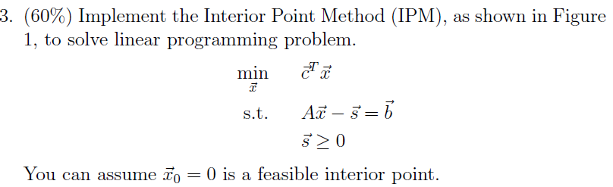

Used Example

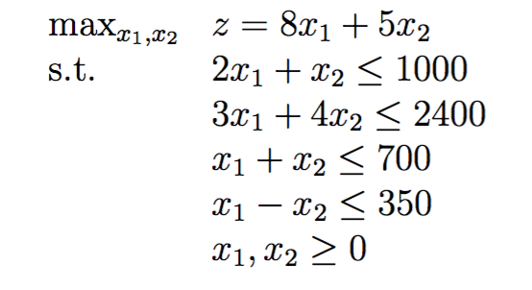

轉換問題為 $\min_{x_{1},x_{2}}{z}=-8x_{1}-5x_{2}$, $σ=0.4 (測試過,步數最少)$

$$A= \left(\begin{matrix}-2 & -1 \\ -3 & -4 \\ -1 & -1 \\ -1 & 1 \\ 1 & 0 \\ 0 & 1\end{matrix}\right) b=\left(\begin{matrix}-1000 \\ -2400 \\ -700 \\ -350 \\ 0 \\ 0\end{matrix}\right) lambda=\left(\begin{matrix}1 \\ 1 \\ 1 \\ 1 \\ 1 \\ 1\end{matrix}\right)s_{0}=\left(\begin{matrix}1000 \\ 2400 \\ 700 \\ 350 \\ 0 \\ 0\end{matrix}\right)$$

$c=\left(\begin{matrix}-8 \\ -5\end{matrix}\right),x_{0}=\left(\begin{matrix}0 \\ 0\end{matrix}\right)$ 收斂條件改 (u <=0.001 )而非u==0 不然要等好久…

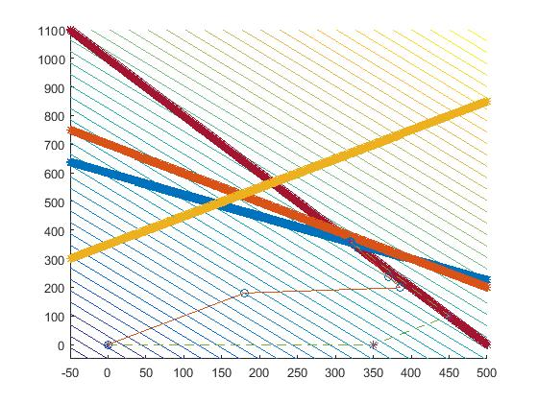

IPM(圈圈)與simplex method(*)比較

IPM撞牆壁之後,似乎就很難移動了.每次移動均很小步

function [Z X]=interior_point_method(A, b, c, x0, lambda0, s0)

X=[0;0]; %init returnX record path

%init 相關變數

x = x0;

lambda=lambda0;

s = s0;

F = [x;lambda;s];

[m,n] = size(A);

sigma = 0.4;

alpha = 100;

u = (lambda'*s)/m;

r=0.001;

while(u >0.001 ) % 收斂條件 u==0

alpha = 100;

H=[zeros(n,n),-A',zeros(n,m); A,zeros(m,m),eye(m);zeros(m,n),diag(s),diag(lambda)];

u = (lambda'*s)/m;

g = [A'*lambda-c;A*x-s-b;sigma*u*ones(m,1)-diag(lambda)*diag(s)*ones(m,1)];

d=H\g;

%compute appropriate alpha

try_point= F+alpha*d; %先走alpah步看看

while(min(try_point(n+1:n+m).*try_point(n+m+1:n+2*m))<r*u)

%檢查是否越界

alpha=alpha/2; %改走小步一點

try_point= F+alpha*d; %在走走看

end

%update

F = F+alpha*d; %正式走 updata

x = F(1:n);

lambda = F(n+1:n+m);

s = F(n+m+1:n+2*m);

X=[X x]; %record path

end

x

Z=c'*x;

end