**1.**

**Is your browser running HTTP version 1.0 or 1.1?**

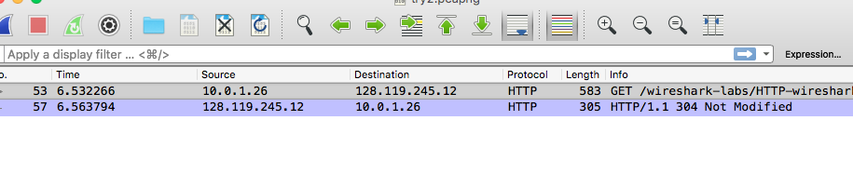

2.

**When was the HTML file that you are retrieving last modified at the server?**

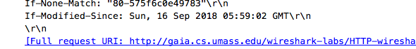

3.

**What is the IP address of your computer? Of the gaia.cs.umass.edu server?**

My IP ends in .26

Server ends in .12

4.

What languages (if any) does your browser ind

icate that it can accept to the

server?

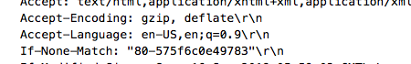



5.

When was the HTML file that you are retrieving last modified at the server?

ANSWERED IN QUESTION #2