Tracert Result

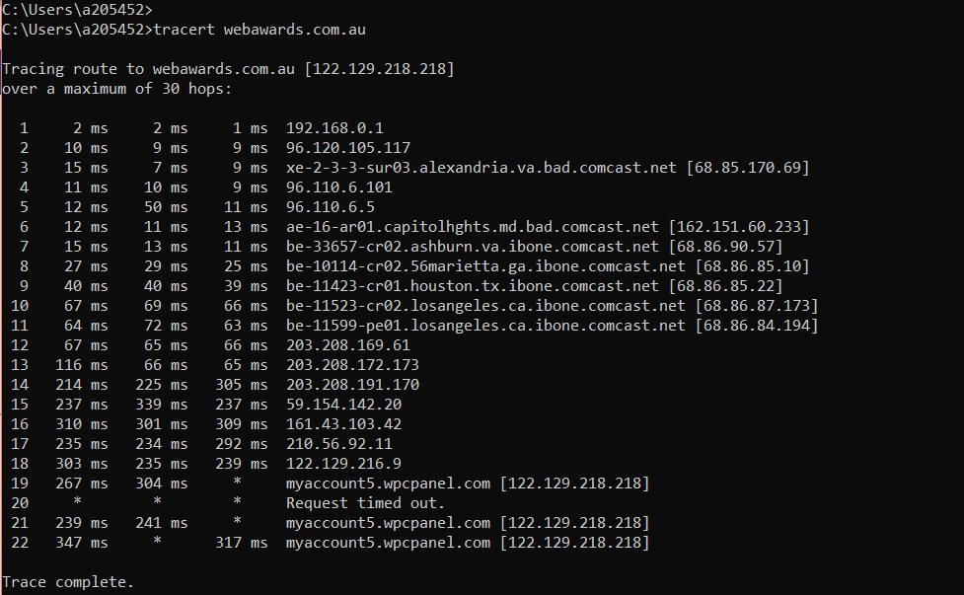

1.What is your computers IP address? (This is not included in your traceroute results). Take a screenshot of your computers IP address.

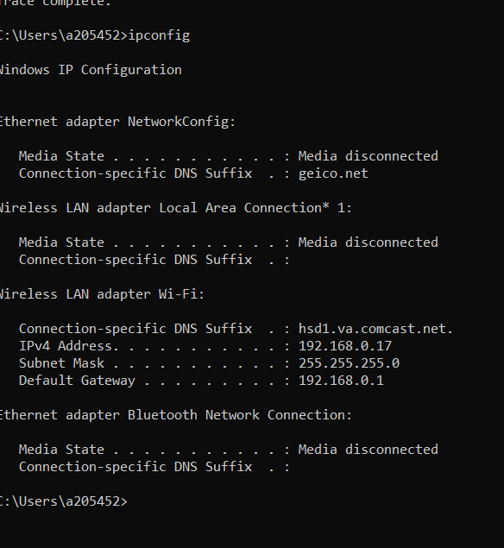

2. With reference to private/public IP addresses. What type of IP address is the first IP from your traceroute result.

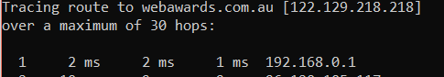

It is a private IP address. I am not sure why it hopped to LA first- as the second hop is laurel NJ (96.120.105.117) and the first actual location to show is Alexandria VA. 

3. With reference to private/public IP addresses. What type of IP address is the second IP from your traceroute result.

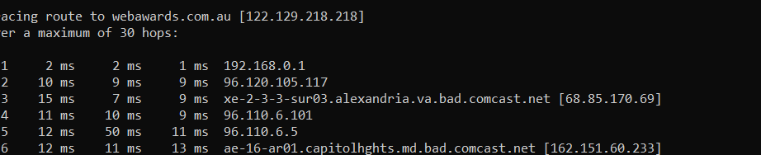

It is a public IP address

4. In a tabular format (use table example below), and in sequential order. Indicate the location of each IP address (include state for US states) and the organization that owns the IP address. (Use https://www.ultratools.com/tools/ipWhoisLookup to look up IP address whois information).

|  |  |  |  |
| --- | --- | --- | --- |
| Hop Count | IP Address | Organization | Location |
| 1 | 192.168.0.1 | Internet Assigned Numbers Authority | Los Angeles, United States |
| 2 | 96.120.105.117 | Comcast Cable Communications | MT Laurel NJ, United States |
| 3 | 68.85.170.69 | Comcast Cable Communications | MT Laurel NJ, United States |

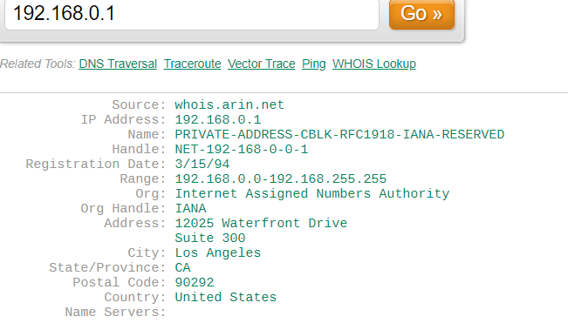

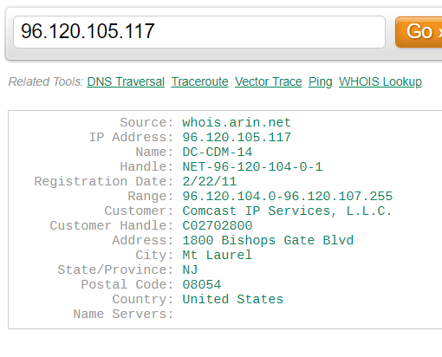 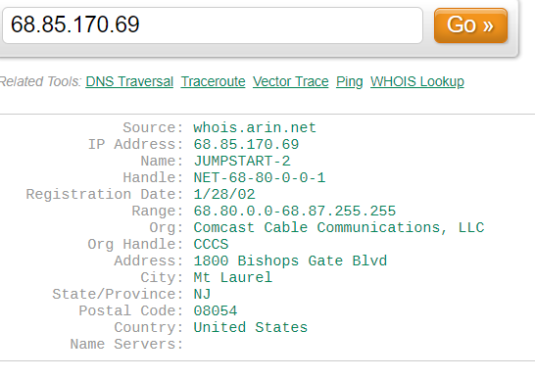

5. In your own words, explain everything you just did, and what route did your packet took from source to destination. How many US states did your packet go through? How many countries if any?

I traced the website to its destination and had 22 hops. I didn’t get a response from some of the routers because of the ICMP protocol that was disabled. It went through the east cost then made its way towards the west coast then first hit Singapore as the first international country) then Austria (59.154.142.20).