IP ADDRESS:

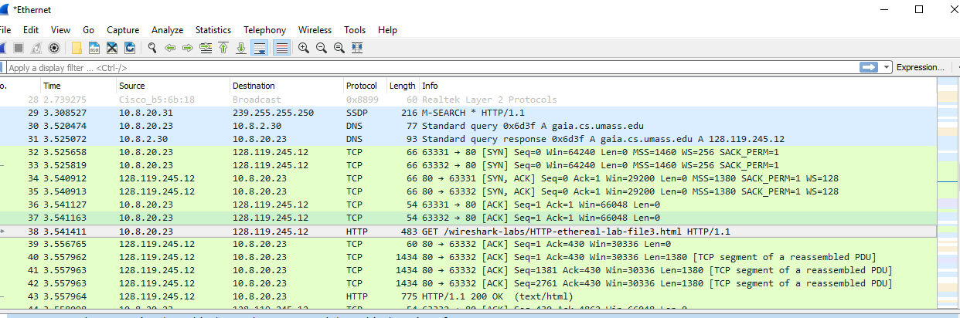

1.What is the MAC address

from your computer

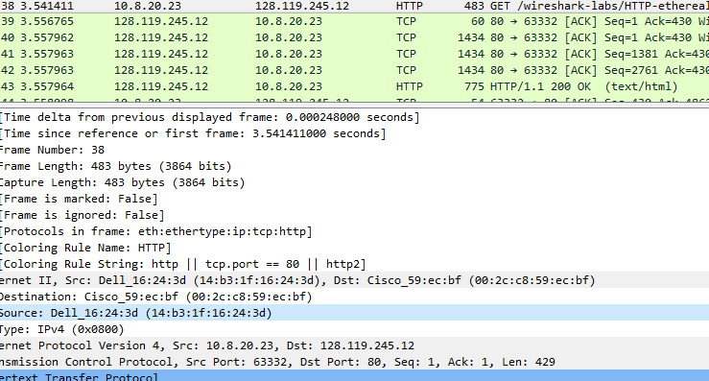

2.

What is the destination MAC address?

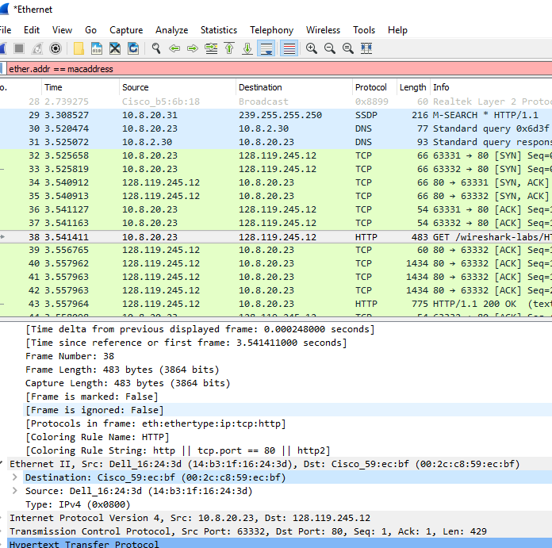

3.

What device has the MAC address shown in the destination?



4.

Explain the relationship between the destination MAC address and the destination IP

address.

The IP address is a number that is assigned to the connection on the network; but the MAC address is an identifiable address that is unique to the device on the network. Both the IP & MAC addresses are different from each other. The ARP protocol uses the MAC addresses to map IPs on the network through broadcasting. You can see the broadcasting through the filter “ARP”

5.Using the terminal (cmd in Windows, Terminal in mac), run a command to display your

full ARP list table. (Find out wh

at the command is, and print a full screen shot of your

result.)

