IP Address

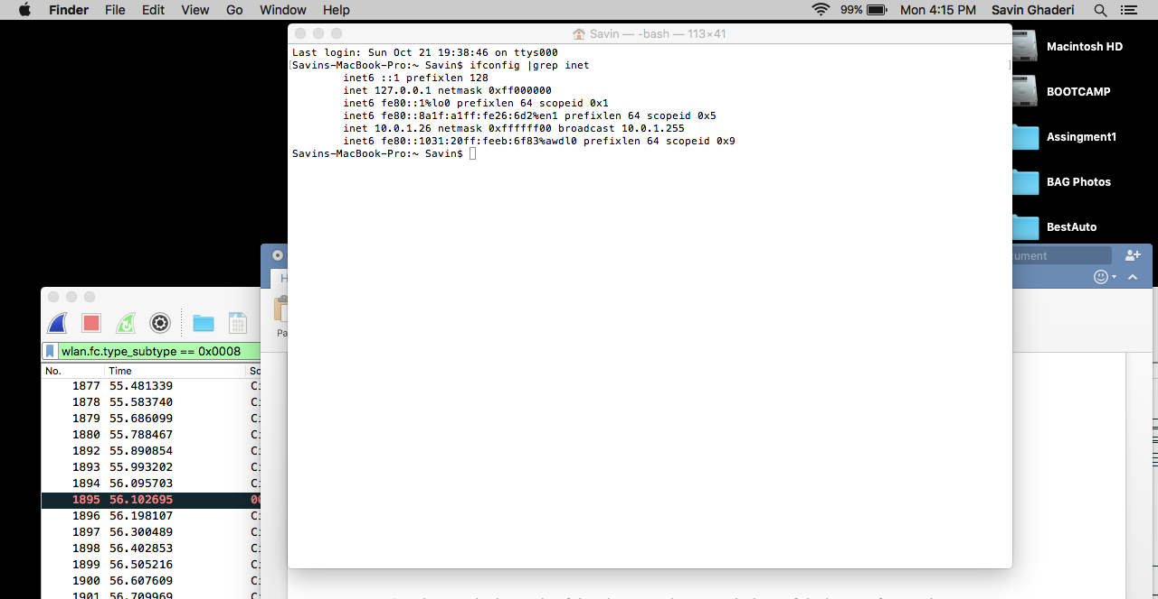

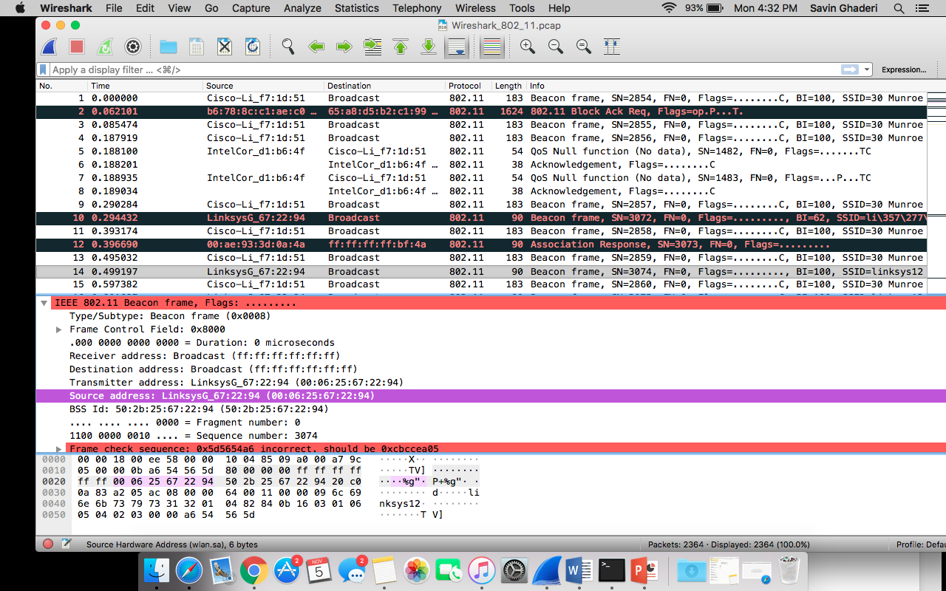1.What are the SSIDs of the two access points that are issuing most of the beacon frames in this trace?

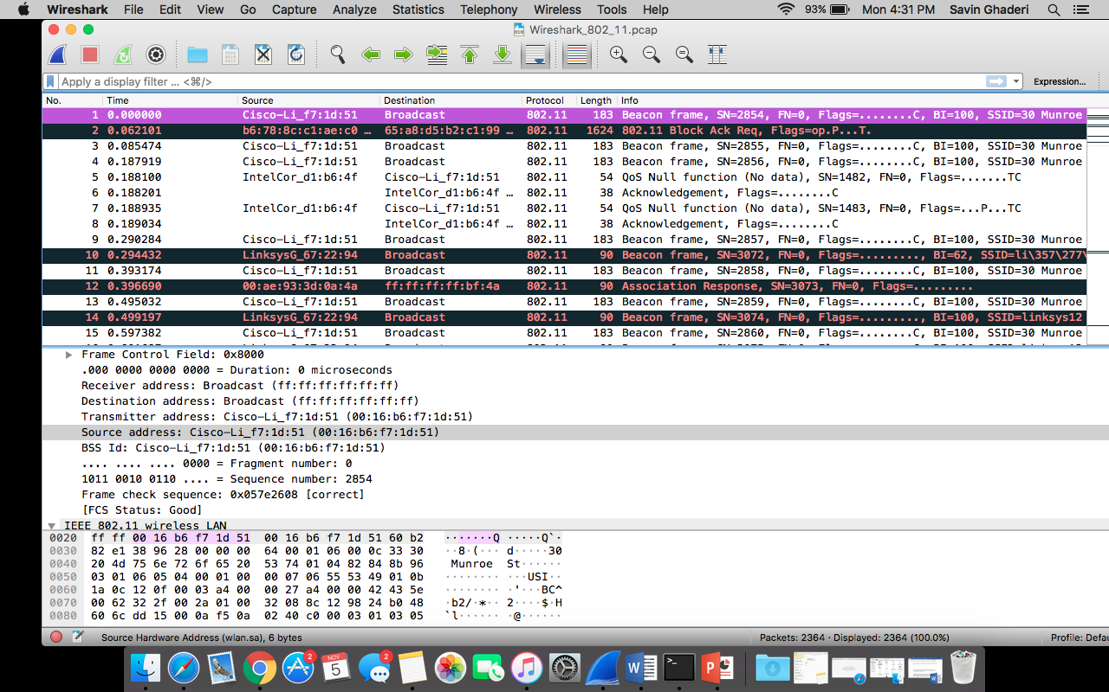

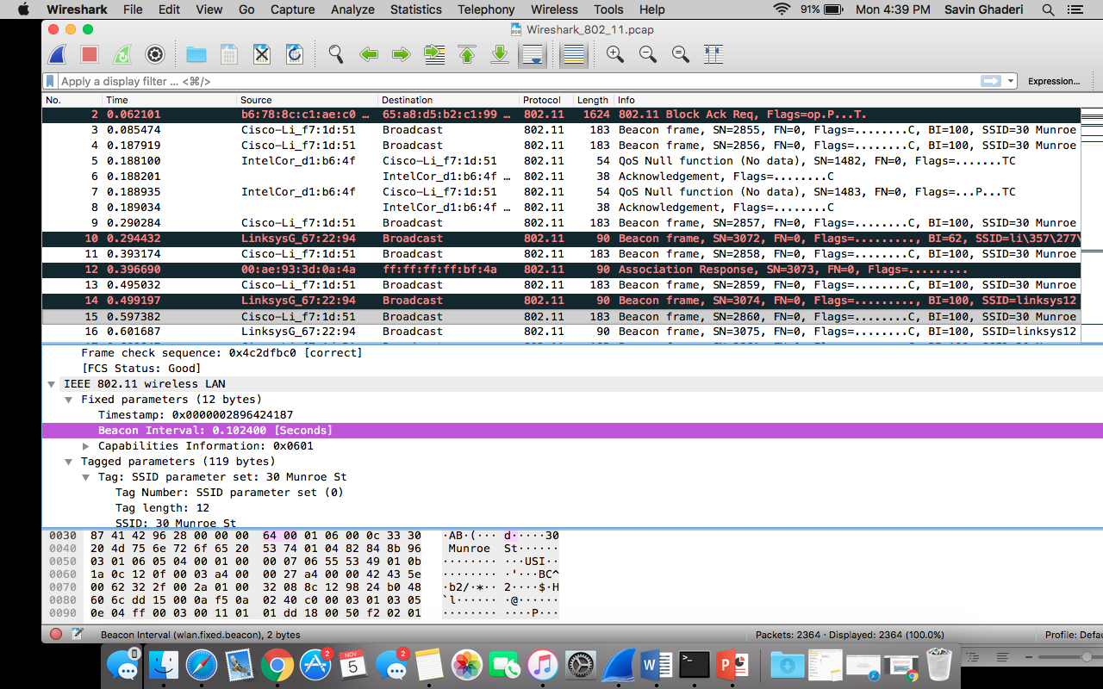 2. What are the intervals of time between the transmissions of the beacon frames the linksys_ses_24086 access point? From the 30 Munroe St. access point? (Hint: this interval of time is contained in the beacon frame itself

3. What (in hexadecimal notation) is the source MAC address on the beacon frame from 30 Munroe St? Recall from Figure 7.13 in the text that the source, destination, and BSS are three addresses used in an 802.11 frame. For a detailed discussion of the 802.11 frame structure, see section 7 in the IEEE 802.11 standards document (cited above).

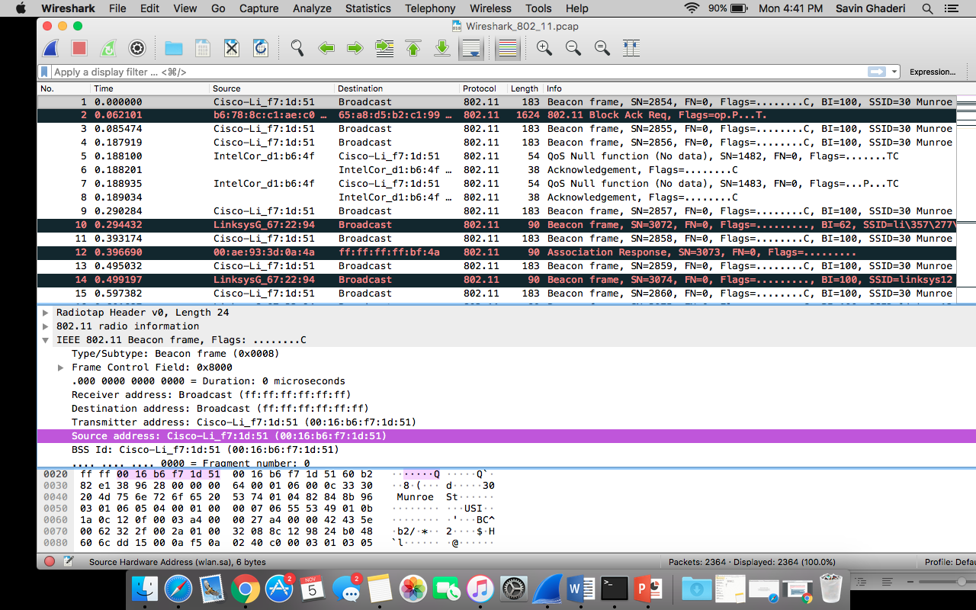

4. What (in hexadecimal notation) is the destination MAC address on the beacon frame from 30 Munroe St??

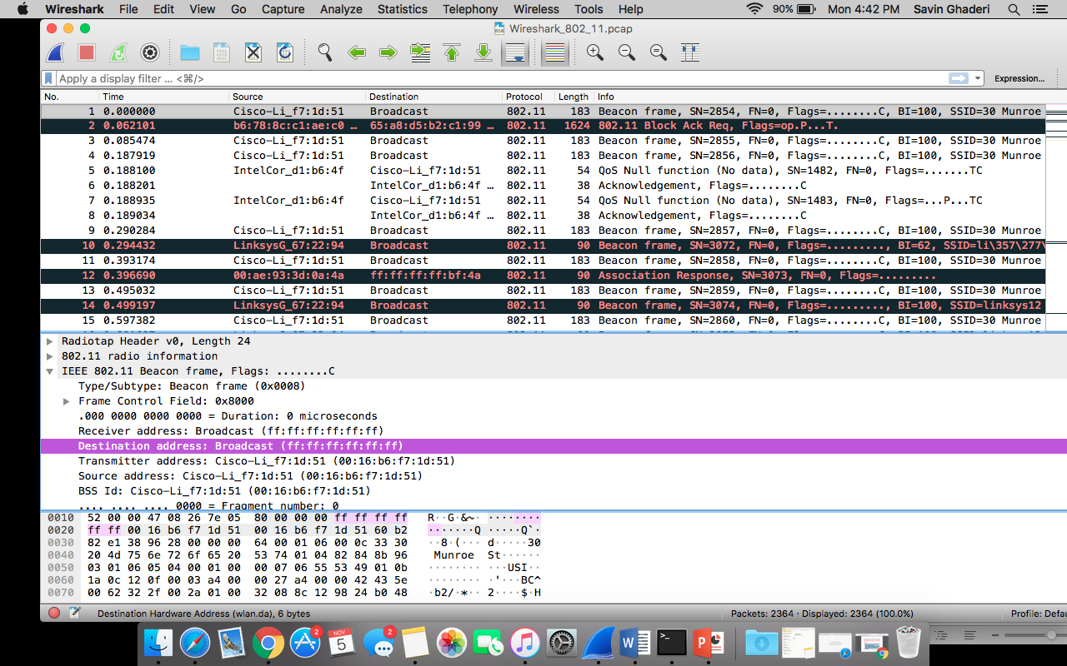

5. What (in hexadecimal notation) is the MAC BSS id on the beacon frame from 30 Munroe St?

