

**BHARATI VIDYAPEETH**

**(Deemed to be University)**

**INSTIUTE OF MANAGEMENT AND ENTREPRENEURSHIP DEVELOPMENT**

**Navi Mumbai**

A Project On

**Macro Access Variable Search Engine (MAVS)**

Submitted to

**“Bachelor of Computer Application (B.C.A Sem-IV)”**

Submitted By

Sohail Ansari, Zahir Amiri Mehul Jain, Vasanta Kumari

**BATCH: 2016-2019**

Under the guidance of

**Prof. Mayuri Dendge**

**BHARATI VIDYAPEETH**

**(Deemed to be University)**

**INSTIUTE OF MANAGEMENT AND ENTREPRENEURSHIP DEVELOPMENT** **Navi Mumbai**

**CERTIFICATE**

This is to certify that the project titled **Macro Access Variable Search Engine (MAVS)** is successfully doneby **Mr./Ms. Sohail Ansari, Mehul Jain, Zahir Amiri, Vasanta Kumari** during BCA SEM IV of his/her course in partial fulfilment of **Bachelor of Computer Application** under the **Bharati Vidyapeeth (Deemed to be University),** Navi Mumbai carried out by him/her under our guidance and supervision.

**External Examiner Internal Examiner**

(Signature & Date) (Signature & Date)



**BHARATI VIDYAPEETH**

**(Deemed to be University)**

**INSTIUTE OF MANAGEMENT AND ENTREPRENEURSHIP DEVELOPMENT**

**Navi Mumbai**

**CERTIFICATE**

This is to certify that the project titled **Macro Access Variable Search Engine (MAVS)** is successfully doneby **Mr/Ms. Sohail Ansari, Mehul Jain, Zahir Amiri, Vasanta Kumari** during BCA SEM IV of his/her course in partial fulfilment of Bachelor **of Computer Application** under the **Bharati Vidyapeeth (Deemed to be University),** Navi Mumbai carried out by him/her under our guidance and supervision during academic year 2017-18.

**Dr. Suhasini Vijaykumar**

In charge Director

**Declaration**

I hereby solemnly declare that the project entitled “**Macro Access Variable Search Engine (MAVS)**” is an original work done by me under the guidance and supervision of Prof. Mayuri Dendge submitted to the Bharati Vidyapeeth (Deemed to be University)in partial fulfilment of the requirement for the award of Bachelor of Computer Application (SEM IV) during academic year 2017-2018.

I further declare that, to the best of my knowledge, this report or any part of the report is not submitted in this University or in any other University.

**Mr/Ms. Sohail Ansari, Mehul Jain, Zahir Amiri, Vasanta Kumari**

(Signature & Date)

**Acknowledgment**

I avail this opportunity to express my sincere and deep gratitude to many who are a factor in helping me gain the knowledge and experience during the project and throughout the course.

I have great pleasure in presenting this project. The completion of this project is not merely due to only my own efforts but also due to the guidance given by our professors.

I am thankful to our project guide Prof. Mayuri Dendge for her support. I also thank Dr. Suhasini Vijaykumar, in charge Director and respected faculty members for their kind support and help throughout the entire course.

Finally, I express my deep regards to all of those who stretch their helping hands in the execution of my project.

**Table of contents**

|  |  |  |
| --- | --- | --- |
| **Sr. No.** | **Topics** | **Page No.** |
|  | | |
| **1** | **Introduction** | **7** |
| 1.1 | Problem Description | 7 |
| 1.2 | Domain Knowledge | 7 |
| 1.3 | Project Aim and Objective | 8 |
| 1.4 | Scope of the Project | 8 |
| 1.5 | Operation Environment | 9 |
| **2** | **System Study** | **9** |
| 2.1 | Software Requirement Specification | 9 |
| 2.2 | Existing system | 9 |
| 2.3 | Proposed System | 9 |
| 2.4 | Software Tool Used | 10 |
| **3** | **System Analysis and Design** | **11** |
| 3.1 | Software Requirement | 11 |
| 3.2 | Hardware Requirement | 11 |
| 3.3 | Algorithm/Flowchart | 12 |
| 3.4 | Data Flow Diagram | 13 |
| 3.5 | Estimation and Planning | 14 |
| **4** | **System Implementation** | **14** |
| 4.1 | Module Description | 14 |
| 4.2 | Source Code | 15 |
| 4.3 | Screen Shot | 110 |
| **5** | Conclusion | 121 |
| 5.1 | Limitation | 121 |
| 5.2 | Enhancement | 121 |
| **6** | **References** | 121 |
| 6.1 | Bibliography | 121 |
| 6.2 | Webliography | 121 |

**1. Introduction.**

**1.1 Problem description:**

The project that is being developed is not present in the market as if so, but there are similar projects but those can only work on Linux and other operating systems; The project designed are on different platforms and language because of the efficiency provided by the other languages such as robust, OOP, Platform independency, security etc. So, the goal is to design the project without the use of those characteristics.

The problem with the projects developed on other language is speed. As we know, C language is considered as the fastest output processing language because of the fact that it works on machine level. As every other project developed on other language needs to travel through levels until it reaches the machine level; so, because of the C language the speed is not compromised and we get the output quickly as compared to others.

And the project will not be only consisting of a search engine, but it will have some extra features such as assistant, account login for users, administrators and new users providing safety and notification for the designed system.

**1.2 Domain Knowledge:**

Abstract - The generic search engines existing today are using ‘search as you type’ technique while searching the information in order to retrieve information faster as compared to keyword search. But generic search engine fails to distinguish different users. Each user is unique and has got his/her unique interests. The generic search engine shows same results to different users without being bothered of their needs/interests. Most of the personalized search engines retrieve the relevant information but use only the keyword search technique. The project proposes domain knowledge driven personalized web search by using the typing technique in order to retrieve pertinent information and compare the results with that of keyword search.

Let’s take analysis of different developed search engines methodologies for efficient search results and the proposed method for crucial web page results. Different search engine approaches are applicable for efficient prediction of web page results. Some of the search engines have their own working model with special features. Google has features like android specific application where as Microsoft Bing has application specific to windows platform and yahoo is lagging far behind them, but their main focus is at services like Yahoo Mail, Yahoo answer. Every search engine has its own advantages and disadvantages.

**1.3 Objective of the project:**

Web search engines commonly provide search results without considering the user interests or context. It proposes +a personalized search methodology that can easily extend a conventional search engine on the client side as well as on the server side. The mapping framework automatically maps a set of known user interests onto a group of categories in the database and takes advantage of manually edited data that is available in database for training the text classifiers, thereby categorizing and personalizing search results according to user interests. The objectives of the project are:

1. More accurate the data more accurate the result.

2. Objective in proposed is to provide efficient algorithm for page hits calculation

3. Objective here is not only to have correct prediction for web pages but to make algorithm generalized

4. Correctly detected bounced results & false entries rectification will give us the correct prediction while searching.

**1.4 Scope of project:**

Web search engine is a data structure-based system that is designed to search for information on the World Wide Web. The results obtained after searching are generally presented in a line of results often referred to as search engine result pages. The information may be a mixture of web pages, images, and other types of files. Some search engines perform mining of the data that is available in databases or open directories. Unlike most of the web directories, which are maintained only by human editors, search engines also perform the task of maintaining real-time information by running an algorithm on a web crawler. Web search engines perform the work by storing information about several web pages, and later retrieve them from the HTML mark-up of the pages. These pages are retrieved by a Web crawler which follows every link on the site. Search engine then analyses the contents of each web page and determines how indexing should be performed (for example, words can be extracted from the titles, large page content, headings, or other special fields called meta tags).Data regarding web pages are stored in an index database for the use in later queries. A query from a user can be a single word or group of words. The index helps find information relating to the query as quickly as possible. This cached page always holds the actual search text since it is the one that was actually indexed, hence it can be very fruitful when the content of the current page has been updated and the search terms are no longer in it. This paper proposes architecture for constructing search engine using domain knowledge and user history.

1.5 **Operating Environment:**

Processor-Pentium Dual core processor.

Operating System-Windows XP/Vista/7/8/10.

Memory-1 GB.

Hard disk-500 GB.

Database-Windows File System.

**2. SYSTEM STUDY:**

2.1 **Software Requirement Specification:**

Microsoft Word 2010

Turbo C Version 2.0

DOSBox

2.2 **Existing System:**

Now a day, the World Wide Web has contributed a lot in searching information. But still there is room for improvement because current search engines do not consider the specific user’s interest and serves each user equally. For the generic search engine, it become difficult to identify what the user actually wants.

2.3 **Proposed System:**

Framework for proposed system

Usually, with the help of present web search engines users

often miss the goal of their searching or receive the

ambiguous results. But the framework of personalized web

search considers the specific user's interest and suggests the

relevant pages of his/her interest. We have proposed a simple and efficient model which ensures good suggestions as well as

promises for effective and relevant information retrieval.

2.4 **Software Tool Used:**

Data Structure is a way of collecting and organising data in such a way that we can perform operations on these data in an effective way. Data Structures is about rendering data elements in terms of some relationship, for better organization and storage.

In search engine project we are using following tools: -

Search:

The simplest, most general, and least efficient search structure is merely an unordered sequential [list](https://en.wikipedia.org/wiki/List_(computing)) of all the items. Locating the desired item in such a list, by the [linear search](https://en.wikipedia.org/wiki/Linear_search) method, inevitably requires a number of operations proportional to the number *n* of items, in the [worst case](https://en.wikipedia.org/wiki/Worst_case_complexity) as well as in the [average case](https://en.wikipedia.org/wiki/Average_case_complexity). Useful search data structures allow faster retrieval; however, they are limited to queries of some specific kind. Moreover, since the cost of building such structures is at least proportional to *n*, they only pay off if several queries are to be performed on the same database. Static search structures are designed for answering many [queries](https://en.wikipedia.org/wiki/Information_retrieval) on a fixed database; dynamic structures also allow insertion, deletion, or modification of items between successive queries.

3. **System Analysis and Design.**

3. 1 **Software Requirements**:

Microsoft office 2016.

Turbo C Version 2.0.

DOSBox.

Google Drive.

Gmail.

Windows operating system.

Web browser.

3.2 **Hardware requirements**:

Processor-Pentium Dual core processor.

Memory-1 GB.

Hard disk-500 GB.

Database-Windows File System.

3.3 **Flowchart.**C:\Users\exam\Downloads\Untitled Diagram (1).png3.4 Data Flow Diagram:

3.5 **GANTT Chart.** (Estimation and Planning)

4. **System Implementation.**

4.1 **Module description**:

Homepage – It’s the first project introduction page.

Login Page – User credentials will be verified here if there’s no existing user a guest account will be created.

Notification Centre – Notifications such as date, time, weather is displayed here.

Assistant – A user friendly assistant helps user with minor tasks such as BMI calculations, currency, temperature conversions can be done. It displays some quotes and also riddles can be solved.

Search Engine – The main operations of the project can be done here. Just like a search engine the user can find topics of interest. New posts can also be created and searched.

4.2 **Source Code.**

Homepage: -

#include<graphics.h>

#include<stdlib.h>

#include<stdio.h>

#include<conio.h>

#include"main.h"

void hp()

{

int i,j,a1,a2,b1,b2,c1,c2,d1,d2,a,b,c,d,no;

int midx, midy;

char str[100],str1[100];

int gdriver = DETECT, gmode;

initgraph(&gdriver, &gmode, "c:\\turboc3\\bgi");

midx = getmaxx() / 2;

midy = getmaxy() / 2;

settextstyle(1, 0, 4);

settextjustify(1, 1);

setbkcolor(CYAN);

a=a1=a2=midx-310;

b=b1=b2=midy-235;

c=c1=c2=midx+310;

d=d1=d2=midy+235;

for(i=0;i<37;i++)

{

delay(25);

setcolor(15);

rectangle(a1,b1,c1,d1-285);

a1+=5,b1+=5,c1-=5;

setcolor(15);

rectangle(a2,b2+285,c2,d2);

a2+=5,c2-=5,d2-=5;

for(j=0;j<2;j++)

{

setcolor(3);

rectangle(midx -310,midy - 50,midx + 310, midy + 50);

setfillstyle(9,15 );

floodfill(midx, midy, 3);

sprintf(str, "Macro Access Variable Search engine");

outtextxy(midx, midy, str);

}

}

cleardevice();

clrscr();

for(i=0;i<37;i++)

{

setcolor(15);

rectangle(a,b,c,d);

a+=5,b+=5,c-=5,d-=5;

}

setbkcolor(15);

setcolor(3);

rectangle(midx -310,midy - 50,midx + 310, midy + 50);

setfillstyle(9,15);

floodfill(midx, midy, 15);

sprintf(str, "Macro Access Variable Search engine");

outtextxy(midx, midy, str);

getch();

pc();

closegraph();

}

Password:-

#include<graphics.h>

#include<stdlib.h>

#include<stdio.h>

#include<conio.h>

#include<time.h>

#include<dos.h>

#include"main.h"

char new_id[20],new_pass[20];

int password_count=3;

int rect(int,int,int);

int a=0;

void pc()

{

int gdriver = DETECT, gmode, errorcode;

int midx,midy,count;

char user_id[20],password[20],user_id1[20]={"sohail"},user_id2[20]={"mehul"},user_id3[]={"zahir"},user_id4[]={"vasanthi"},password1[]={"s123"},password2[]={"m123"},password3[]={"z123"},password4[]={"v123"};

int hour,minute,second;

struct date today;

struct time stime;

gettime(&stime);

getdate(&today);

initgraph(&gdriver, &gmode, "c:\\turboc3\\bgi");

midx = getmaxx() / 2;

midy = getmaxy() / 2;

a=recta(midx,midy,a);

//

gotoxy(27,4);

printf("LOGIN PAGE");

gotoxy(63,3);

printf("Date: %d/%d/%d",today.da_day,today.da_mon,today.da_year);

gotoxy(63,4);

printf("Time: %d:%d:%d",stime.ti_hour,stime.ti_min,stime.ti_sec);

//

gotoxy(4,7);

printf("Enter Your Id: ");

scanf("%s",&user_id);

gotoxy(4,8);

printf("Enter Password: ");

scanf("%s",&password);

rectangle(midx-310,midy-100,midx+310,midy+230);//i3

if((strcmp(user_id1,user_id)==0 && strcmp(password1,password)==0) || (strcmp(user_id2,user_id)==0 &&strcmp(password2,password)==0) || (strcmp(user_id3,user_id)==0 &&strcmp(password3,password)==0) || (strcmp(user_id4,user_id)==0 &&strcmp(password4,password)==0) || (strcmp(new_id,user_id)==0 &&strcmp(new_pass,password)==0))

{

int i;

for (i=30; i<200; i++)

{

delay(2);

setcolor(i/10);

arc(midx, midx+50, 0, 180, i-10);

}

gotoxy(21,25);

printf("Username and password accepted, Welcome!");

getch();

password_count=3;

ls();

}

else

{

while(password_count>=0)

{

int choice;

gotoxy(4,11);

printf("Invalid user id and/or password!");

gotoxy(4,13);

printf("Do you wish to continue or create a guest account?");

gotoxy(4,14);

printf("1. continue.");

gotoxy(4,15);

printf("2. Create new.");

gotoxy(4,16);

printf("3. Exit.");

gotoxy(4,18);

printf("Your choice: ");

scanf("%d",&choice);

if(choice==1)

{

gotoxy(4,20);

printf("You have %d attempts left!",--password_count);

if(password_count==0)

{

gotoxy(4,21);

printf("press any key to exit!");

getch();

exit(0);

}

gotoxy(4,21);

printf("Press any key to continue...");

getch();

pc();

break;

}

else if(choice==2)

{

gotoxy(4,20);

printf("Enter a new guest id: ");

scanf("%s",&new_id);

gotoxy(4,21);

printf("Enter a new guest password: ");

scanf("%s",&new_pass);

gotoxy(4,23);

printf("Id and password created for the guest!");

gotoxy(4,24);

printf("press any key to return to the main menu.\n");

getch();

pc();

}

else if(choice==3)

exit(0);

else

{

gotoxy(4,20);

printf("Wrong choice entered, please try again!");

pc();

getch();

break;

}

}

}

getch();

closegraph();

}

int recta(int midx,int midy,int a)

{

int ch;

if(a==0)

delay(100);

rectangle(midx-319,midy-239,midx+319,midy+239);//o1

rectangle(midx-317,midy-237,midx+317,midy+237);//o2

if(a==0)

delay(150);

rectangle(midx-310,midy-230,midx+310,(midy+20)-175);//o3

rectangle(midx-305,midy-225,midx+165,(midy+20)-180);//i1

rectangle(midx+170,midy-225,midx+305,(midy+20)-180);//i2

if(a==0)

delay(200);

rectangle(midx-310,midy-150,midx+310,midy-105);//i3

rectangle(midx-310,midy-100,midx+310,midy+230);//i3

a=1;

return a;

}

Loading Screen: -

#include <graphics.h>

#include <stdlib.h>

#include "main.h"

int scr_count=2;

void ls()

{

int gdriver = DETECT, gmode, errorcode;

int maxx, maxy,i,j,x=35,y=15;

initgraph(&gdriver, &gmode, "c:\\turboc3\\bgi");

maxx = getmaxx();

maxy = getmaxy();

if(scr_count==1)

nc();

else

{

gotoxy(x+2,y-2);

printf("loading...");

setcolor(15);

rectangle((maxx/2)-55,(maxy/2)-20,(maxx/2)+64,(maxy/2)+5);

floodfill((maxx/2)+1, (maxy/2)+1, 15);

for(i=0;i<13;i++)

{

delay(100);

gotoxy(x,y);

printf("|");

x++;

for(j=0;j<5;j++)

{

setfillstyle(SOLID_FILL, i);

rectangle(0, 0, maxx, maxy);

circle(maxx / 3, maxy /2, 55);

circle(maxx / 2, 20, 100);

circle(maxx-20, maxy-50, 75);

circle(20, maxy-20, 25);

floodfill(2, 2, getmaxcolor());

}

if(i==12)

{

gotoxy(x-18,y+10);

printf("Tap any key to continue!");

}

}

getch();

scr_count--;

closegraph();

nc();

}

}

Notification: -

#include<conio.h>

#include<time.h>

#include<dos.h>

#include<graphics.h>

#include<stdio.h>

#include"main.h"

int nc()

{

const float inr=65.07,eur=0.8492,cny=6.6275,gbp=0.7586,aud=1.2853,cad=1.2658,nzd=1.4499,sar=3.7504,sgd=1.3622,chf=0.9888;

int gdriver = DETECT, gmode,midx,midy;

int hour,minute,second,choice;

struct date today;

struct time stime;

gettime(&stime);

getdate(&today);

initgraph(&gdriver, &gmode, "c:\\turboc3\\bgi");

midx = getmaxx() / 2;

midy = getmaxy() / 2;

delay(100);

rectangle(midx-319,midy-239,midx+319,midy+239);//o1

rectangle(midx-317,midy-237,midx+317,midy+237);//o2

delay(150);

rectangle(midx-310,midy-230,midx+310,(midy+20)-175);//o3

delay(200);

rectangle(midx-305,midy-225,midx+165,(midy+20)-180);//i1

rectangle(midx+170,midy-225,midx+305,(midy+20)-180);//i2

gotoxy(23,4);

printf("NOTIFICATION CENTRE");

gotoxy(63,3);

printf("Date: %d/%d/%d",today.da_day,today.da_mon,today.da_year);

gotoxy(63,4);

printf("Time: %d:%d:%d",stime.ti_hour,stime.ti_min,stime.ti_sec);

delay(260);

rectangle(midx-310,midy-150,midx+310,midy-125);//i3

gotoxy(4,7);

printf("1. Search Engine 2. Assistant. 3. Logout. 4. Exit. || Choice(1/2/3/4): ");

delay(250);

rectangle(midx-310,midy-120,midx+310,midy-75);//i4

gotoxy(4,9);

printf("Hey, Sohail/Mehul/Vasanta/Zahir!");

gotoxy(4,10);

printf("Here are some updates for you.\n\n");

delay(275);

rectangle(midx-310,midy-70,midx+310,(midy-15));//i5

gotoxy(4,12);

if(stime.ti_hour>=1 && stime.ti_hour<=5)

{

printf("It is night time...");

gotoxy(4,13);

printf("The weather is very cold and humid.");

gotoxy(4,14);

printf("Current temperature is: %d degree C",rand()%20);

}

else if((stime.ti_hour>5 && stime.ti_hour<=12))// && (minute>=0) && (second>=0))

{

printf("It's morning...");

gotoxy(4,13);

printf("The weather is cold and has dew.");

gotoxy(4,14);

printf("Current temperature is: %d degree C\n",rand()%25);

}

else if((stime.ti_hour>12 && stime.ti_hour<=17))// && (minute>=0) && (second>=0))

{

printf("Its day time...");

gotoxy(4,13);

printf("The weather is sunny and hot this afternoon");

gotoxy(4,14);

printf("Current temperature is: %d degree C",rand()%35);

}

else if((stime.ti_hour>17 && stime.ti_hour<24))// && (minute>0) && (second>=0))

{

printf("Its evening...");

gotoxy(4,13);

printf("The weather is dusky and a bit cold.");

gotoxy(4,14);

printf("Current temperature is: %d degree C",rand()%30);

}

delay(300);

rectangle(midx-310,midy-10,midx+310,midy+115);//i6

rectangle(midx-310,midy+20,midx+310,(midy+20));//l1

gotoxy(4,16);

printf("The current currency values w.r.t the USD(US Dollars) are as follows: ");

delay(325);

rectangle(midx,midy+25,midx,(midy+115));//l2

rectangle(midx-305,midy+25,midx+305,(midy+115));//i7

gotoxy(4,18);

printf("INR(Indian rupees)");

gotoxy(30,18);

printf(": %.1f",inr);

gotoxy(43,18);

printf("EUR(European euros)");

gotoxy(69,18);

printf(": %.2f",eur);

gotoxy(4,19);

printf("CNY(Chinese Yen)");

gotoxy(30,19);

printf(": %.2f",cny);

gotoxy(43,19);

printf("GBP(British Pound)");

gotoxy(69,19);

printf(": %.2f",gbp);

gotoxy(4,20);

printf("AUD(Aust Dollars)");

gotoxy(30,20);

printf(": %.2f",aud);

gotoxy(43,20);

printf("CAD(Canadian Dollars)");

gotoxy(69,20);

printf(": %.2f",cad);

gotoxy(4,21);

printf("NZD(New Z's Dollars)");

gotoxy(30,21);

printf(": %.2f",nzd);

gotoxy(43,21);

printf("SAR(Saudi Riyal)");

gotoxy(69,21);

printf(": %.2f",sar);

gotoxy(4,22);

printf("SGD(Singapore Dollars)");

gotoxy(30,22);

printf(": %.2f",sgd);

gotoxy(43,22);

printf("CHF(Swiss Franc)");

gotoxy(69,22);

printf(": %.2f",chf);

delay(350);

rectangle(midx-310,midy+120,midx+310,midy+230);//i8

rectangle(midx-310,midy+150,midx+310,midy+150);//l3

gotoxy(4,24);

delay(375);

rectangle(midx-305,midy+155,midx+305,midy+230);//i9

printf("Developers of this application are:\n\n");

printf(" ******************** Ansari Sohail Mohammed Akbarali *******************\n");

printf(" **************************** Vasantakumari Nadar ***********************\n");

printf(" *************************** Zahir Abbas Amiri **************************\n");

printf(" ****************************** Mehul Jain ******************************");

rectangle(midx-317,midy-237,midx+317,midy+237);//o1

rectangle(midx-319,midy-239,midx+319,midy+239);//o2

rectangle(midx-310,midy+120,midx+310,midy+230);//i8

rectangle(midx-310,midy+150,midx+310,midy+150);//l3

rectangle(midx-305,midy+155,midx+305,midy+230);//i9*/

gotoxy(75,7);

scanf("%d",&choice);

if(choice==1)

{

cleardevice();

clrscr();

system("cls");

se2();

}

else if(choice==2)

ast();

else if(choice==3)

pc();

else if(choice==4)

exit(0);

else

nc();

return choice;

}

Assistant: -

//include these header files:

#include<stdio.h>

#include<string.h>

#include<math.h>

#include<conio.h>

#include<stdlib.h>

#include<time.h>

#include<dos.h>

#include<graphics.h>

#include"main.h"

void riddle(int,int);

void calculator(int,int);

void head_and_tail(int,int);

void weather(int,int);

void currency_converter(int,int);

void temperature_converter(int,int);

void quotes(int,int);

void bmi_calc(int,int);

void assi_info(int,int);

int rect(int,int,int,int);

void assistant_menu();

void anoth_rect(int,int);

void ast()

{

assistant_menu();

cleardevice();

getch();

}

int cnt=0;

void assistant_menu()

{

int m;

//clrscr();

int gdriver = DETECT, gmode,midx,midy;

int hour,minute,second,choice;

struct date today;

struct time stime;

gettime(&stime);

getdate(&today);

initgraph(&gdriver, &gmode, "c:\\turboc3\\bgi");

midx = getmaxx() / 2;

midy = getmaxy() / 2;

cleardevice();

cnt=rect(midx,midy,1,cnt);

gotoxy(28,4);

printf("ASSISTANT");

gotoxy(63,3);

printf("Date: %d/%d/%d",today.da_day,today.da_mon,today.da_year);

gotoxy(63,4);

printf("Time: %d:%d:%d",stime.ti_hour,stime.ti_min,stime.ti_sec);

randomize();

gotoxy(39,8);

printf("[PRESS]");

gotoxy(4,9);

printf("Lets's solve some riddles. (1)");

gotoxy(4,10);

printf("Calculator. (2)");

gotoxy(4,11);

printf("Head and tail. (3)");

gotoxy(4,12);

printf("Give me the weather forcast. (4)");

gotoxy(4,13);

printf("I want to convert currency. (5)");

gotoxy(4,14);

printf("I want to convert temperature. (6)");

gotoxy(4,15);

printf("Show me some motivational quotes. (7)");

gotoxy(4,16);

printf("BMI calculator. (8)");

gotoxy(4,17);

printf("Info about the assistant. (9)");

gotoxy(4,18);

printf("Main menu. (10)");

gotoxy(4,19);

printf("Exit. (11)");

gotoxy(10,21);

printf("Your choice: ");

scanf("%d",&m);

switch(m)

{

case 1:

riddle(midx,midy);

break;

case 2:

calculator(midx,midy);

break;

case 3:

head_and_tail(midx,midy);

break;

case 4:

weather(midx,midy);

break;

case 5:

currency_converter(midx,midy);

break;

case 6:

temperature_converter(midx,midy);

break;

case 7:

quotes(midx,midy);

break;

case 8:

bmi_calc(midx,midy);

break;

case 9:

assi_info(midx,midy);

break;

case 10:

nc();

break;

case 11:

{

gotoxy(4,23);

printf("Press any key to exit!");

getch();

exit(0);

}

default:

gotoxy(4,22);

printf("Invalid choice!");

break;

}

getch();

}

int rect(int midx,int midy,int a,int cnt)

{

cleardevice();

if(a==1 && cnt==0)

delay(100);

rectangle(midx-319,midy-239,midx+319,midy+239);//o1

rectangle(midx-317,midy-237,midx+317,midy+237);//o2

if(a==1)

{

if(cnt==0)

delay(150);

rectangle(midx-310,midy-230,midx+310,(midy+20)-175);//o3

}

if(a==1)

{

if(cnt==0)

delay(250);

rectangle(midx-305,midy-225,midx+165,(midy+20)-180);//i1

rectangle(midx+170,midy-225,midx+305,(midy+20)-180);//i2

rectangle(midx-310,midy-150,midx+310,midy+230);//i3

}

if(a!=1)

{

//gotoxy(38,3);

gotoxy(29,4);

rectangle(midx-310,midy-230,midx+310,(midy+20)-175);//o3

rectangle(midx-310,midy-150,midx+310,midy+230);//i3

(a==2)?printf("---------RIDDLE---------"):(a==3)?printf("-------CALCULATOR-------"):(a==4)?printf("------HEAD AND TAIL------"):(a==5)?printf("----WEATHER FORCAST----"):(a==6)?printf("--CURRENCY CONVERTER--"):(a==7)?printf("--MOTIVATIONAL QUOTES--"):(a==8)?printf("-----BMI CALCULATOR----"):(a==9)?printf("-ASSISTANT INFORMATION-"):printf("wrong");

gotoxy(4,8);

}

cnt=2;

return cnt;

}

void anoth_rect(int midx,int midy)

{

rectangle(midx-319,midy-239,midx+319,midy+239);//o1

rectangle(midx-317,midy-237,midx+317,midy+237);//o2

rectangle(midx-310,midy-230,midx+310,(midy+20)-175);//o3

rectangle(midx-310,midy-150,midx+310,midy+230);//i3

}

//*Riddle:

void riddle(midx,midy)

{

int rv,r_ch;

char answer[20];

clrscr();

rect(midx,midy,2,1);

rv=rand()%100;

if(rv>=0 && rv<11)

{

printf("My goal is to have $12.");

gotoxy(4,9);

printf("If I save $1 a month then it will take me 12 months to save $12.");

gotoxy(4,10);

printf("If I save $2 a month then it will take me 6 months to save $12.");

gotoxy(4,11);

printf("What if I saved $1.50 each month?");

gotoxy(4,12);

printf("How many months would it take me to save $12?");

gotoxy(10,14);

printf("Your answer: ");

scanf("%s",&answer);

gotoxy(10,16);

(strcmp(answer,"8")==0 || strcmp(answer,"eight")==0)?printf("Congratulations! Your answer is correct!"):printf("Oh, that's the wrong answer! The correct answer is 8/Eight.");

gotoxy(4,18);

//

}

else if(rv>=11 && rv<21)

{

printf("I start with M and end with X. I have a never ending amount of letters.");

gotoxy(4,9);

printf("What am I?");

gotoxy(10,11);

printf("Your answer: ");

scanf("%s",&answer);

gotoxy(10,13);

(strcmp(answer,"mailbox")==0)?printf("Congratulations! Your answer is correct!"):printf("Oh, that's the wrong answer! The correct answer is mailbox.");

gotoxy(4,15);

}

else if(rv>=21 && rv<31)

{

printf("I have a head & no body, but I do have a tail. What am I?");

gotoxy(10,9);

printf("Your answer: ");

scanf("%s",&answer);

gotoxy(10,11);

(strcmp(answer,"coin")==0)?printf("Congratulations! Your answer is correct!"):printf("Oh, that's the wrong answer! The correct answer is coin.");

gotoxy(4,13);

}

else if(rv>=31 && rv<41)

{

printf("If you are running in a race and pass the second place person");

gotoxy(4,9);

printf("what place are you in?");

gotoxy(10,11);

printf("Your answer: ");

scanf("%s",&answer);

gotoxy(10,13);

(strcmp(answer,"2nd")==0 || strcmp(answer,"second")==0 || strcmp(answer,"2")==0)?printf("Congratulations! Your answer is correct!"):printf("Oh, that's the wrong answer! The correct answer is 2nd/second");

gotoxy(4,15);

}

else if(rv>=41 && rv<51)

{

printf("I can be made and I can be played. I can be cracked and I can be told.");

gotoxy(4,9);

printf("What am I?");

gotoxy(10,11);

printf("Your answer: ");

scanf("%s",&answer);

gotoxy(10,13);

(strcmp(answer,"joke")==0 || strcmp(answer,"jokes")==0)?printf("Congratulations! Your answer is correct!"):printf("Oh, that's the wrong answer! The correct answer is joke");

gotoxy(4,15);

}

else if(rv>=51 && rv<61)

{

printf("What has a bed but doesn't sleep and a mouth but never eats?");

gotoxy(10,10);

printf("Your answer: ");

scanf("%s",&answer);

gotoxy(10,12);

(strcmp(answer,"river")==0 || strcmp(answer,"rivers")==0)?printf("Congratulations! Your answer is correct!"):printf("Oh, that's the wrong answer! The correct answer is river");

gotoxy(4,14);

}

else if(rv>=61 && rv<71)

{

printf("We see it once in a year, twice in a week but never in a day.");

gotoxy(4,9);

printf("What is it?");

gotoxy(10,11);

printf("Your answer: ");

scanf("%s",&answer);

gotoxy(10,13);

(strcmp(answer,"E")==0 || strcmp(answer,"e")==0)?printf("Congratulations! Your answer is correct!"):printf("Oh, that's the wrong answer! The correct answer is e");

gotoxy(4,15);

}

else if(rv>=71 && rv<81)

{

printf("I am a container with no sides and no lid, yet golden treasure lays inside.");

gotoxy(4,9);

printf("What am I?");

gotoxy(10,11);

printf("Your answer: ");

scanf("%s",&answer);

gotoxy(10,13);

(strcmp(answer,"egg")==0 || strcmp(answer,"eggs")==0)?printf("Congratulations! Your answer is correct!"):printf("Oh, that's the wrong answer! The correct answer is egg");

gotoxy(4,15);

}

else if(rv>=81 && rv<91)

{

printf("Which letter of the alphabet contains the most water?");

gotoxy(10,10);

printf("Your answer: ");

scanf("%s",&answer);

gotoxy(10,12);

(strcmp(answer,"C")==0 || strcmp(answer,"c")==0)?printf("Congratulations! Your answer is correct!"):printf("Oh, that's the wrong answer! The correct answer is c");

gotoxy(4,14);

}

else if(rv>=91 && rv<101)

{

printf("You buy me to eat, but never eat me. What am I?");

gotoxy(10,10);

printf("Your answer: ");

scanf("%s",&answer);

gotoxy(10,12);

(strcmp(answer,"utensils")==0 || strcmp(answer,"utensil")==0)?printf("Congratulations! Your answer is correct!"):printf("Oh, that's the wrong answer! The correct answer is utensil");

gotoxy(4,14);

}

printf("Do you want to solve some more riddles (1-yes)||(2-no)? ");

scanf("%d",&r_ch);

(r_ch==1)?riddle(midx,midy):assistant_menu();

}

//*calci:

void calculator(int midx,int midy)

{

static float no1=0,no2=0;

int calci_choice;

clrscr();

rect(midx,midy,3,1);

printf("Enter number 1: ");

scanf("%f",&no1);

gotoxy(4,9);

printf("Enter number 2: ");

scanf("%f",&no2);

gotoxy(10,11);

printf("1. addition.");

gotoxy(10,12);

printf("2. subtraction.");

gotoxy(10,13);

printf("3. multiplication.");

gotoxy(10,14);

printf("4. division.");

gotoxy(10,15);

printf("5. all operations.");

gotoxy(10,16);

printf("6. Return to main menu.");

gotoxy(10,17);

printf("7. Exit.");

gotoxy(15,19);

printf("Your choice: ");

scanf("%d",&calci_choice);

gotoxy(10,21);

if(calci_choice==1)

printf("addition of %.0f + %.0f = %.2f",no1,no2,no1+no2);

else if(calci_choice==2)

printf("subtraction of %.0f - %.0f = %.2f",no1,no2,no1-no2);

else if(calci_choice==3)

printf("multiplication of %.0f * %.0f = %.2f",no1,no2,no1*no2);

else if(calci_choice==4)

printf("division of %.0f / %.0f = %.2f",no1,no2,no1/no2);

else if(calci_choice==5)

{

printf("addition of %.0f + %.0f = %.2f",no1,no2,no1+no2);

gotoxy(10,22);

printf("subtraction of %.0f - %.0f = %.2f",no1,no2,no1-no2);

gotoxy(10,23);

printf("multiplication of %.0f * %.0f = %.2f",no1,no2,no1*no2);

gotoxy(10,24);

printf("division of %.0f / %.0f = %.2f",no1,no2,no1/no2);

gotoxy(4,25);

printf("\n Press any key to return to the main menu.");

anoth_rect(midx,midy);

getch();

assistant_menu();

}

else if(calci_choice==6)

assistant_menu();

else if(calci_choice==7)

{

printf("Ok, press any to exit!");

getch();

exit(0);

}

else

printf("Wrong choice!");

if(calci_choice==(1||2||3||4))

{

gotoxy(4,23);

printf("Press any key to return to the main menu.");

getch();

assistant_menu();

}

}

//*roll a die:

void head_and_tail(midx,midy)

{

int random_answer,no;

char call[5];

clrscr();

rect(midx,midy,4,1);

printf("Make a call(head/heads/h | tail/tails/t): ");

scanf("%s",&call);

gotoxy(10,10);

printf("Ok, the coin is rolling...");

gotoxy(10,11);

printf("Press any key to stop the coin.");

getch();

gotoxy(10,13);

randomize();

if(rand()%2==0)

{

printf("Heads appeared!");

gotoxy(10,14);

((strcmp(call,"heads")==0) || (strcmp(call,"head")==0) || (strcmp(call,"h")==0))?printf("Congratulation! you win..."):((strcmp(call,"tails")==0) || (strcmp(call,"tail")==0) || (strcmp(call,"t")==0))?printf("Sorry you lose! Try again later...!"):printf("");

}

else

{

printf("Tails appeared!");

gotoxy(10,14);

((strcmp(call,"tails")==0) || (strcmp(call,"tail")==0) || (strcmp(call,"t")==0))?printf("Congratulation! you win..."):((strcmp(call,"heads")==0) || (strcmp(call,"head")==0) || (strcmp(call,"h")==0))?printf("Sorry you lose! Try again later...!"):printf("");

}

gotoxy(4,16);

printf("Press any key to return to the main menu.");

getch();

assistant_menu();

}

//*weather forcast:

void weather(int midx,int midy)

{

int hour,minute,second;

struct date today;

struct time stime;

int rv;

gettime(&stime);

getdate(&today);

rect(midx,midy,5,1);

printf("Today's Date: %d|%d|%d & Time: %d:%d:%d",today.da_day,today.da_mon,today.da_year,stime.ti_hour,stime.ti_min,stime.ti_sec);

gotoxy(10,10);

if(stime.ti_hour>=1 && stime.ti_hour<=5)

{

printf("It is night time...");

gotoxy(10,11);

printf("The weather is very cold and humid.");

randomize();

rv=rand()%20;

if(rv>=0 && rv<5)

rv+=13;

else if(rv>=5 && rv<10)

rv+=9;

else if(rv>=10 && rv<15)

rv+=4;

gotoxy(4,13);

printf("Current temperature is: %d degree C",rv);

}

else if((stime.ti_hour>5 && stime.ti_hour<=12))// && (minute>=0) && (second>=0))

{

printf("It's morning...");

gotoxy(10,11);

printf("The weather is cold and has dew.");

randomize();

rv=rand()%25;

if(rv>=0 && rv<5)

rv+=18;

else if(rv>=5 && rv<10)

rv+=12;

else if(rv>=10 && rv<15)

rv+=7;

else if(rv>=15 && rv<20)

rv+=4;

gotoxy(4,13);

printf("Current temperature is: %d degree C",rv);

}

else if((stime.ti_hour>12 && stime.ti_hour<=17))// && (minute>=0) && (second>=0))

{

printf("Its day time...");

gotoxy(10,11);

printf("The weather is sunny and hot this afternoon.");

randomize();

rv=rand()%35;

if(rv>=0 && rv<10)

rv+=24;

else if(rv>=10 && rv<20)

rv+=14;

else if(rv>=20 && rv<30)

rv+=4;

gotoxy(4,13);

printf("Current temperature is: %d degree C.",rv);

}

else if((stime.ti_hour>17 && stime.ti_hour<24))// && (minute>0) && (second>=0))

{

printf("Its evening...");

gotoxy(10,11);

printf("The weather is dusky and a bit cold.");

randomize();

rv=rand()%30;

if(rv>=0 && rv<5)

rv+=23;

else if(rv>=5 && rv<10)

rv+=17;

else if(rv>=10 && rv<15)

rv+=12;

else if(rv>=15 && rv<20)

rv+=7;

else if(rv>=15 && rv<20)

rv+=4;

gotoxy(4,13);

printf("Current temperature is: %d degree C",rv);

}

gotoxy(4,16);

printf("Press any key to return to the main menu.");

getch();

assistant_menu();

}

//*Currency:

void currency_converter(int midx,int midy)

{

float currency;

int cur_ch,inr_ch,usd_ch,eur_ch,cny_ch,gbp_ch;

static float usd1=0.0154,eur1=0.013,cny1=0.1019,gbp1=0.0117,inr2=65.07,eur2=0.8492,cny2=6.6275,gbp2=0.7586,inr3=76.64,usd3=1.1776,cny3=7.8055,gbp3=0.8934,inr4=9.8183,usd4=0.1509,eur4=0.1281,gbp4=0.1148,inr5=85.779,usd5=1.3183,eur5=1.1195,cny5=8.7073;

clrscr();

rect(midx,midy,6,1);

printf("Enter the Currency amount to convert: ");

scanf("%f",&currency);

gotoxy(10,10);

printf("In which currency have you entered the amount? ");

gotoxy(10,11);

printf("[ 1. INR. | 2. USD. | 3. EUR. | 4. CNY. | 5. GBP. | 6. Exit. ]");

gotoxy(15,13);

printf("Enter your choice in number: ");

scanf("%d",&cur_ch);

gotoxy(10,15);

if(cur_ch==1)

{

printf("To which currency do you want to convert it in? ");

gotoxy(10,16);

printf("[ 1. USD. | 2. EUR. | 3. CNY. | 4. GBP. | 5. Exit. ]");

gotoxy(15,18);

printf("Enter your choice in number: ");

scanf("%d",&inr_ch);

gotoxy(10,20);

if(inr_ch==1)

printf("%f INR in USD is: %f",currency,currency*usd1);

else if(inr_ch==2)

printf("%f INR in EUR is: %f",currency,currency*eur1);

else if(inr_ch==3)

printf("%f INR in CNY is: %f",currency,currency*cny1);

else if(inr_ch==4)

printf("%f INR in GBP is: %f",currency,currency*gbp1);

else if(inr_ch==5)

{

gotoxy(4,20);

printf("Ok, tap any key to exit...");

getch();

exit(0);

}

else

{printf("Wrong choice entered! Press any key to return to the main menu...!");}

gotoxy(4,22);

printf("Press any key to return to the main menu.");

getch();

assistant_menu();

}

else if(cur_ch==2)

{

printf("To which currency do you want to convert it in? ");

gotoxy(10,16);

printf("[ 1. INR. | 2. EUR. | 3. CNY. | 4. GBP. | 5. Exit. ]");

gotoxy(15,18);

printf("Enter your choice in number: ");

scanf("%d",&usd_ch);

gotoxy(10,20);

if(usd_ch==1)

printf("%f choice in INR is: %f",currency,currency*inr2);

else if(usd_ch==2)

printf("%f choice in EUR is: %f",currency,currency*eur2);

else if(usd_ch==3)

printf("%f choice in CNY is: %f",currency,currency*cny2);

else if(usd_ch==4)

printf("%f choice in GBP is: %f",currency,currency*gbp2);

else if(usd_ch==5)

{

gotoxy(4,20);

printf("Ok, tap any key to exit...");

getch();

exit(0);

}

else

{printf("Wrong choice entered! Press any key to return to the main menu...");}

gotoxy(4,22);

printf("Press any key to return to the main menu.");

getch();

assistant_menu();

}

else if(cur_ch==3)

{

printf("To which currency do you want to convert it in? ");

gotoxy(10,16);

printf("[ 1. INR. | 2. USD. | 3. CNY. | 4. GBP. | 5. Exit. ]");

gotoxy(15,18);

printf("Enter your choice in number: ");

scanf("%d",&eur_ch);

gotoxy(10,20);

if(eur_ch==1)

printf("%f choice in INR is: %f",currency,currency*inr3);

else if(eur_ch==2)

printf("%f choice in USD is: %f",currency,currency*usd3);

else if(eur_ch==3)

printf("%f choice in CNY is: %f",currency,currency*cny3);

else if(eur_ch==4)

printf("%f choice in GBP is: %f",currency,currency*gbp3);

else if(eur_ch==5)

{

gotoxy(4,20);

printf("Ok, tap any key to exit...");

getch();

exit(0);

}

else

{printf("Wrong choice entered! Press any key to return to the main menu...!");}

gotoxy(4,22);

printf("Press any key to return to the main menu.");

getch();

assistant_menu();

}

else if(cur_ch==4)

{

printf("To which currency do you want to convert it in? ");

gotoxy(10,16);

printf("[ 1. INR. | 2. USD. | 3. EUR. | 4. GBP. | 5. Exit. ]");

gotoxy(15,18);

printf("Enter your choice in number: ");

scanf("%d",&cny_ch);

gotoxy(10,20);

//printf("cny_ch: %f,currency: %f\n\n",cny_ch,currency);

if(cny_ch==1)

printf("%f choice in INR is: %f",currency,currency*inr4);

else if(cny_ch==2)

printf("%f choice in USD is: %f",currency,currency*usd4);

else if(cny_ch==3)

printf("%f choice in EUR is: %f",currency,currency*eur4);

else if(cny_ch==4)

{printf("%f choice in GBP is: %f",currency,currency*gbp4);}

else if(cny_ch==5)

{

gotoxy(4,20);

printf("Ok, tap any key to exit...");

getch();

exit(0);

}

else

{printf("Wrong choice entered! Press any key to return to the main menu...!");}

gotoxy(4,22);

printf("Press any key to return to the main menu.");

getch();

assistant_menu();

}

else if(cur_ch==5)

{

printf("To which currency do you want to convert it in? ");

gotoxy(10,16);

printf(" | 1. INR. | 2. USD. | 3. EUR. | 4. CNY. | 5. Exit. ]");

gotoxy(15,18);

printf("Enter your choice in number: ");

scanf("%d",&gbp_ch);

gotoxy(10,20);

if(gbp_ch==1)

printf("%f choice in INR is: %f",currency,currency*inr5);

else if(gbp_ch==2)

printf("%f choice in USD is: %f",currency,currency*usd5);

else if(gbp_ch==3)

printf("%f choice in EUR is: %f",currency,currency*eur5);

else if(gbp_ch==4)

printf("%f choice in CNY is: %f",currency,currency*cny5);

else if(gbp_ch==5)

{

gotoxy(4,20);

printf("Ok, tap any key to exit...");

getch();

exit(0);

}

else

{printf("Wrong choice entered! Press any key to return to the main menu...!");}

gotoxy(4,22);

printf("Press any key to return to the main menu.");

getch();

assistant_menu();

}

else if(cur_ch==6)

{

gotoxy(4,15);

printf("Ok, tap any key to exit...");

getch();

exit(0);

}

else if(cur_ch!=(1||2||3||4||5||6))

{

gotoxy(4,15);

printf("Wrong choice entered!");

getch();

exit(0);

}

}

//*Temperature:

void temperature_converter(int midx,int midy)

{

int c,c1,c2,c3;

c1=c2=c3=0;

rect(midx,midy,7,1);

printf("Select the temperature which you want to convert: ");

gotoxy(10,9);

printf("[ 1. fahrenheit. | 2. celcius. | 3. kelvin. ]");

gotoxy(15,11);

printf("Enter your choice in number: ");

scanf("%d",&c);

gotoxy(4,13);

if(c==1)

{

float fah_temp=0;

printf("Ok, to which temperature you wanna convert it in?");

gotoxy(10,14);

printf("[ 1. To celcius. | 2. to kelvin. ]");

gotoxy(15,16);

printf("Your choice in number: ");

scanf("%d",&c1);

gotoxy(10,19);

if(c1==1)

{

printf("Enter your temperature: ");

scanf("%f",&fah_temp);

gotoxy(4,22);

printf("Your temperature: %.2f(fahrenheit) in celcius is: %.2f",fah_temp,((fah_temp-32)*5/9));

}

else if(c1==2)

{

printf("Enter your temperature: ");

scanf("%f",&fah_temp);

gotoxy(4,22);

printf("Your temperature: %.2f(fahrenheit) in kelvin is: %.2f",fah_temp,((fah_temp-32)*5/9+273.15));

}

else

printf("Wrong choice entered!");

gotoxy(4,23);

printf("Press any key to return to the main menu.");

getch();

assistant_menu();

}

else if(c==2)

{

float cel_temp;

printf("Ok, in which temperature do you wanna convert it in?");

gotoxy(10,14);

printf("1. To fahrenheit. | 2. to kelvin. ]");

gotoxy(15,16);

printf("Your choice in number: ");

scanf("%d",&c2);

gotoxy(10,19);

if(c2==1)

{

printf("Enter your temperature: ");

scanf("%f",&cel_temp);

gotoxy(4,22);

printf("Your temperature: %.2f(celcius) in fahrenheit is: %.2f",cel_temp,((cel_temp*9/5)+32));

}

else if(c2==2)

{

printf("Enter your temperature: ");

scanf("%f",&cel_temp);

gotoxy(4,22);

printf("Your temperature: %.2f(celcius) in kelvin is: %.2f",cel_temp,(cel_temp+273.15));

}

else

printf("Wrong choice entered!");

gotoxy(4,23);

printf("Press any key to return to the main menu.");

getch();

assistant_menu();

}

else if(c==3)

{

float kel_temp;

printf("ok, in which temperature you wanna convert it in?");

gotoxy(10,14);

printf("[ 1. To fahrenheit. | 2. To celcius. ]");

gotoxy(15,16);

printf("Your choice: ");

scanf("%d",&c3);

gotoxy(10,19);

if(c3==1)

{

printf("Enter your temperature: ");

scanf("%f",&kel_temp);

gotoxy(4,22);

printf("Your temperature: %.2f(kelvin) in fahrenheit is: %.2f",kel_temp,((kel_temp-273.15)*9/5+32));

}

else if(c3==2)

{

printf("Enter your temperature: ");

scanf("%f",&kel_temp);

gotoxy(4,22);

printf("Your temperature: %.2f(kelvin) in celcius: %.2f",kel_temp,(kel_temp-273.15));

}

else

printf("Wrong choice entered!");

gotoxy(4,23);

printf("Press any key to return to the main menu.");

getch();

assistant_menu();

}

else

{

gotoxy(10,15);

printf("Wrong choice entered!");

}

}

//*quotes:

void quotes(int midx,int midy)

{

int rv,ch;

clrscr();

rect(midx,midy,7,1);

randomize();

rv=rand()%100;

gotoxy(4,8);

while(1)

{

if(rv>=0 && rv<5)

{

printf("You can't use up creativity. The more you use, the more you have.");

gotoxy(10,9);

printf("-Maya Angelou");

gotoxy(4,11);

printf("Do you want to see some more?");

gotoxy(10,13);

printf("1. Yes.");

gotoxy(10,14);

printf("2. No.");

gotoxy(10,16);

printf("Your choice: ");

scanf("%d",&ch);

if(ch==1)

quotes(midx,midy);

else

{

gotoxy(4,18);

printf("Ok, press any key to return to the main menu!");

getch(); assistant_menu(); break;

}

}

else if(rv>=5 && rv<10)

{

printf("Never let go of that fiery sadness called desire.");

gotoxy(10,9);

printf("-Patti Smith");

gotoxy(4,11);

printf("Do you want to see some more?");

gotoxy(10,13);

printf("1. Yes.");

gotoxy(10,14);

printf("2. No.");

gotoxy(10,16);

printf("Your choice: ");

scanf("%d",&ch);

if(ch==1)

quotes(midx,midy);

else

{

gotoxy(4,18);

printf("Ok, press any key to return to the main menu!");

getch(); assistant_menu(); break;

}

}

else if(rv>=10 && rv<15)

{

printf("Challenges are gifts that force us to search for a new center of gravity.");

gotoxy(4,9);

printf("Don't fight them. Just find a new way to stand.");

gotoxy(10,10);

printf("-Oprah Winfrey");

gotoxy(4,12);

printf("Do you want to see some more?");

gotoxy(10,14);

printf("1. Yes.");

gotoxy(10,15);

printf("2. No.");

gotoxy(10,17);

printf("Your choice: ");

scanf("%d",&ch);

if(ch==1)

quotes(midx,midy);

else

{

gotoxy(4,19);

printf("Ok, press any key to return to the main menu!");

getch(); assistant_menu(); break;

}

}

else if(rv>=15 && rv<20)

{

printf("What would you do if you weren't afraid? ");

gotoxy(10,9);

printf("-Sheryl Sandberg");

gotoxy(4,11);

printf("Do you want to see some more?");

gotoxy(10,13);

printf("1. Yes.");

gotoxy(10,14);

printf("2. No.");

gotoxy(10,16);

printf("Your choice: ");

scanf("%d",&ch); if(ch==1)

quotes(midx,midy);

else

{

gotoxy(4,18);

printf("Ok, press any key to return to the main menu!");

getch(); assistant_menu(); break;

}

}

else if(rv>=20 && rv<25)

{

printf("It is not true that people stop pursuing dreams because they grow old.");

gotoxy(4,9);

printf("They grow old because they stop pursuing dreams. ");

gotoxy(10,10);

printf("-Gabriel Garcia Marquez");

gotoxy(4,12);

printf("Do you want to see some more?");

gotoxy(10,14);

printf("1. Yes.");

gotoxy(10,15);

printf("2. No.");

gotoxy(10,17);

printf("Your choice: ");

scanf("%d",&ch);

if(ch==1)

quotes(midx,midy);

else

{

gotoxy(4,19);

printf("Ok, press any key to return to the main menu!");

getch(); assistant_menu(); break;

}

}

else if(rv>=25 && rv<30)

{

printf("Innovation distinguishes between a leader and a follower.");

gotoxy(10,9);

printf("-Steve Jobs");

gotoxy(4,11);

printf("Do you want to see some more?");

gotoxy(10,13);

printf("1. Yes.");

gotoxy(10,14);

printf("2. No.");

gotoxy(10,16);

printf("Your choice: ");

scanf("%d",&ch);

if(ch==1)

quotes(midx,midy);

else

{

gotoxy(4,18);

printf("Ok, press any key to return to the main menu!");

getch(); assistant_menu(); break;

}

}

else if(rv>=30 && rv<35)

{

printf("I have not failed. I've just found 10,000 ways that won't work. ");

gotoxy(10,9);

printf("-Thomas Edison");

gotoxy(4,11);

printf("Do you want to see some more?");

gotoxy(10,13);

printf("1. Yes.");

gotoxy(10,14);

printf("2. No.");

gotoxy(10,16);

printf("Your choice: ");

scanf("%d",&ch);

if(ch==1)

quotes(midx,midy);

else

{

gotoxy(4,18);

printf("Ok, press any key to return to the main menu!");

getch(); assistant_menu(); break;

}

}

else if(rv>=35 && rv<40)

{

printf("Hustle until you no longer need to introduce yourself. ");

gotoxy(10,9);

printf("-Anonymous");

gotoxy(4,11);

printf("Do you want to see some more?");

gotoxy(10,13);

printf("1. Yes.");

gotoxy(10,14);

printf("2. No.");

gotoxy(10,16);

printf("Your choice: ");

scanf("%d",&ch);

if(ch==1)

quotes(midx,midy);

else

{

gotoxy(4,18);

printf("Ok, press any key to return to the main menu!");

getch(); assistant_menu(); break;

}

}

else if(rv>=40 && rv<45)

{

printf("Things work out best for those who make the best of how things work out. ");

gotoxy(10,9);

printf("-John Wooden");

gotoxy(4,11);

printf("Do you want to see some more?");

gotoxy(10,13);

printf("1. Yes.");

gotoxy(10,14);

printf("2. No.");

gotoxy(10,16);

printf("Your choice: ");

scanf("%d",&ch);

if(ch==1)

quotes(midx,midy);

else

{

gotoxy(4,18);

printf("Ok, press any key to return to the main menu!");

getch(); assistant_menu(); break;

}

}

else if(rv>=45 && rv<50)

{

printf("If u're not willing to risk the usual,u'll have to settle for the ordinary.");

gotoxy(10,9);

printf("-Jim Rohn");

gotoxy(4,11);

printf("Do you want to see some more?");

gotoxy(10,13);

printf("1. Yes.");

gotoxy(10,14);

printf("2. No.");

gotoxy(10,16);

printf("Your choice: ");

scanf("%d",&ch); if(ch==1)

quotes(midx,midy);

else

{

gotoxy(4,18);

printf("Ok, press any key to return to the main menu!");

getch(); assistant_menu(); break;

}

}

else if(rv>=50 && rv<55)

{

printf("If you don't value your time, neither will others. Stop giving away your");

gotoxy(4,9);

printf("time and talents. Value what you know & start charging for it. ");

gotoxy(10,10);

printf("-Kim Garst");

gotoxy(4,12);

printf("Do you want to see some more?");

gotoxy(10,14);

printf("1. Yes.");

gotoxy(10,15);

printf("2. No.");

gotoxy(10,17);

printf("Your choice: ");

scanf("%d",&ch);

if(ch==1)

quotes(midx,midy);

else

{

gotoxy(4,19);

printf("Ok, press any key to return to the main menu!");

getch(); assistant_menu(); break;

}

}

else if(rv>=55 && rv<60)

{

printf("Fortune sides with him who dares.");

gotoxy(10,9);

printf("-Virgil");

gotoxy(4,11);

printf("Do you want to see some more?");

gotoxy(10,13);

printf("1. Yes.");

gotoxy(10,14);

printf("2. No.");

gotoxy(10,16);

printf("Your choice: ");

scanf("%d",&ch);

if(ch==1)

quotes(midx,midy);

else

{

gotoxy(4,18);

printf("Ok, press any key to return to the main menu!");

getch(); assistant_menu(); break;

}

}

else if(rv>=60 && rv<65)

{

printf("Time is more valuable than money.");

gotoxy(4,9);

printf("You can get more money, but you cannot get more time. ");

gotoxy(10,10);

printf("-Jim Rohn");

gotoxy(4,12);

printf("Do you want to see some more?");

gotoxy(10,14);

printf("1. Yes.");

gotoxy(10,15);

printf("2. No.");

gotoxy(10,17);

printf("Your choice: ");

scanf("%d",&ch);

if(ch==1)

quotes(midx,midy);

else

{

gotoxy(4,19);

printf("Ok, press any key to return to the main menu!");

getch(); assistant_menu(); break;

}

}

else if(rv>=65 && rv<70)

{

printf("The person who doesn't know where his next dollar is coming from usually");

gotoxy(4,9);

printf("doesn't know where his last dollar went. ");

gotoxy(10,10);

printf("-Unknown");

gotoxy(4,12);

printf("Do you want to see some more?");

gotoxy(10,14);

printf("1. Yes.");

gotoxy(10,15);

printf("2. No.");

gotoxy(10,17);

printf("Your choice: ");

scanf("%d",&ch);

if(ch==1)

quotes(midx,midy);

else

{

gotoxy(4,19);

printf("Ok, press any key to return to the main menu!");

getch(); assistant_menu(); break;

}}

else if(rv>=70 && rv<75)

{

printf("The longer you're not taking action the more money you're losing. ");

gotoxy(10,9);

printf("-Carrie Wilkerson");

gotoxy(4,11);

printf("Do you want to see some more?");

gotoxy(10,13);

printf("1. Yes.");

gotoxy(10,14);

printf("2. No.");

gotoxy(10,16);

printf("Your choice: ");

scanf("%d",&ch);

if(ch==1)

quotes(midx,midy);

else

{

gotoxy(4,18);

printf("Ok, press any key to return to the main menu!");

getch(); assistant_menu(); break;

}}

else if(rv>=75 && rv<80)

{

printf("Never depend on single income. Make investments to create a second source");

gotoxy(10,9);

printf("-Warren Buffett");

gotoxy(4,11);

printf("Do you want to see some more?");

gotoxy(10,13);

printf("1. Yes.");

gotoxy(10,14);

printf("2. No.");

gotoxy(10,16);

printf("Your choice: ");

scanf("%d",&ch);

if(ch==1)

quotes(midx,midy);

else

{

gotoxy(4,18);

printf("Ok, press any key to return to the main menu!");

getch(); assistant_menu(); break;

}

}

else if(rv>=80 && rv<85)

{

printf("The more you learn, the more you earn.");

gotoxy(10,9);

printf("-Warren Buffett");

gotoxy(4,11);

printf("Do you want to see some more?");

gotoxy(10,13);

printf("1. Yes.");

gotoxy(10,14);

printf("2. No.");

gotoxy(10,16);

printf("Your choice: ");

scanf("%d",&ch);

if(ch==1)

quotes(midx,midy);

else

{

gotoxy(4,18);

printf("Ok, press any key to return to the main menu!");

getch(); assistant_menu(); break;

}

}

else if(rv>=85 && rv<90)

{

printf("The trouble for most people is they don't decide to get wealthy, they just");

gotoxy(4,9);

printf("dream about it. ");

gotoxy(10,10);

printf("-Michael Masters");

gotoxy(4,12);

printf("Do you want to see some more?");

gotoxy(10,14);

printf("1. Yes.");

gotoxy(10,15);

printf("2. No.");

gotoxy(10,17);

printf("Your choice: ");

scanf("%d",&ch);

if(ch==1)

quotes(midx,midy);

else

{

gotoxy(4,19);

printf("Ok, press any key to return to the main menu!");

getch(); assistant_menu(); break;

}

}

else if(rv>=90 && rv<95)

{

printf("All my life I knew that there was all the money you could want out there.");

gotoxy(4,9);

printf("All you have to do is go after it. ");

gotoxy(10,10);

printf("-Curtis Carlson");

gotoxy(4,12);

printf("Do you want to see some more?");

gotoxy(10,14);

printf("1. Yes.");

gotoxy(10,15);

printf("2. No.");

gotoxy(10,17);

printf("Your choice: ");

scanf("%d",&ch);

if(ch==1)

quotes(midx,midy);

else

{

gotoxy(4,19);

printf("Ok, press any key to return to the main menu!");

getch(); assistant_menu(); break;

}}

else if(rv>=95 && rv<100)

{

printf("People dont change, circumstances do! ");

gotoxy(10,9);

printf("-Sohail Ansari");

gotoxy(4,11);

printf("Do you want to see some more?");

gotoxy(10,13);

printf("1. Yes.");

gotoxy(10,14);

printf("2. No.");

gotoxy(10,16);

printf("Your choice: ");

scanf("%d",&ch);

if(ch==1)

quotes(midx,midy);

else

{

gotoxy(4,18);

printf("Ok, press any key to return to the main menu!");

getch(); assistant_menu(); break;

}}

else

printf("Wrong choice entered!");

}}

void bmi_calc(midx,midy)

{

float weight=0,height=0,bmi=0;

int ch1,ch2;

clrscr();

rect(midx,midy,8,1);

printf("Enter your weight(kg) : ");

scanf("%f",&weight);

gotoxy(4,9);

printf("Enter your height(m) : ");

scanf("%f",&height);

bmi=weight/height;

bmi/=height;

gotoxy(10,11);

printf("Your Body Mass Index is: %.2f",bmi);

gotoxy(4,13);

bmi<18.75?printf("It's underweight"):(bmi<25)?printf("It's normal"):(bmi<30)?printf("It's overweight"):printf("It's obese");

gotoxy(4,14);

printf("press any key to return to the main menu!");

getch();

assistant_menu();

}

void assi_info(midx,midy)

{

int ch;

while(1)

{

clrscr();

rect(midx,midy,9,1);

printf("What do you want to ask me?");

gotoxy(10,10);

printf("What's your name? (1)");

gotoxy(10,11);

printf("What does your name stands for? (2)");

gotoxy(10,12);

printf("What's your Age? (3)");

gotoxy(10,13);

printf("Who's your creator? (4)");

gotoxy(10,14);

printf("Are you a bot? (5)");

gotoxy(10,15);

printf("What do you like? (6)");

gotoxy(10,16);

printf("What's your birthday? (7)");

gotoxy(10,17);

printf("Who are your parents? (8)");

gotoxy(10,18);

printf("Can you speak another language? (9)");

gotoxy(10,19);

printf("Can you learn? (10)");

gotoxy(10,20);

printf("Return to Menu. (11)");

gotoxy(10,21);

printf("Exit. (12)");

gotoxy(10,23);

printf("Your choice: ");

scanf("%d",&ch);

gotoxy(4,25);

if(ch==11)

{

printf("Ok, Press any key to return to the main menu!");

getch();

assistant_menu();

}

else if(ch==12)

{

printf("Press aby key to Exit.");

getch();

exit(0);

}

else if(ch==4)

{

printf("Mehul.\n Vasanta.\n Zahir.\n Sohail.");

anoth_rect(midx,midy);

getch();

continue;

}

else if(ch==7)

{

printf("I dont have one, I go through a lot of versions!!\n You can say I've 365 sort of birthdays");

anoth_rect(midx,midy);

getch();

continue;

}

(ch==1)?printf("You can call me MAV!"):(ch==2)?printf("Macro Access Variable."):(ch==3)?printf("I was born in 2018."):(ch==5)?printf("I'd prefer to think of myself as your friend."):(ch==6)?printf("I crave knowledge! :)"):(ch==8)?printf("I dont have parents, but my creators are my like my family!"):(ch==9)?printf("Not yet, but surely in future!"):(ch==10)?printf("Absolutely, If you can teach me!"):getch();

getch();

}

}

Search Engine: -

#include<stdio.h>

#include <stdlib.h>

#define BUFFER_SIZE 1000

#include"main.h"

struct SE

{

int hash;

char title[100],content[1000],area[100];

}en;

int border(int,int,int,int);

void se_menu();

int br_cnt=0,temp;

//FUNCTION TO INSERT RECORDS TO THE FILE

void insert()

{

FILE *fp,*fp1;

fp = fopen("new.txt", "a");

fp1=fopen("temp1.txt","a");

printf("Enter a HASH value :");

scanf("%d", &en.hash);

printf("Enter the Title :");

scanf("%s", &en.title);

printf("Enter the Content[press tab to end] :");

scanf("%[^\t]s", &en.content);

printf("Enter the area of specification :");

scanf("%s", &en.area);

printf("\n\tDATA inserted!");

getch();

fprintf(fp1,"Hash: %d\nTitle: %s\nContent: %s\nArea of Specification: %s\n",en.hash,en.title,en.content,en.area);

fwrite(&en, sizeof(en), 1, fp);

fclose(fp1);

fclose(fp);

}

// FUNCTION TO DISPLAY RECORDS

void disp()

{

FILE *fp1;

fp1 = fopen("new.txt", "r");

while (fread(&en, sizeof(en), 1, fp1))

{

printf("Hash : %d\n",en.hash);

printf("Title : %s\n",en.title);

printf("content : %s\n",en.content);

printf("area of specification : %s\n\n",en.area);

}

getch();

fclose(fp1);

}

// FUNCTION TO SEARCH THE GIVEN RECORD

void HashSearch()

{

FILE *fp2;

int r, s, avl;

printf("\nEnter the hash you want to search :");

scanf("%d", &r);

avl = AvlHash(r);

if (avl == 0)

printf("\nHash No %d is not available in the file\nPress any key to return to the menu.",r);

else

{

fp2 = fopen("new.txt", "r");

while (fread(&en, sizeof(en), 1, fp2))

{

s = en.hash;

if (s == r)

{

printf("\nHash number = %d", en.hash);

printf("\nTitle = %s", en.title);

printf("\nContent = %s", en.content);

printf("\nArea of specification = %s\n", en.area);

}

}

fclose(fp2);

}

getch();

}

// FUNCTION TO CHECK GIVEN ROLL NO IS AVAILABLE //

void deletefile()

{

FILE *fpo;

FILE *fpt;

int r, s;

printf("Enter the hash you want to delete : ");

scanf("%d", &r);

if (AvlHash(r) == 0)

{

printf("\nHash %d is not available in the file\nPress any key to return to the menu.", r);

getch();

}

else

{

fpo = fopen("new.txt", "r");

fpt = fopen("TempFile", "w");

while (fread(&en, sizeof(en), 1, fpo))

{

s = en.hash;

if (s != r)

fwrite(&en, sizeof(en), 1, fpt);

}

fclose(fpo);

fclose(fpt);

fpo = fopen("new.txt", "w");

fpt = fopen("TempFile", "r");

while (fread(&en, sizeof(en), 1, fpt))

fwrite(&en, sizeof(en), 1, fpo);

printf("\nRECORD DELETED\n");

getch();

fclose(fpo);

fclose(fpt);

}

}

int AvlHash(int rno)

{

FILE *fp;

int c;

fp = fopen("new.txt", "r");

while (!feof(fp))

{

fread(&en, sizeof(en), 1, fp);

if (rno == en.hash)

{

fclose(fp);

return 1;

}

}

fclose(fp);

return 0;

}

//search

void TitleSearch()

{

FILE *fp2;

// int r, s, avl;

int c;

struct SE *s;

//continue

char temp[100],avl[100];int i;

printf("\nEnter the Topic Name you want to search :");

scanf("%s", &temp);

for(i=0;i<100;i++)

avl[i] = avltopicname(temp[i]);

if (strcmp(temp,avl[i]) == 0)

printf("Topic: %s is not available in the file\n",temp);

else

{

fp2 = fopen("new.txt", "r");

while (fread(&en, sizeof(en), 1, fp2))

{

strcpy(s,en.title);

//s=d(char*)malloc(sizeof(char));

if (strcmp(s,temp)==0)

{

printf("\nHash value is = %d", en.hash);

printf("\nTopic name = %s", en.title);

printf("\nContents = %s", en.content);

printf("\nArea specification = %s\n", en.area);

}

}

fclose(fp2);

}

getch();

}

//check weather available or not

int avltopicname(char TN[])

{

FILE *fp;

int c;

fp = fopen("new.txt", "r");

while (!feof(fp))

{

fread(&en, sizeof(en), 1, fp);

if (strcmp(&en.title,TN)==0)

{

fclose(fp);

return 1;

}

}

fclose(fp);

return 0;

}

//FUNCTION TO CHECK THE FILE IS EMPTY OR NOT

int empty()

{

int c = 0,i;

FILE *fp;

fp = fopen("new.txt", "r");

while (fread(&en, sizeof(en), 1, fp))

c = 1;

fclose(fp);

return c;

}

int border(int n,int br_cnt,int bdis,int temp)

{

int i,j,k=80,l=2;

clrscr();

for(i=0;i<n;i++)

{

if(br_cnt==0)

delay(2);

printf("*");

for(j=0;j<3;j++)

{

if(i==79)

{

delay(20);

printf("|");

gotoxy(k,l);

printf("|");

l++;

}

}

if(temp==0)

for(j=0;j<18;j++)

{

if(i==159)

{

if(br_cnt==0)

delay(2);

printf("|");

if(l==5)

l++;

gotoxy(k,l);

printf("|");

l++;

}

}

}

if(bdis==1)

{

gotoxy(33,3);

printf("SEARCH ENGINE");

}

else if(bdis==2)

{

gotoxy(37,3);

printf("INSERT\n\n\n\n");

}

else if(bdis==3)

{

gotoxy(38,3);

printf("DISPLAY\n\n\n\n");

}

else if(bdis==4)

{

gotoxy(39,3);

printf("SEARCH\n\n\n\n");

}

else if(bdis==5)

{

gotoxy(38,3);

printf("DELETE\n\n\n\n");

}

else if(bdis==6)

{

gotoxy(36,3);

printf("TITLE SEARCH\n\n\n\n");

}

else if(bdis==7)

{

gotoxy(35,3);

printf("HASH SEARCH\n\n\n\n");

}

else if(bdis==8)

{

gotoxy(35,3);

printf("WORD SEARCH\n\n\n\n");

}

br_cnt=2;

return br_cnt;

}

// word search(use in another window)

void se2()

{

int c, emp,ch;

clrscr();

do

{

clrscr();

br_cnt=border(240,br_cnt,1,0);

// cnt=border(1,cnt);

gotoxy(5,7);

printf("INSERT (1)");

gotoxy(5,8);

printf("DISPLAY (2)");

gotoxy(5,9);

printf("SEARCH (3)");

gotoxy(5,10);

printf("DELETE (4)");

gotoxy(5,11);

printf("MAIN MENU (5)");

gotoxy(5,12);

printf("EXIT (6)");

gotoxy(10,14);

printf("Enter your choice: ");

scanf("%d", &c);

printf("\n");

switch (c)

{

case 1:

border(160,br_cnt,2,1);

insert();

break;

case 2:

{

emp = empty();

if (emp == 0)

printf("\nThe file is EMPTY\n");

else

border(160,br_cnt,3,1);

disp();

break;

}

case 3:

{

border(160,br_cnt,4,1);

// while(1)

// {

printf(" [Options] [Press]\n\nTitle Name. (1)\nHash Search. (2)\nWord Search. (3)\nMenu. (4)\n\n\tYour Choice: ");

scanf("%d",&ch);

if(ch==1)

{

br_cnt=border(160,br_cnt,6,1);

TitleSearch();

//break;

}

else if(ch==2)

{

br_cnt=border(160,br_cnt,7,1);

HashSearch();

break;

}

else if(ch==3)

{

br_cnt=border(160,br_cnt,8,1);

se1();

break;

}

else if(ch==4)

{

se2();

break;

}

else

printf("\n\tIncorrect choice!");

break;

//}

}

case 4:

{

border(160,br_cnt,5,1);

deletefile();

break;

}

case 5:

{nc();}

case 6:

{

gotoxy(5,16);

printf("Ok, tap any key to exit!");

getch();

exit(1);

break;

}

default:

{

gotoxy(5,16);

printf("Wrong choice, Please try again...[press any key]");

getch();

break;

}

}

} while (c != 5);

} int countOccurrences(FILE *fptr, const char *word);

int se1()

{

FILE *fptr;

char path[100];

char word[50];

int wCount;

//clrscr();

//border(160,br_cnt,4,1);

printf("Enter word/string/character to search in file: ");

scanf("%s", word);

// gets(word);

fptr = fopen("temp1.txt", "r");

if (fptr == NULL)

{

printf("Unable to open file.\n");

printf("Please check you have read/write previleges.\n");

exit(EXIT_FAILURE);

}

wCount = countOccurrences(fptr, word);

printf("\n'%s' is found %d times in file.", word, wCount);

getch();

fclose(fptr);

return 0;

}

int countOccurrences(FILE *fptr, const char *word)

{

char str[BUFFER_SIZE];

char *pos,ch;

int index, count;

count = 0;

printf("\nContents of file are: ");

while((ch = fgetc(fptr)) != EOF)

printf("%c", ch);

rewind(fptr);

while ((fgets(str, BUFFER_SIZE, fptr)) != NULL)

{

index = 0;

// Fin1d next occurrence of word in str

while ((pos = strstr(str + index, word)) != NULL)

{

index = (pos - str) + 1;

count++;

}

}

return count;

}

4.3 **Screen Shots:**

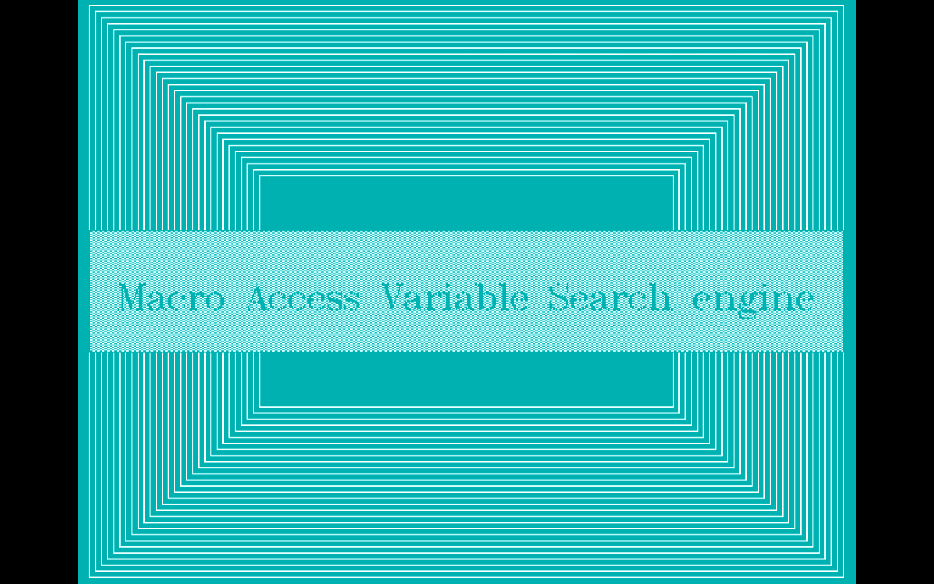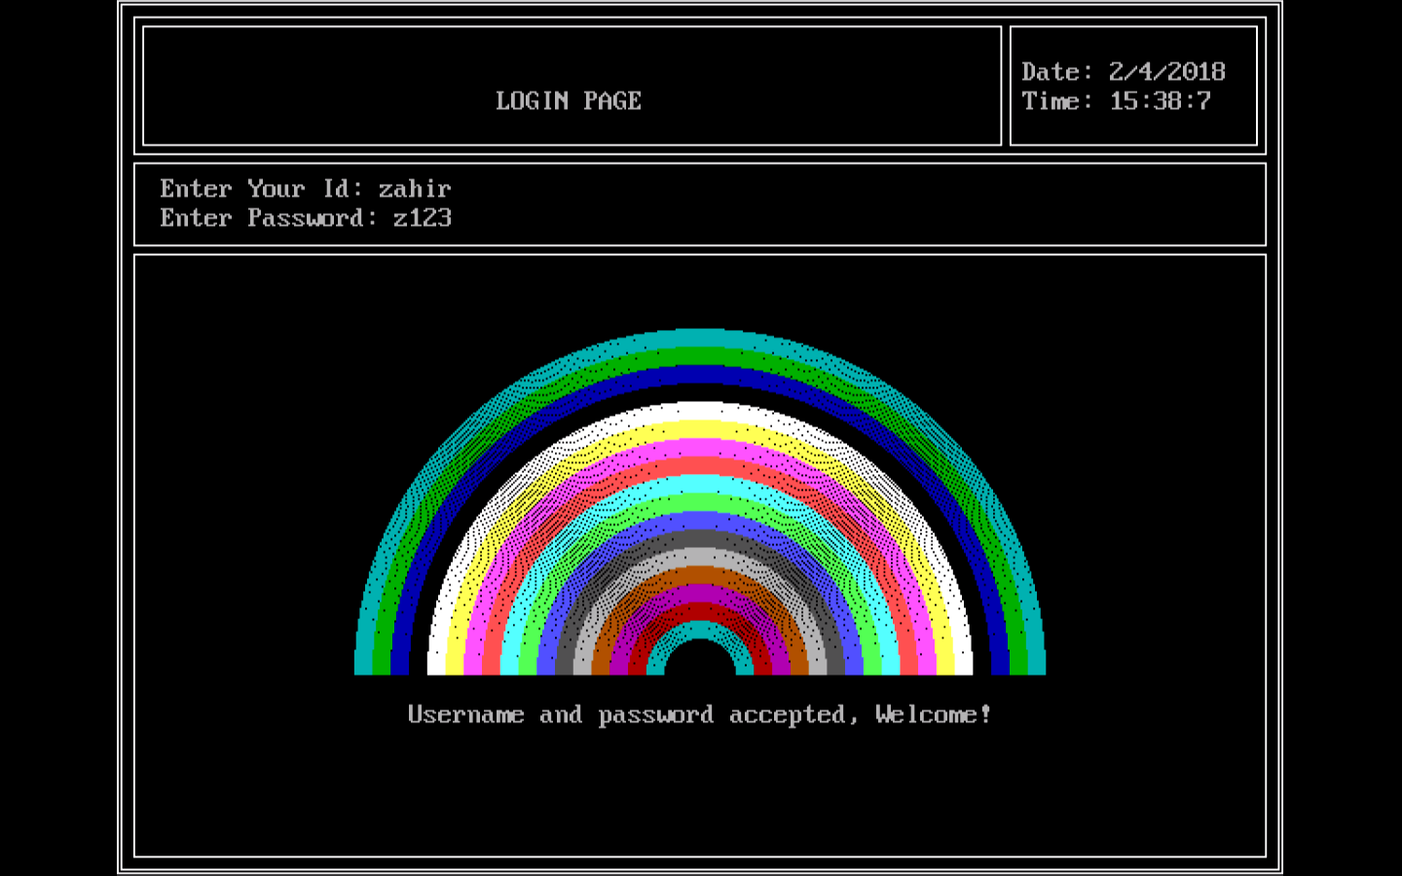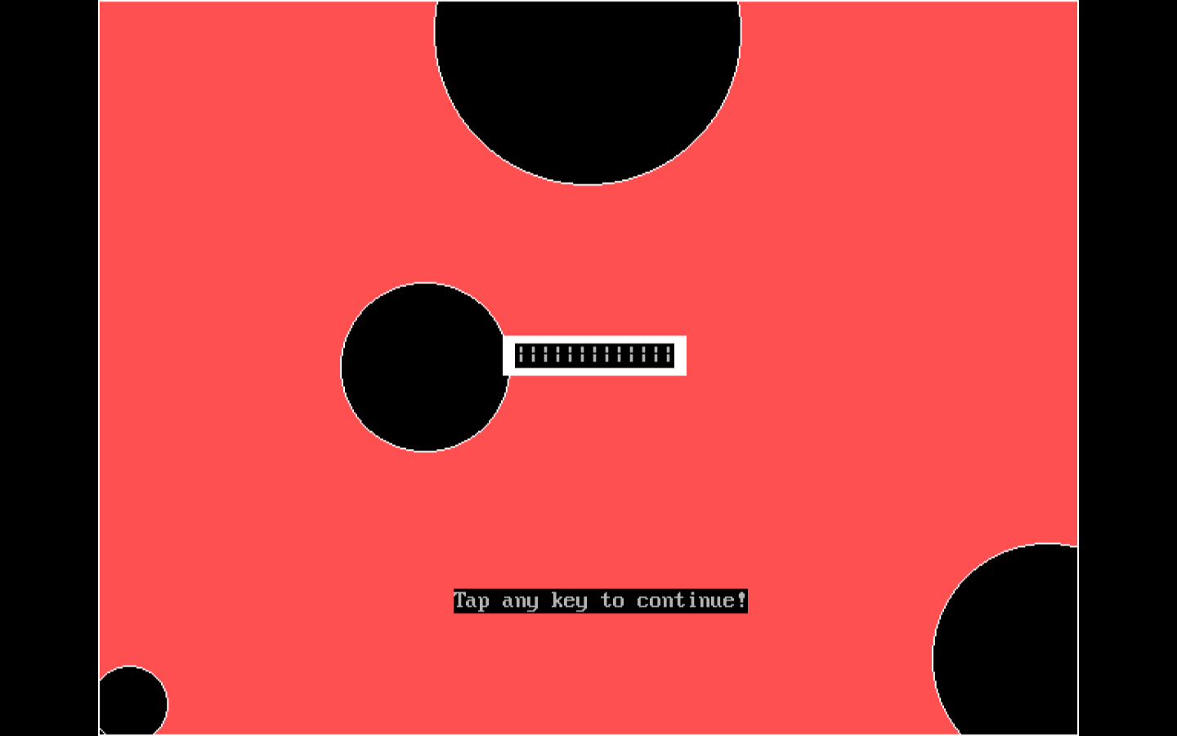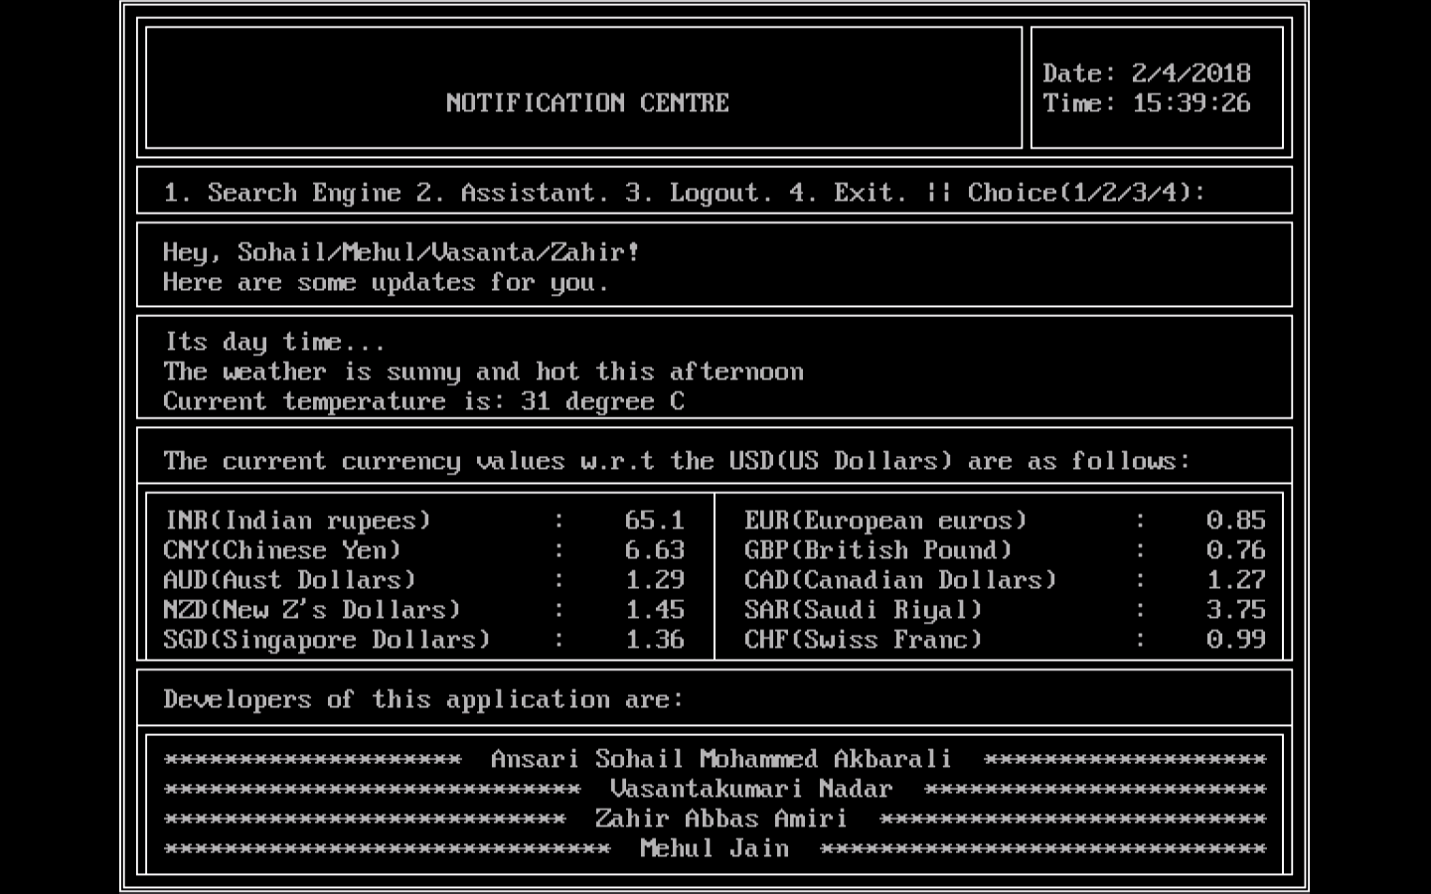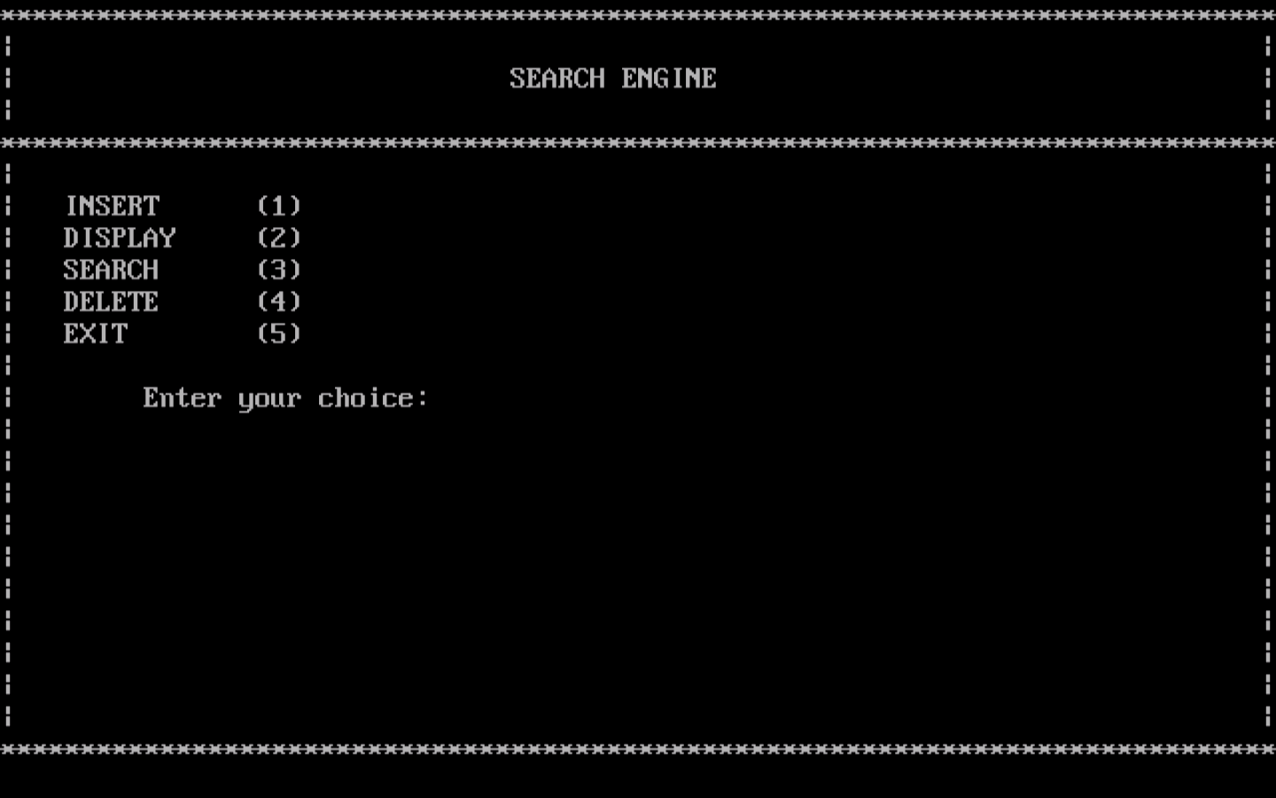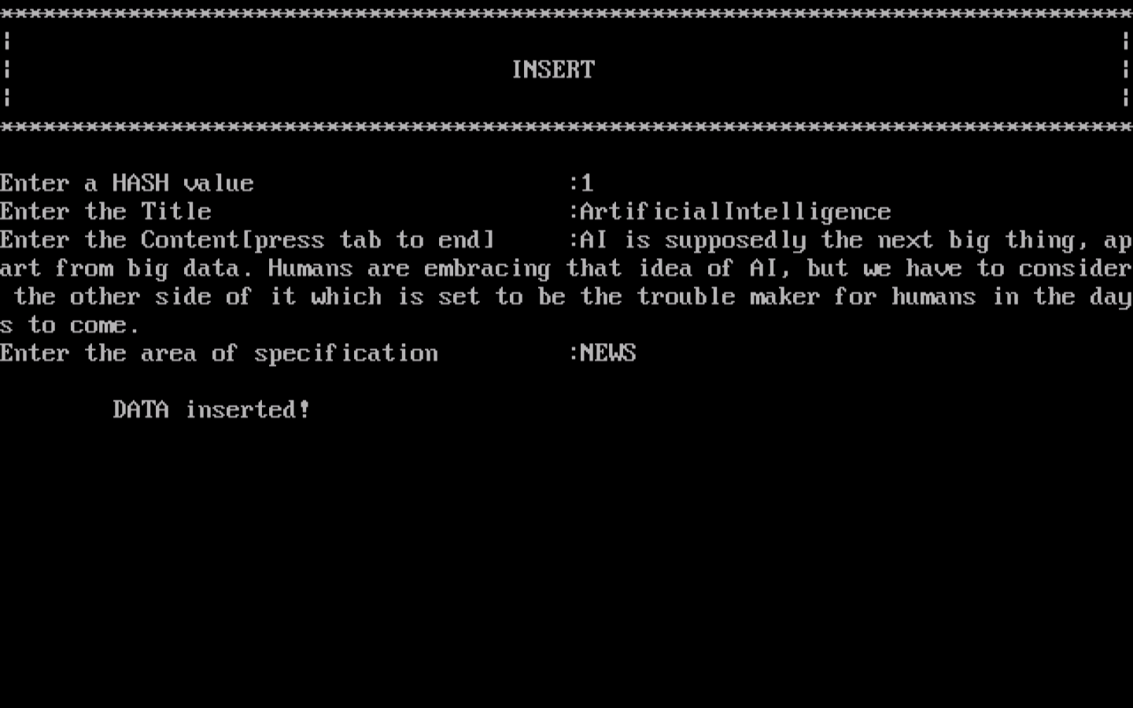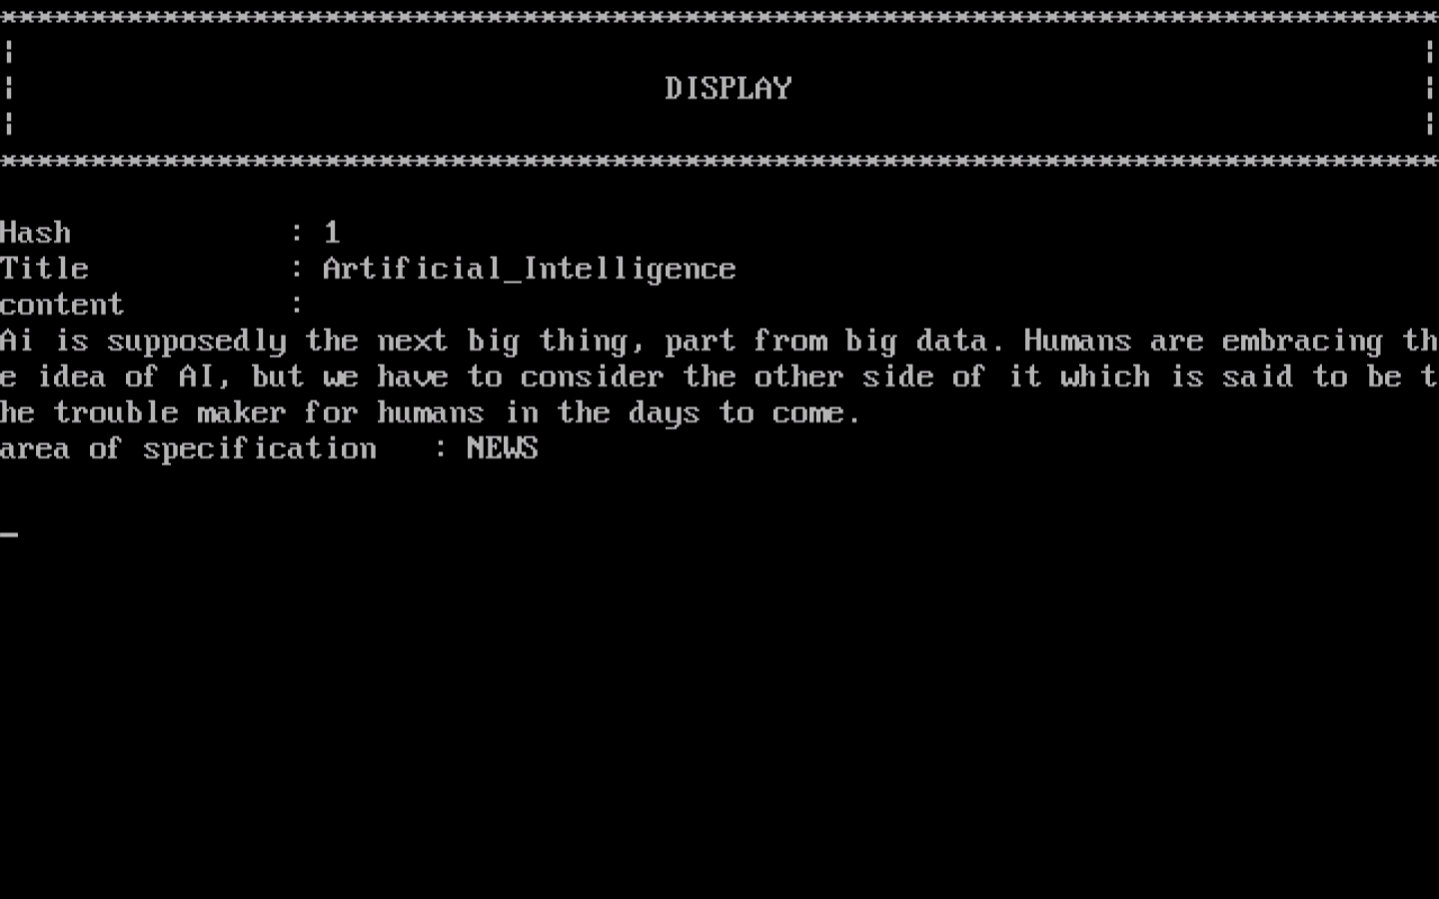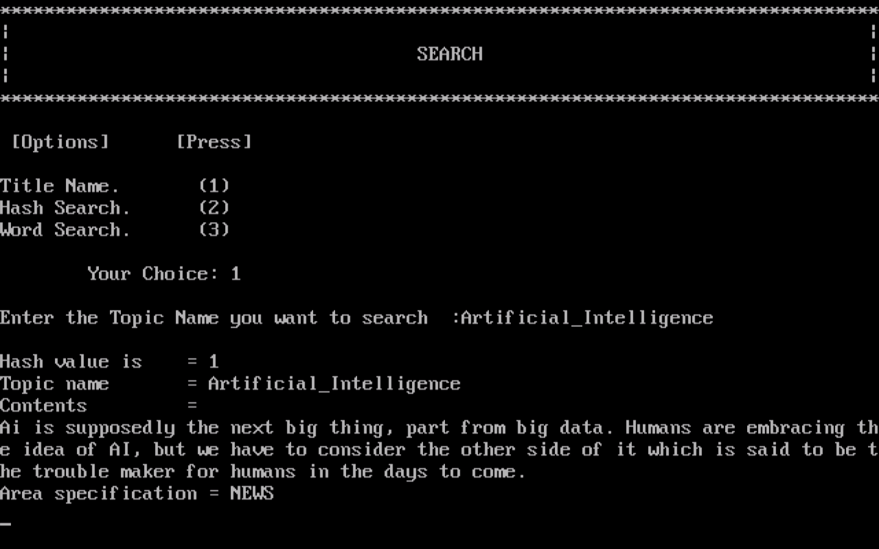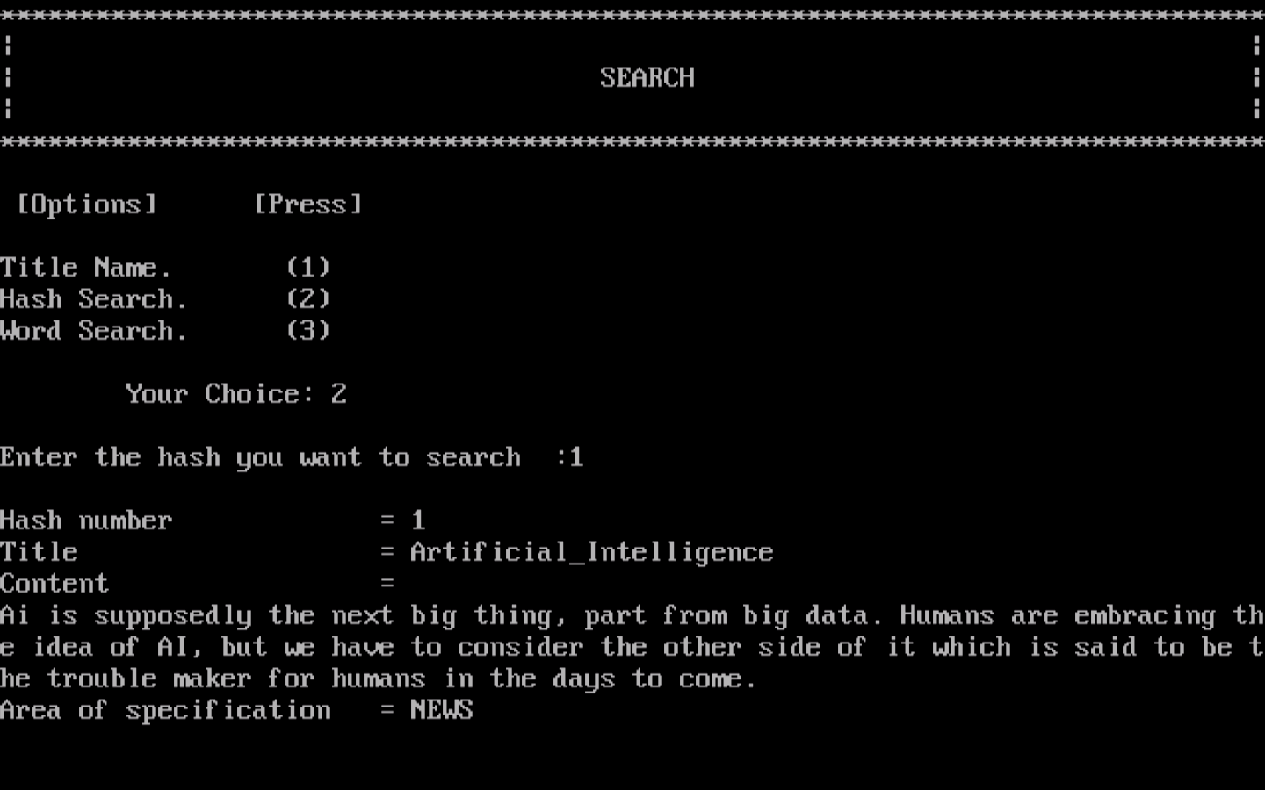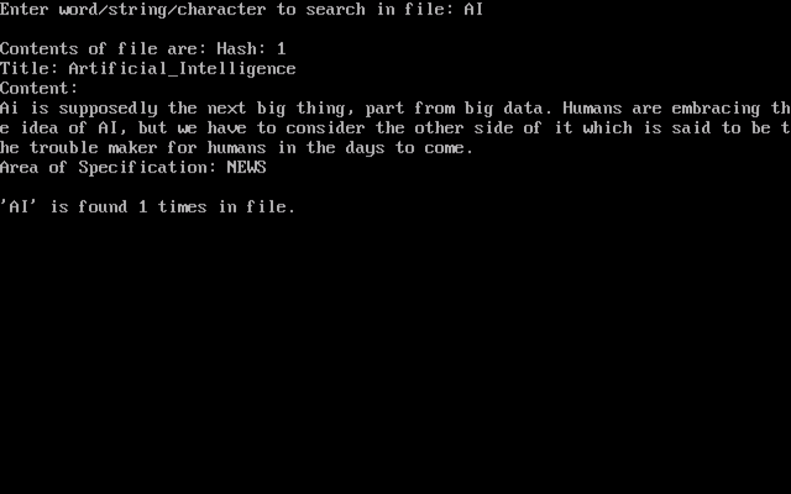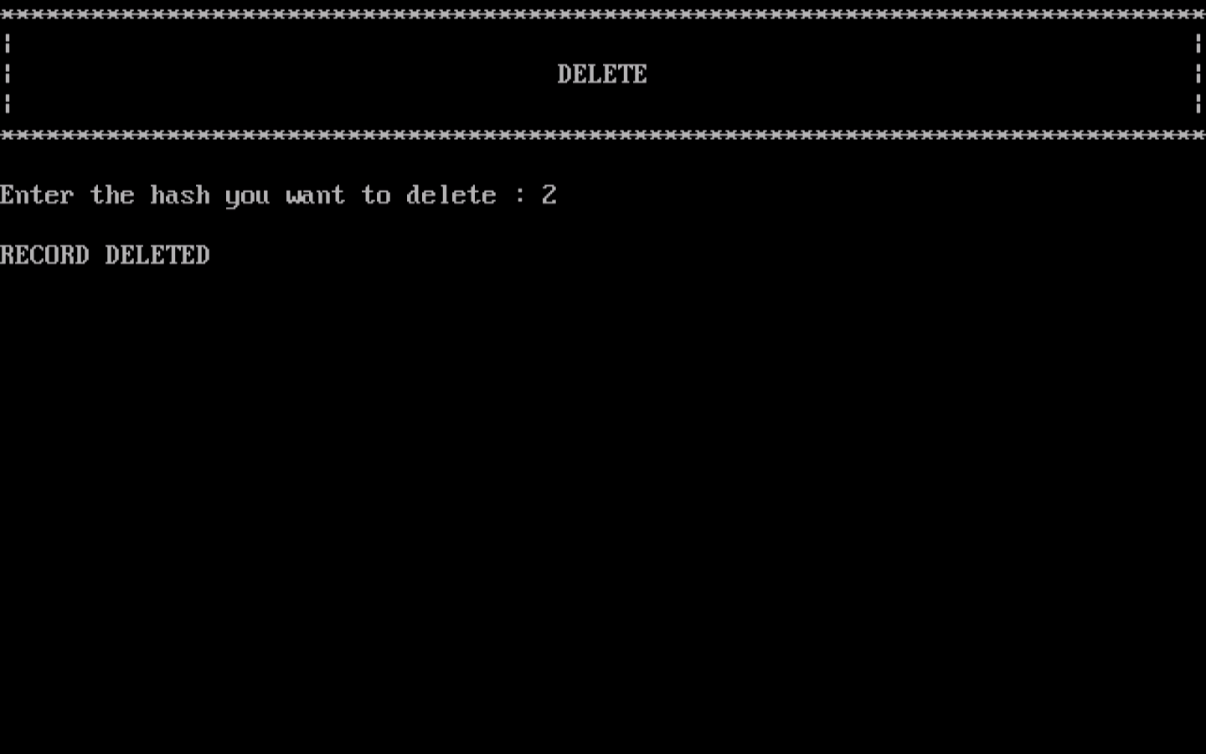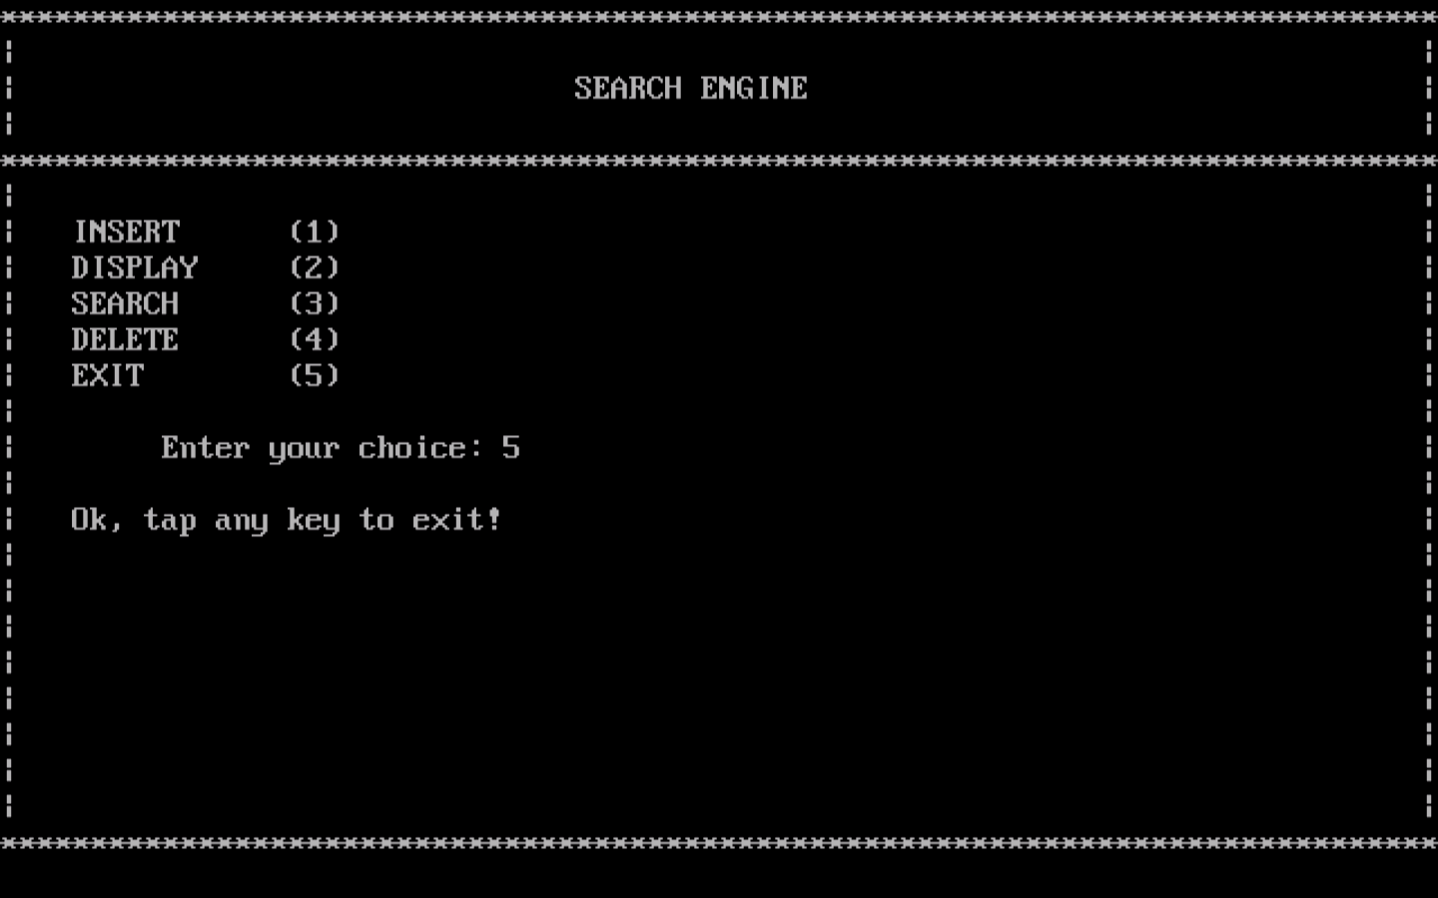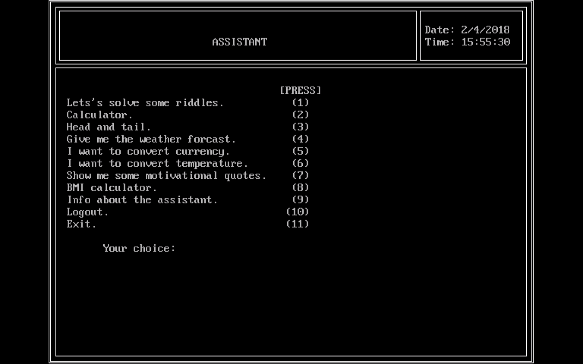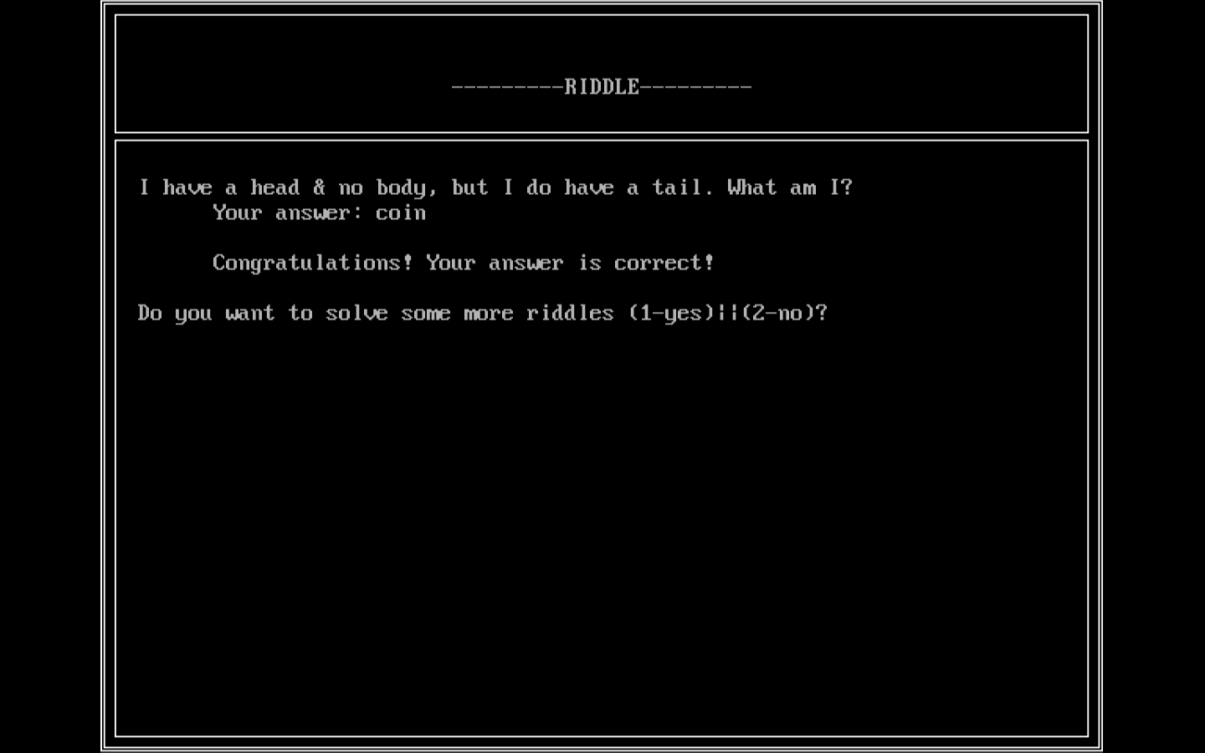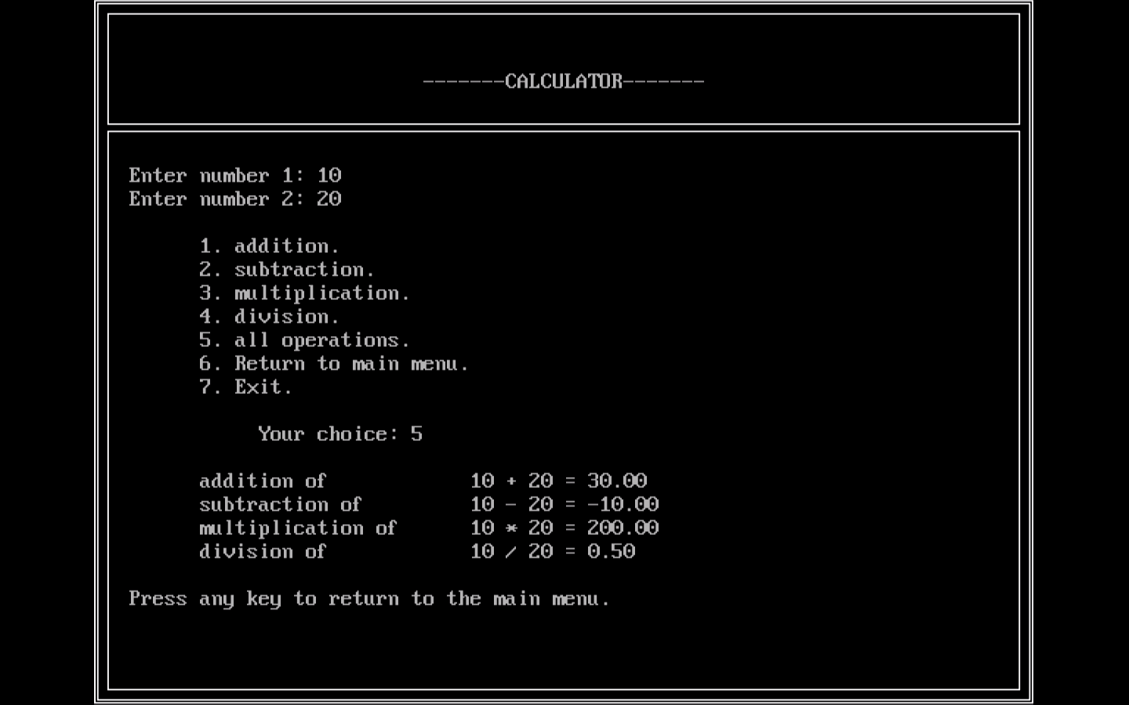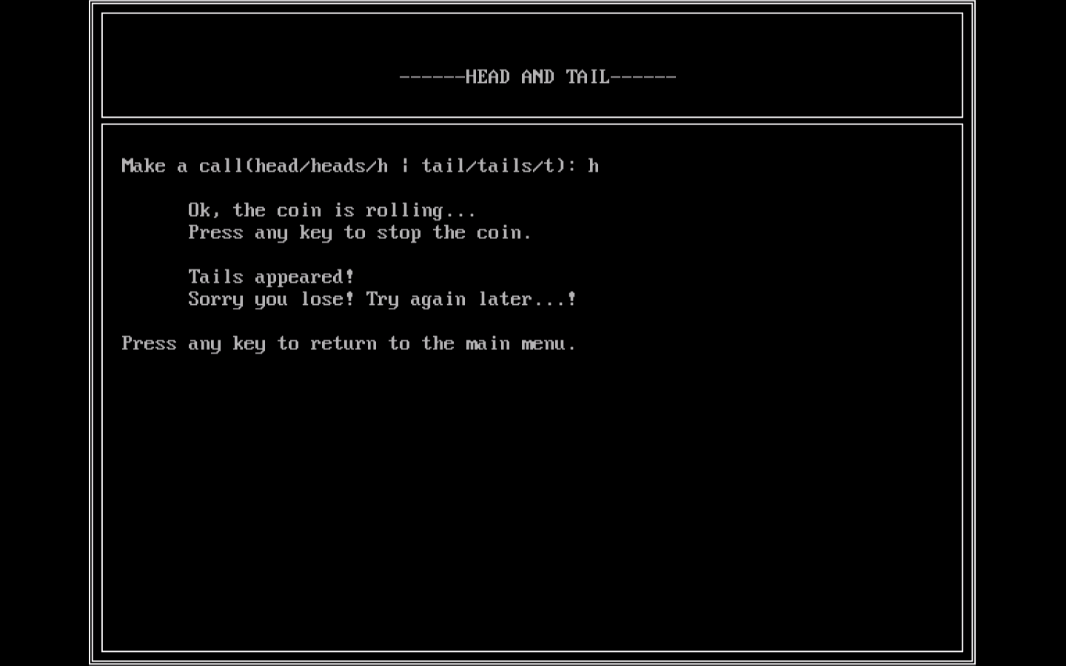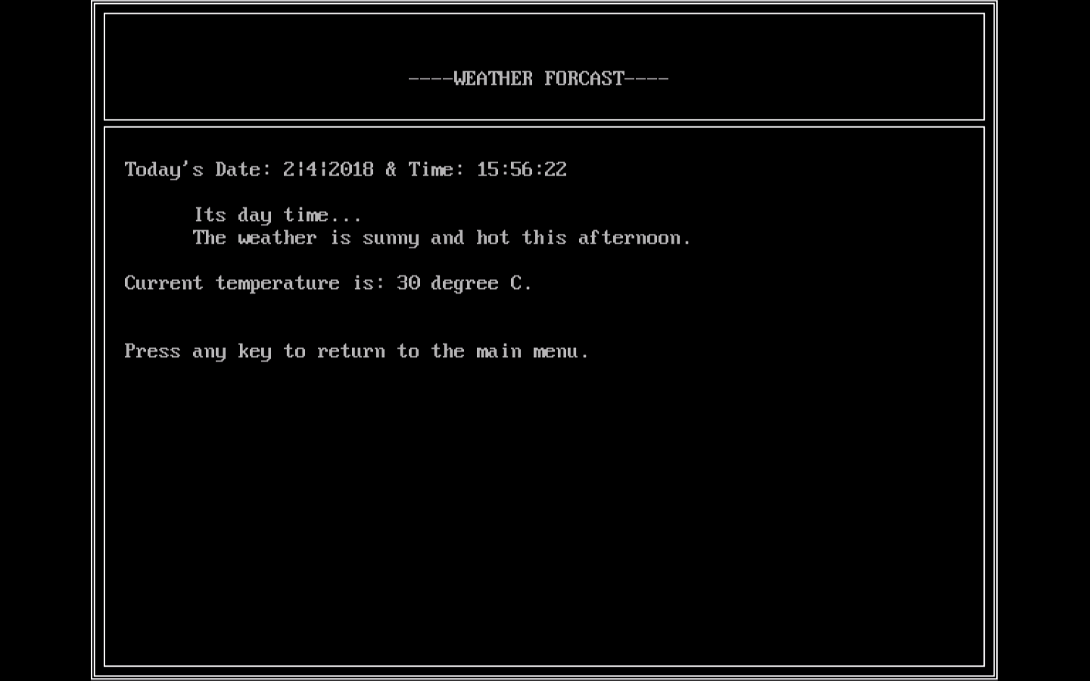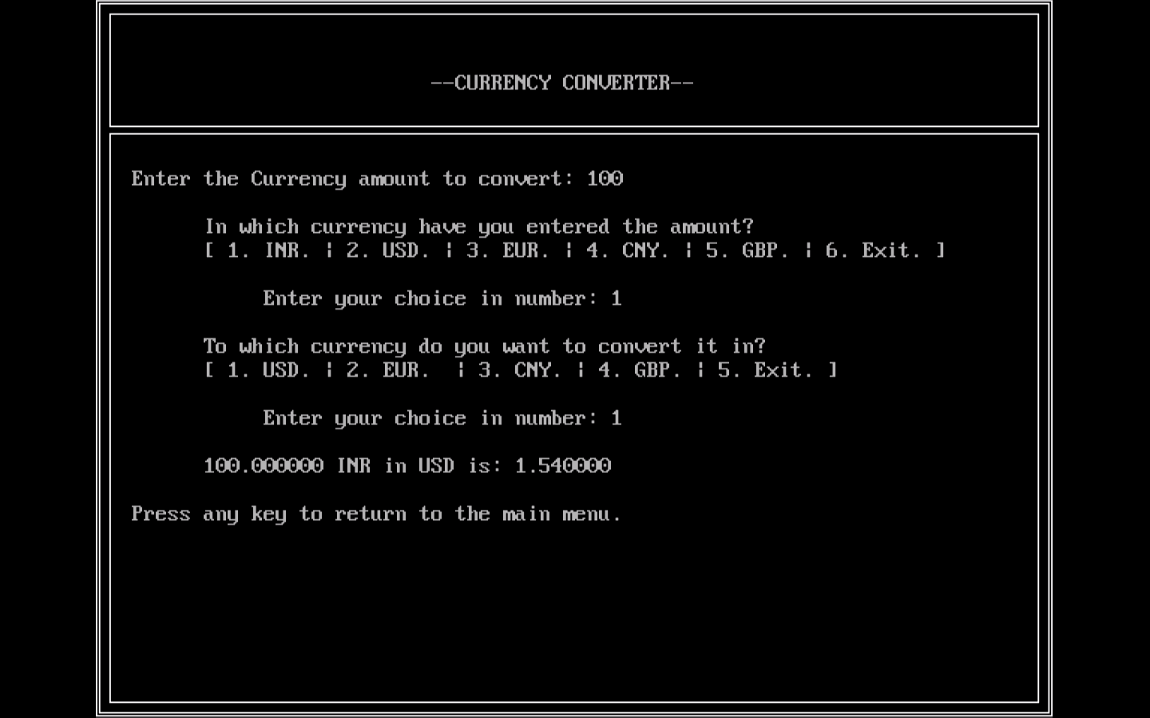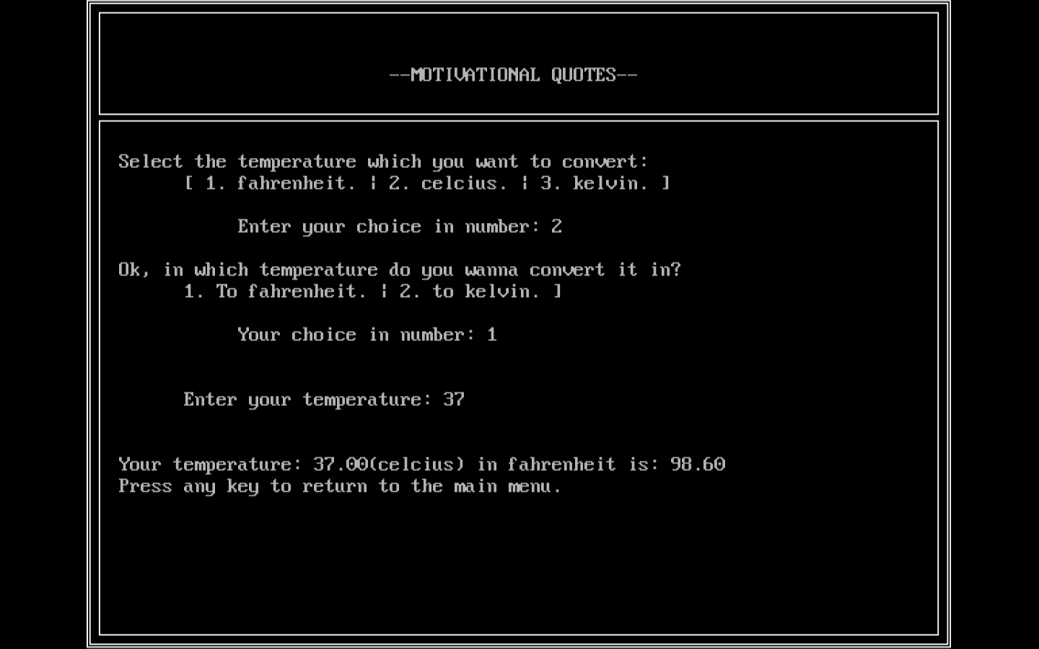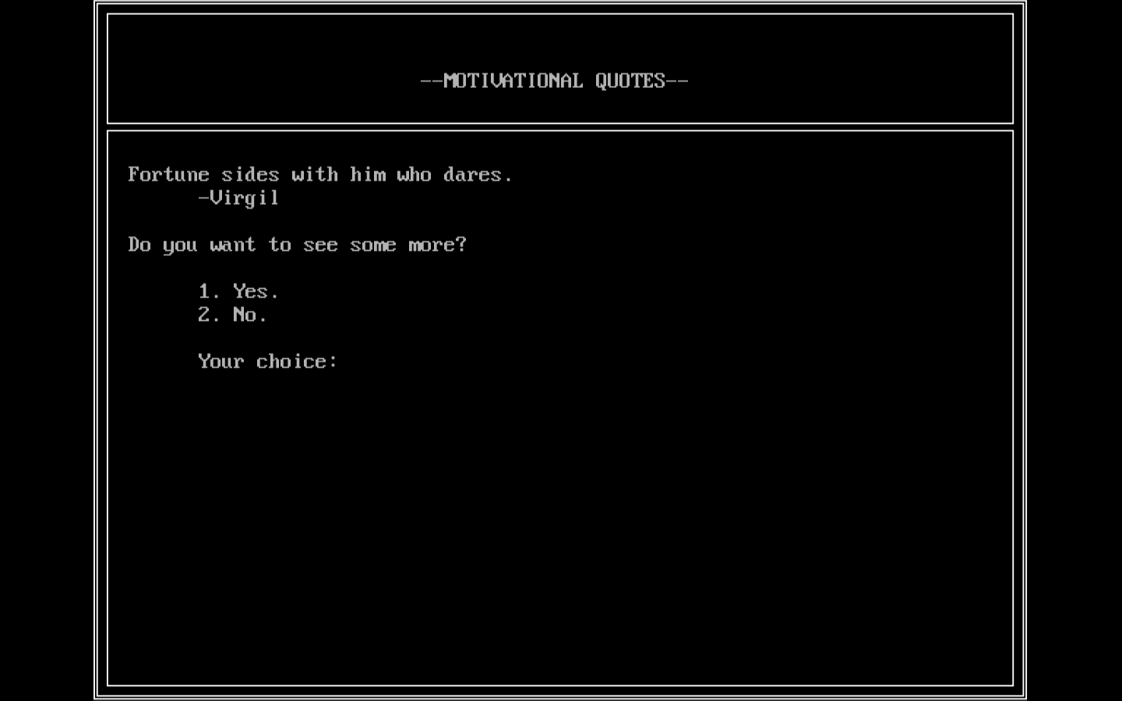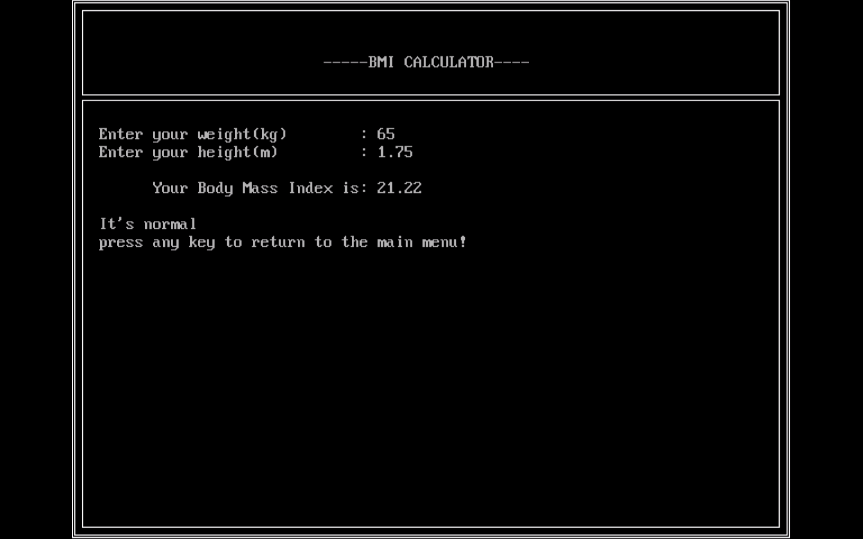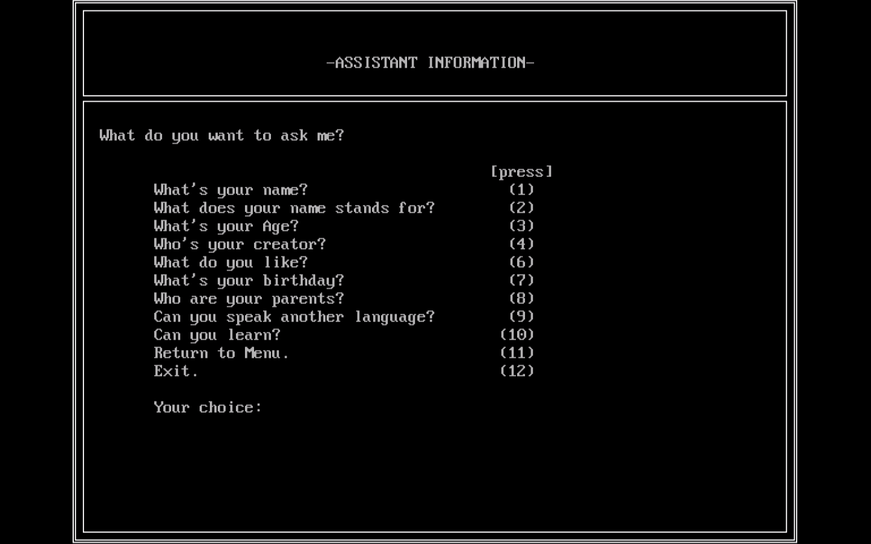

5. **Conclusion:**

5.1 **Limitation:**

* Project cannot be hosted online.
* Static time and date.
* Once the data is inserted in the search engine, it can’t be modified.
* Can have abnormal program termination sometimes.
* Using pointer can affect program security.

5.2 **Enhancement**:

* Data in the search engine can be modified.
* Scientific calculator can be implemented.
* Creating new user accounts may be possible.

**References**:

6.1 **Bibliography**:

ANSI by balguruswami (6th edition).

Let us C by yashwantrao kanetkar (4th edition).

6.2 **Webliography**:

[www.w3schools.com](http://www.w3schools.com)

[www.quora.com](http://www.quora.com)

[www.tutorialspoint.com](http://www.tutorialspoint.com)

[www.google.com](http://www.google.com)

[www.programiz.com](http://www.programiz.com)

[www.youtube.com](http://www.youtube.com)