LZW Encoding of a 6×6 Data Matrix

1. Problem Statement:
The goal of this assignment is to encode a 6×6 matrix of integer data using the LZW (Lempel–Ziv–Welch) compression algorithm. LZW is a lossless data compression technique that builds a dictionary of sequences dynamically and replaces repeated patterns with shorter codes.

2. Input Data:
The input is a 6×6 matrix of integers:
$$\left[ \begin{aligned} \\ 36 36 36 126 126 126 \\ 36 36 36 126 126 126 \\ 36 36 36 126 126 126 \\ 36 36 36 126 126 126 \\ 36 36 36 126 126 126 \\ 36 36 36 126 126 126 \\ \end{aligned} \right]$$

Each value represents a symbol to be encoded.

3. Steps of LZW Encoding:

Step 1: Flatten the Data
LZW encoding requires a 1D sequence instead of a 2D matrix.
data_lst = []
for i in range(6):
for j in range(6):
data_lst.append(int(data[i][j]))
After flattening, the sequence becomes: [39, 39, 39, 126, 126, 126 ……..]
Total elements = 36

Step 2: Initialize Dictionary
Initially, the dictionary contains all possible single-byte symbols (0–255):
dictionary = {tuple([i]): i for i in range(256)}
dict_size = 256
So:
- (39) → 39
- (126) → 126
- etc.

Step 3: Initialize Variables
w = ()
result = []
- w: current sequence
- result: compressed output codes

Step 4: Encoding Process
For each symbol in the sequence:
for i in data_lst:
wk = w + (i,)
if wk in dictionary:
w = wk
else:
result.append(dictionary[w])
dictionary[wk] = dict_size
dict_size += 1
w = (i,)

Explanation:
- Combination of current sequence w with next symbol: wk
- If wk exists in dictionary then extend sequence
- Otherwise:
  - Output code for w
  - Add wk to dictionary
  - Reset w

Step 5: Final Output
if w:
result.append(dictionary[w])
This ensures the last sequence is also encoded.

4. Working Example:
Step | Input | w (before) | wk | Action | Output | New Dictionary Entry
1 | 39 | () | (39) | Exists → w=wk | - | -
2 | 39 | (39) | (39,39) | Not found | 39 | 256 → (39,39)
3 | 39 | (39) | (39,39) | Exists → w=wk | - | -
4 | 126 | (39,39) | (39,39,126) | Not found | 256 | 257 → (39,39,126)
5 | 126 | (126) | (126,126) | Not found | 126 | 258 → (126,126)
6 | 126 | (126) | (126,126) | Exists → w=wk | - | -
7 | 39 | (126,126) | (126,126,39) | Not found | 258 | 259 → (126,126,39)
8 | 39 | (39) | (39,39) | Exists → w=wk | - | -
9 | 39 | (39,39) | (39,39,39) | Not found | 256 | 260 → (39,39,39)
10 | 126 | (39) | (39,126) | Not found | 39 | 261 → (39,126)
11 | 126 | (126) | (126,126) | Exists → w=wk | - | -
12 | 126 | (126,126) | (126,126,126) | Not found | 258 | 262 → (126,126,126)
13 | 39 | (126) | (126,39) | Not found | 126 | 263 → (126,39)
14 | 39 | (39) | (39,39) | Exists → w=wk | - | -
15 | 39 | (39,39) | (39,39,39) | Exists → w=wk | - | -
16 | 126 | (39,39,39) | (39,39,39,126) | Not found | 260 | 264 → (39,39,39,126)
17 | 126 | (126) | (126,126) | Exists → w=wk | - | -
18 | 126 | (126,126) | (126,126,126) | Exists → w=wk | - | -
19 | 39 | (126,126,126) | (126,126,126,39) | Not found | 262 | 265 → (126,126,126,39)
20 | 39 | (39) | (39,39) | Exists → w=wk | - | -
21 | 39 | (39,39) | (39,39,39) | Exists → w=wk | - | -
22 | 126 | (39,39,39) | (39,39,39,126) | Exists → w=wk | - | -
23 | 126 | (39,39,39,126) | (39,39,39,126,126) | Not found | 264 | 266 → (39,39,39,126,126)
24 | 126 | (126) | (126,126) | Exists → w=wk | - | -
25 | 39 | (126,126) | (126,126,39) | Exists → w=wk | - | -
26 | 39 | (126,126,39) | (126,126,39,39) | Not found | 259 | 267 → (126,126,39,39)
27 | 39 | (39) | (39,39) | Exists → w=wk | - | -
28 | 126 | (39,39) | (39,39,126) | Exists → w=wk | - | -
29 | 126 | (39,39,126) | (39,39,126,126) | Not found | 257 | 268 → (39,39,126,126)
30 | 126 | (126) | (126,126) | Exists → w=wk | - | -
31 | 39 | (126,126) | (126,126,39) | Exists → w=wk | - | -
32 | 39 | (126,126,39) | (126,126,39,39) | Exists → w=wk | - | -
33 | 39 | (126,126,39,39) | (126,126,39,39,39) | Not found | 267 | 269 → (126,126,39,39,39)
34 | 126 | (39) | (39,126) | Exists → w=wk | - | -
35 | 126 | (39,126) | (39,126,126) | Not found | 261 | 270 → (39,126,126)
36 | 126 | (126) | (126,126) | Exists → w=wk | - | -

5. Encoded Output:
After running the algorithm:
print(result)
We will get a list of integer codes representing the compressed data.
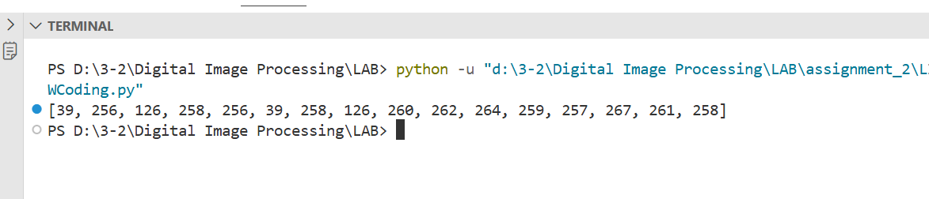

6. Source Code:
import numpy as np

data = np.array([
[39, 39, 39, 126, 126, 126],
[39, 39, 39, 126, 126, 126],
[39, 39, 39, 126, 126, 126],
[39, 39, 39, 126, 126, 126],
[39, 39, 39, 126, 126, 126],
[39, 39, 39, 126, 126, 126],
])

data_lst = []
for i in range(6):
for j in range(6):
data_lst.append(int(data[i][j]))

dictionary = {tuple([i]): i for i in range(256)}
dict_size = 256

w = ()
result = []

for i in data_lst:
wk = w + (i,)
if wk in dictionary:
w = wk
else:
result.append(dictionary[w])
dictionary[wk] = dict_size
dict_size += 1
w = (i,)

if w:
result.append(dictionary[w])

print(result)

