Kazakh-British Technical University
Data collection and preparation

STUDENTS' INDEPENDENT STUDY (SIS) №1
The relationship between air quality and population
of cities in Kazakhstan

Full name: Baibolov Sultanmakhmut
ID: 23B031235

29.10.2026
Almaty

CONTENTS
Project goal 3
Web scraping 3
Geocoding API 4
Air Quality API 5
Data merging 5
EDA 6

Project goal
The primary goal of this project is to analyze the relationship between urban population sizes and air quality metrics across major cities in Kazakhstan and evaluate whether higher demographic density directly correlates with increased atmospheric pollution. To achieve this, the project implements a complete data collection and analysis pipeline by using real-world data from public Open-Meteo weather API and static website CityPopulation.

Web scraping

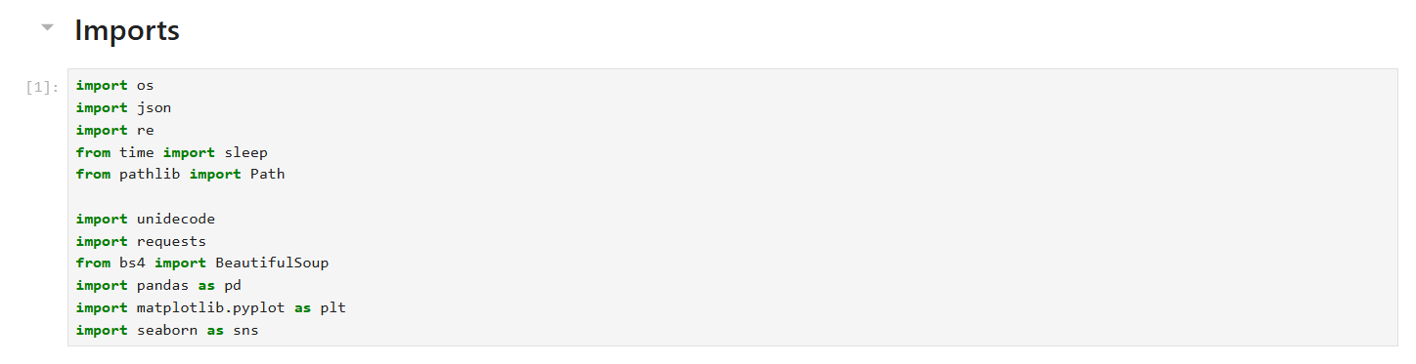

I divided the work on the project into two parts: collecting data from web pages and APIs, and analyzing the collected data. First, I collected cities with a known population for 2026. Instead of making new requests each time, I saved all the data (including HTML and JSON) in separate files, from which I then retrieved the information. For each individual dataset, I created a CSV file.

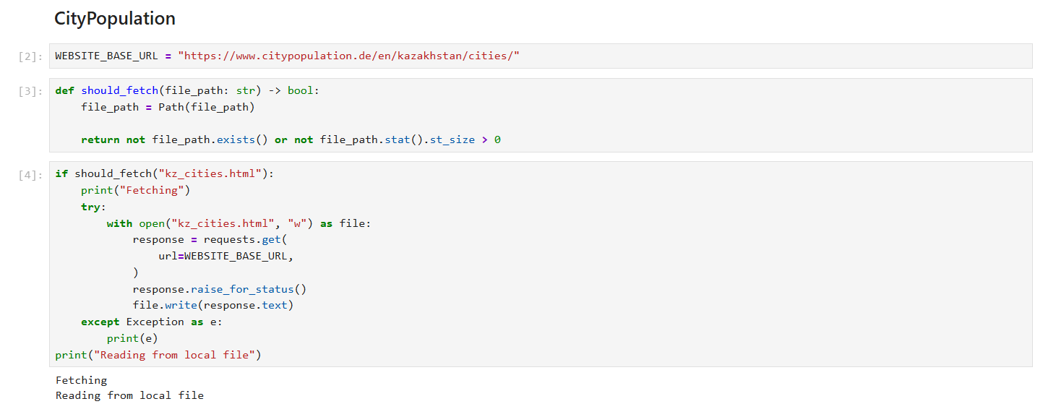
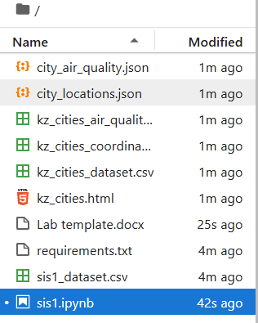

Geocoding API
After receiving the list of cities and villages with their populations, I needed to find their coordinates. To do this, I used the same Open Weather API, but not for air quality, but to find the coordinates. Since the names were in Latin script, and sometimes with other variants, I needed to normalize them and convert them to the English alphabet (ASCII). For this, I used a third‑party library called Unidecode. However, it didn’t always translate correctly from the new Kazakh Latin script, so some city entries were deleted in the final dataset.

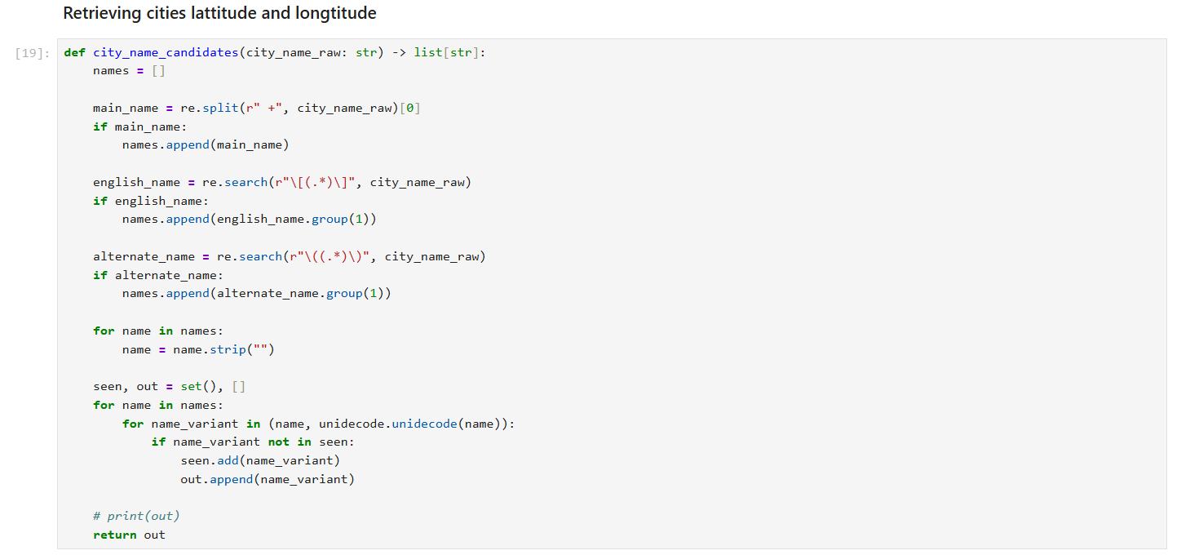

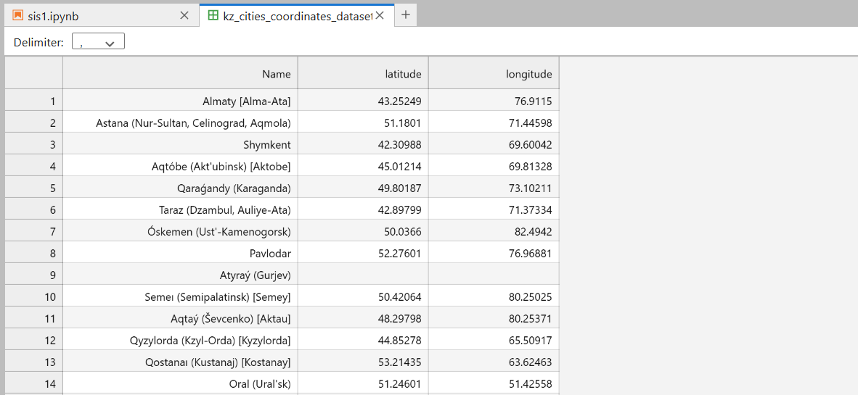

Air Quality API

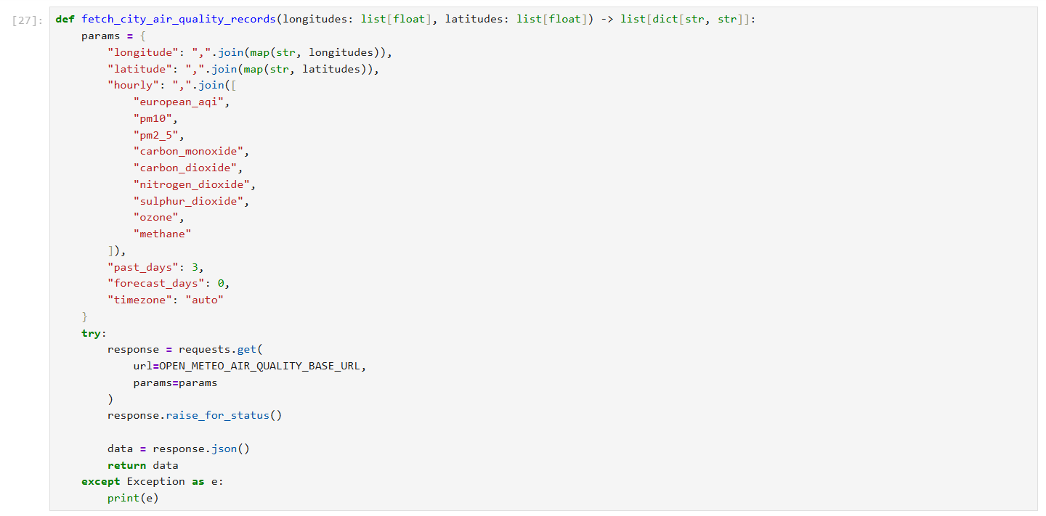

For each record from the created dataset with coordinates, where the coordinates were available, I made a request to the Air Quality API to obtain data on particles, gases, and the air quality index for the past 3 days for each hour. That is, there were 72 records per populated area.

Data merging
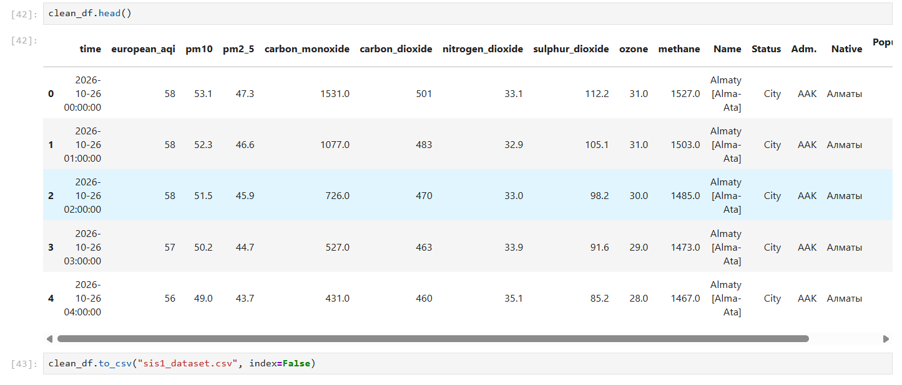

As a result, I combined 2 datasets — the populations of cities and data on their air quality. In the end, I got a dataset consisting of more than 4,000 records with hourly values of indicators for the last 3 days for each city.

EDA
Based on the dataset I received, I conducted an initial analysis of the data, deriving 8 findings that, in my opinion, are particularly interesting and can be found in the file itself.
Based on the analysis, I concluded that there is no correlation between the population of cities in Kazakhstan and their air quality index. However, despite this, I drew conclusions about how many people are affected by polluted air, which cities are the most polluted, and how the number of particles and other gases changes throughout the day in Almaty and Zhanaozen.

