High Risk Construction Work Safe Work Method Statement

NOTE: Work must be performed in accordance with this SWMS.
This SWMS must be kept and be available for inspection until the high risk construction work to which this SWMS relates is completed. If the SWMS is revised, all versions should be kept.
If a notifiable incident occurs in relation to the high risk construction work in this SWMS, the SWMS must be kept for at least 2 years from the date of the notifiable incident.

 |  |  |  | Principal Contractor (PC) |  |  | Ruby Homes
Works Manager: Contact phone: |  | Andrew Daher 0406 641 049 |  | Date SWMS provided to PC:  Workplace location: |  |  | 9th October 2026
Work activity: |  | Carpentry |  |  |  |  | Lot 27, 7 Travellers Way, Tahmoor NSW 2573
High risk construction work: |  | Risk of a person falling more than 2 metres (note: in some jurisdictions this is 3 metres) | Work on a telecommunication tower |  |  |  |  | Demolition of load-bearing structure
 |  | Likely to involve disturbing asbestos | Temporary load-bearing support for structural alterations or repairs |  |  |  |  | Work in or near a confined space
 |  | Work in or near a shaft or trench deeper than 1.5 m or a tunnel | Use of explosives |  |  |  |  | Work on or near pressurised gas mains or piping
 |  | Work on or near chemical, fuel or refrigerant lines | Work on or near energised electrical installations or services |  |  |  |  | Work in an area that may have a contaminated or flammable atmosphere
 |  | Tilt-up or precast concrete elements | Work on, in or adjacent to a road, railway, shipping lane or other traffic corridor in use by traffic other than pedestrians |  |  |  |  | Work in an area with movement of powered mobile plant
 |  | Work in areas with artificial extremes of temperature | Work in or near water or other liquid that involves a risk of drowning |  |  |  |  | Diving work

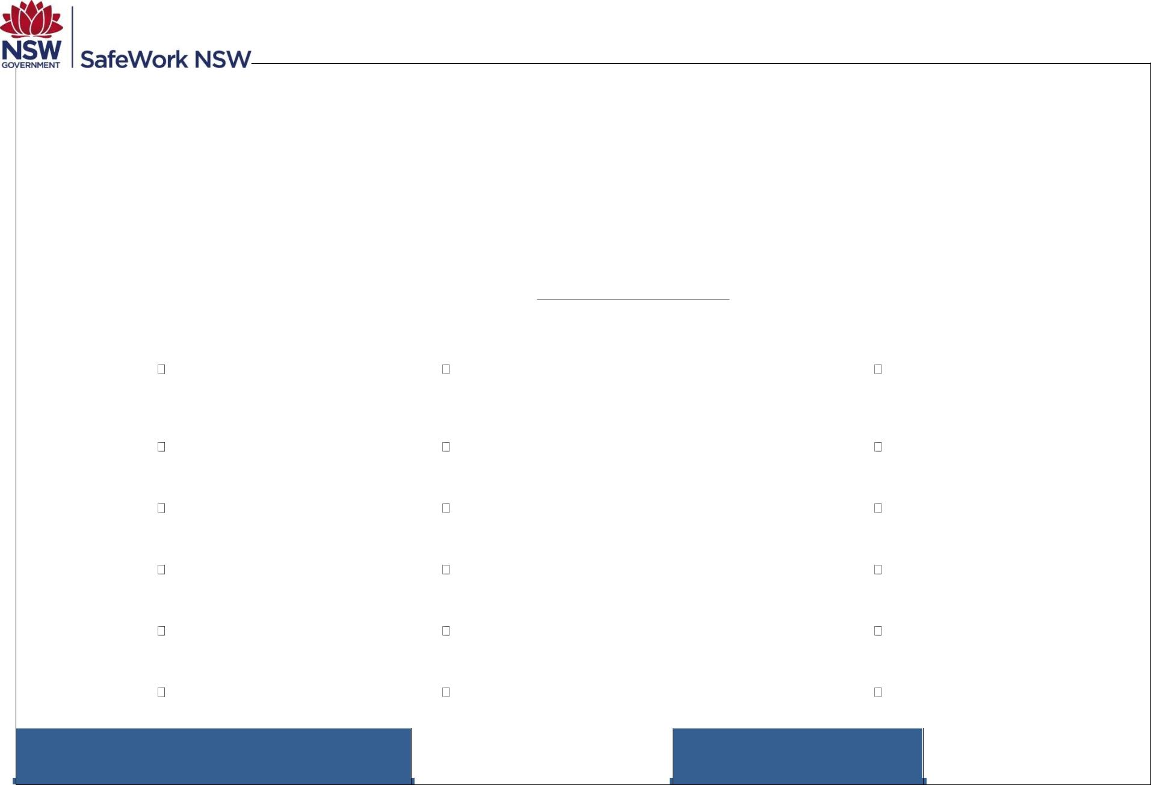
Person responsible for ensuring compliance with
SWMS:
Sudeep Joshi Date SWMS received:

What measures are in place to ensure compliance with the SWMS? | Supervision & close monitoring.
Person responsible for reviewing SWMS control measures: | Sudeep Joshi | Date SWMS received by reviewer:
How will the SWMS control measures be reviewed? | The principal contractor should be given a copy of the revised SWMS.  All workers that will be involved in the high risk construction work are provided with the relevant information and instruction that will assist them to understand and implement the revised SWMS.
Review date: |  | Reviewer’s signature:

What are the tasks involved? | What are the hazards and risks? | What are the control measures?
List the work tasks in a logical order. | Identify the hazards and risks that may cause harm to workers or the public. | Describe what will be done to control the risk. What will you do to make the activity as safe as possible?
Entry To Site | Entering hazardous areas with movement of site personnel vehicles, plant & equipment. | Risk assessment of site conditions & training of all employees in such instances.
Unloading Equipment | Fall from vehicle  Injuring yourself unloading materials, tools & equipment | Training employees in load & unloading equipment. Training in manual handling.  Team lifting.  Unload in clear, level area, beware of other trades people & vehicles.

Setting Up Equipment | Injury to individual, e.g., falls, slips, trips, cuts, etc… | Set up equipment on level ground.  Avoid rough & difficult terrain (dangerous surfaces). Use P.P.E equipment when required, e.g., safety shoes, gloves, hats, etc.…  Training in the setup of electrical leads.
Unloading Framework; rafters, posts, struts & other structure  Installing Wall Frames & Floor Joist | Individual injured by stand still or moving delivery trucks or crane. Caused by instances such as, gear failure.  Collision with crane, crush injuries & falling objects.  Trip Hazard and injury to worker. Protentional falling objects.  Risk of falling due to height and working on ladders.  Injury from nail guns.  Cuts from power saws when cutting joists.  Damage to feet.  Slips trips & falls when carrying materials. Fall from heights. | Employees to be instructed upon arrival of entry and set up are of crane or equipment.  Crane & truck operators to be made aware of location of onsite personnel.  Only suitably trained personnel to work with maintained plant & equipment.  All persons on site understand the movements of the crane in their work area.  Operator has consulted with others onsite about their movements and route.  Training & use of P.P.E equipment such as hard hats, safety vests (high visibility clothing) Supervision.  Ensuring the work environment is always clean and tidy to avoid trip hazards.  Preventing injury with close monitoring and supervision.  Clear work area of debris & obstructions  Training in the use of power tools & running of leads. Use PPE equipment safety glasses, gloves when necessary. Training in the use of hazardous  substances.  Preventing injury with close monitoring and supervision.

Installing Ceiling & Roof | Injury from nail guns. Electrocution.  Cuts from power saws when cutting joists. Damage to feet.  Slips trips & falls when carrying materials. Fall from heights. | Clear work area of debris & obstructions  Training in the use of power tools & running of leads. Installation of scaffolding & harness.  Use PPE equipment safety glasses, gloves when necessary. Training in the use of hazardous substances.

Clean-up & leave site. | Cuts, slips, trips when loading waste  materials into bins | De-nail unused materials Ensure clear access to waste bin Avoid rough terrain

PLEASE NOTE: THE TRIAL PERIOD FOR THIS DOCUMENT HAS CONCLUDED AND IS NOW BEING REVIEWED. THE CONTROLS ARE INDICATIVE ONLY AND WILL CHANGE IN ACCORDANCE WITH SITE CONDITIONS.

NAME OF WORKER | WORKERS SIGNATURE(S) | DATE
ANDREW DAHER
CHARBEL YOUNANE
GIO ABI NAHED
Charbel Hanna
Joe Habib
Gabriel Hanna
Ahmed Ldaayen
Christopher Abi Nahed
Fahad Sawadi
Rahul Pawar
Simbarashe Marowatasanga
Anthony Khouzam

Construction work Page 6 of 6

