ABC Bookstore Data Analysis ReportI designed and developed a comprehensive Business Intelligence Dashboard to provide strategic insights into the sales performance and inventory management of the ABC Bookstore.

Key Responsibilities & Tools Used:
- Data Preparation: Leveraged Power Query to clean, transform, and prepare large datasets, ensuring data accuracy and reliability for subsequent analysis.
- Analysis & Visualization: Utilized Tableau to create powerful, interactive visualizations, allowing stakeholders to easily interpret complex metrics.

Notable Achievements & Results:
- Optimized Inventory Management: Identified the actual distribution of stock quantities (e.g., Sequential Art accounted for 28.24% of total quantity), informing efficient purchasing and stocking decisions.
- Informed Pricing Strategy: Analyzed average category prices, highlighting the most expensive categories, such as Suspense (averaging $58.33), to support margin review.
- Performance Measurement: Delivered a quick overview of 999 titles with an overall average rating of $3.00$, and pinpointed top-rated categories (e.g., Adult Fiction, Novels).

Problem Statement:
ABC Bookstore is struggling to optimize the efficiency of capital invested in inventory (Inventory ROI) and increase its overall revenue due to a lack of clear understanding of the relationship between customer satisfaction (Ratings), price distribution, and inventory allocation across its 50 different categories.
The management requires data-driven insights to guide future purchasing and stocking decisions, and to stop allocating space and capital to products that may not yield the expected profit or meet customer satisfaction.

1. Key Metrics Summary
The dashboard provides a quick overview of the store's inventory volume and distribution.
Metric | Value
Total Titles | 999
Total Category | 50
Avg. Rating | 3.00
Total Quantity | 8,585
Avg. Price | $35
Quantity per Book | 8.59

Insight: The store has a wide assortment (999 titles) with a reasonable average price ($35), but the average customer rating (3.00) indicates significant room for improving inventory quality to raise overall satisfaction.

2. Addressing Key Analytical Questions
Data extracted from the ABC Bookstore Dashboard was used to answer the challenges outlined in the Problem Statement.
- Investment Opportunities: Which high-rated categories should the store increase its investment in?
Extracted Data (from Top 8 Book Category by Rating chart):
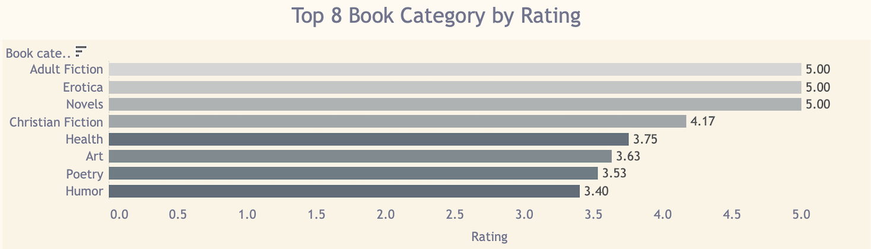
- Adult Fiction, Erotica, and Novels achieved the highest rating (5.00).
- They are followed by Christian Fiction (4.17), Health (3.75), and Art (3.63).
Answer & Insight: ABC Bookstore should focus on Novels and Adult Fiction, as they achieve the highest level of customer satisfaction (5.00). These categories represent clear opportunities to boost sales driven by high quality.

B. Price Management: How are the most expensive categories distributed, and does their high price justify high ratings?
Extracted Data (from Top 5 Most Expensive Book Category chart):
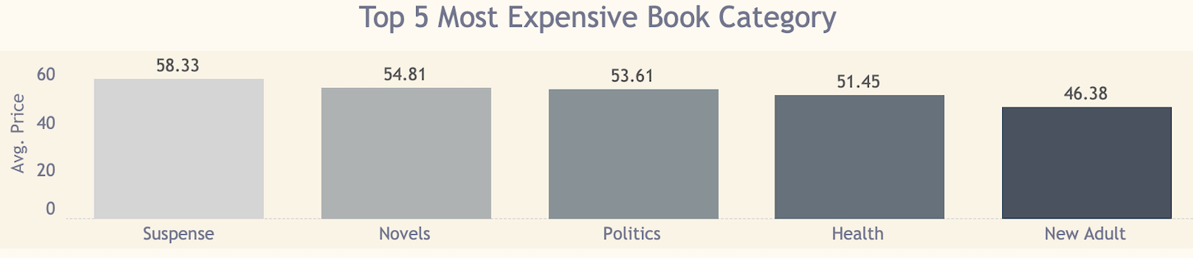
- The most expensive categories are Suspense ($58.33), Novels ($54.81), and Politics ($53.61).
Answer & Insight:
- Novels is the second most expensive category ($54.81) but carries the highest rating (5.00). This suggests customers perceive the quality in this category as justifying the high price.
- In contrast, Suspense is the most expensive category ($58.33) but did not appear among the top 8 rated categories. This warrants a review of its pricing or the quality of its titles.
- Stagnant Inventory: Which titles have excessive inventory compared to average prices or ratings?

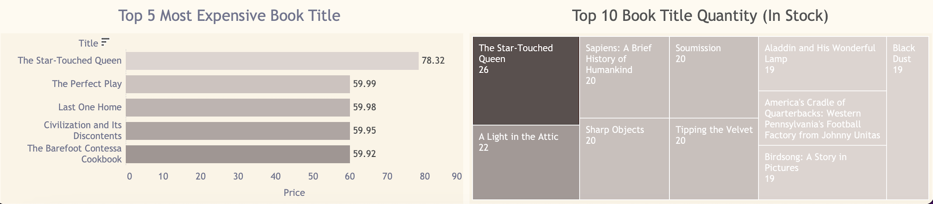
Extracted Data (from Price and Inventory charts):
- The book "The Star-Touched Queen" is the most expensive title in the store ($78.32).
- The same book has the highest individual quantity in stock (26 copies) among all listed titles.
- Other titles like Sapiens and Sharp have high stock (20 copies each).
Answer & Insight:
The biggest risk lies with The Star-Touched Queen. The combination of the highest selling price and the highest individual stock quantity represents the highest financial risk for the store (high-value inventory prone to stagnation). Management must immediately check the sales turnover rate for this title.

3. Recommendations
Based on the analysis:
- Reinforce Quality Investment: Increase the purchasing budget to diversify titles within the Novels and Adult Fiction categories to maximize customer satisfaction (5.00 rating).
- Inventory Risk Management: Conduct an immediate audit of the inventory turnover rate for "The Star-Touched Queen" to determine if the quantity (26 copies) is justified. If the turnover rate is slow, it is recommended to offer promotions to move this high-value stock.
- Review Key Categories: Review the performance of the Suspense category (most expensive) and the Sequential Art category (highest stock quantity at 28.24% of total inventory), to ensure large volumes still align with actual demand and are not just surplus storage.

