ICPP Project
Meeting report
Meeting report 2

Owner | Rîmbu Ion
Document title and version | Meeting Minutes
Date and the time of the meeting | 02.10.2026
Project reference | Privacy Hub
Meeting place | Universitatea UTM

Recipients
Attended the meeting? | Owner | Group | E-mail
 | Rîmbu Ion | SD-262 | ion.rimbu@stud.fcim.utm.md
 | Moraru Maxim | SD-261 | maxim.moraru@stud.fcim.utm.md
 | Pușcașu Maxim | SD-261 | maxim.puscasu@stud.fcim.utm.md
 | Naco Artiom | SD-262 | artiom.naco@stud.fcim.utm.md
 | Brumă Liviu | SD-262 | liviu.bruma@stud.fcim.utm.md
 | Sîrbu Nicolae | SD-262 | nicolae.sirbu@stud.fcim.utm.md

Table of Contents
Objectives of the meeting 3
Agenda 3
Discussion points 3
Refer to the action register for the complete list of actions. 4
Decisions 4
Next meetings 4

Objectives of the meeting
What are the objectives set for this meeting?
Why did you gather these members in this place on that day?
Define, evaluate, and select the primary project proposal for development.

Distribute roles, responsibilities, and initial project tasks among team members.

Agenda
Previous agenda
Welcome & Meeting Objectives
Final idea evaluation
Task Distribution

Discussion points
Subjects discussed in the meeting
Subject 1: Smart Traffic Light System
Summary of discussions: Rejected because the concept was deemed too easy to implement and lacked sufficient technical challenge for the project scope.

Subject 2: Privacy Hub
Summary of discussions: Selected as the final project idea. The team agreed it was fine, well-balanced in scope, and offered strong practical utility.

Subject 3: Room Availability & Classroom Scheduling Application
Summary of discussions: Rejected because it was too easy to build and no one would really need it or use it in practice.

Subject 4: Task Allocation & Role Assignment
Discussed the division of work for the Privacy Hub project, specifically assigning team responsibilities for creating the Gantt chart, gathering software information, building the prototype, writing the meeting minutes report, drafting the main project report, and preparing the PPT presentation.

Actions

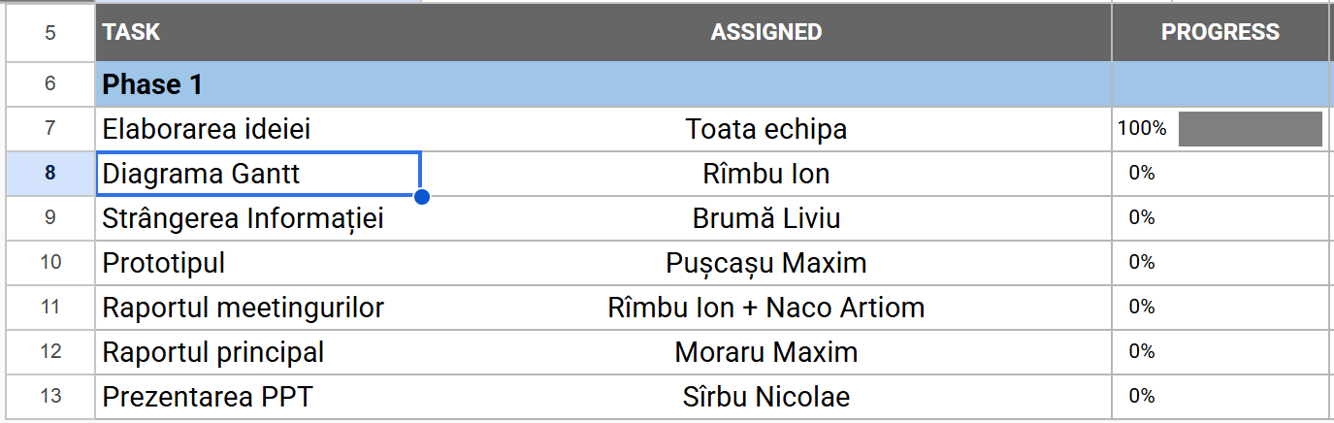

Refer to the action register for the complete list of actions.

Decisions
Taken decisions and recommendations
Final Project Selection: Agreed to proceed with Subject 2: Privacy Hub (PrivacyPack) as the official project.
Tasks were distributed among team members.

Next meetings
Dates and places of the next meetings if they have been defined
16.10.2026

