ICPP Project
Meeting report
Meeting report 1

Owner | Rîmbu Ion
Document title and version | Meeting Minutes
Date and the time of the meeting | 25.09.2026
Project reference | Privacy Hub
Meeting place | Universitatea UTM

Recipients
Attended the meeting? | Owner | Group | E-mail
 | Rîmbu Ion | SD-262 | ion.rimbu@stud.fcim.utm.md
X | Moraru Maxim | SD-261 | maxim.moraru@stud.fcim.utm.md
X | Pușcașu Maxim | SD-261 | maxim.puscasu@stud.fcim.utm.md
 | Naco Artiom | SD-262 | artiom.naco@stud.fcim.utm.md
 | Brumă Liviu | SD-262 | liviu.bruma@stud.fcim.utm.md
 | Sîrbu Nicolae | SD-262 | nicolae.sirbu@stud.fcim.utm.md

Table of Contents
Objectives of the meeting 3
Agenda 3
Discussion points 3
Refer to the action register for the complete list of actions. 4
Decisions 4
Next meetings 4

Objectives of the meeting
What are the objectives set for this meeting?
Why did you gather these members in this place on that day?
Brainstorming and validating the project idea

Agenda
Previous agenda
Welcome & Meeting Objectives
Project Brainstorming & Pitches
Evaluation & Selection

Discussion points
Subjects discussed in the meeting
Subject 1: Smart Traffic Light System
Summary of discussions: Evaluated the concept of an adaptive traffic light system that regulates signal timings dynamically based on real-time road traffic density.

Subject 2: Privacy Hub
Summary of discussions: Evaluated build that allows users to discover, select, and compile personalized software packs of open-source, privacy-respecting tools and optimization utilities based on their operating system and use case.

Subject 3: Room Availability & Classroom Scheduling Application
Summary of discussions: Explored a scheduling application designed to organize timetables around room capacity and real-time availability (e.g., tracking occupied classrooms, scheduled courses, and assigned student groups across available rooms).

Actions

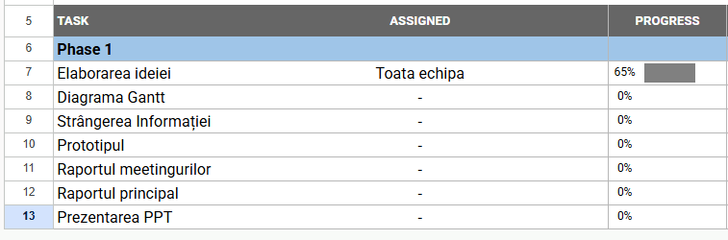

Refer to the action register for the complete list of actions.

Decisions
Taken decisions and recommendations
No final decisions were reached during this session. The team held preliminary discussions on the project concepts.

Next meetings
Dates and places of the next meetings if they have been defined
02.10.2026

