**What I know about...**

1. My First name Only and last initial Only:

**Angel L**

1. My present understanding about this topic:

**I have a normal understanding, but not expert because my previous school mainly focused on unity, rpg maker (by my choice), adobe creative cloud and others. Not so much standard HTML, Javascript, etc type coding**

1. Something I would like to learn about this topic:

**Get an understanding of how to code with these types taught in the class since it doesn’t have the other ones**

1. **Links to websites or Apps that might be helpful about this topic**
2. <http://google.ca>
3. <https://www.khanacademy.org/>
4. <https://www.codecademy.com/>
5. <https://www.udemy.com/>
6. <https://www.skillshare.com/>
7. **Images or videos connected to the above topic**
8. 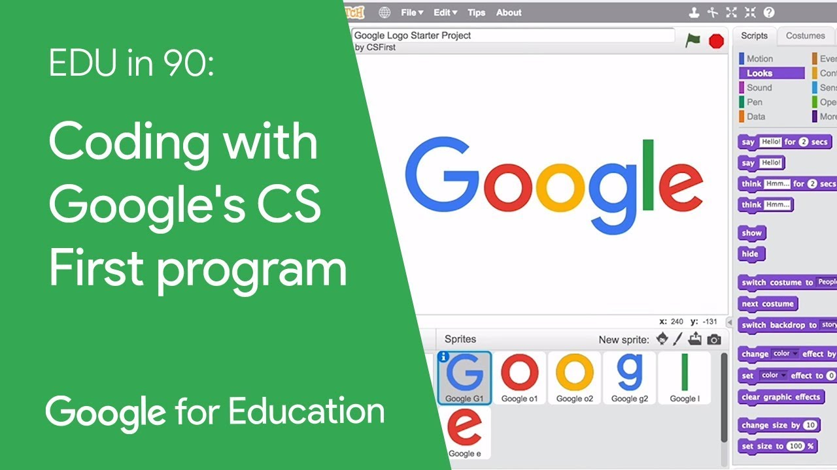
9. 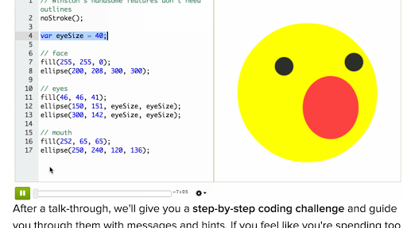
10. 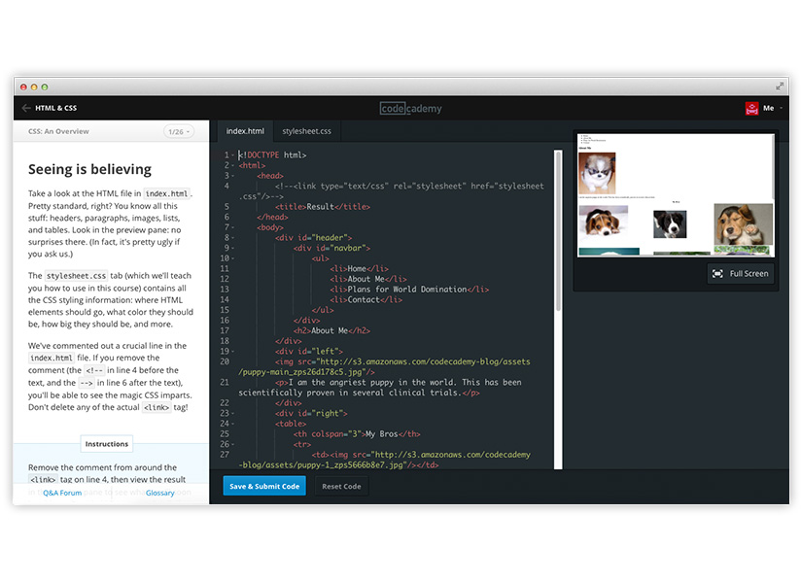
11. 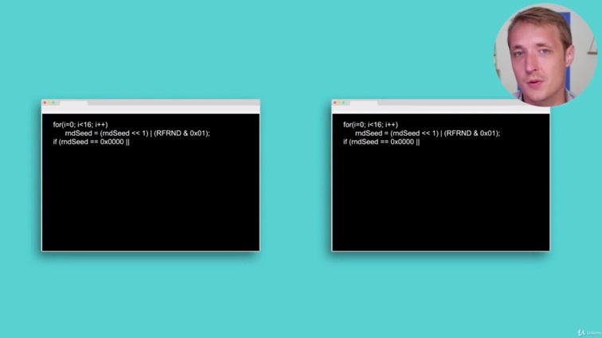
12. 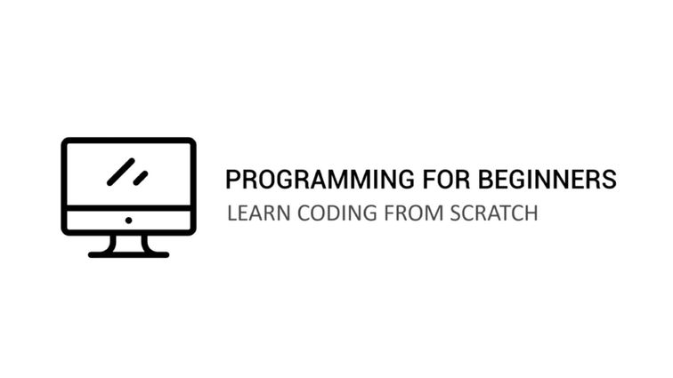
13. **Anything else?**

Since I was mainly being taught adobe, unity and dedicated game dev apps, it might take me a little bit to get adjusted to solely learning just Javascript