number: 44

Group member:

Jiayun Hu

Hyun Ji Moon

Wai Tong Suen

Hao Wu

The project is about COVID-19 contact tracing website that we start do some research.

Main page

The first relevant map we found was google map <https://news.google.com/covid19/map>. When we visited the homepage, what appeared was a COVID map, each state marked the number of recent cases and show us the location of the case. On the right-hand side, it got the small button “+”, “-”, this will let user easy to make the map bigger or smaller. There is a search engine under the map, which can help users to search accurately the place they want to query. This simple design makes the website easy to use.

Map showing

Another web is also about COVID-19 <https://www.bbc.com/news/world-51235105>. This website is similar to the first website in that it shows the number and distribution of cases on the map. The difference is that there are not many places for users to choose from on this website, only a few options are given to users, which cannot be accurate to the region. For users, using search can make it easier for users to find the place they want to view than choice the place.

What's interesting is that this map uses small circle and large circle to circle the approximate range of cases. When the user clicks on the circle, the total cases will be displayed.

Log in

We find the log-in page from RAA <https://www.raa.com.au/>. We decided to design a simple and easy-to-understand login interface to provide the necessary functions and information while being simple. The login page of RAA, this is very simple, divided into two sides, one is account login, the other is login with social account. The login interface we designed will be similar to this one. We would add a sentence “Are you a shop owner?” under the “Don’t have an account?”.

Check-in history

In the check in page, we got some idea from this link <https://www.trivago.com.au/>. After the user login to the user page, we want the user history check in show on the user page like this. This module is very suitable for showing users the timeline of their check-in. In this way, it is also very convenient for users to find the time, place and location of their check-in. This appearance also looks very clear and clean, without making users unable to quickly find their history.

Account manage page (user)

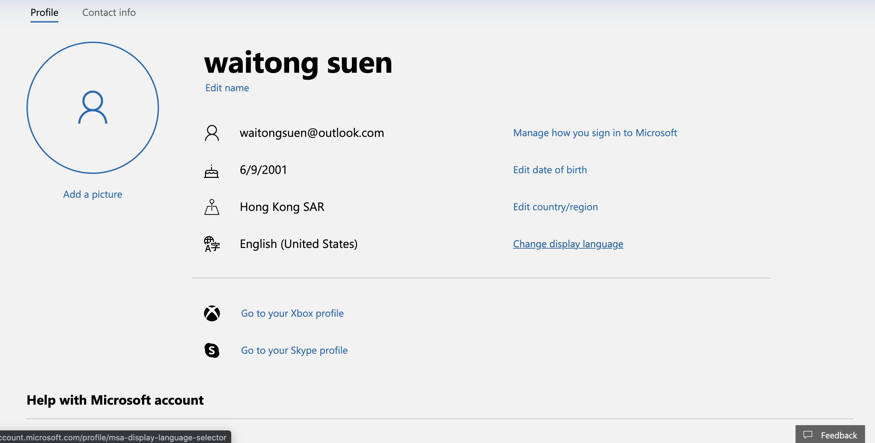

For individual user, we prefer to use the layout from outlook email account[https://outlook.live.com/]. This layout is clear, low cognitive load, user don’t have to think too much while they want to change their information, the affordance of this layout is pretty high due to the graph(symbol) relevant to the information. The relevant information for user list together, the feedback button would directly link to the contact us.

Check in

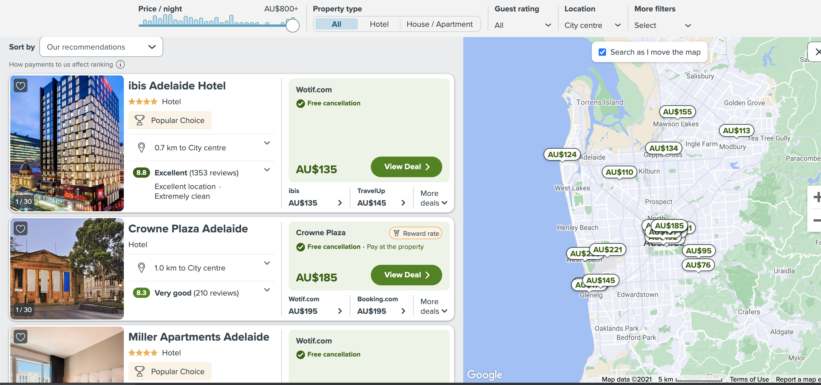

For check in part, instead of using QR code, we think about using “venue nearby” check-in, we would have a input place for you to input the venue id to check-in and also get your location, list the venue nearby you and check in just like the the design above from chivago [https://www.trivago.com.au/], and the bracket will show location information and also a button for you to check-in , we would also have an automatically check-in to let you check in the nearest venue by clicking one button.