**Student Name:** Darshit Modi  
**ID:** 4961714  
**Tutor Name:** Tanjila Kanij   
**Team members:**   
Josh Hardy (7678282)  
Gurkeerat Singh (100023641)  
Luke Sutherland (1751328)

__________________________________________________________________________________

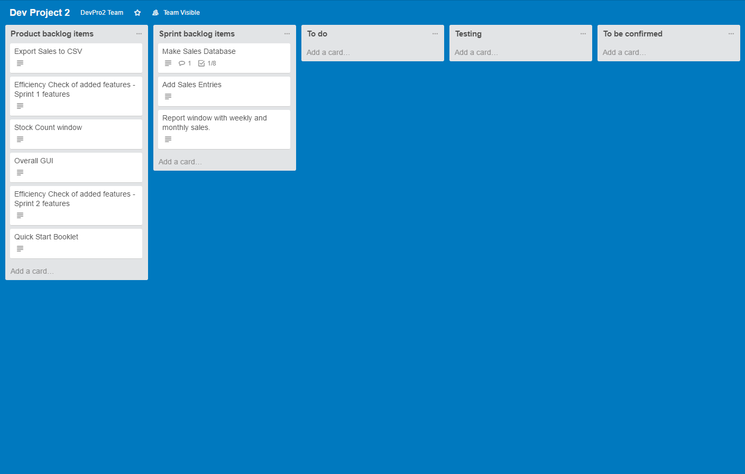**Task Board:**

Trello link: **https://trello.com/b/leEndqmr/dev-project-2**

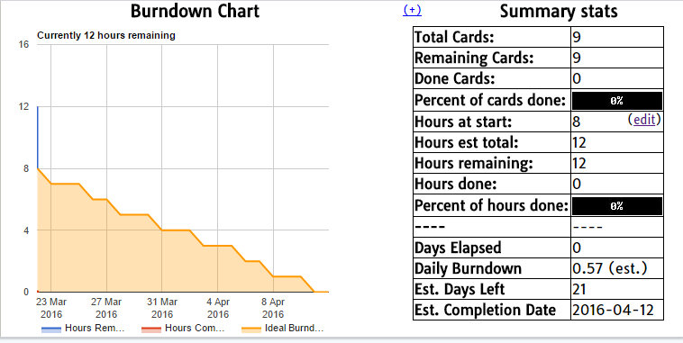**Burn down Chart:**

Github: **https://github.com/s100023641/DevPro2**

