**Student Name:** Darshit Modi  
**ID:** 4961714  
**Tutor Name:** Tanjila Kanij   
**Team members:**   
Josh Hardy (7678282)  
Gurkeerat Singh (100023641)  
Luke Sutherland (1751328)

__________________________________________________________________________________

**5.2 Sprint 1 - Week 2:**

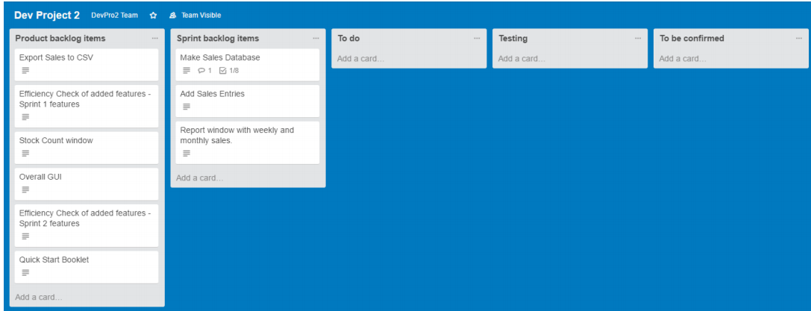**Trello task board: (Days 5-10):**  
**Days 5-8:**

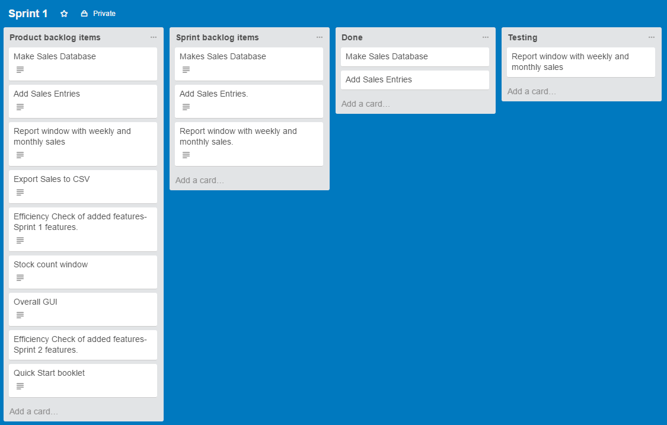**Days 8-10:**

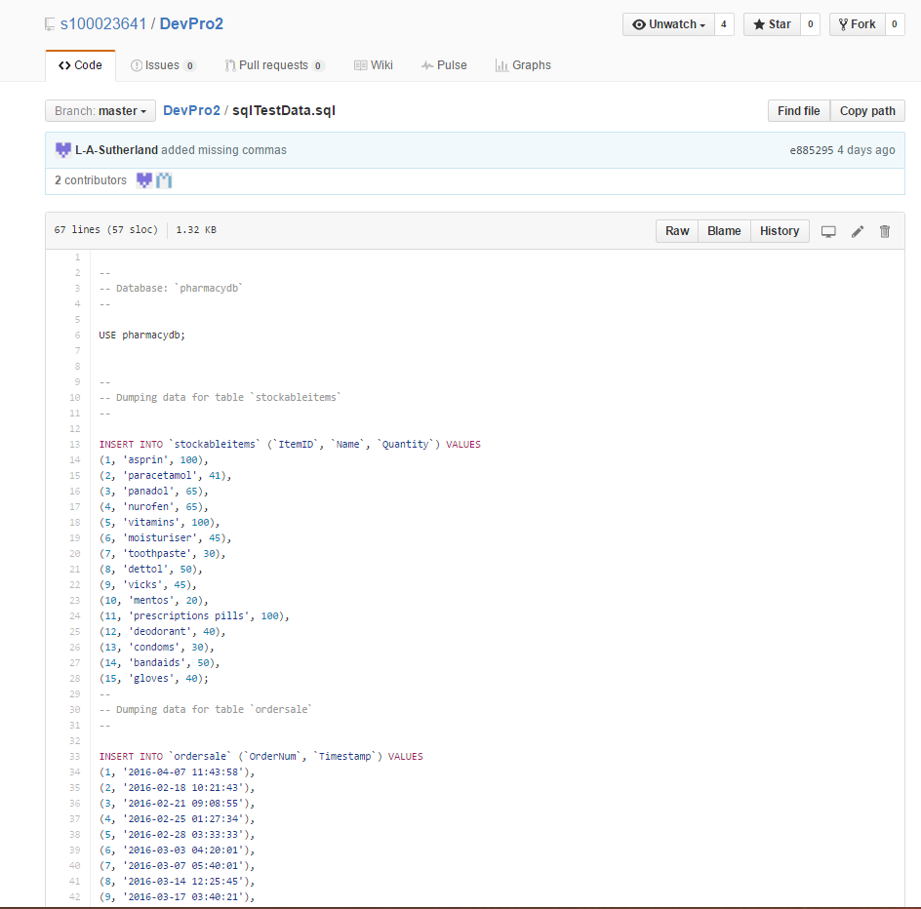**GitHub Repository:  
Day 8:**

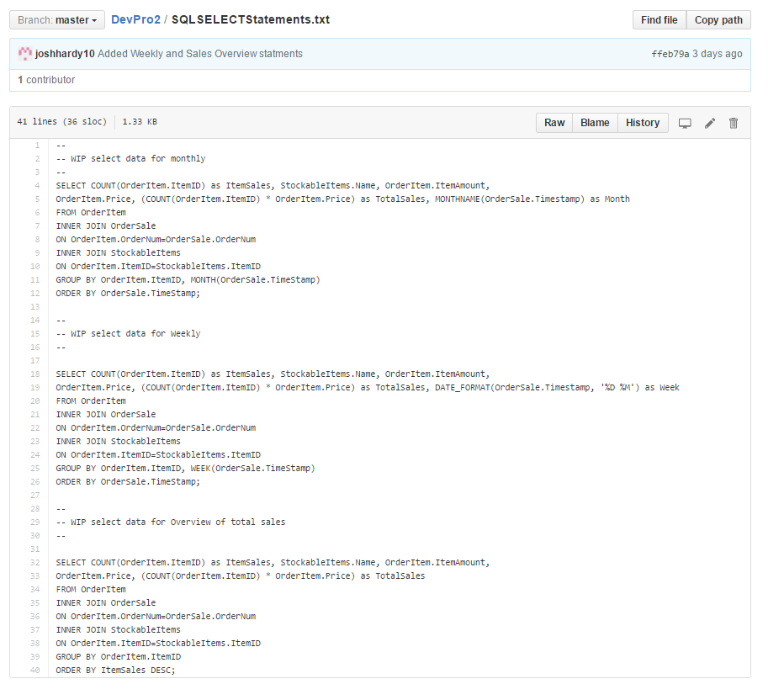**Day 9:**

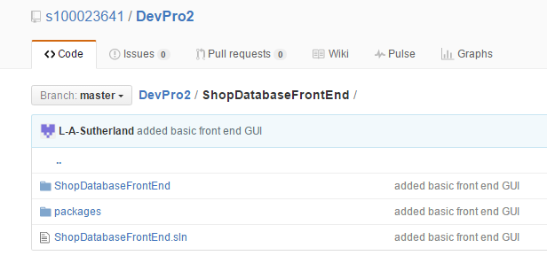**Day 10:**

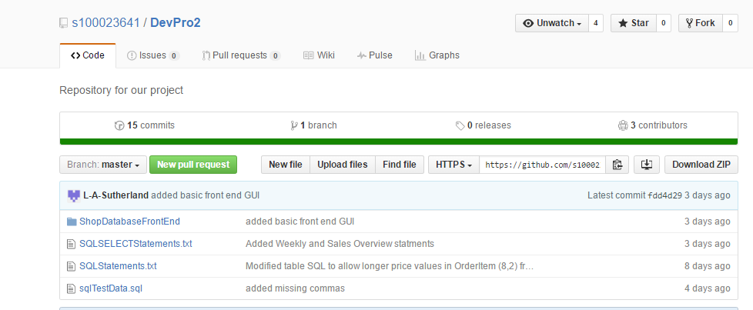**Total overview of repo:**

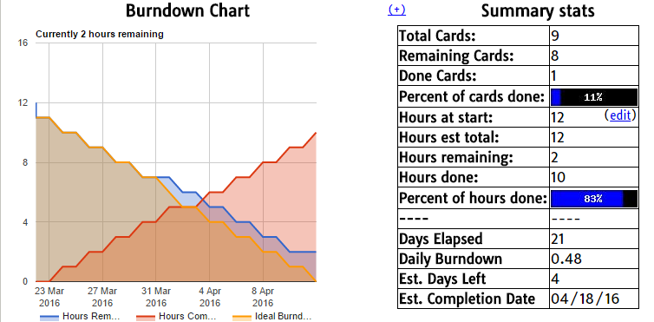**Burn down chart overview:  
Note:** Due to something going wrong with our burn down chart we were unable to provide a day by day update. (As explained during the sprint 1 demonstration in the tutorial).