**Student Name:** Darshit Modi  
**ID:** 4961714  
**Tutor Name:** Tanjila Kanij   
**Team members:**   
Josh Hardy (7678282)  
Gurkeerat Singh (100023641)  
Luke Sutherland (1751328)

__________________________________________________________________________________

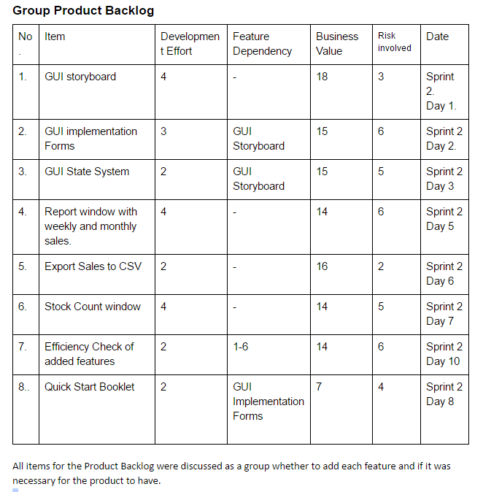**6.3P Sprint Planning Meeting 2:**

**Highest Priority Task(s):**  
**-Overall GUI.**

This was the highest priority task because the team felt like it was the longest task from the sprint backlog. Overall GUI is the visual board of the program that the team is trying to create. So this task had to broke down into further steps to simply the task. Every member of the team decided this was a good idea and each part of the GUI could be assigned to one team member to be worked on and put together at the end to combine it and make an overall GUI.

So this is the reason why the GUI items were at the top of the priority list because the team felt it was the most important task and it had to be completed as soon as possible. All of the other tasks such as specific forms like Stock Count Window, export sales to csv and the quick start booklet are tasks that would only be able to be worked on after the GUI has been implemented. This is why the team felt these items in the sprint backlog are lower down on the list in terms of priority.

**Further Steps:**-GUI Storyboard.  
-GUI Implementation forms.  
-GUI State system.

The team felt like breaking down the overall GUI into smaller tasks using a WBS would be easier to work with and it allows the members to delegate work to one another and work on individual parts of the GUI and combine the end result after it has been worked on.  
  
**WBS:**

**GUI**

**State system**

**Storyboard**

**Implementation forms**

-Coding each page. - Page names. - Controls user interface.  
-Implementing the design. - Navigation. - 2HR.  
- 3HR. - Page design.  
 - 4HR.  
**Total Hours for GUI (Estimation):**  
- 9 Hours.