**Student Name:** Darshit Modi  
**ID:** 4961714  
**Tutor Name:** Tanjila Kanij   
**Team members:**   
Josh Hardy (7678282)  
Gurkeerat Singh (100023641)  
Luke Sutherland (1751328)

__________________________________________________________________________________

**6.4P Sprint 2 Setup:**

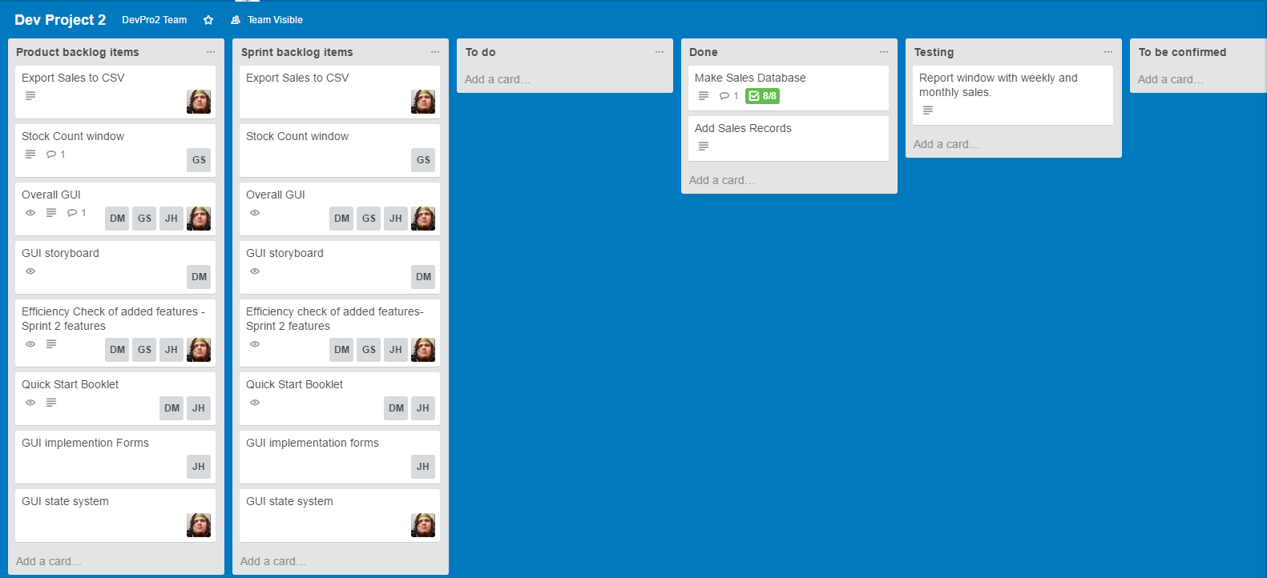**Day 0 Trello Board:**

**Trello :** [**https://trello.com/b/leEndqmr/dev-project-2**](https://trello.com/b/leEndqmr/dev-project-2)

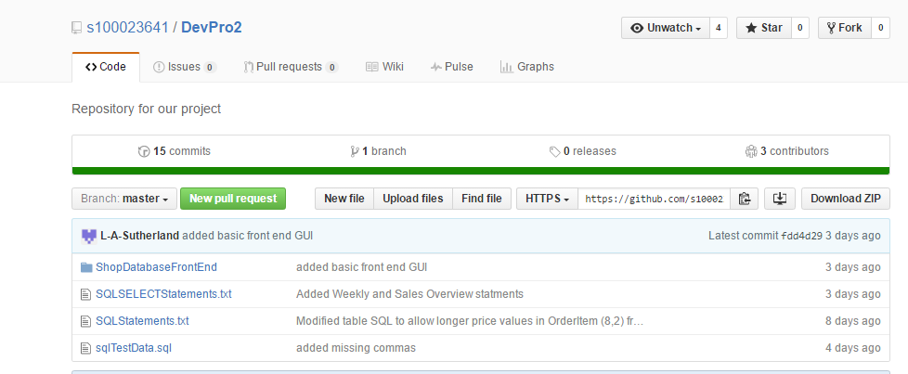**Github**: https://github.com/s100023641/DevPro2

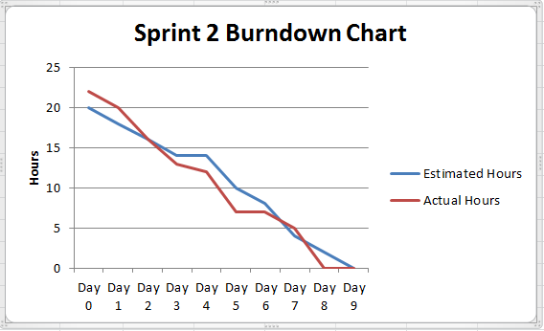Burn down Chart: