**Student Name:** Darshit Modi  
**ID:** 4961714  
**Tutor Name:** Tanjila Kanij   
**Team members:**   
Josh Hardy (7678282)  
Gurkeerat Singh (100023641)  
Luke Sutherland (1751328)

__________________________________________________________________________________

**7.2P Sprint 2 Week 1:  
Trello Boards:**

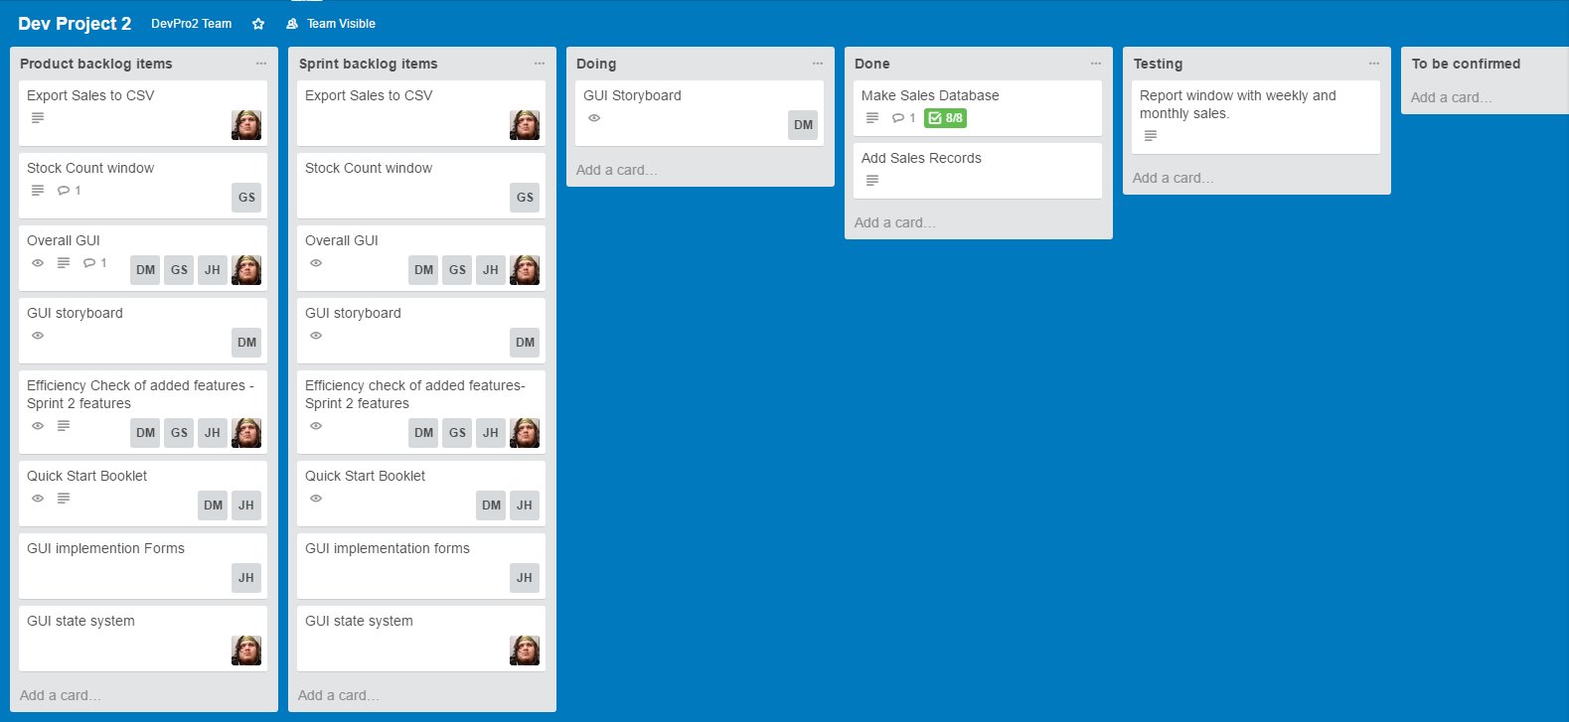**Day 1 Trello Board:**

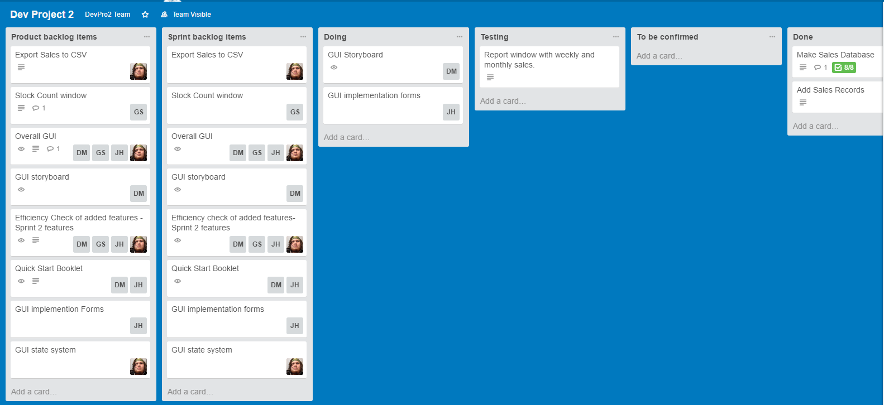**Day 2 Trello Board:**

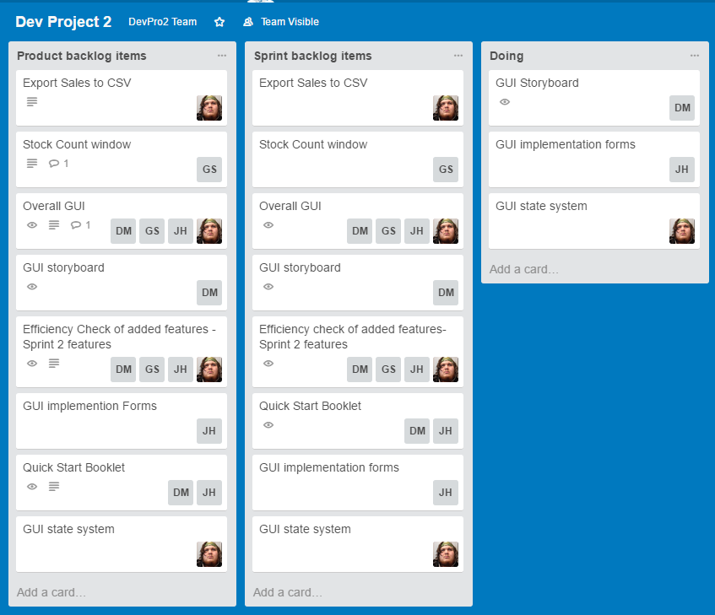**Day 3 Trello Board:**

**Day 4 Trello Board:**

**Day 5 Trello Board:**

**Team Meetings:**

**Day 0**Start: 9:10pm  
End: 9:17pm

**Topics:   
-** Discussed how to perform the GUI storyboard and GUI implementation.  
- Set a deadline to Stock Count Window that should be done by day 3 or 4.   
- Kirat did not participate in this meeting.  
- Did 6.2P definition of done and talked about what we think is done for each task(s).

**Day 1**Start: 8:57pm  
End: 9:05pm

**Topics:**-Storyboard was made. Team mates talked about changing a few things to it or adding some things in.  
- Export sales to CSV was mentioned as work on that should start soon.  
- Kirat did not participate in this meeting.  
- Josh has started on the implementation forms.  
- Luke has started on the state system code.

**Day 2**Start: 8:36pm  
End: 8:42pm

**Topics:  
-** Updated storyboard and made changes from previous team meeting.  
- Josh committed the forms from visual basic on GitHub.  
- Kirat did not participate in this meeting.  
- Luke will work on the state system tomorrow as he did not get a chance to work on the state system today.

**Day 4**Start: 8:59pm  
End: 9:06pm

**Topics:  
-** State system is being worked on.  
- Stock count window page has been started.  
- Josh is still working on implementation forms.

**Day 5**Start: 8:45pm  
End: 8:53pm

**Topics:  
-** Kirat did not participate in this meeting.  
-Implementation of weekly/monthly sales (report window) was done by Josh.  
-Kirat was told to get the stock count window done by Thursday (Day 7).  
-Discussing about what Josh did in the report window.  
- What time Josh and Danny should start working on the booklet was mentioned.