

School of InfoComm Technology

Data Virtualization
Diploma in Data Science (DS)
2025 Oct Semester

INDIVIDUAL ASSIGNMENT
(40% of Module)

09 Jan 2026 – 01 Feb 2026

Deadline for Submission:
Denodo Database File, Report and PowerPoint Slides: 01 Feb 2026 (Sun), 2359hrs

Student Name | : | Simon saw
Student Number | : | S10267332J

Penalty for late submission:
10% of the marks will be deducted every day after the deadline.
NO submission will be accepted after 08 Feb 2026, 23:59.

Table of Contents
1
School of InfoComm Technology 1
1. Introduction with Value-based Problem Statement 3
Understand the business context 3
Identify the business problem 3
Define the Value-Based problem statement 3
Stakeholders 3
Possible Exploratory Questions 4
2. Data sources and Base views 5
Overview of data sources 5
Overview of base views 6
3. Feature Engineering and Derived/Integrated Views 9
Overview of Integrated Views 9
First integrated view 9
Second integrated view 11
Third integrated view 12
4. Final Integrated View 15
Overview of final integrated view 15
CSV files contributing to the final report view 15
5. REST Deployment 17
Overview of REST Deployment 17
6. Summary and Further Improvements 21

1. Introduction with Value-based Problem Statement

Understand the business context

The Bike retail company operates multiple stores and sells a wide range of bicycle products across different categories and brands. Daily operations generate large volumes of data related to customer orders, product sales, and inventory levels. However, this data is stored across multiple operational tables, making it difficult for management to gain a consolidated and meaningful overview of business performance.
Without an integrated view, decision-makers struggle to assess sales trends, identify high-performing or underperforming products, and ensure inventory levels are aligned with customer demand.

Identify the business problem

The sales, product, store, and inventory data are fragmented and spread across different tables. This leads to delayed insights and slower decision-making. There is no real time integrated view of sales performance across stores, inventory availability and stock levels, causing the management team to rely on manual data extraction from different places which is time-consuming, prone to making errors, and not scalable.

Define the Value-Based problem statement

This lack of integration results in slow and inefficient decision-making, causing capital to be tied up in overstocked products with low sales velocity, while high-demand items risk stockouts. As a result, inventory turnover is reduced, cash flow is constrained, and potential revenue opportunities are missed. The inability to quickly identify slow-moving inventory and reallocate stock effectively leads to delayed profit realization and increased holding costs.
Furthermore, reliance on manual data consolidation introduces delays and errors, limiting management’s ability to respond rapidly to demand changes. Without a real-time, integrated view of sales and inventory data, the company experiences slower profit flow, reduced operational efficiency, and suboptimal inventory planning decisions.

Stakeholders

- Sales Manager
Requires visibility into revenue trends, top-performing products, and category-level sales performance to optimize pricing and promotional strategies

- Inventory Planners
Need accurate insights into stock levels and product demand to prevent stockouts and reduce overstock situations.

- Store Managers
Use store-level performance metrics to compare sales across outlets and identify operational improvement opportunities.

- Business Analysts
Require easy and flexible access to integrated data via REST services for analytics, reporting, and dashboard development.

Possible Exploratory Questions

- Which products and categories generate the highest total revenue across all stores, and how do their sales volumes compare?
- How does sales performance and inventory availability differ across stores for the same product categories?
- Which products have a low stock-to-sales ratio and are therefore at risk of stockouts despite strong sales demand?
- Are there products with high inventory levels but relatively low sales volumes, indicating potential overstocking issues?

2. Data sources and Base views

Overview of data sources

The data sources came from multiple CSV files that shows the different parts of the bike retail business. These CSV files were then ingested into Denodo as base views.
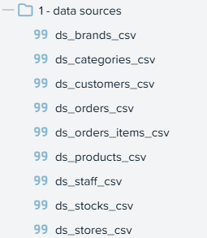

- ds_orders_csv
This dataset contains order-level transactional data, including order identifiers, order dates, customer IDs, and store IDs. It provides the temporal and store context for sales transactions and forms the foundation for sales analysis.

- ds_orders_items_csv
This dataset stores detailed line-item information for each order, including product IDs, quantities sold, and list prices. It is essential for calculating sales volume and total revenue.

- ds_products_csv
This dataset provides product-level details such as product name, category ID, and brand ID. It enables product-based and category-based sales analysis.

- ds_stores_csv
This dataset contains store-related information such as store ID and store name, allowing sales and inventory performance to be analyzed across different store locations.

- ds_stocks_csv
Includes inventory data such as product ID, store ID, and current stock quantity. This dataset is essential for inventory availability and stock-to-sales analysis.

- ds_categories_csv
This dataset contains category reference data, including category IDs and category names. It supports consistent product categorization and enables aggregated reporting such as total sales by category.
- ds_customers_csv
This dataset stores customer-related information such as customer ID and basic contact or location details. While not directly used in the final inventory-focused report view, it provides extensibility for future customer-level or regional sales analysis.

- ds_brands_csv
This dataset contains brand reference data associated with products.

- ds_staffs_csv
This dataset contains staff-related information.

Overview of base views

I created base views from the individual CSV files.
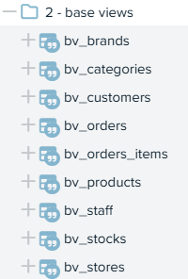

During the creation of base views, data types were reviewed and standardised to ensure consistency and correctness across all datasets.

Identifier fields such as order_id, product_id, store_id, and customer_id were converted from text to integer data types. This ensures proper join behavior between related datasets and improves query performance during integration and aggregation.
Similarly, numeric fields such as quantity, list_price, and stock_quantity were converted from text to integer or numeric data types (float) where appropriate. This conversion is essential to enable accurate calculations for metrics such as total quantity sold, total revenue, and stock-to-sales ratio.

Date-related fields such as order_date were also validated and stored using the correct date data type to support time-based analysis and derived fields.

For example
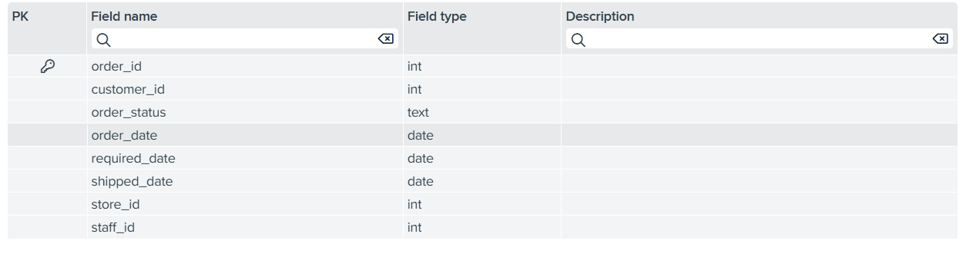
This is ds_orders_csv.

I changed the order_id, customer_id, store_id, staff_id from text to id.
I changed the order_date, required_date, shipped_date from text to date.

Here are the other base views with the changed field types.

bv_brands
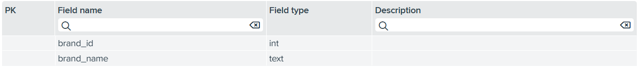

bv_categories
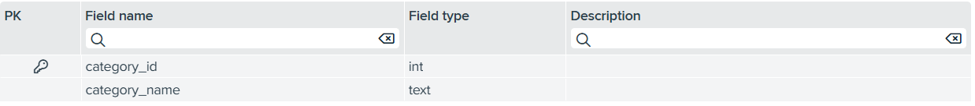

bv_customers
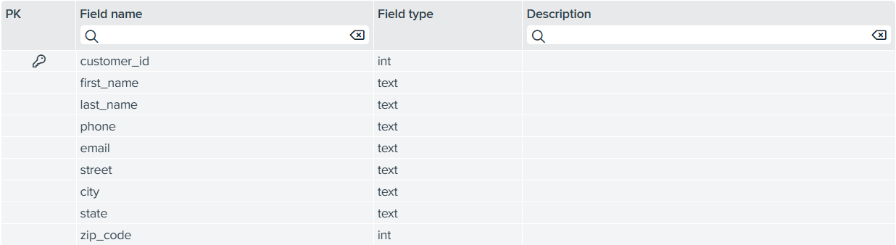

bv_order_items
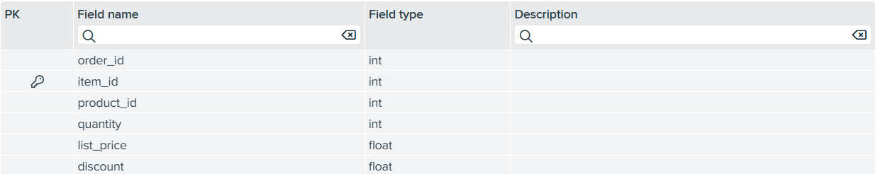

bv_products
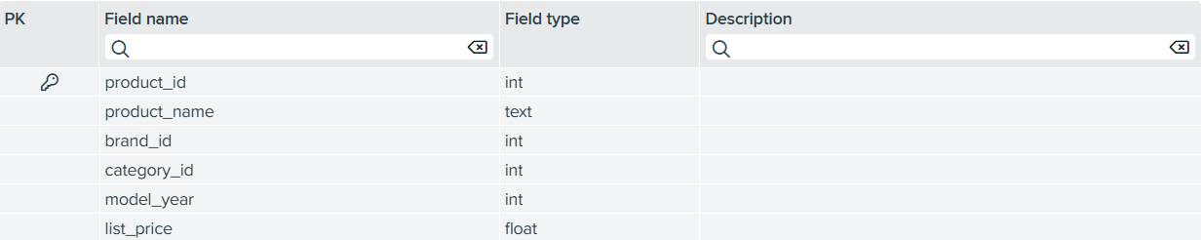

bv_staff
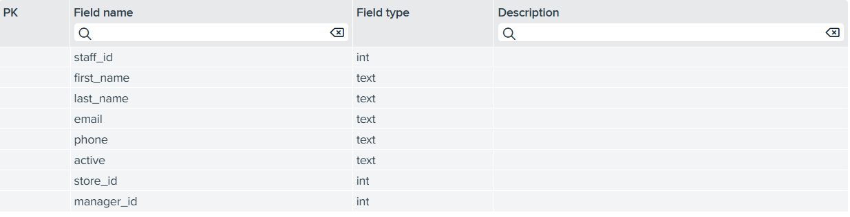

bv_stocks
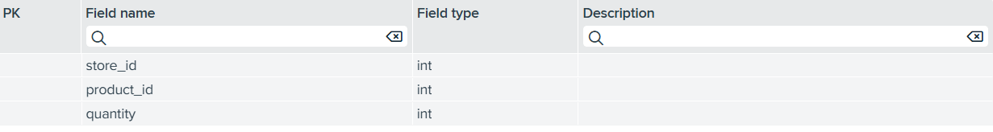

bv_stores
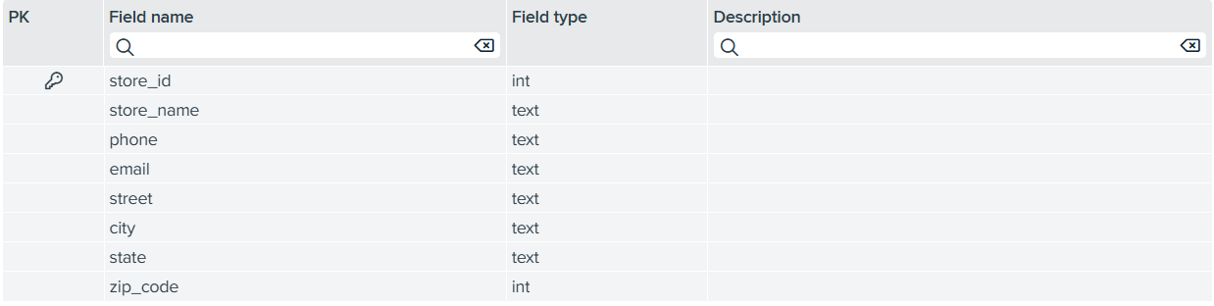

Although base views were created for all available CSV files, not all datasets were required in the final integrated report view. Datasets such as brands and staff were excluded to reduce unnecessary complexity and because they did not contribute directly to the inventory and sales performance metrics defined in the business problem.

3. Feature Engineering and Derived/Integrated Views

Overview of Integrated Views

After establishing the base views, feature engineering and data integration were performed to transform raw operational data into meaningful analytical datasets. This stage focused on combining related data sources, deriving new business metrics, and aggregating transactional data to support management-level analysis. The result is a set of derived and integrated views that progressively enrich the data and reduce complexity for reporting and REST consumption.

First integrated view

For my first integrated view (iv_sales_detail), I joined 5 base views(bv_orders, bv_order_items, bv_products, bv_stores, bv_categories) to make this integrated view.
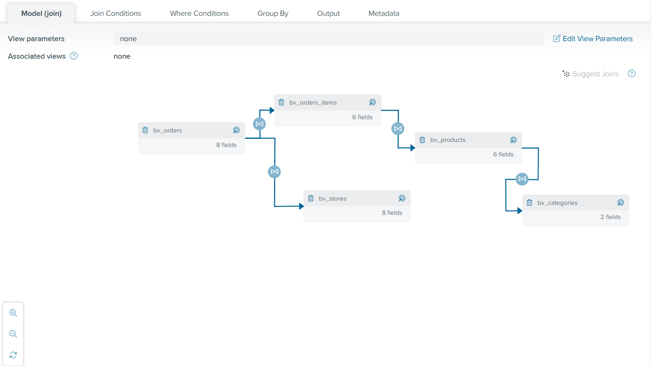

Join Conditions:
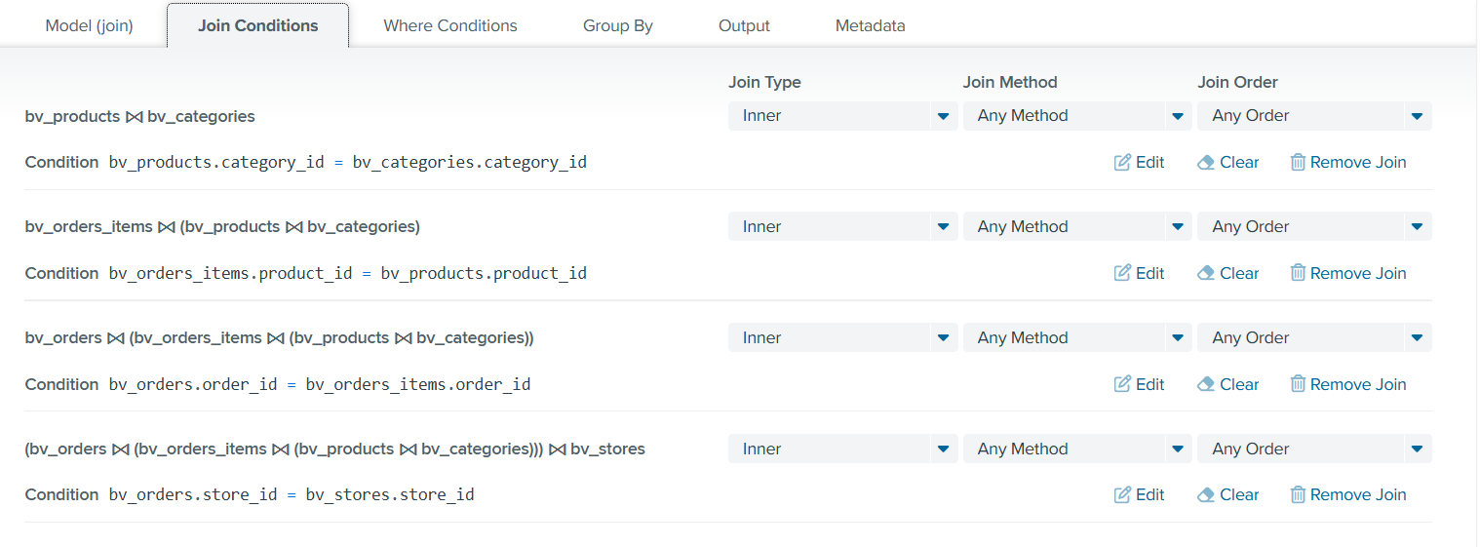

This iv_sales_detail was constructed using a series of INNER joins between base views. INNER joins were deliberately chosen to ensure that only records with valid and complete relationships across all datasets are included in the final integrated view.

Feature Engineering:

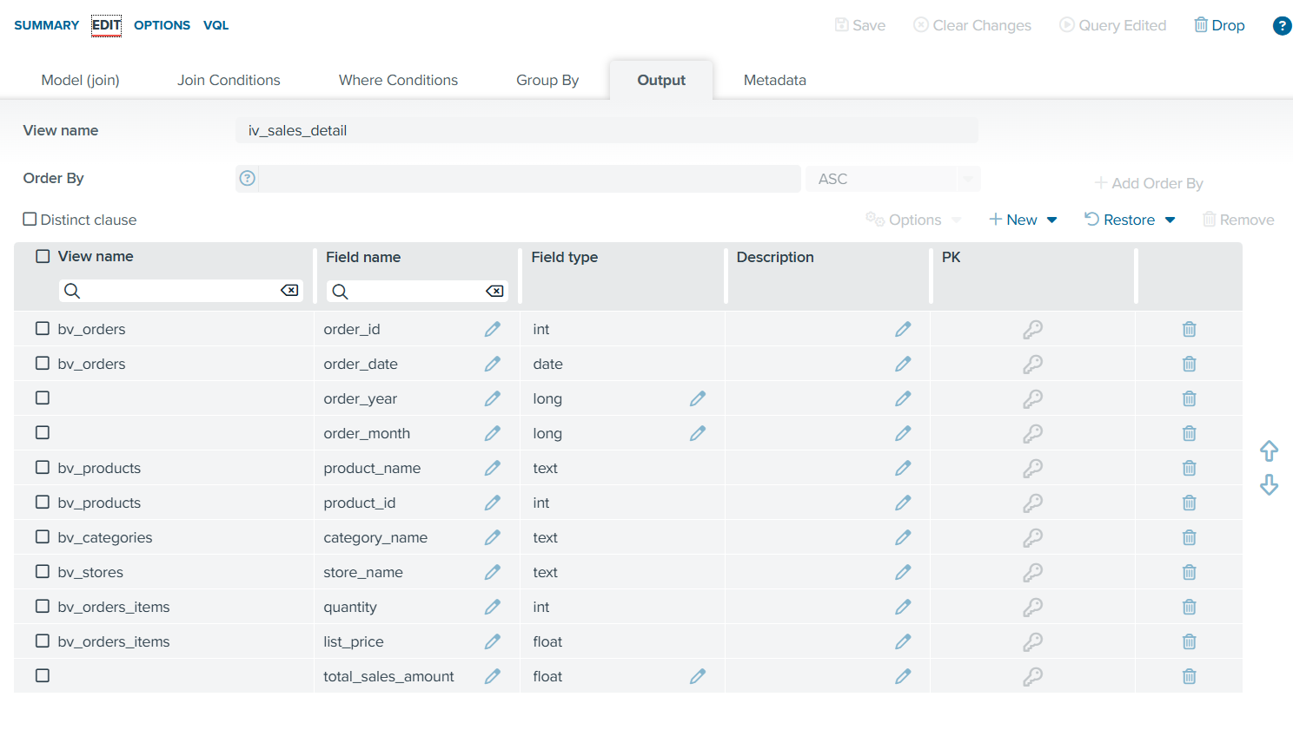
I also made new fields such as order_year, order_month and total_sales_amount.

The order_year field was derived from the order_date column in the bv_orders base view.
The order_month field was also derived from the order_date column.
The total_sales_amount was derived from multiplying quantity and list_price from bv_order_items.

I also deleted all unnecessary views such as category_id , city and state because all these views do not contribute to making a iv_sales_details.
I only kept product_id from bv_products because product_id is needed in the join condition for my third integrated view (iv_inventory_sales_analysis)

Second integrated view

The iv_product_sales_summary view was created as an aggregation view to summarize product-level sales performance. Its purpose is to transform detailed transactional data into meaningful business metrics that can be easily consumed by management and analytics tools.
For my second integrated view (iv_product_sales_summary), I used iv_sales_view.

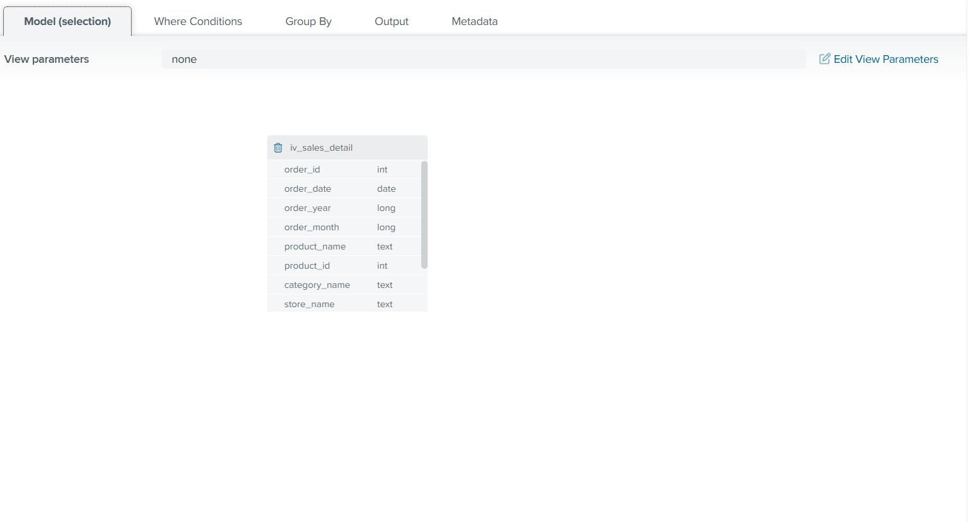
GROUP BY:

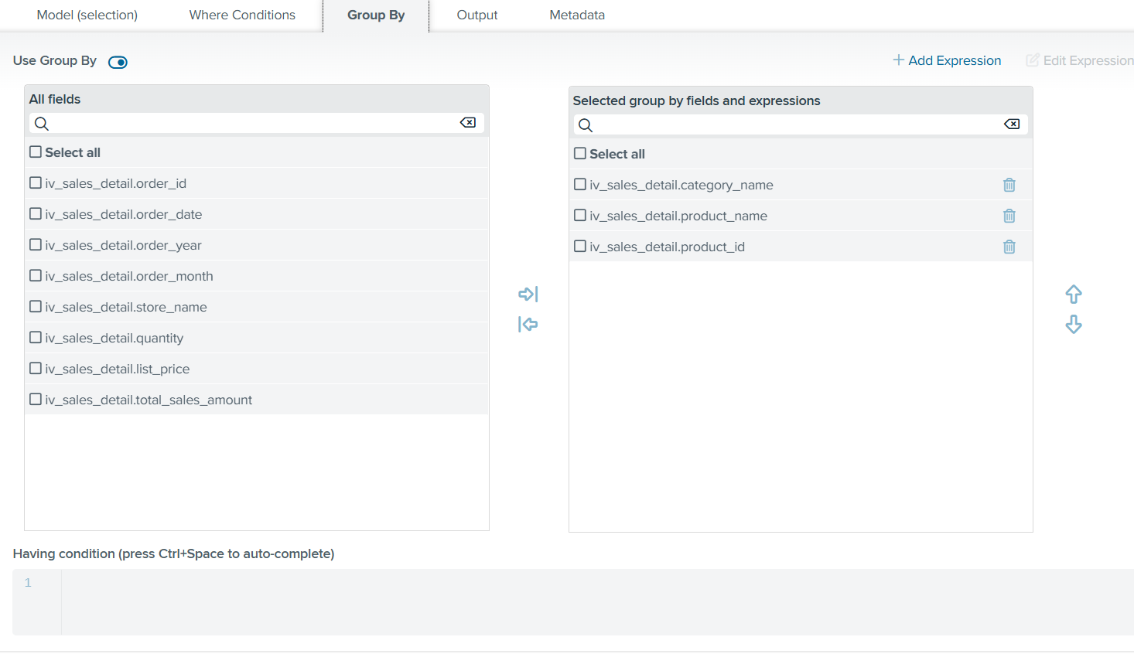
The view uses GROUP BY operations on category_name , product_name , product_id.
These grouping fields define the grain of the view as one row per product per category, enabling accurate product-level reporting.
Feature Engineering:
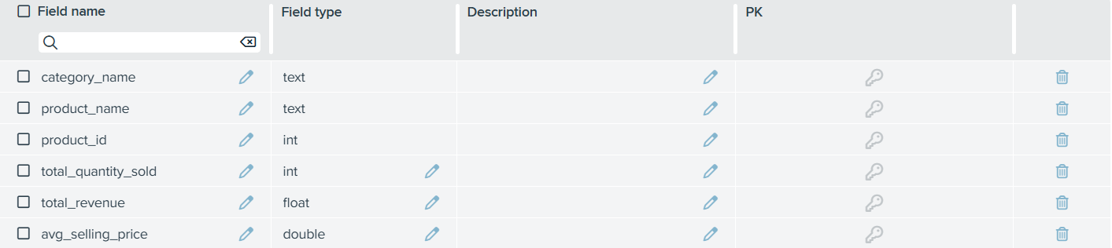

I made new fields (total_quantity_sold, total_revenue, avg_selling_price)

The total_quantity_sold field was derived by applying a SUM aggregation on the quantity field from the bv_orders_items base view, representing the total units sold per product.
The total_revenue field was derived by summing the calculated total_sales_amount, providing an aggregated measure of revenue generated per product.
The avg_selling_price field was derived using an AVG aggregation on the list_price field from the bv_orders_items base view, reflecting the average selling price of each product.

I still kept product_id because product_id is needed in the join condition for my third integrated view (iv_inventory_sales_analysis)

Third integrated view

For my third integrated view (iv_inventory_sales_analysis), I used iv_product_sales_summary , bv_stocks, bv_stores.
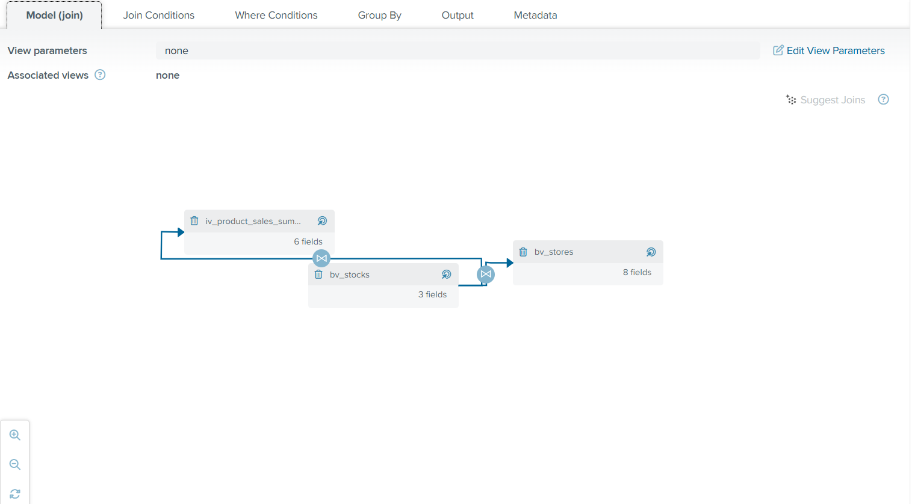

Join Conditions:
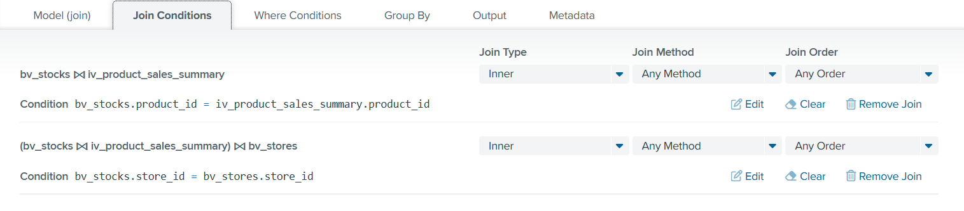
This inner join links inventory stock data with aggregated product sales using product_id and store_id, ensuring only valid products with both sales and stock information are included for accurate inventory-to-sales analysis.

Feature Engineering:
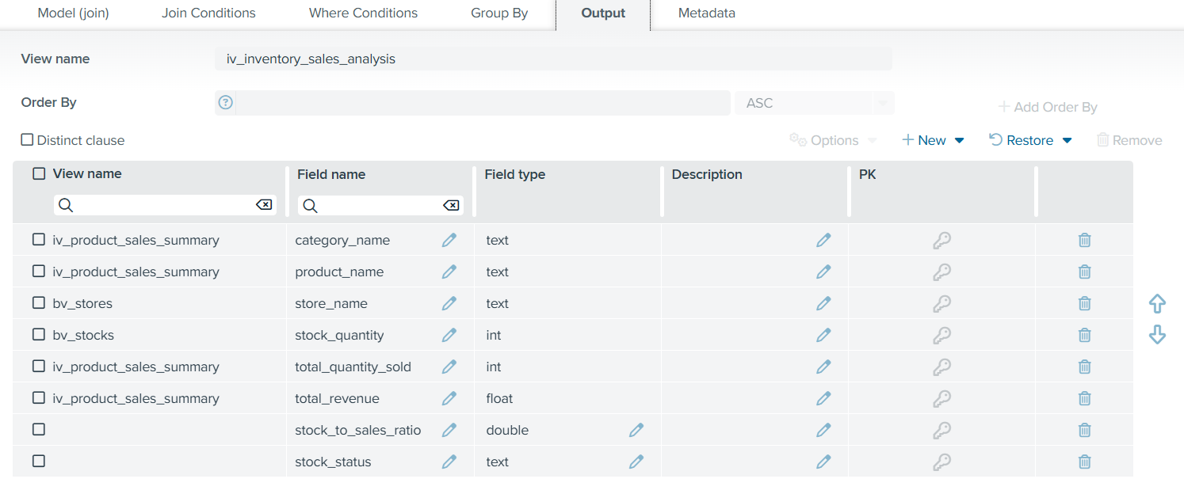

The stock_to_sales_ratio is a derived metric created to measure the relationship between current inventory levels and historical sales performance for each product at a specific store.
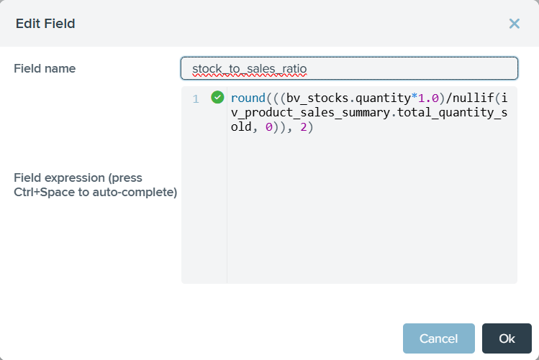

The stock_status field is a categorical feature derived from the stock_to_sales_ratio to translate numeric values into an easily interpretable business indicator.
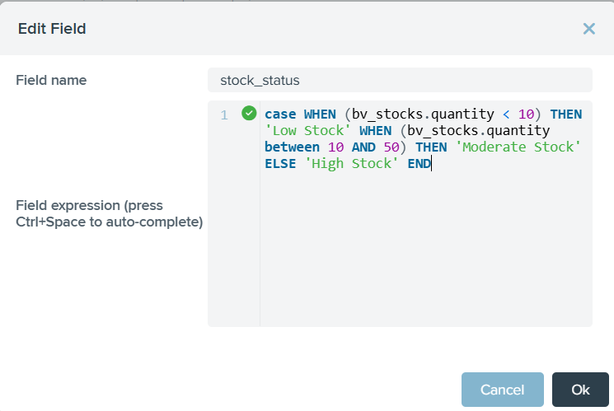

4. Final Integrated View

Overview of final integrated view

The final integrated view (final_iv_management_sales_inventory_report_view) represents a consolidated and business-ready dataset that integrates sales performance and inventory information across products, categories, and stores. This view was designed to provide management and operational stakeholders with a single, unified source of truth for monitoring sales trends, inventory availability, and stock health.
By combining transactional sales data with inventory data and derived metrics, this final view eliminates the need for manual data extraction from multiple sources and supports near real-time, data-driven decision-making.

CSV files contributing to the final report view

The final report view is built upon base views derived from the following core CSV files
- ds_orders_csv
Provides order-level transactional data such as order dates and store identifiers. This dataset enables the analysis of sales activity across time and across different store locations.
- ds_orders_items_csv
Contains detailed order line-item data including product IDs, quantities sold, and list prices. This dataset is essential for calculating sales-related metrics such as total quantity sold and total revenue.
- ds_stocks_csv
Supplies inventory-level data including product IDs, store IDs, and current stock quantities. This dataset supports inventory availability analysis and enables the calculation of stock-to-sales metrics.
- ds_products_csv
Provides product-level information such as product ID and product name. This dataset enables product-level sales analysis and acts as a key link between transactional sales data and inventory data.
- ds_categories_csv
Contains category reference data that maps products to their respective categories. This dataset supports category-level aggregation and allows sales and inventory performance to be analyzed by product category.
- ds_stores_csv
Stores store-related reference data such as store ID and store name. This dataset enables store-level reporting and comparison of sales and inventory performance across different retail locations.

For my final view (final_management_sales_inventory_report_view), I used iv_inventory_sales_analysis

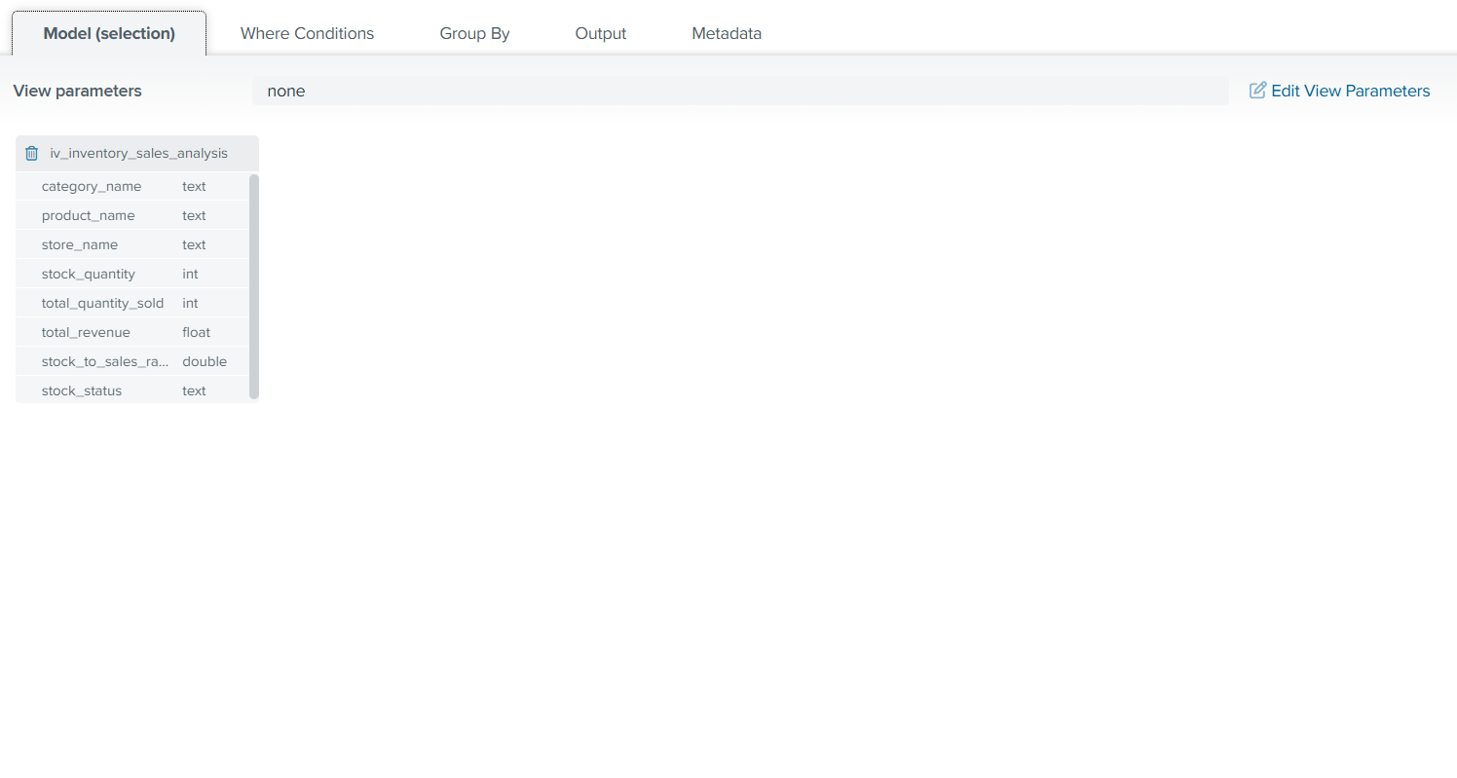
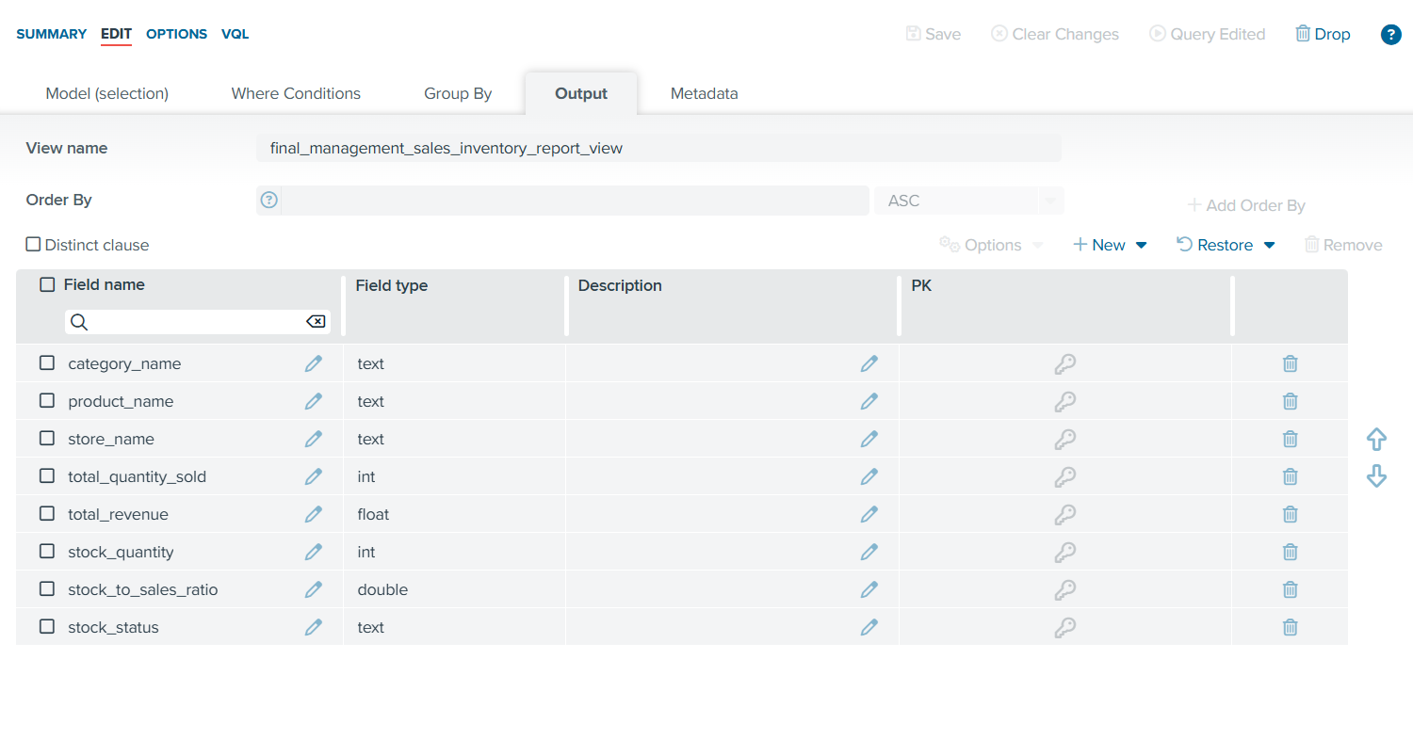
The final_management_sales_inventory_report_view includes the following key fields:
- category_name – Provides category-level context for aggregated reporting
- product_name – Enables product-level performance analysis
- store_name – Supports store-level comparisons
- total_quantity_sold – Represents total units sold per product per store
- total_revenue – Indicates total revenue generated
- stock_quantity – Shows current inventory levels
- stock_to_sales_ratio – Measures inventory relative to sales demand
- stock_status – Classifies inventory health into business-friendly categories
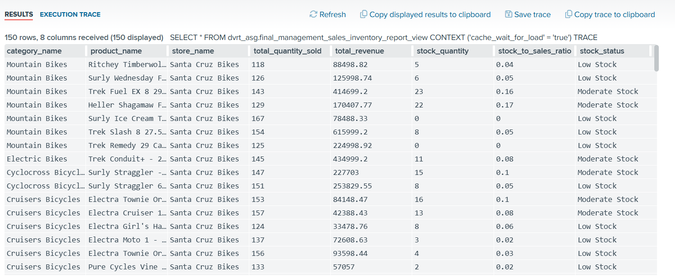

The final_management_sales_inventory_report_view enables management to quickly identify high-performing and underperforming products, stores at risk of stockouts, inventory imbalances relative to demand, opportunities for improved stock planning and replenishment.

By centralizing sales and inventory insights into a single integrated view, the organization can improve operational efficiency, enhance customer satisfaction, and support data-driven strategic decisions.

5. REST Deployment

Overview of REST Deployment

To enable easy and flexible data consumption by downstream applications and stakeholders, the final integrated report view was deployed as a REST web service using Denodo’s built-in data services functionality. This approach allows the consolidated sales and inventory data to be accessed in real time without requiring direct database connectivity.

REST was chosen over SOAP for this project because it provides a lightweight, flexible, and widely adopted approach for exposing data services. REST uses standard HTTP methods and supports simple, human-readable data formats such as JSON, making it easier to integrate with modern analytics tools, dashboards, and web applications. In contrast, SOAP relies on heavier XML-based messaging and strict service contracts, which introduce additional complexity without providing significant benefits for the read-only, data-retrieval use case of this project. Since the final integrated view is primarily consumed for reporting and analytical purposes, REST offers better performance, lower overhead, and faster development and testing cycles. Additionally, Denodo’s native REST support and automatic OpenAPI documentation further simplify service deployment and consumption, making REST a more suitable choice for scalable and self-service data access.

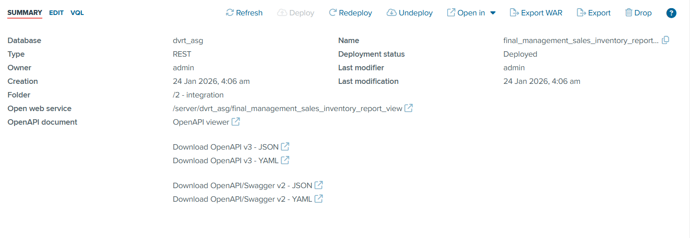
The final integrated view, named final_management_sales_inventory_report_view, was selected as the resource for deployment. This view was chosen because it provides a comprehensive and business-ready dataset combining sales performance, inventory levels, and derived metrics such as stock-to-sales ratio and stock status. Deploying this view as a REST service ensures that business users and technical teams can retrieve consistent, governed data through a single endpoint.
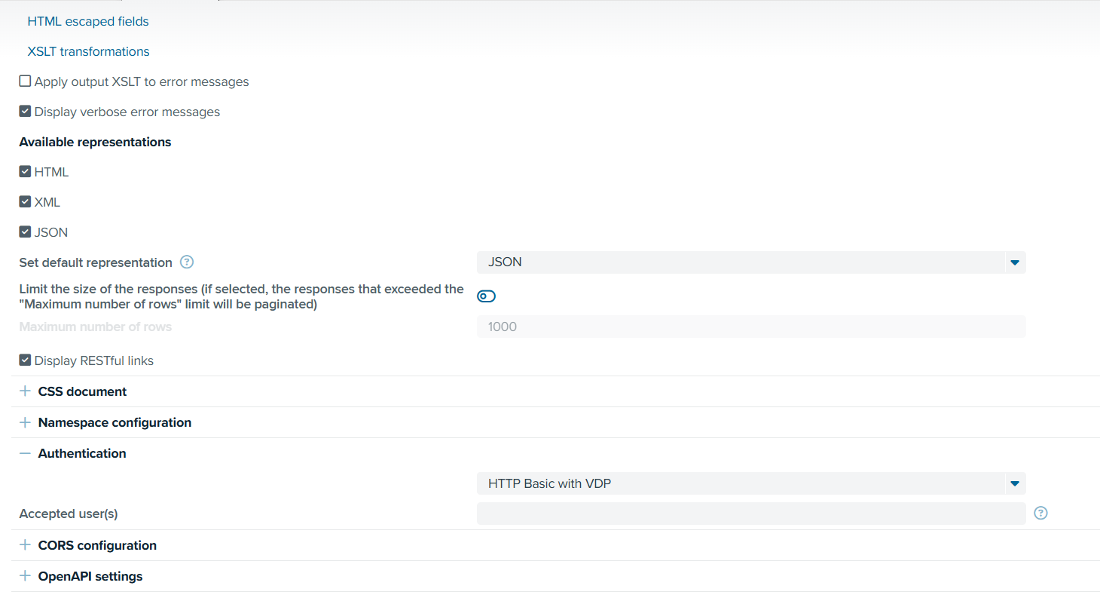
Multiple response representations were enabled, including HTML, XML, and JSON, to support different consumption needs. JSON was set as the default representation because it is lightweight and widely used for system integration, analytics tools, and dashboards. HTML was retained to allow quick visual verification of results directly through a web browser, while XML provides compatibility with legacy systems.
To manage performance and scalability, response size limiting with pagination was enabled. A maximum row limit was configured so that large result sets are automatically paginated. This prevents excessive memory usage and improves response time when querying large datasets.

Authentication was configured using HTTP Basic authentication with VDP, ensuring that only authorised users can access the REST endpoint. This aligns with data governance and security best practices by preventing unauthorised access to sensitive sales and inventory data.

Overall, these settings ensure that the REST service is secure, performant, developer-friendly, and suitable for real-time enterprise data consumption, supporting the overall objective of enabling scalable and governed access to integrated sales and inventory insights.

Proof that the REST service is working:

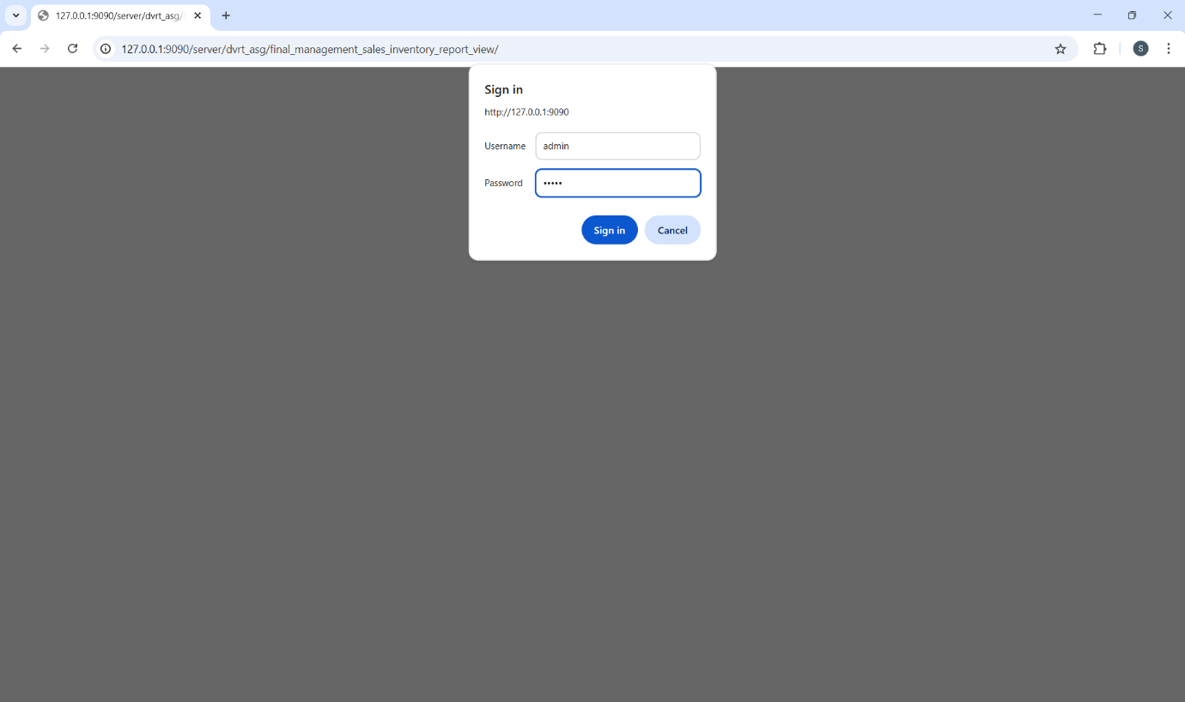

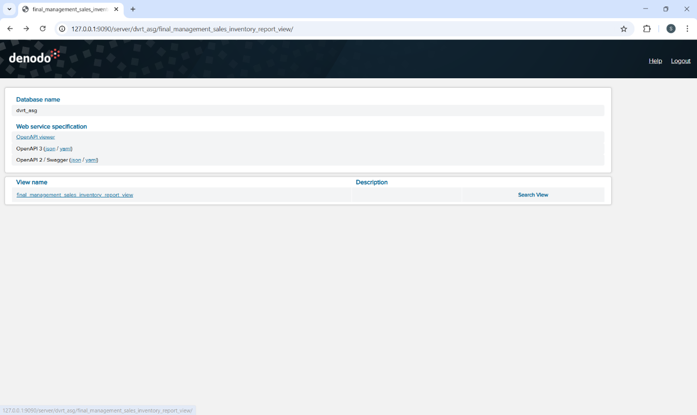
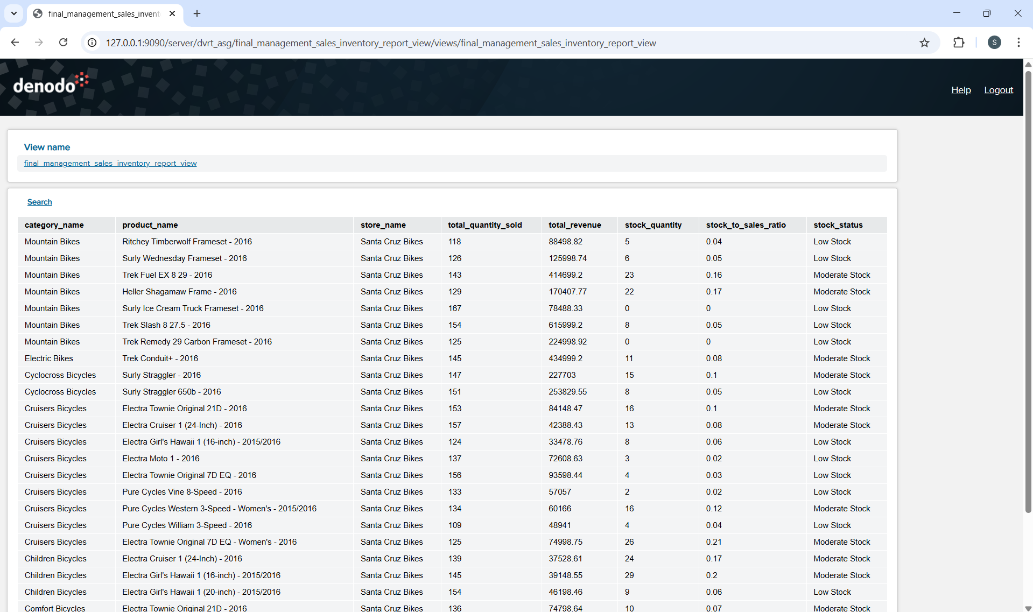
The final report view is deployed on REST service and can be seen and then used for business needs.

6. Summary and Further Improvements

This project demonstrated how Denodo can be used to integrate fragmented data into a unified, virtualised data layer that supports timely and data-driven decision-making. By ingesting multiple CSV data sources as base views, standardising data types, and applying logical joins and aggregations, an end-to-end data pipeline was successfully built.
Feature engineering techniques such as derived time attributes, revenue calculations, aggregation views, and stock-to-sales metrics enabled meaningful business insights into sales performance and inventory health. The final integrated view was deployed as a REST web service, allowing the data to be easily consumed by downstream systems, dashboards, and analytics tools in real time.

Performance could be further optimised by using caching strategies in Denodo for frequently accessed views. Advanced security configurations such as role-based access control could be implemented to support company wide level deployment.
Overall, I found this assignment to be very useful for my future work, and learning how to set up a database using Denodo definitely enhanced my understanding of data virtualization, data integration, and real-world analytics workflows.

