AssetFund Report

Student name: Chuanjin Sun
ID: z5660980

Abstract
AssetFund transforms the foundation of Project A into 13 investable equity, crypto and combined funds, and tests whether equity-sector news improves those funds. All portfolios are evaluated using a monthly expanding-window backtest. The year 2020 observations make up the first estimation sample, while the live testing is done from January 2021 to December 2023. A custom two-stage sleeve risk-parity fund first balances risk within the equity and crypto sleeves and then balances risk between them. This prevents the 50 equity securities and 10 cryptocurrencies from mechanically determining the cross-asset allocation through asset count alone. Headlines are scored using NLTK VADER with a conservative 23-term finance extension. The development review uses 60 headlines, followed by a separate locked holdout of 30 headlines. The finance extension increases the holdout macro F1 score from 0.548 to 0.585. A coverage-aware rank signal increases the primary fund’s 2023 Sharpe ratio by 0.016 before transaction costs, but the advantage disappears at 50 basis points. The Streamlit app presents the fund comparisons, factsheets, allocation tools and sentiment evidence.

1. Introduction
AssetFund aims at a retail investor looking for managed exposure rather than a set of individual investments. The investment problem statement can be formulated in the following way: which systematic fund suits in the investor's risk budget, and does the sentiment signal bring any additional value taking into account timing and trading costs? The present project answers this investment problem by means of comparable out-of-sample performance, portfolios and an application providing the research results visibility.
The minimum course baseline consists of the combination of the equity and crypto universe with two optimisation methods. This solution is extended across four axes, which are related to each other. First, the equity-only, crypto-only and combined family of funds is created using four widely-used optimisation methods. Second, a two-stage sleeve risk parity strategy is developed for the combined universe. Third, a finance-aware VADER extension is evaluated on a reviewed development sample and locked holdout of headlines. Fourth, two sentiment overlays are implemented using the fixed rule and three transaction cost assumptions. Such extensions are required since each of them addresses an observed failure case: imbalance in the number of assets, lack of finance-specific language, uneven sector coverage and small gross trading edge.
The findings are deliberately heterogeneous. Several solutions produce high gross returns. Still, some crypto funds demonstrate drawdowns exceeding 75%. At one rebalance, one minimum variance portfolio invests around 99% into Bitcoin. The sentiment overlay improves the primary fund relative to its baseline under the zero cost assumption; however, it slightly underperforms the baseline at 50 basis points. The recommendations are driven by these findings and not a maximisation of backtests performance.

2. Funds and walk-forward design

2.1 Data, calendars and live schedule
The clean panels of Project A consist of 50 U.S. equities in 10 sectors and 10 cryptocurrencies from 2020 to 2023. The equity and combined portfolios use the common equity trading calendar and 252 trading periods per year. Cryptocurrency portfolios retain their seven-day calendar and use 365 periods per year. The risk-free rate is set to zero and specified for each Sharpe ratio. As a result, the combined panel does not create weekend equity returns, while the cryptocurrency factsheets retain their different trading frequency.
The backtest starts with 2020 as the estimation window. At each month end, the model uses data strictly before the next holding month, calculates a new target and applies that target from the first available date of the next month. The window expands rather than rolling. Equity and combined funds have 753 live observations from 4 January 2021 to 29 December 2023. Crypto funds have 1,095 observations from 1 January 2021 to 31 December 2023. Each fund has 36 target portfolios. Decision dates are earlier than effective dates in the saved audit table.
$$r_{p,t}=\sum_{i}{w_{i,t-1}}r_{i,t}$$
Here rₚ,ₜ is the portfolio return on date t, rᵢ,ₜ is asset i’s simple daily return, and wᵢ,ₜ₋₁ is asset i’s live portfolio weight entering date t. The target weights drift with asset returns within each monthly block. Turnover at the next rebalance is calculated using the new target and the drifted live portfolio rather than the previous target. This distinction is important for methods concentrating in volatile assets. One-way turnover equals half the sum of absolute weight changes. Costs of 0, 10 and 50 basis points are applied at later rebalances. The initial formation cost is not included because there is no previous live portfolio.
$$r_{t}^{net}=\left(1+r_{t}^{gross}\right)\left(1-\frac{τ_{t}c}{10000}\right)-1$$

2.2 Portfolio rules
The minimum-variance portfolio follows the mean-variance approach of Markowitz (1952). Maximum Sharpe follows Sharpe (1966) and uses the historical daily mean and covariance, with equal-weight and inverse-volatility starting points to reduce solver dependence. Risk parity equalises fractional variance contributions following Maillard et al. (2010). Covariance objectives are scaled before optimisation because very small daily values can make SLSQP accept an unchanged starting vector.
$$\min_{w}w^{T}Σw\text{ subject to }1^{T}w=1\text{ and }0≤w_{i}≤1$$
$$\max_{w}\frac{w^{T}μ-r_{f}}{\sqrt{w^{T}Σw}}$$
$${RC}_{i}=\frac{w_{i}{\left(Σw\right)}_{i}}{w^{T}Σw}=\frac{1}{N}$$
The implementation map appears in Table 4. The custom combined method first solves risk parity among equities and among cryptocurrencies. It then treats the two sleeve returns as assets and solves a second risk-parity problem. Each asset's final weight equals its within-sleeve weight times the sleeve weight. This separates economic asset-class allocation from the number of tickers supplied to each sleeve.

3. Out-of-sample fund evidence
Table 1. Gross walk-forward performance across 13 funds. Annualised return is the arithmetic daily mean times 252 for equity and combined funds, or 365 for crypto. The risk-free rate is zero. Sample: 1 January 2021 to 31 December 2023, with equity and combined funds starting 4 January 2021. Source: FINS5545 and AssetFund calculations.
Universe | Method | Ann. return | Ann. vol. | Sharpe | Max DD | Eff. holdings
Equity | Equal weight | 13.2% | 16.1% | 0.819 | -20.2% | 50.0
Equity | Maximum Sharpe | 15.7% | 23.7% | 0.663 | -37.7% | 2.9
Equity | Minimum variance | 7.5% | 12.7% | 0.589 | -18.0% | 8.8
Equity | Risk parity | 10.7% | 14.9% | 0.717 | -19.4% | 45.9
Crypto | Equal weight | 67.9% | 81.9% | 0.829 | -81.6% | 10.0
Crypto | Maximum Sharpe | 43.2% | 79.4% | 0.544 | -85.1% | 2.4
Crypto | Minimum variance | 45.3% | 65.2% | 0.695 | -75.6% | 1.3
Crypto | Risk parity | 67.5% | 80.3% | 0.841 | -80.5% | 9.7
Combined | Equal weight | 16.4% | 21.6% | 0.761 | -27.9% | 60.0
Combined | Two-stage sleeve RP | 18.3% | 25.0% | 0.729 | -33.5% | 54.8
Combined | Maximum Sharpe | 13.9% | 34.9% | 0.398 | -52.1% | 4.0
Combined | Minimum variance | 7.5% | 12.7% | 0.589 | -18.0% | 8.8
Combined | Risk parity | 13.6% | 17.4% | 0.777 | -22.4% | 52.6
The 13-fund comparison in Table 1 shows that the highest return is not the lowest risk choice. Crypto Equal Weight and Crypto Risk Parity earn arithmetic annualised returns near 68%, yet their maximum drawdowns are 81.6% and 80.5%. An investor would need the capacity to hold through a loss of roughly four-fifths of capital. The crypto CAGR is lower than the arithmetic annualised return because volatility reduces compounded wealth.
The combined funds make the trade-offs clearer. Minimum Variance has the lowest volatility of 12.75% and the smallest drawdown of 18.0%, yet its annualised return is 7.51%. Combined Risk Parity generates a 13.56% annualised return, 17.44% volatility and the highest combined-family Sharpe ratio of 0.777. The Two-stage Sleeve Risk Parity fund records an annualised return of 18.26%, with 25.04% volatility and a 33.5% drawdown. It should therefore be treated as a growth-oriented cross-asset exposure strategy rather than a defensive replacement for minimum variance.
The result also illustrates estimation risk. Combined Maximum Sharpe holds approximately four effective positions, turns over 15.4% per month on average and records the weakest combined-family Sharpe ratio of 0.398. Thus, despite a higher ex-ante objective, the fund did not deliver better realised efficiency. The optimiser is sensitive to estimated means, while minimum variance and risk parity rely mainly on the covariance matrix.
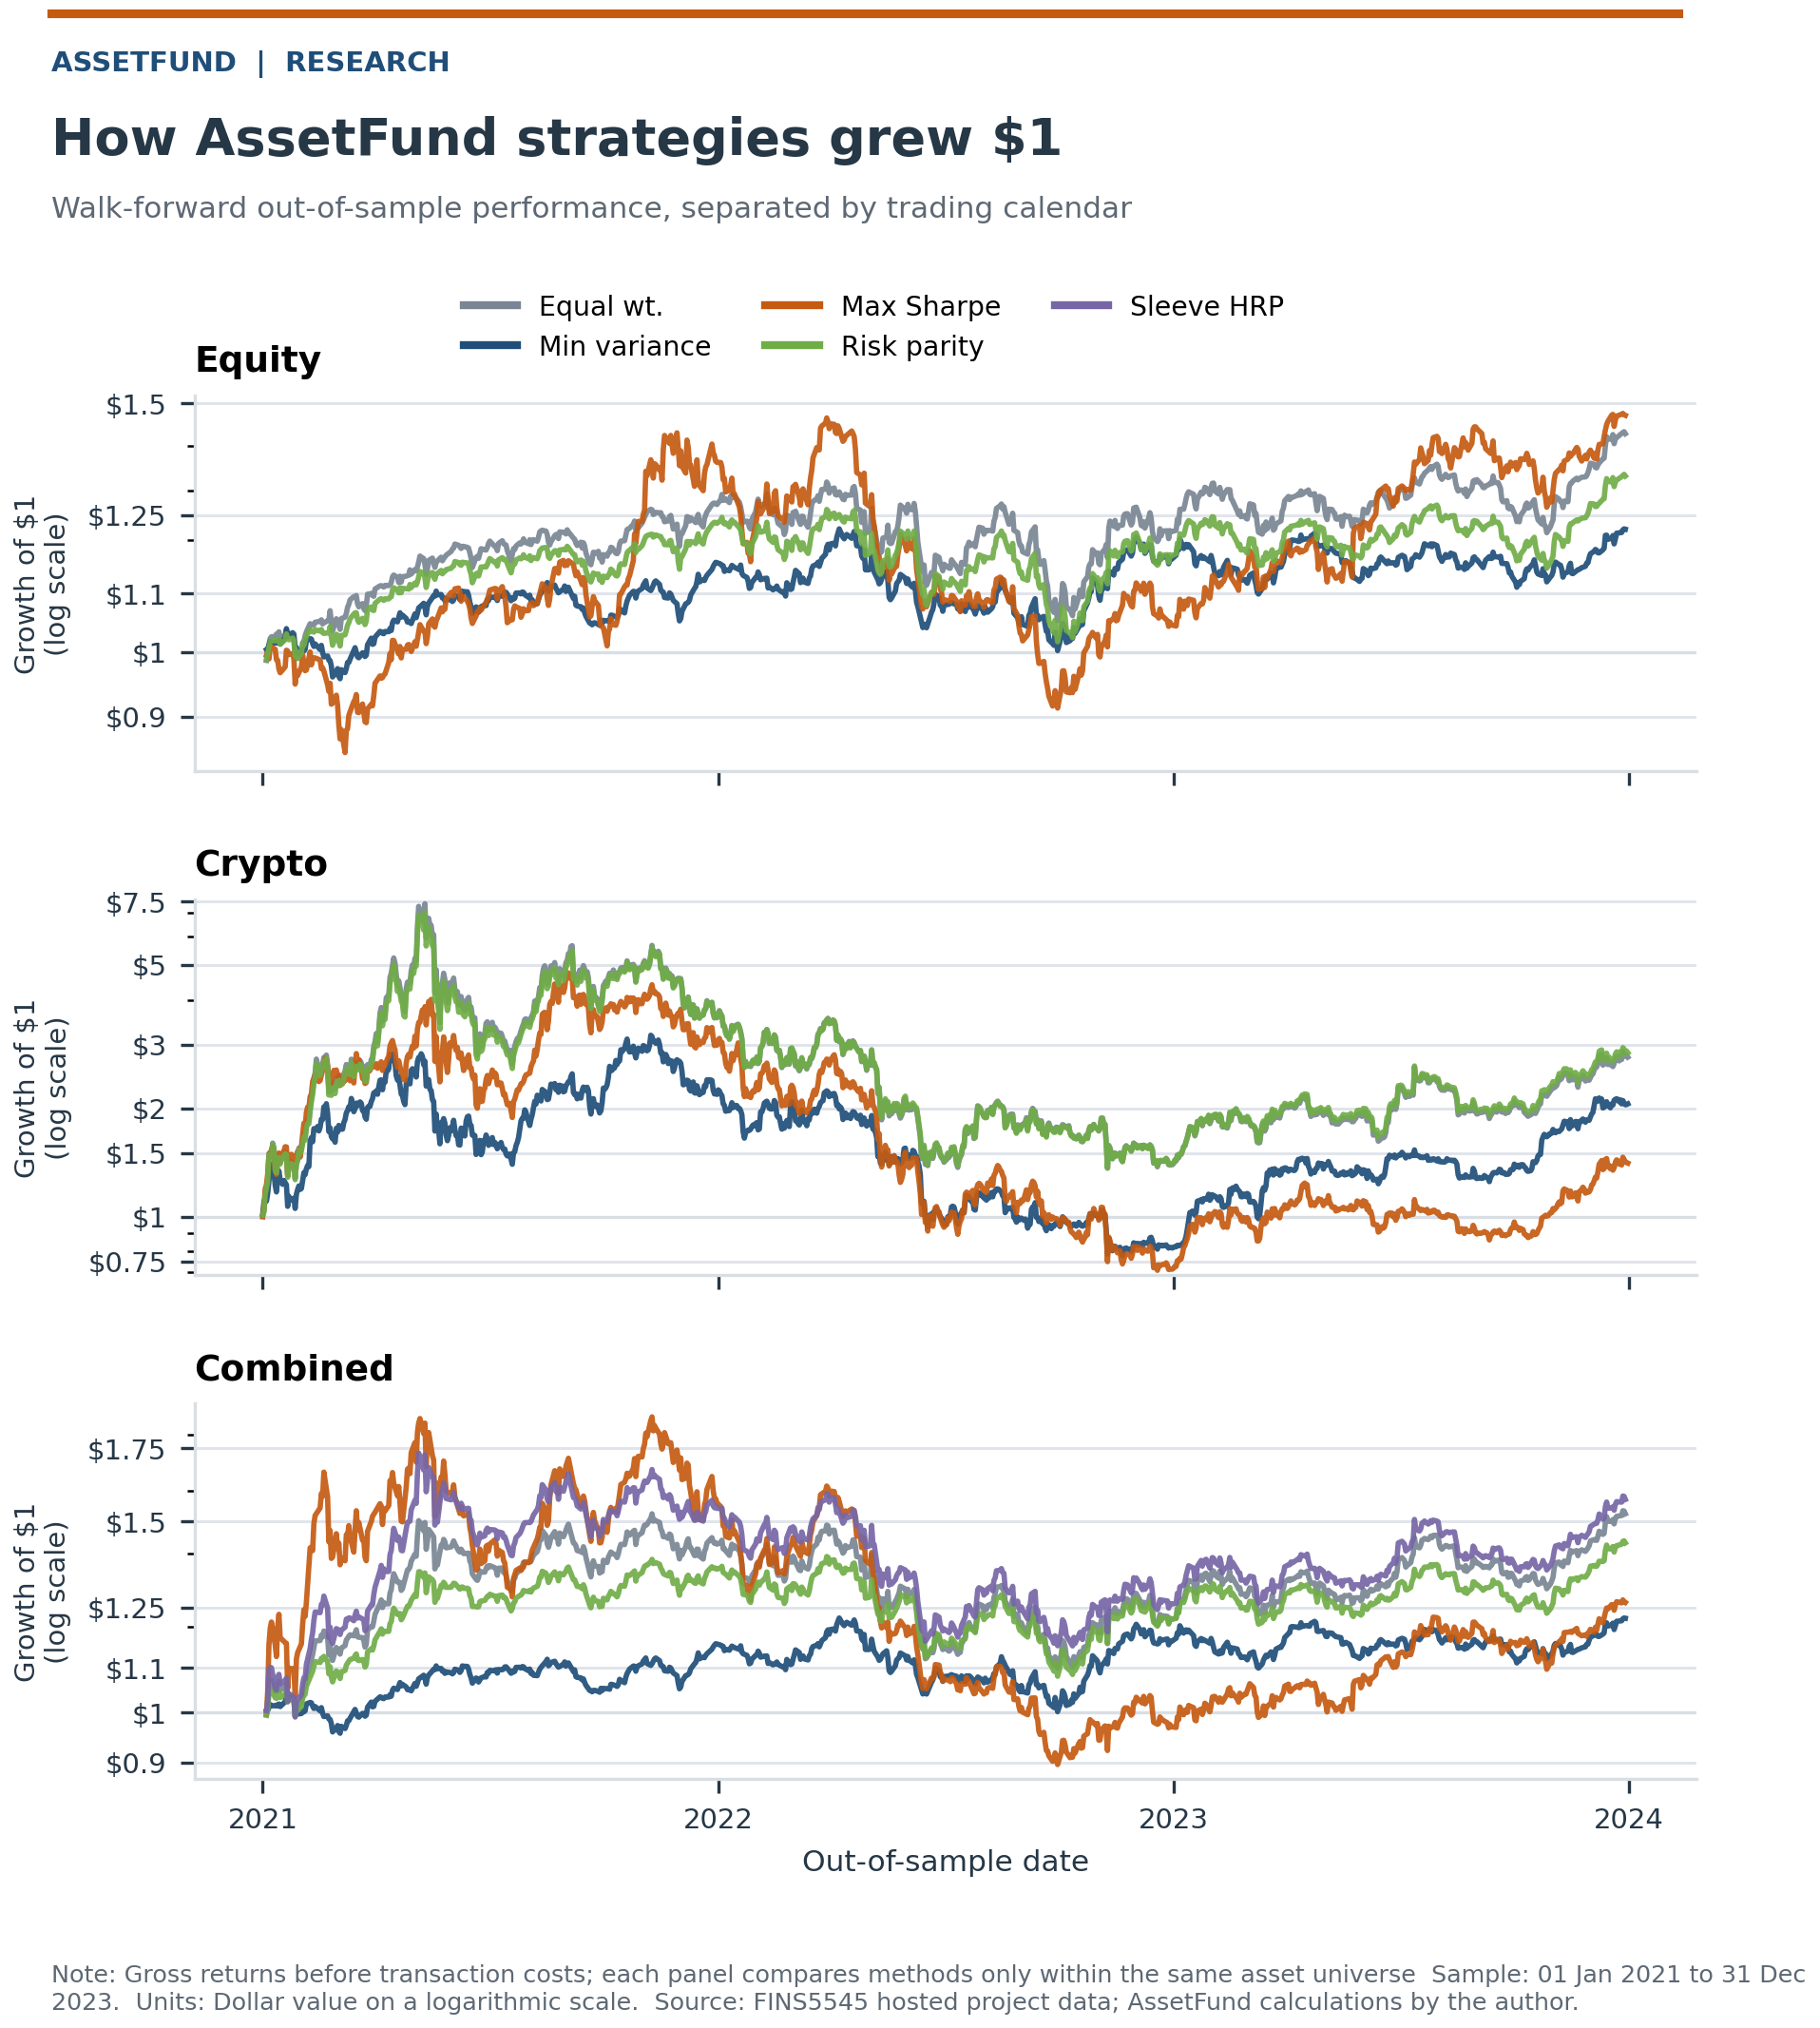
Figure 1. Growth of $1 across the 13 gross out-of-sample fund histories. Equity and combined funds run from 4 January 2021 to 29 December 2023. Crypto funds run from 1 January 2021 to 31 December 2023. The vertical scale is logarithmic. Source: FINS5545 and AssetFund calculations.
The path evidence in Figure 1 clarifies why a terminal return alone is insufficient. Crypto strategies rise quickly, then experience large 2021 and 2022 losses. The equity minimum-variance and combined minimum-variance paths are almost identical because the combined optimiser assigns negligible weight to the volatile crypto sleeve. The custom sleeve method avoids collapse by assigning risk at the sleeve level, which produces visible crypto participation and a higher growth path with a larger drawdown.

4. Portfolio behaviour and investor factsheets
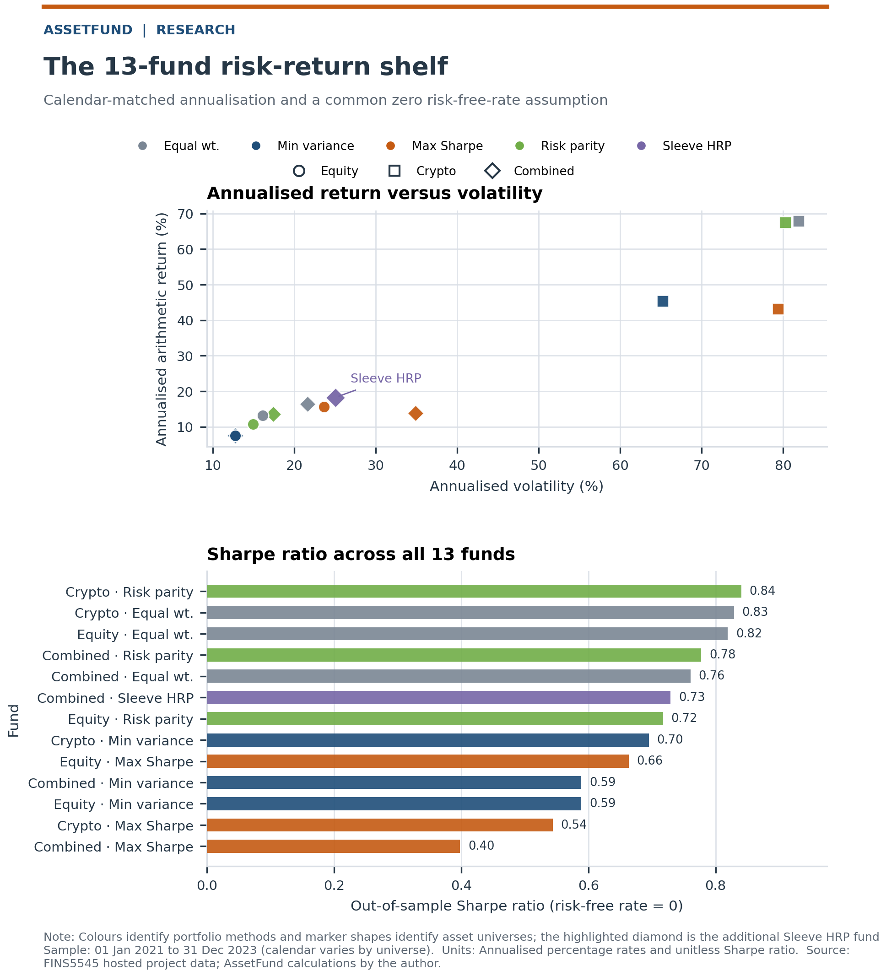
Figure 2. Annualised risk, return and Sharpe ratios across the 13 gross out-of-sample funds. Circles denote equity, squares crypto and diamonds combined funds. Sample: 1 January 2021 to 31 December 2023, with equity and combined funds starting 4 January. Source: FINS5545 and AssetFund calculations.
The risk-return map in Figure 2 separates the fund shelf into investor jobs. Crypto Risk Parity exhibits the highest Sharpe ratio of 0.841, followed by Crypto Equal Weight with 0.829 and Equity Equal Weight with 0.819. Combined Risk Parity shows a Sharpe ratio of 0.777 with wider asset exposure. Cryptocurrency funds fall in a different risk category, and some exhibit drawdowns of more than 80%. The Sharpe ratio alone thus cannot measure the loss an investor will have to endure.
The effective number of positions is used to measure the degree of concentration instead of the number of assets itself. The latest effective number of positions starts from 1.3 for Crypto Minimum Variance and goes up to 60 for Combined Equal Weight. At the effective rebalance of October 2021, Crypto Minimum Variance exhibits 98.84% exposure to Bitcoin. It is possible to achieve such a high exposure within the long-only constraint framework but contradicts the idea of diversification. The app shows the latest target holdings along with the performance metrics since the optimiser name cannot be treated as a guarantee of safety.
Drawdown of the primary combined fund with and without sentiment overlays is shown in Figure A1 in the appendix. Figure A2 displays the combined sleeve weights across the five portfolio construction methodologies. Minimum Variance mitigates cryptocurrency risk while the two-stage sleeve risk-parity rule keeps both sleeves economically relevant. Those two figures connect the statistics with the portfolio construction methodologies.
Growth of one dollar, drawdown, annualised return, volatility, Sharpe ratio, maximum drawdown and the latest target holdings are provided in the app factsheets. The returns are presented as gross. Transaction cost assumptions serve only as research checks.

5. Sector news-sentiment index

5.1 Text rule and validation
The VADER implementation provided by NLTK 3.10.2 is used by the sentiment engine to score the stored raw headline text. Punctuation and capitalization are maintained in the scoring process since NLTK VADER employs the capitalization of terms, intensifiers and punctuations as part of the ruleset (Hutto & Gilbert, 2014). The full sentiment scoring output contains 146,836 aligned headline records, including 105,334 unique strings. Duplicate strings are scored once and mapped back without changes to the original text. Six aligned headline records fall beyond the equity trading calendar and are excluded from the trading index.
Raw VADER returns exact zero scores in 48.85% of the sample. A zero score could be generated by either neutral language or finance terms that do not exist in the general VADER lexicon. A balanced 60-headline development sample from 10 sectors and three diagnostic groups was reviewed. The review resulted in a deliberately small extension containing 23 finance terms and one phrase. High-precision words such as beat, upgrade, downgrade, outperform and underperform were retained. Broad words that caused target mismatch were excluded. The rule changes 8.67% of headline classifications rather than rewriting the whole lexicon.
Table 2. Headline-classification diagnostics for unmodified and finance-aware NLTK VADER. The development set contains 60 reviewed headlines. The locked holdout contains 30 different headlines whose file and model rules were frozen before evaluation. Source: author labels and AssetFund calculations.
Split | Model | n | Accuracy | Balanced acc. | Macro F1
Development | Baseline VADER | 60 | 0.567 | 0.602 | 0.563
Development | Finance-aware VADER | 60 | 0.683 | 0.741 | 0.682
Locked 2023 holdout | Baseline VADER | 30 | 0.567 | 0.611 | 0.548
Locked 2023 holdout | Finance-aware VADER | 30 | 0.600 | 0.667 | 0.585
The diagnostics in Table 2 show improvement on both samples. Development macro F1 rises from 0.563 to 0.682. The separate 30-headline holdout improves from 0.548 to 0.585, while balanced accuracy rises from 0.611 to 0.667. The holdout file and model rule were hashed before evaluation. The samples are small, so the metrics support the direction of the extension rather than a claim of production-grade accuracy.

5.2 Index construction
Headline compound scores are first averaged within each ticker and trading day. The sector index then equal-weights ticker-day scores inside each sector. Missing ticker-days receive a neutral zero, while a separate coverage flag records whether news existed. Dropping missing days would make a sector index depend on which firms attracted coverage. Carrying the last headline forward would convert old news into a fresh signal. Neutral fill keeps the full 50-ticker grid and makes sparsity measurable.
$$S_{s,t}=\frac{1}{N_{s}}\sum_{i∈s}{c_{i,t}}$$
The trading signal is shifted by one equity trading day. A headline aligned to Monday can first affect Tuesday’s portfolio decision. A past-only expanding z-score requiring at least 21 prior observations converts each sector’s sentiment level into a surprise relative to its own history. Materials and Real Estate have the lowest mean ticker coverage, at approximately 53% and 56%, while Consumer coverage is approximately 94%. The coverage field is therefore part of the economic signal rather than merely a metadata column.
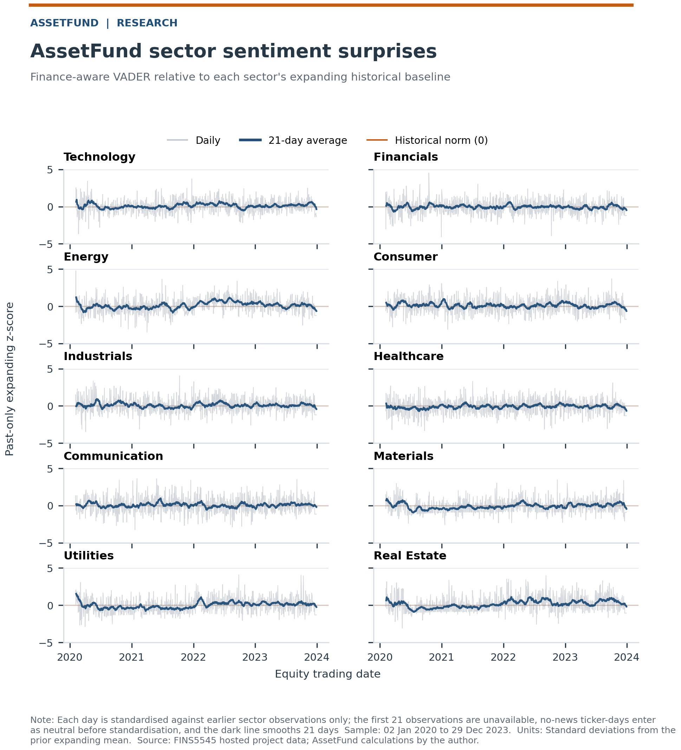
Figure 3. Past-only standardised sentiment surprises for 10 equity sectors. The index equally weights tickers, assigns a neutral zero sentiment score and sets a coverage flag for ticker-days with no news, and has a lag of one equity trading day in information. Time period: 2 January 2020 to 29 December 2023. Data source: FINS5545 and AssetFund calculations.
The paths of sector sentiment surprises in Figure 3 are characterized by short peaks, but not by persistent signals. It is explained by the structure of the input data – headlines reflect current sentiment and attention, not future cash flows. Therefore, the signal is used as a bounded monthly tilt to an existing portfolio rather than as a standalone strategy.

6. Sentiment fusion and execution-cost gate
The naive benchmark scales the equity sectors’ base weights by a factor of one plus the raw lagged compound score and then reweights equities to their original sleeve total. The primary rule ranks all sectors in a cross-section of 10 sectors, maps rank to a number between −1 and 1 and then multiplies it by lagged news coverage. Prespecified tilt strength is 0.25. Crypto sleeve weights are untouched and the total equity sleeve weight is preserved. The rule checks whether relative well-covered sector news could improve security weights without changing the strategic asset allocation.
$$q_{s,t}=\left[2\frac{{rank}_{s,t}-1}{10-1}-1\right]×{coverage}_{s,t}$$
$$m_{s,t}=1+0.25q_{s,t}$$
The rule is applied to nine equity-bearing base funds. Results are divided into development years from 2021 to 2022 and a locked 2023 holdout period. The Combined Two-stage Sleeve Risk Parity fund is the primary case due to its design which keeps both asset sleeves active and provides an appropriate place for an equity-only signal. Both the fund and the rule were fixed before the holdout comparison. No parameter was adjusted after the 2023 result.
Table 3. Locked 2023 evidence for the Combined Two-stage Sleeve Risk Parity fund and two sentiment overlays. Costs are charged on one-way turnover only at each later rebalance date. The initial formation cost is not counted. Sample: 3 January to 29 December 2023. Source: FINS5545 and AssetFund calculations.
Cost | Variant | Ann. return | Sharpe | Δ Sharpe | Max DD
0 bp | Base | 23.6% | 1.484 | +0.000 | -10.4%
0 bp | Naive | 23.7% | 1.489 | +0.004 | -10.5%
0 bp | Coverage-rank | 23.9% | 1.500 | +0.016 | -10.6%
10 bp | Base | 23.6% | 1.482 | +0.000 | -10.4%
10 bp | Naive | 23.6% | 1.485 | +0.003 | -10.5%
10 bp | Coverage-rank | 23.8% | 1.495 | +0.013 | -10.6%
50 bp | Base | 23.5% | 1.473 | +0.000 | -10.5%
50 bp | Naive | 23.4% | 1.471 | -0.002 | -10.6%
50 bp | Coverage-rank | 23.4% | 1.472 | -0.001 | -10.7%
The locked evidence in Table 3 is relatively scarce but interesting. In zero trading cost, the coverage-rank rule improves Sharpe from 1.484 to 1.500, which is 0.016. The naïve Sharpe gain is only 0.004. In 10 basis points of trading cost, the Sharpe gain of the coverage-rank rule is still 0.013. When the trading cost reaches 50 basis points, its Sharpe falls to 1.472 compared with 1.473 of the base fund, implying a negative gain. The maximum drawdown is also around 0.18 percentage points worse than before costs. The signal meets a low-cost implementation, yet fails a conservative cost gate.
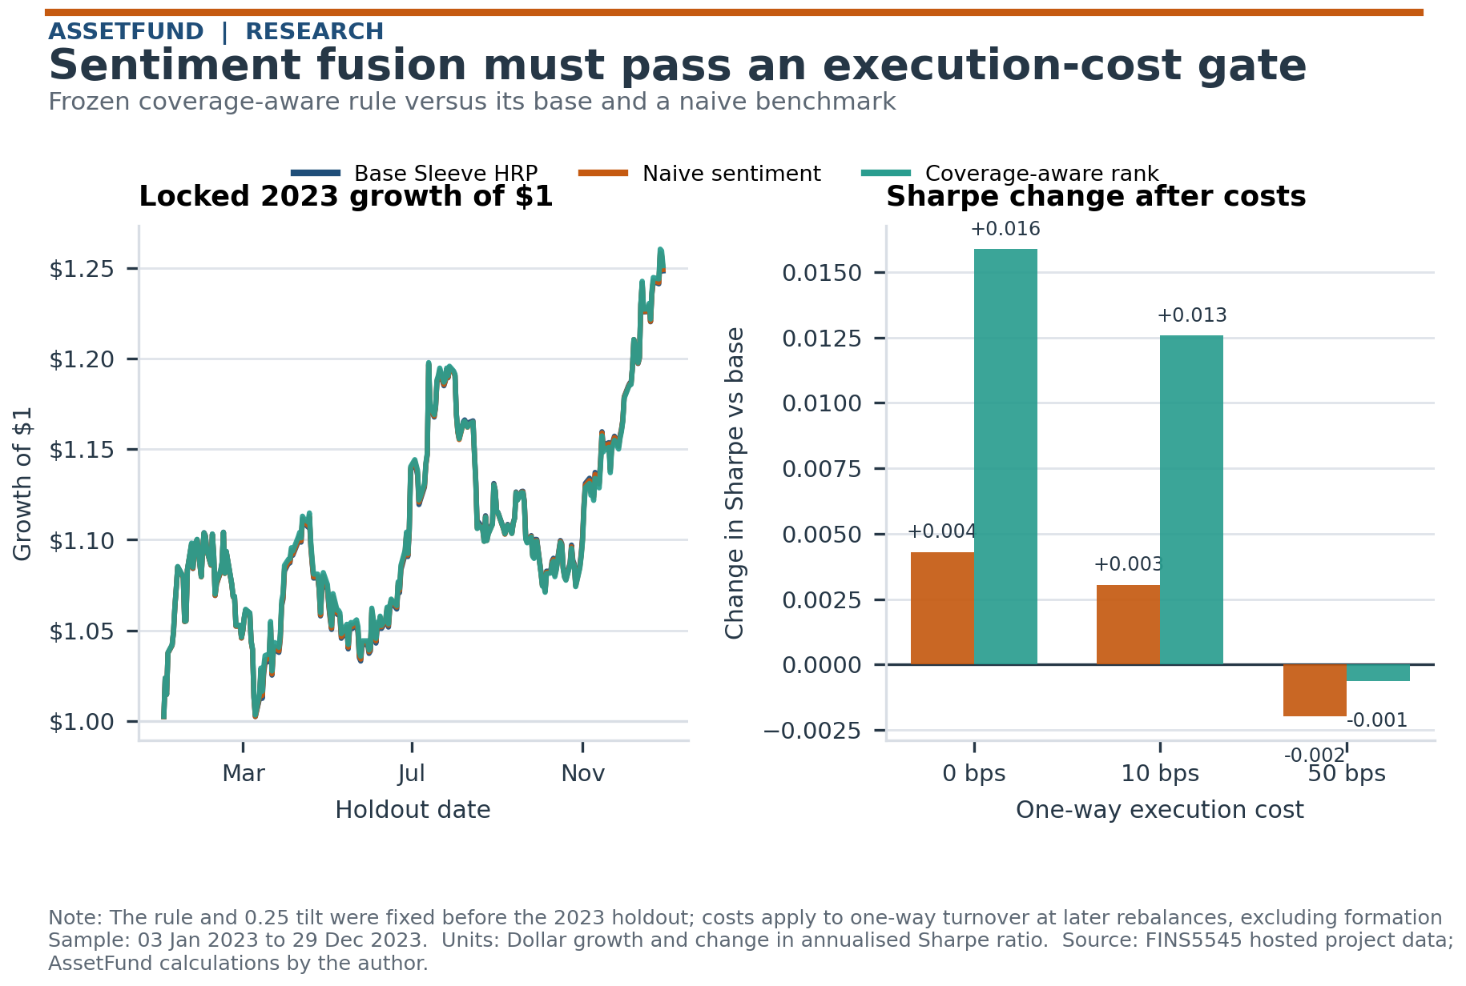
Figure 4. 2023 locked before-and-after fusion test for Combined Two-stage Sleeve Risk Parity. The left plot is for gross growth of $1. The right plot is for the Sharpe ratio gain at cost levels of 0, 10 and 50 basis points per unit of one-way turnover. Source: FINS5545 and AssetFund calculations.
The cost gate in Figure 4 disallows interpreting a minor gross improvement as a reliable trading edge. The coverage-aware rule outperforms the raw-score benchmark since ranking lowers the sensitivity to the VADER score range and the coverage adjustment lowers signals for sectors with limited news coverage. However, the estimated gross gain is still too low for high-cost trading. This negative result is included in the product evidence.

7. AssetFund app and investor journey
The Streamlit app translates the analysis to four investor choices. Compare Funds selects funds from the 13-fund shelf and places selected out-of-sample wealth paths beside the risk-return plot. Fund Factsheet summarizes the performance, drawdown, and latest holdings of a selected fund. Build Allocation combines two to five selected funds, takes initial weights and an illustrative annual management fee, and produces gross value, net value and fee drag. Sentiment Research gives the sector index, sentiment-model diagnostics, and the fusion cost test.
Allocation page operates at the product level but maintains transparency of look-through. Weights of products evolve based on realized returns. Equity funds retain their latest value on the crypto-only weekends to avoid constructing an artificial equity return. Management fees accumulate in accordance with passed calendar days. Latest security exposures aggregate duplicate holdings across selected funds and show how many selected funds hold each security. This way, the overlap not evident from a list of funds' names becomes known.
App build is made deliberately lightweight. It reads committed CSV artifacts but does not re-run the portfolio optimization or the VADER scoring process. Data contract checks include presence of required columns, uniqueness of fund-date combinations, fully invested target weight, and validity of connections between base and fusion funds. Navigation employs stable query parameters for shareability and session state for fast page switching. The current version of the codebase passes 77 automated tests. Live app: https://fins5545-assetfund-cj.streamlit.app. GitHub: https://github.com/s1046915557-ui/z5660980_projectB.
The visual design follows a navy-structured, orange-actioned theme and modest colors for comparisons through the app and report figures. Every page reiterates the sample status and the gross return warning. The idea is to help an investor to progress from comparison to evidence and eventually to allocation without treating the backtest as an investment recommendation.

8. Reflection and recommendations
The walk-forward approach, date audits and separate calendar handling address the identified backtest risks of mechanical nature. They do not solve the estimation risk problem. Sample covers the period of 2020 to 2023, includes 50 equities and 10 cryptocurrencies and is exposed to pandemic-related conditions as well as unusual conditions in crypto markets. Returns are gross in the absence of explicit cost scenario. Taxes, spreads, market impact, capacity, borrow restrictions and fund fees are outside the model. Arithmetic annualised return metric is adequate for calculating the Sharpe ratio, whereas CAGR reflects actual compounded returns. Both metrics are presented to avoid confusion.
The strongest portfolio result is a variety of different risk profiles and not a dominance of a certain optimiser. Portfolio construction under equal weighting and risk parity assumptions reduces the dependency on mean estimates. Minimum variance is responsible for managing volatility but can turn into a concentrated low volatility portfolio. Maximum Sharpe portfolio is unstable and highly concentrated in this particular sample. The Combined Two-stage Sleeve Risk Parity fund addresses the problem of unbalanced asset count but intentionally accepts greater crypto exposure and a larger maximum drawdown.
Sentiment analysis is successful in improving language classification and constructing a completely dated sector index. Its limitations are substantial. The headlines can be ambiguous, a rules-based scoring system cannot identify which firm the headline refers to if there is more than one entity mentioned, and 30 holdout observations represent a noisy measure of classification quality. The 2023 trading gains are minor and cost-sensitive. A production decision should therefore treat sentiment analysis as a monitored research overlay.

Three recommendations
- Match the fund to an explicitly stated loss budget. Choose Combined Minimum Variance if a maximum drawdown of about 18% is acceptable. Combined Risk Parity provides broader exposure with a higher realised Sharpe ratio. Two-stage Sleeve Risk Parity fund can be used only by investors who can withstand a historical maximum drawdown of about 34%.
- Use additional concentration management prior to treating any optimiser output as investable. An approach that involves setting a maximum security position and showing the minimum effective number of holdings is a good example. The 98.84% Bitcoin rebalance highlights why fully invested and long-only constraints are insufficient on their own.
- Apply the coverage-aware sentiment overlay if the estimate of one-way execution costs remains below the threshold eliminating its holdout advantage. Rerun the locked protocol on later data, monitor turnover and coverage, and suspend the tilt when the rolling net Sharpe difference becomes non-positive.

9. Conclusion
The AssetFund process offers a full pipeline from clean prices and headline information through to the funds, supporting evidence, and the investor interface. The core contribution is the decision process around the extensions. The two-stage portfolio construction reduces bias from asset count. The finance lexicon is tested independently on a holdout sample that has not been touched. The fusion rule is lagged, bounded, and tested under transaction-cost assumptions. This design generates a valuable set of funds without obscuring the key weaknesses. The live application rounds out the investor interface. The next phase will be monitoring, and rules can only be changed with new development and holdout cycles.

References
Hutto, C. J., & Gilbert, E. (2014). VADER: A parsimonious rule-based model for sentiment analysis of social media text. Proceedings of the International AAAI Conference on Web and Social Media, 8(1), 216-225. https://doi.org/10.1609/icwsm.v8i1.14550
Maillard, S, Roncalli, T & Teïletche, J 2010, ‘The Properties of Equally Weighted Risk Contribution Portfolios’, Journal of portfolio management, vol. 36, no. 4, pp. 60–70. https://doi.org/10.3905/jpm.2010.36.4.060
Markowitz, H 1952, ‘PORTFOLIO SELECTION’, The Journal of finance (New York), vol. 7, no. 1, pp. 77–91. https://doi.org/10.1111/j.1540-6261.1952.tb01525.x
Sharpe, WF 1966, ‘Mutual Fund Performance’, The Journal of business (Chicago, Ill.), vol. 39, no. 1, pp. 119–138. https://doi.org/10.1086/294846

Appendix
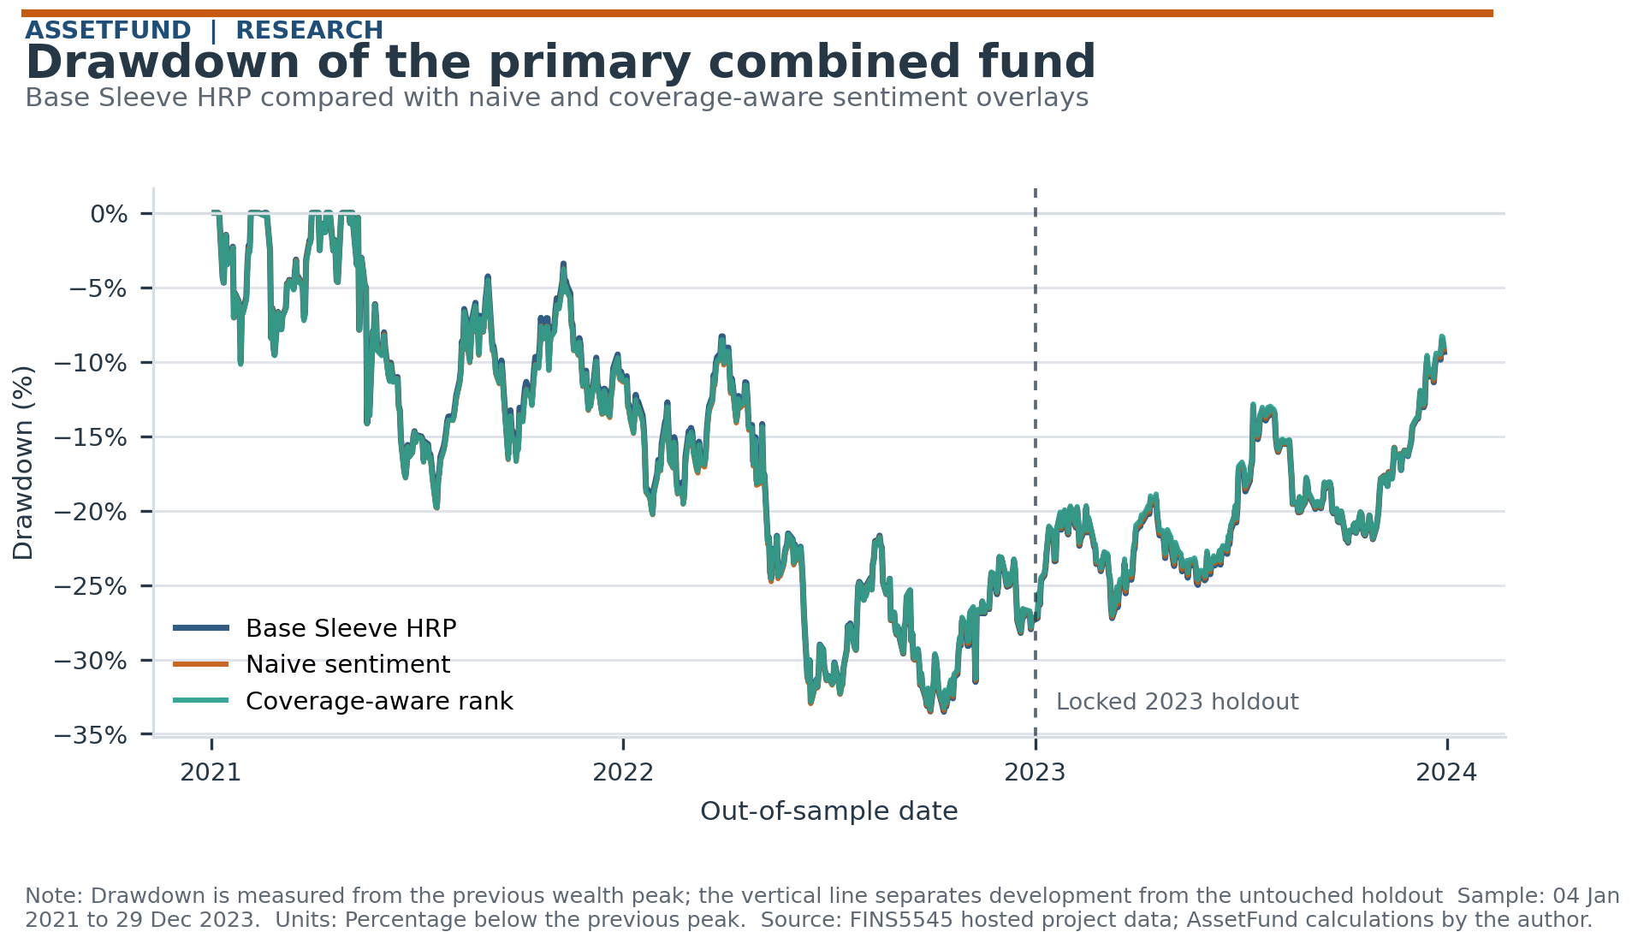
Figure A1. Drawdown for Combined Two-stage Sleeve Risk Parity and both sentiment overlays. The vertical dashed line separates the 2021–2022 development period from the locked 2023 holdout. Sample: 4 January 2021 to 29 December 2023. Source: FINS5545 and AssetFund calculations.

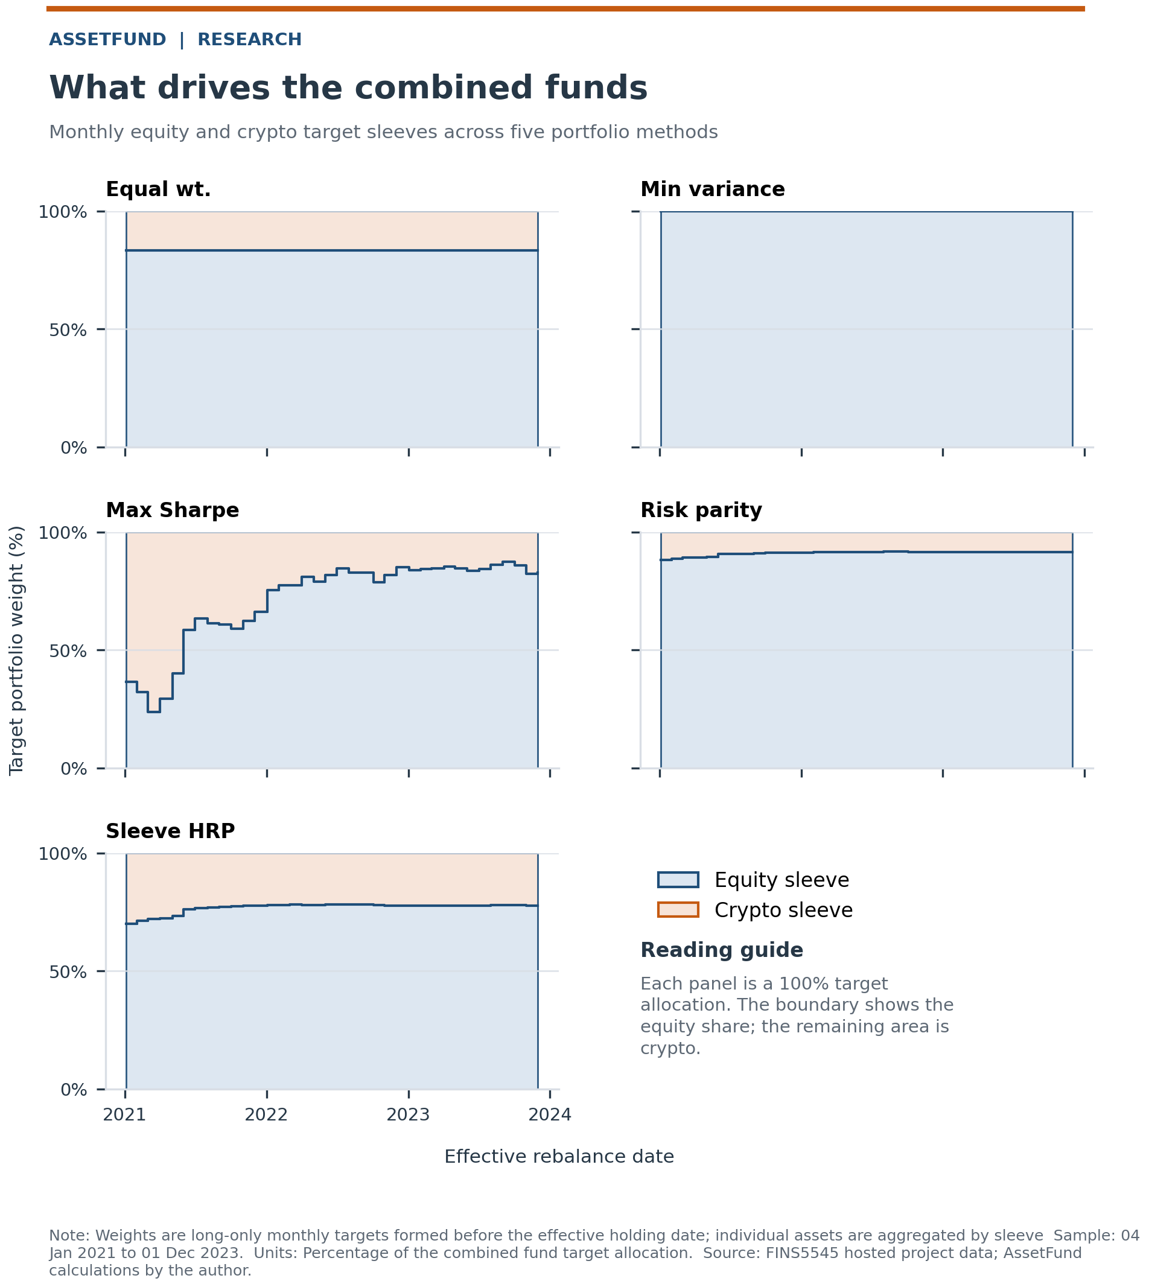
Figure A2. Equity and crypto sleeve targets across the five combined-fund methods. Each point is a monthly target effective on the shown date. Sample: 4 January 2021 to 1 December 2023. Source: FINS5545 and AssetFund calculations.

Table 4. Fund construction rules. All methods are long-only and fully invested. Each rule is re-estimated monthly using an expanding history that ends before the next holding month.
Method | Rule | Design purpose
Equal weight | 1/N | Transparent diversification benchmark
Minimum variance | Minimise forecast variance | Lower realised risk, possible concentration
Maximum Sharpe | Maximise expected excess return per unit risk | Sensitive to estimated means
Risk parity | Equalise asset risk contributions | Diversifies forecast risk
Two-stage sleeve RP | Risk parity within and across asset sleeves | Stops the 50 versus 10 asset count setting the sleeve budget

