──────────────────────────────────

**Homework #1 Hybrid Images**

107081028 常安彥

──────────────────────────────────

1. **Implementation**
   1. 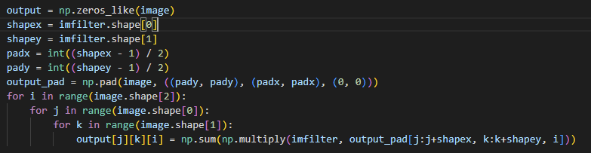**Image filtering**

I padded the input image with half of the width and height of the filter respectively. The half of the width I took was int( ( width of filter – 1) / 2 ). After that, I multiply the padded image and the filter from the left-top corner and sum them up, producing a convolved image same size as the input.

* 1. **Extract and combine the high-frequency and low-frequency signals**.
  2. **Others (10%)**

Run hw1.py with the correct image path.

1. **Experiments** 
   1. **Hybrid Image (15%)**

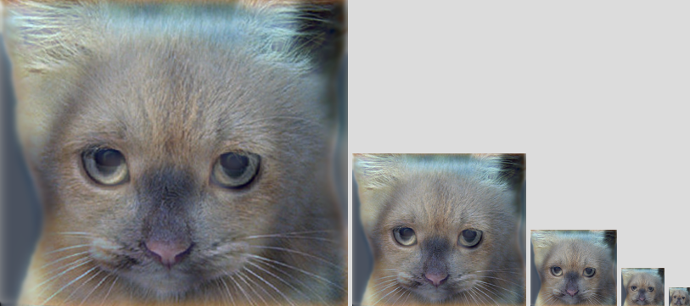Put your hybrid result from the cat-dog pair and briefly explain your result.

The image of cat was sharpened by a high-pass filter, so is seen more clearly on the big scaled photos. On the other side, the dog was blurred by a low-pass filter, so can only be observed on smaller photos.

* 1. **Other hybrid images (15%)**

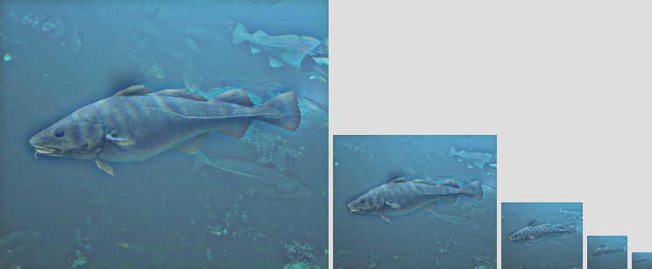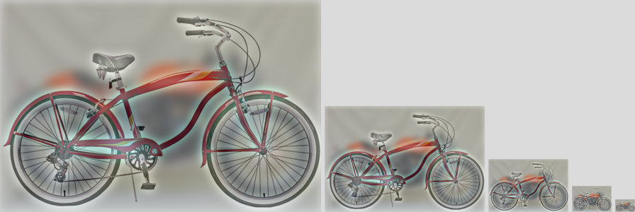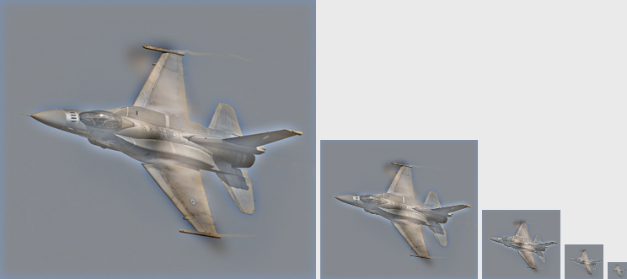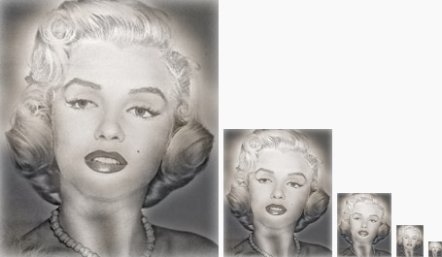Try different pairs of pictures in the folder **/data** and put your results here. Comparing the result of Problem 2.1, what’s the difference?

The pair of cat and dog had different colors, while the others had similar colors. Therefore, the previous hybrid image had a totally different cat as a result, as the others didn’t show big difference.

* 1. **Customized hybrid images (10%)**

Gather your own picture pairs and show your results of hybrid results.

I combined one thousand New Taiwanese paper money and the two thousand one. With cutoff frequency set as 7, the number 2000 and the salmons were still clearly observed as the image shrank. So, I set the cutoff frequency to 3, and the result balanced more. This is because as the frequency decreased, the low-frequency image became less blur and the high-frequency image became less sharpened. The more the filter size shrank, the count of pixels it observed every tick decreased.

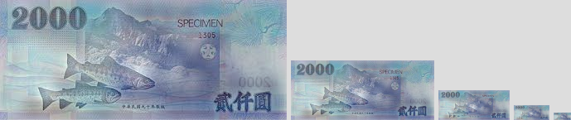 **Cutoff frequency = 7**

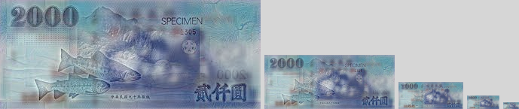 **Cutoff frequency = 3**

1. **Discussion (10%)**

Do you discover anything special in your experimental results?

The results and my adjustment were mentioned in the previous question. I assigned the cutoff frequency as 3 to balance the hybrid image.

What applications do you think this technology can be used for?

1. Anti-counterfeiting

Some particular signals can be hybrid onto works or ownings in order to prevent copies or stealing.

1. Building Texture

Textures can be created as blur images, and be tried on targets in order to decrease cost and save time.

1. Cipher

Some secrets can be encrypted and combined into images.

1. More information

More information can be zipped in the same piece of data, and less resource will be needed.