CV_HW2 Structure from Motion 107081028 常安彥

3.1 Camera Pose from Essential Matrix

Q = UWVT or UWTVT

R = det(Q)•Q

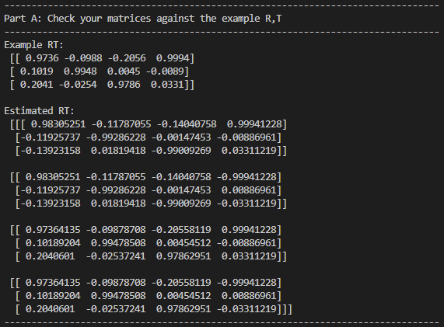T = ±u3

3.2 Linear 3D Points Estimation

[ v1M13 – M12

M11 – u1M13

…

vnMn3 – Mn2

Mn1 – unMn3 ]

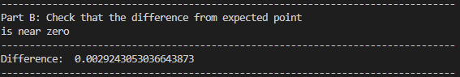 SVD solution and normalization

(near 0)

3.3 Non-Linear 3D Points Estimation

y = MiP

pi` = 1 / y3 [ y1 y2 ]

ei = pi` - pi

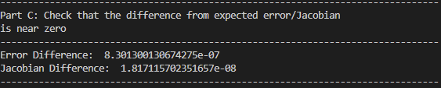

(near 0)

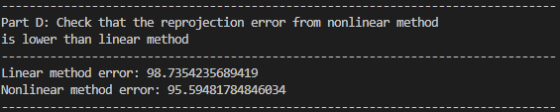P = P – (JTJ)-1JTe

(Nonlinear lower than linear)

3.4 Decide the Correct RT

First, estimate initial R and T.

Next, for every pair of R and T, calculate the corresponding 3D point.

Then, transform the 3D point to another camera coordinate.

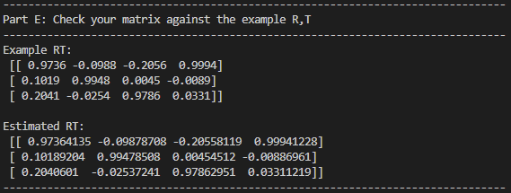 Finally, count the best pair with most positive z-coordinates.

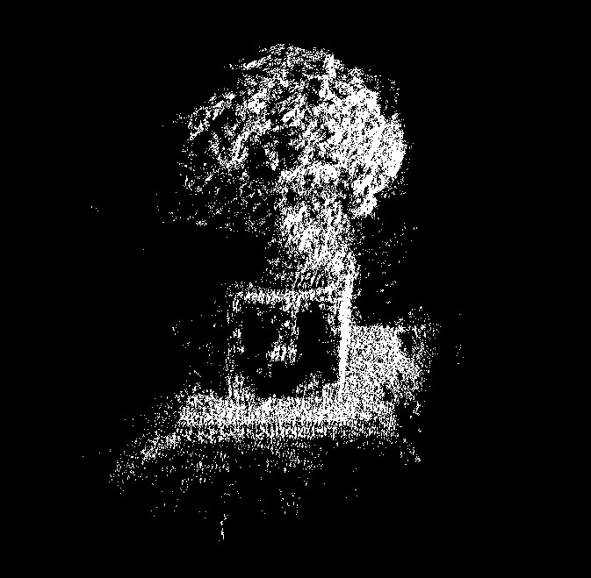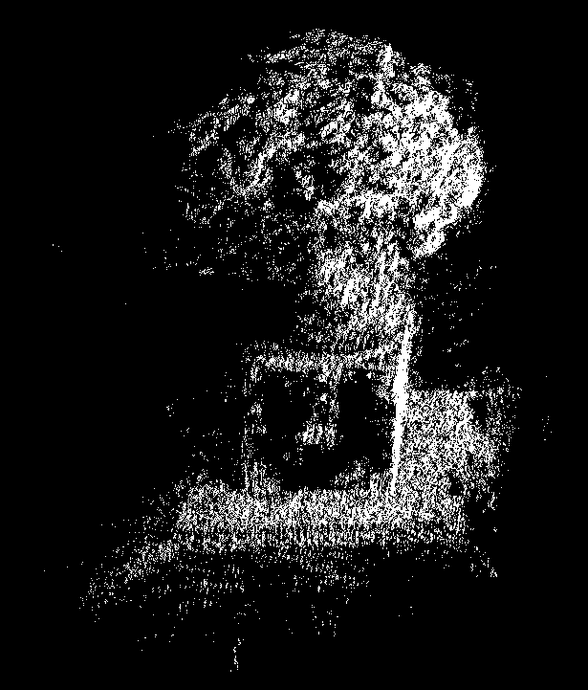3.4.2 SFM Pipeline

Left figure was done with non-linear estimation, and the right one was done with linear estimation.